October BEDS Enrollment

OVERVIEW 2
Basic Definitions 2
Uses of October BEDS Enrollment 2
How October BEDS Enrollment Is Determined 3
Where October BEDS Data Are Collected and Official Sources 3
REVIEWING, VERIFYING, CERTIFYING, AND CONFIRMING DATA 4
TIMELINE FOR OCTOBER BEDS ENROLLMENT ACTIVITIES 5
VERIFICATION REPORTS (VRs) 10
General Descriptions 10
VR by Location of Enrollment and Student Subgroup 11
VR by District of Residence 14
VR for District Pre-K 16
VR of Supplemental Counts for State Aid 18
SOURCES OF DATA IN VERIFICATION REPORTS 22
Data Elements Common to Multiple Verification Reports 22
Data Elements Unique to the VR of Counts for State Aid 23
Data Elements Unique to the VR for District Pre-K 24

OVERVIEW

The 2011–12 school year brought a fundamental change to the manner in which the October BEDS enrollment is reported. Starting with the 2011–12 school year, the New York State Education Department (NYSED) will determine the October BEDS enrollment for all public schools and districts using records in the Student Information Repository System (SIRS). For more information on SIRS, see http://www.p12.nysed.gov/irs/sirs/. Prior to 2011–12, schools and districts determined their October BEDS enrollment from their individual student management systems and reported that enrollment using the BEDS Online Internet application. Prior to 2011–12, districts and schools could consider their October BEDS enrollment as submitted via BEDS Online as final (with the exception of subsequent changes due to errors made in the initial reporting process) in the fall of the school year. In 2011–12, October BEDS data in local student management systems should be considered preliminary, as final October BEDS data will not be available until these data as reported in SIRS are verified and certified by districts in early January.

Basic Definitions
“BEDS” is an acronym for the Basic Educational Data System, which is a system that has annually collected aggregate student enrollment from all schools, districts, and BOCES in New York State since the 1966–67 school year. In recent years, BEDS data were gathered from all public and nonpublic schools using School Data and District Summary forms in a Web application known as the BEDS Online. Though student enrollment will cease to be collected in BEDS Online starting in 2011–12, BEDS Online will continue to gather other student-related information that is more easily or efficiently collected using this method rather than SIRS. BEDS will also continue to collect information on school staff, resources, and programs to complement information that can be derived from SIRS.

“BEDS Day” is the first Wednesday in October. This date was chosen because it comes after the end of the first attendance period when returning and new student registrations have been processed and stable enrollment counts can be obtained. Students are counted in the school or district where they were enrolled as of BEDS Day. Every enrolled student is counted only once. If students were counted as of different dates, it could lead to some students being counted in multiple places or some students not being counted at all due to student mobility. BEDS Day provides a point in time when student enrollment counts can be complete, unduplicated and comparable.

Uses of October BEDS Enrollment
The October BEDS enrollment data are used for many purposes, including but not limited to:
- determining accountability statuses,
- making State aid calculations,
- generating targeted federal program aid,
- providing the source of LEP counts for Part 154,
- reporting enrollment counts in New York State Report Cards, and
- providing data to the media and general public upon request.

How October BEDS Enrollment Is Determined
The October BEDS enrollment is determined solely on the basis of enrollment and the consequent expectation of attendance in a specific school or district. Though the district of reporting responsibility and the district of residence usually correlate highly with the school or district of enrollment, they do not directly determine the October BEDS enrollment. Students may be the reporting responsibility of one district but enrolled in another; likewise, students may be residents of one district but enrolled in another. If a student is enrolled in a specific school or district, the student is counted as part of the October BEDS enrollment, regardless of any other qualifying or disqualifying factors, such as where the student lives and other demographic or program service considerations.
Students reported in SIRS with any of the following Reason for Beginning Enrollment codes are included in the October BEDS enrollment count:
- 0011 (Enrollment in building or grade)
- 0022 (Foreign Exchange Student)
- 5544 (Transferred under NCLB Title 1, School in Improvement Status)
- 7000 (Transferred under NCLB, Persistently Dangerous School)
- 7011 (Transferred under NCLB, Victim of a Serious Violent Incident)

To be included in the October BEDS enrollment count, a student’s beginning enrollment date must be on or before BEDS Day, and the ending enrollment date must be on or after BEDS Day.

Where October BEDS Data Are Collected and Official Sources
The 2011-12 school year is a transition year for BEDS and SIRS data collection. Portions of data historically collected in BEDS are being captured in both the BEDS Online as well as in SIRS for 2011-12. The chart below indicates which BEDS data will be collected in SIRS and which in BEDS Online and whether NYSED will be pulling these data from SIRS or BEDS Online as the official source for reporting purposes in 2011–12 and 2012–13.
Type of Data | Collected in 2011–12 | Official Source in 2011–12 | Collected in 2012–13 | Official Source in 2012–13
Total BEDS Day Enrollment by Grade (K-12, including ungraded elementary and ungraded secondary) | SIRS | SIRS | SIRS | SIRS
District of Residence for BEDS Day Enrolled Students | BEDS Online for charter school students; SIRS for all students | BEDS Online | SIRS | SIRS
District Pre-K Distribution of BEDS Day Enrolled Students | BEDS Online and SIRS | BEDS Online | SIRS | SIRS
Other Counts of BEDS Day Enrolled Students Required for State Aid | BEDS Online and SIRS | BEDS Online | SIRS | SIRS

REVIEWING, VERIFYING, CERTIFYING, AND CONFIRMING DATA

October BEDS data as reported in SIRS can be reviewed, verified, certified, and confirmed using October BEDS Enrollment Verification Reports that are described later in this document. These reports will facilitate confirmation that all students enrolled in any of grades pre-kindergarten through grade 12, including ungraded elementary and ungraded secondary students, in a district or charter school as of BEDS Day have records in SIRS and that those records contain accurate subgroup and program information.
Districts and charter schools will be notified each year by the first week in August of the specific dates when the October BEDS Enrollment Verification Reports are expected to be deployed and of the specific dates by which data in the reports need to be reviewed, verified, certified or confirmed. Definitions of the terms review, verify, certify and confirm for purposes of this document are as follows:
Review: check and scrutinize data for reasonableness and internal consistency without necessarily looking to underlying or external data sources.
Verify: follow up to review where data are checked against underlying and external data sources to ensure completeness and accuracy.
Certify: attest to the verification process by acknowledging that data are either complete and accurate, or not complete and accurate and in need of remedial action.
Confirm: compare data against a prior snapshot of the data and, if changes are found, verify that the changes are both intended and correct, else attest to the correctness of no change.
The October BEDS Enrollment Verification Report by Location of Enrollment and Student Subgroup was made available in the Level 2 Reporting environment (L2RPT) in mid-November for 2011–12, the first year of the BEDS to SIRS transition. Four October BEDS Enrollment Verification Reports will be made available in October for the 2012–13 and beyond as soon as districts begin loading data into SIRS for the new school year.
A general overview of the timelines for activities and actions that will be required of schools and districts in conjunction with the October BEDS enrollment submitted via SIRS is as follows:

TIMELINE FOR OCTOBER BEDS ENROLLMENT ACTIVITIES

Data | Action Required
Data | 2011–12 |  | 20012–13
Data | January | April | January | April
Total October (BEDS Day) Enrollment by Grade | Verify and Certify | Confirm | Verify and Certify | Confirm
Subgroup and Program Data for BEDS Day Enrolled Students | Review | Verify | Review | Verify
District of Residence for BEDS Day Enrolled Students | Review | Review | Verify and Certify | Confirm
District Pre-K Distribution for BEDS Day Enrolled Students | Review | Review | Verify and Certify | Confirm
Other Counts for BEDS Day Enrolled Students Required for State Aid | Review | Review | Verify and Certify | Confirm

Beginning in 2011–12, verification and certification of the total October BEDS enrollment by grade that appears in the “All Students” line of the “October BEDS Enrollment Verification Report by Location of Enrollment and Student Subgroup” will be required by early January. Confirmation of that total October BEDS enrollment by grade will be required in early April. Confirmation means that a district or charter school will review their total October BEDS enrollment by grade and confirm that any changes in data since the January certification were both intended and correct. Confirmation in early April provides the opportunity for a district or charter school to correct any error that may have been made during the January verification process so that final total October BEDS enrollment by grade is correct for State aid and public reporting purposes.
Subgroup and program data that appear in the “October BEDS Enrollment Verification Report by Location of Enrollment and Student Subgroup” will remain open to update through the end of the school year. Districts and charter schools are expected in January to review the subgroup and program service data for accuracy and completeness and to act locally as their data warrant. Districts and charter schools are expected in April to verify the accuracy and completeness of subgroup and program service data for BEDS Day enrolled students as the data are known to exist in local student management systems at that point in time. Certification of subgroup and program data will take place at the end of the school year in conjunction with assessment verification.
NOTE: Subgroup and program data for BEDS Day enrolled students will reflect the school year status. That is, if a student was a member of a subgroup or program category (e.g., race/ethnicity, disability, LEP, etc.) at any point in the school year, then that student will be counted as a member of that subgroup or program category for that school year. This means a student who was counted as a member of a particular subgroup in a January report will continue to be counted as a member of that subgroup in April reports and beyond. However, a student who did not appear as a member of a particular subgroup in January report may appear as a member of that subgroup in April reports and beyond, provided the student was enrolled on BEDS day.
In February 2012, SED will deploy three additional October BEDS Enrollment Verification Reports that will contain 2011–12 data derived from SIRS records:
- October BEDS Enrollment Verification Report by District of Residence
- October BEDS Enrollment Verification Report for District Pre-K
- October BEDS Enrollment Verification Report for State Aid Calculations
District will not be required to certify 2011–12 data in these three reports, but will be required to do so for 2012–13. Districts are expected to review data in these three October BEDS Enrollment Verification Reports and to compare with similar counts reported through the BEDS Online for 2011–12. Corrections should be made to student records in SIRS if a district’s review reveals any error in the student records. Corrections should be made to the fall 2011 BEDS Online if a district’s review reveals any error in the fall 2011 BEDS Online submission. The fall 2011 BEDS Online, the official source of these counts for 2011–12, must be correct in order for State aid based on these counts to be correct.
Beginning in 2012–13, verification and certification of total October BEDS enrollment by grade, district of residence, district Pre-K and supplemental counts for use in State aid calculations will be required in early January followed by a confirmation of these data in early April.
Following verification and certification of the total October BEDS enrollment by grade that will take place in January of each year, SED will extract the October BEDS enrollment from SIRS. This will occur on or about January 10th of each year and will be referred to as the January Snapshot. Grade-by-grade enrollment by district from the January snapshot will be transmitted to the Department’s State Aid Unit for use in State aid projections. January snapshot records will be permanently stored in L2RPT with a naming convention of “January 20XY BEDS Enrollment Snapshot.”

NOTE: The first use of the October BEDS enrollment is in mid-January, when total district enrollment by grade is supplied for use in State aid projections. Once the October BEDS enrollment data have been supplied for State aid use, they are considered public information and will be provided to any requestor on demand. Those requestors may include, but are not limited to, the State’s Division of Budget, other school districts, the media, the NYS High School Athletic Association, and the inquiring public. The October BEDS enrollment that have been released prior to April of any school year have been and will continue to be labeled as preliminary.

The January snapshot will be used as the source of the October BEDS enrollment, albeit preliminary, until an April snapshot replaces the January snapshot as the official and final source of the October BEDS enrollment. Once replaced by the April snapshot, the January snapshot will have no other use other than as documentation of what October BEDS enrollment by grade for each district was provided to the Department’s State Aid Unit in January.

Following the January snapshot, schools and districts will be able to continue loading student records into SIRS, adding and/or updating student subgroup and program facts to account for the fluid nature of their information and student bodies. The October BEDS Enrollment Verification reports will continue to be available in L2RPT following the January snapshot and will be refreshed continuously.

Districts and charter schools will be required by the first Friday in April in all school years to confirm their total October BEDS enrollment by grade as it appears in the “All Students” line of the “October BEDS Enrollment Verification Report by Location of Enrollment and Student Subgroup”. Following confirmation of the October BEDS enrollment, SED will extract a BEDS Day enrollment snapshot from SIRS as of the first data refresh in April. The April snapshot records will be permanently stored in L2RPT with a naming convention of “April 20XY BEDS Enrollment Snapshot” and will be considered by the Department for all purposes as containing the final October BEDS grade-by-grade enrollment for all districts and schools. Enrollment by grade for all districts from the April snapshot will be transmitted to SED’s State Aid Unit.

Districts and charter schools will be required by the first Friday in April in all school years to verify subgroup and program service information for BEDS Day enrolled students as being complete and accurate as of early April. As noted earlier, final verification and certification of subgroup and program service data will take place at the end of the school year in conjunction with assessment verification.
Schools and districts should secure copies of their October BEDS enrollment data as contained in the October BEDS Enrollment Verification Reports for both the January Snapshot as well as the April Snapshot, keeping in mind that the April Snapshot replaces the January Snapshot as the official record of total grade-by-grade enrollment counts. As noted earlier, the purpose for districts and charter schools of securing copies of their January Snapshot of data is to have a record of what data were provided to the Department’s State Aid Unit in January.

NOTE: October BEDS Enrollment Verification Reports are currently being generated only for public schools and districts, including charter schools. Nonpublic schools, including Article 81 schools, will not see verification reports at this time. Reports may be developed in the future for nonpublic schools.

Data displayed in the October BEDS Enrollment Verification Reports may be saved and downloaded in multiple ways. The reports themselves as well as their user guides should be consulted for details on saving data.

NOTE: The October BEDS enrollment verification reports are intended to serve the needs of both the Department as well as the field. Additional reports or modifications to existing reports can be subjects for further discussion.

October BEDS Enrollment Timeline in SIRS for 2011–12
When | Event
first Wednesday in October | BEDS Day
mid-October | Districts begin loading student enrollment, demographic, and program service data into SIRS.
mid-November | SED deploys the October BEDS Enrollment Verification Report by Location of Enrollment and Student Subgroup in the Level 2 Reporting Environment (L2RPT).
first Friday in January | Deadline for districts to verify total October BEDS enrollment by grade and review data by subgroup based on the October BEDS Enrollment Verification Report by Location of Enrollment and Student Subgroup.
second Friday in January | Deadline for districts to certify total October BEDS enrollment by grade.
early-January | The January Snapshot extracted from SIRS as of the first refresh in January. SED transmits total October BEDS enrollment by grade from the January Snapshot for each district to the Department’s State Aid Unit for use in State aid projections.
early-February | SED deploys three additional October BEDS Enrollment Verification Reports:  - October BEDS Enrollment Verification Report of Supplemental Counts for State Aid Calculations,  - October BEDS Enrollment Verification Report by District of Residence, and  - October BEDS Enrollment Verification Report for District Pre-K.  Districts review but do not verify data contained in these three reports for 2011–12. Verification and certification of data in these reports will be required for 2012–13 when SIRS is expected to become the official source of these data.
January through March | Districts continue to load and clean student data in SIRS with particular focus on making any final corrections in anticipation of confirming the total October BEDS Enrollment by grade.
first Friday in April | Districts confirm the total October BEDS enrollment by grade based on the October BEDS Enrollment Verification Report by Location of Enrollment and Student Subgroup. Districts verify data by subgroup as complete and accurate as of this point in the school year. Final verification and certification of data by subgroup for all students, including BEDS Day enrolled, will take place at the end of the school year in conjunction with assessment verification.
mid-April | The April Snapshot is extracted from SIRS records as of the first refresh in April. SED transmits total October BEDS enrollment by grade for each district from the April Snapshot to the Department’s State Aid Unit for use in State aid calculations.

October BEDS Enrollment Timeline in SIRS for 2012–13
When | Event
first Wednesday in October | BEDS Day
mid-October | Districts begin loading student enrollment, demographic, and program service data into SIRS. Four October BEDS Enrollment Verification Reports become available in L2RPT for districts and schools with data in the Repository:  - Location of Enrollment and Student Subgroup  - District of Residence  - District Pre-K  - Supplemental Counts for State Aid Calculations
first Friday in January | Deadline for districts to verify data contained in all four October BEDS Enrollment Verification Reports listed above as of the first SIRS refresh in January. Data by subgroup for BEDS Day enrolled students will remain open to update through the end of the school year.
second Friday in January | Deadline for districts to certify the total October BEDS enrollment by grade, district of residence for their BEDS Day enrolled students, the district Pre-K distribution and supplemental counts for State aid calculations based on the October BEDS Enrollment Verification Reports. Districts must review and verify the accuracy and completeness, as known to date, of data by subgroup for BEDS Day enrolled students.
early-January | The January Snapshot extracted from SIRS as of the first refresh in January. SED transmits total October BEDS enrollment by grade as well as Supplemental Counts for State Aid Calculations from the January Snapshot for each district to the Department’s State Aid Unit for use in State aid projections.
January through March | Districts continue to load and clean student data in SIRS with particular focus on making any final corrections in anticipation of confirming total October BEDS Enrollment by grade.
first Friday in April | Districts confirm the total October BEDS enrollment by grade, district of residence for their BEDS Day enrolled students, the district Pre-K distribution and supplemental counts for State aid calculations based on the October BEDS Enrollment Verification Reports. Districts confirm the accuracy and completeness, as known to date, of data by subgroup for BEDS Day enrolled students. Final verification and certification of data by subgroup for all students, including BEDS Day enrolled, will take place at the end of the school year in conjunction with assessment verification.
mid-April | The April Snapshot is extracted from SIRS as of the first refresh in April. SED transmits total October BEDS enrollment by grade as well as other data necessary for State aid from the April Snapshot to the Department’s State Aid Unit.

VERIFICATION REPORTS (VRs)

General Descriptions
The following are the October BEDS data verification reports for reviewing, verifying, certifying, and confirming BEDS data in SIRS:
- October BEDS Enrollment Verification Report by Location of Enrollment and Student Subgroup (Enroll)
- October BEDS Enrollment Verification Report by District of Residence (DResid)
- October BEDS Enrollment Verification Report for District Pre-K (PreK)
- October BEDS Enrollment Verification Report of Supplemental Counts for State Aid (StAid)
Also available is a Student Detail Report (Detail) for each of the above.
1) The October BEDS Enrollment Verification Report by Location of Enrollment and Student Subgroup presents counts of students by grade for All Students and for the subgroups of gender, race/ethnicity, disability status, English proficiency status, and economic status.

2) The October BEDS Enrollment Verification Report by District of Residence, scheduled for a February 2012 deployment, presents counts of enrolled students by grade and by their District of Residence. The District of Residence is the district that a school-age child is entitled to attend based on the location of the child’s residence. District of Residence is used in calculations for textbook and transportation aid, and provides insight into from where charter schools, magnet schools, and nonpublic schools draw their students.

3) The October BEDS Enrollment Verification Report for District Pre-K, scheduled for a February 2012 deployment, presents district totals for pre-kindergarten and will differentiate half- and full-day pre-kindergarten as well as Universal Pre-K (UPK) funded versus non-Universal Pre-K funded students. Data in this report are used to monitor the Universal Pre-kindergarten program and for “maintenance of effort” and other funding considerations.

NOTE: BEDS Online will be the official source of the Pre-K/UPK student counts for 2011–12. Pre-K/UPK data will be collected in parallel in the BEDS Online and in SIRS in 2011–12. SIRS records for Pre-K/UPK need to be accurate in 2011–12 so that a smooth transition to SIRS as the official source of Pre-K/UPK student counts can take place in 2012–13. Once a full transition of the Pre-K/UPK data and reliance upon SIRS records for these data have taken place, this verification report will replace counts currently collected using BEDS Online in items 1d, 1e, and 1f of the District Summary Form.

4) The October BEDS Enrollment Verification Report for State Aid Calculation, scheduled for a February 2012 deployment, presents student counts that are used in State aid calculations. In general terms, the majority of state aid is reserved for students based on where they are enrolled; however, textbook and transportation aid is reserved for students based on their district of residence. For textbook and transportation aid, non-resident enrolled students are excluded, while resident students enrolled outside of the district are included.

VR by Location of Enrollment and Student Subgroup

The October BEDS Enrollment Verification Report by Location of Enrollment and Student Subgroup presents counts of students by grade for “All Students” and for the subgroups of gender, race/ethnicity, disability status, English proficiency status, and economic status, as shown below:

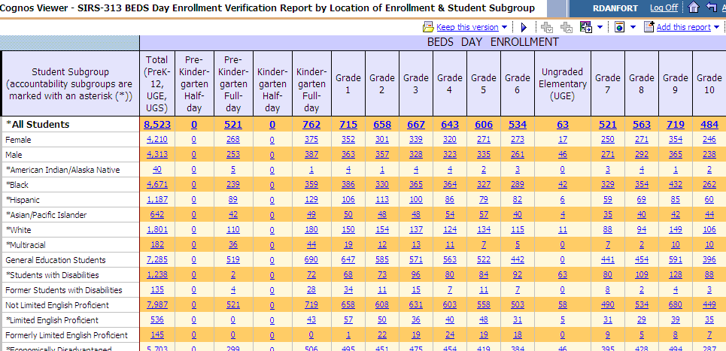

Beginning in 2011–12, counts in the “All Students” line of this report (only this one line) will need to be verified and certified by early January and confirmed in early April for each school year.

Counts of students by subgroup and program category (e.g., race/ethnicity, disability, LEP, etc.) appear in this report to provide focus on these data earlier in the school year due to their use and significance in measures of school accountability. Inclusion provides a mechanism for schools and districts to verify the accuracy and completeness of these data as local awareness of the data evolves prior to assessment verification that takes place at the end of the school year. The subgroup categories appearing in this report are the same as those used in the New York State Report Card and required for federal reporting. Subgroup and program service data for BEDS Day enrolled students will remain open to update through the end of the school year. Final verification and certification of subgroup and program data constituting the accountability subgroups will take place at the end of the school year in conjunction with assessment verification.
Data in the “All Students” and gender and race/ethnicity rows in the “October BEDS Enrollment Verification Report by Location of Enrollment and Student Subgroup” by school replace the student counts that were previously collected in Item 3 Enrollment in This School in the BEDS School Data Form in BEDS Online, as shown below:

3. Enrollment in This School
Grade | American Indian or  Alaska Native |  | Black or  African American  (not Hispanic origin) |  | Asian or  Pacific Islander |  | Hispanic or Latino |  | White  (not Hispanic origin) |  | Multi-Racial  (not Hispanic origin) |  | Total  Enroll-ment
Grade | Male | Female | Male | Female | Male | Female | Male | Female | Male | Female | Male | Female | Total  Enroll-ment

Prekindergarten
Kindergarten-HD
Kindergarten-FD
First
Second
Third
Fourth
Fifth
Sixth
Ungraded Elem
Seventh
Eighth
Ninth

Tenth
Eleventh
Twelfth
Ungraded Sec
Note: Exclude students attending BOCES full-time. Ungraded Elementary and Ungraded Secondary refer to students with disabilities. Non-graded Non-graded students who are not students with disabilities should be assigned, according to age, to a grade above.

Data in the “All Students” row of the “October BEDS Enrollment Verification Report by Location of Enrollment and Student Subgroup” by school will be recognized as official BEDS Day grade-by-grade enrollment for all schools.

Data in the “All Students” row on the District BEDS Total version of the “October BEDS Enrollment Verification Report by Location of Enrollment and Student Subgroup” replaces the student counts that were previously collected in Item 1a Enrollment in This District in the BEDS District Summary Form in BEDS Online, as shown below:

1. Enrollment in This District
- Regular day school enrollment by grade in this district. Note: Enrollment in this part “a” will
cumulate automatically as each school’s enrollment data are submitted online.
.

Pre-K* K (half) K(full) 1 2 3 4 5 6 Ungr.Elem.**

7 8 9 10 11 12 Ungr. Sec** Total
* Will automatically populate with the total number of all full- and part-time pre-kindergarten students
reported in Item 1d below.
**Students with disabilities receiving all of their instruction from BOCES personnel (either in BOCES
facilities, district classrooms or other facilities) should be excluded above, and reported in Item 4c.

Data in the “All Students” row on the District BEDS Total version of the “October BEDS Enrollment Verification Report by Location of Enrollment and Student Subgroup” is arrived at by adding the comparable cells for each school in the district plus the Universal Pre-kindergarten (UPK) students who are in Community-based Settings (CBOs) and who have been reported with a Location Code ending in “0666”. The Universal Pre-kindergarten (UPK) students who are in Community-based Settings (CBOs) and who have been reported with a Location Code ending in “0666” are the same Pre-K students who have been reported in Item 1d on the BEDS District Summary Form as the “Number of UPK Students in CBO Operated Settings.”

 | Universal Pre-K Funded Students  (including former TPK Programs) |  | Number of Pre-K Students NOT Funded by UPK Money
 | Number of UPK Students in District Operated Classrooms | Number of UPK Students in  CBO Operated Settings | Number of Pre-K Students NOT Funded by UPK Money
Half - Day
Full - Day

Data in the “All Students” row on the District BEDS Total version of the “October BEDS Enrollment Verification Report by Location of Enrollment and Student Subgroup” will be recognized as official BEDS grade-by-grade enrollment for all districts.

BEDS enrollment does not include preschool (PS) students, GED enrolled students (GD), homebound students (Location Code ending in “0777”), home schooled students(Location Code ending in “0888”), or out-of-district placement students.

VR by District of Residence

The October BEDS Enrollment Verification Report by District of Residence presents counts of enrolled students by grade and by their District of Residence, as shown below:

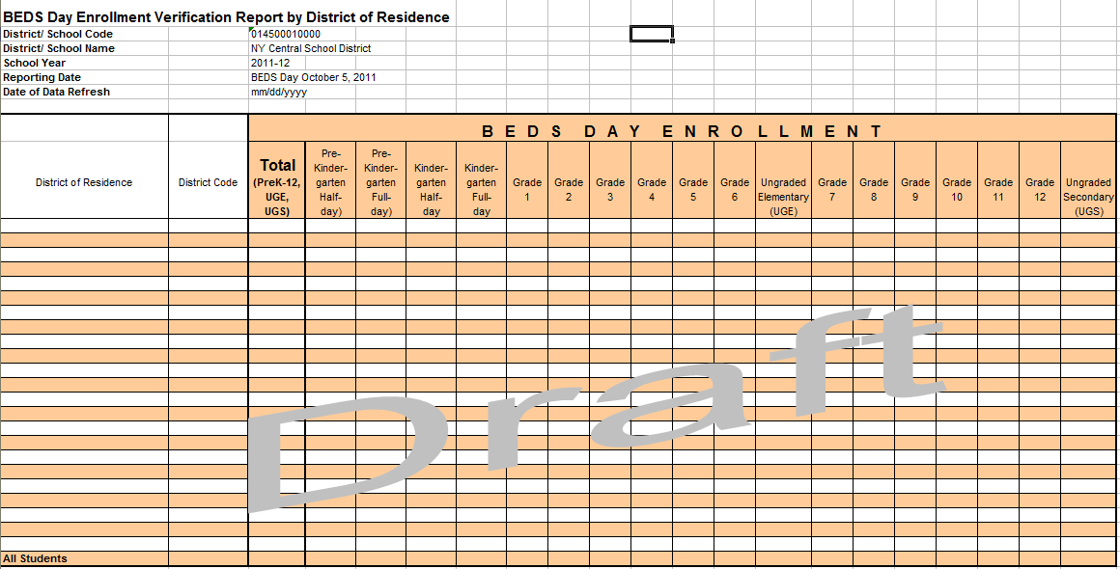

In this report, if all enrolled students are residents of the district in which they are enrolled, then the report will show one “detail” row with all enrolled students appearing as residents of that district and one “All Students” row that will be the same as the detail row. However, if students are from multiple districts of residence, the report will show multiple rows displaying counts of students for each district of residence as well as a row for all students combined. For example, if the “All Students” count is “100”, “95” of these students are residents of district A, “4” students are residents of district B, and “1” student is a resident of district C, the report will have four populated rows: one showing “95” enrolled students as residents of district A, one showing “4” enrolled students as residents of district B, one showing “1” enrolled student as a resident of district C, and the “All Students” row showing the sum of the data in the rows for districts A, B, and C.

The counts displayed in the “All Students” row of the report by District of Residence and the “October BEDS Enrollment Verification Report by Location of Enrollment and Student Subgroup” will be the same. The report by District of Residence will be viewable for both individual schools as well as for the District BEDS Total.

Prior to the 2011–12 requirement that District of Residence be part of every student record, District of Residence was only collected in the aggregate for charter and nonpublic school students. A sample of the manner in which District of Residence was collected on the BEDS Charter School Data Form is shown below:

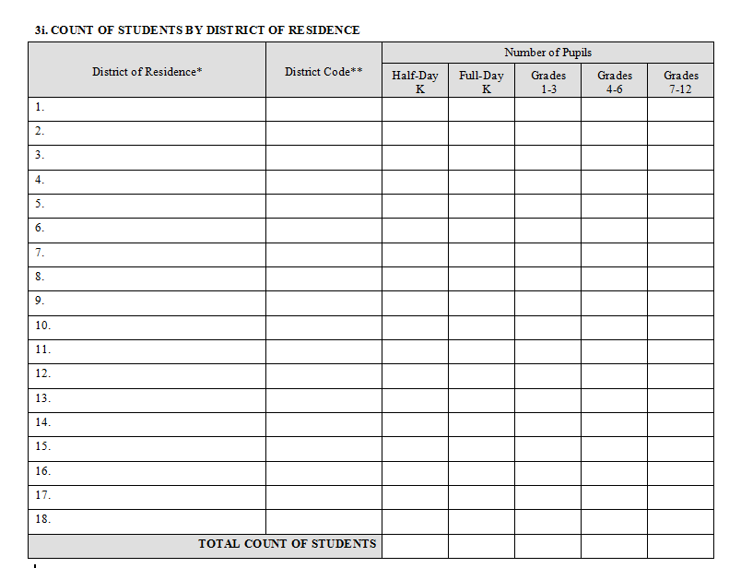

District of Residence is used to determine which students should be counted in the following general categories that appear with more specificity in the “October BEDS Enrollment Verification Report of Supplemental Counts for State Aid Calculations”:

- resident students enrolled outside of the district and for whom the district is paying or could be charged tuition,
- non-resident students enrolled in the district and for whom tuition is or could be charged, and
- resident students enrolled in approved AHSEP or HSEP programs.

VR for District Pre-K

The October BEDS Enrollment Verification Report for District Pre-K presents district totals for pre-kindergarten and will differentiate half- and full-day pre-kindergarten as well as Universal Pre-K (UPK) funded versus non-Universal Pre-K funded students, as shown below:

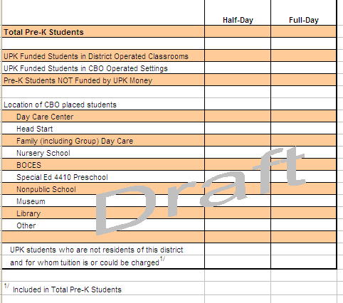

NOTE: BEDS Online will be the official source of 2011–12 student counts for Pre-K/UPK that will be used in State aid calculations. The 2011–12 SIRS records for Pre-K/UPK represent the first year that such detail for Pre-K/UPK has been collected in the student record. Pre-K/UPK detail in SIRS for 2011–12 should be viewed as a pilot for this level of detail and an opportunity to sort out procedures necessary to arrive at Pre-K/UPK data in the student records that can be used as the official source for 2012–13. Once a full transition of the Pre-K/UPK data and reliance upon SIRS for these data has taken place, this verification report will replace counts currently collected in Items 1d, 1e, and 1f of the BEDS District Summary Form using BEDS Online, as shown below:

- Distribute the total number of students to be reported in the Pre-K section of Item 1a into the following:
 | Universal Pre-K Funded Students  (including former TPK Programs) |  | Number of Pre-K Students NOT Funded by UPK Money
 | Number of UPK Students in District Operated Classrooms | Number of UPK Students in  CBO Operated Settings | Number of Pre-K Students NOT Funded by UPK Money
Half - day
Full - Day

e. Enter the number of Universal Pre-K Students reported in Item 1d who are not residents of this district and for whom tuition is or could be charged …………

- Enter the number of CBO-placed UPK students reported in 1d who are in the following
Community-based Organization settings:
CBO Setting: | Number of  Students | CBO Setting: | Number of Students
Day Care Center |  | Special Ed 4410 Preschool
Head Start |  | Nonpublic School
Family (incl. Group) Day Care |  | Museum
Nursery School |  | Library
BOCES |  | Other

The district total for pre-kindergarten will be a sum of pre-kindergarten students reported as enrolled in any school in the district plus the Universal Pre-kindergarten (UPK) students who are in Community-based Settings (CBOs) and who have been reported with a Location Code ending in “0666”.

The district’s UPK grant coordinator should be consulted by district staff who enter information into the district’s Student Management System (SMS) to ensure that the correct students are reported as UPK using the summary of reporting requirements that follow.

It is important for funding received under a State Universal Pre-K grant that Pre-K students are reported with a correct Program Type and UPK Setting Type, if the Program Type is UPK:

- PreK students who are supported by Universal PreK funds and located in district-operated classrooms must be reported with a PreK Program Type of 902 and a UPK Setting Type of 1309.
- PreK students who are supported by Universal PreK funds and located in classrooms operated by Community-based Organizations (CBO)must be reported with a PreK Program Type of 902 and ONE of the UPK Setting Types of 1320 through 1419.
- PreK students who are not supported by Universal PreK funds should be reported with a PreK Program Type of 990 and NO UPK Setting Type.

Pre-K/UPK reporting rules translated to Pre-K/UPK data currently collected in the BEDS Online are shown below:

Universal Pre-K Funded Students  (including former TPK Programs) |  | Number of Pre-K Students NOT Funded by UPK Money
Number of UPK Students in  District Operated Classrooms | Number of UPK Students in  CBO Operated Settings | Number of Pre-K Students NOT Funded by UPK Money
Program_CD = 902  Setting Type CD = 1309 | Program_CD = 902  Setting Type CD = One of 1320, 1331,1342,1353, 1364, 1375, 1386, 1397, 1408,1419 | Program_CD = 990  Setting Type CD = None

CBO Setting: | Program/ Setting | CBO Setting: | Program / Setting
Day Care Center | 902 / 1320 | Special Ed 4410 Preschool | 902 / 1375
Head Start | 902 / 1331 | Nonpublic School | 902 / 1386
Family (incl. Group) Day Care | 902 / 1342 | Museum | 902 / 1397
Nursery School | 902 / 1353 | Library | 902 / 1408
BOCES | 902 / 1364 | Other | 902 / 1419

VR of Supplemental Counts for State Aid

The October BEDS Enrollment Verification Report of Supplemental Counts for State Aid presents particular student counts that are used in State aid calculations, as shown below:

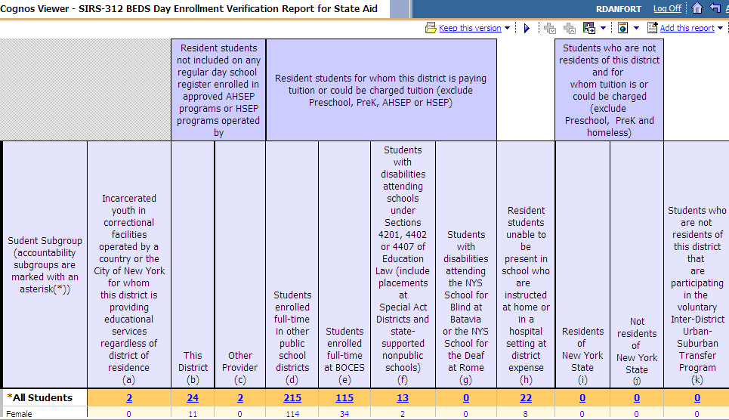

The majority of students in this report fall into two general categories: 1) resident students who are enrolled outside of the district, and 2) non-resident students who are enrolled in the district. General examples of such students are:

- resident students placed by the district outside of the district, including special-education placements and students enrolled full-time at BOCES;
- resident students attending other public school districts by parental choice;
- resident students unable to attend school and served by the district in home or hospital settings;
- resident students in approved HSEP or AHSEP programs and eligible for Equivalent Attendance Aid;
- non-resident students who are enrolled in the district; and
- incarcerated youth in correctional facilities served by the district.

Counts required for State aid will be collected in parallel in BEDS Online and SIRS in 2011–12. However, BEDS Online will be the official source of these particular counts for State aid in 2011–12. To ensure a smooth transition to the use of State aid data from BEDS Online in 2011–12 to SIRS in 2012–13 as official source, it is critical that these data be reported accurately in both BEDS Online and SIRS in 2011–12. These counts are currently collected in items 1b1, 1b2, 1c, 2, 3, and all of item 4 in the BEDS District Summary Form via BEDS Online, as shown below:
1b. Enter the number of student reported in Item 1a who are not residents of this district and for whom tuition is or could be charged and who are:
- residents of New York State (exclude Pre-K and homeless students) . . . . . . . .
- not residents of New York State (exclude Pre-K and homeless students) . . . . .
c. Enter the number of non-resident students enrolled in this district that are participating in voluntary Inter-District Urban-Suburban Transfer Program . . . . . .
2. Enter the number of incarcerated youth served by this district who are in correctional facilities operated by a county or the City of New York, regardless of district of residence: . . . . . . . . . . . . . . . . . . . . . . . . . . . . . . . . . . . . . . . . . . . . . . . . .
3. Enter the number of resident students who are over the compulsory age of attendance, who are not included on any regular day school register, and who are in equivalent attendance programs operated by:
a. This district b. a BOCES c. Other

4. Enter the number of resident students for whom this district is paying or could be charged tuition for education outside of this district. Do not include students counted in Item 3 or Pre-Kindergarten students.

a. Students with disabilities enrolled full time in other public school districts . . . . . . . . . . . . . . . . . . . .
b. General education students enrolled full time in other public school district . . . . . . . . . . . . . . . . . . .
c. Students with disabilities enrolled full-time at BOCES . . . . . . . . . . . . . . . . . . . . . . . . . . . . . . . . . . . .
d. General education students enrolled full-time at BOCES . . . . . . . . . . . . . . . . . . . . . . . . . . . . . . . . . .
e. Students with disabilities attending schools under Sections 4201, 4401 or 4407 of the Education Law. (Include Special Act District placements and placements at state-supported nonpublic schools.)
f. Students with disabilities attending the New York State School for the Blind at Batavia or the New York State School for the Deaf at Rome . . . . . . . . . . . . . . . . . . . . . . . . . . . . . . . . . . . . . . . . . . . . . . . .

mmmmmmmmmm

The “October BEDS Enrollment Verification Report of Supplemental Counts for State Aid Calculations” and related student detail in SIRS for 2011–12 should be viewed as a pilot for this level of detail and an opportunity to sort out procedures necessary to arrive at student records in SIRS that can be used as the official source of counts required for State aid use for 2012–13.

The table below shows the types of students included in the “October BEDS Enrollment Verification Report of Supplemental Counts for State Aid Calculations”:

Non-resident students enrolled in this district | are reported in SIRS by:
Students placed in this district by their home district’s Committee on Special Education (CSE). | The student’s home district.
Residents of other school districts placed in this district by their parents. | The district where attending.
Children of staff who are residents of other public schools districts and attending this district tuition free. | The district where attending.
Students who completed the terminal grade in a K-6 or K-8 district and are completing their high school education in this district. | The district where attending.
Students who are residents of other states or countries.  (Note: Foreign exchange students are viewed as temporary residents.) | The district where attending.

Resident students enrolled outside of this district | are reported in SIRS by:
Resident students enrolled full-time in other public school districts, including special education placements. | The home district if placed by the home district; the district where the student is attending if NOT placed by the home district.
Resident students enrolled full-time at a BOCES, including special education placements. | The home district if placed by the home district; BOCES if NOT placed by the home district.
Resident students placed by this district in a Special Act School District. | The home district if placed by the home district.
Resident students with disabilities placed by this district in nonpublic school settings. | The home district if placed by the home district.
Resident students placed by this district in the NYS School for the Blind at Batavia or the NYS School for the Deaf at Rome. | The School for the Blind or the School for the Deaf
Resident students attending Charter schools.* | The Charter school.
Resident students attending Nonpublic schools by parental choice.** | The Nonpublic school if applicable.

*Will only appear in the enrollment verification report for the charter school in which enrolled.
**Will not appear in any district’s October BEDS Enrollment Verification Report.
The table below shows which district(s) will see which students in the current scheme in the “October BEDS Enrollment Verification Report of Supplemental Counts for State Aid Calculations.” Additional reports and details will be developed based on need.

Report  Column | Column Description | Who Sees These Students
a | Incarcerated Youth | The district where the correctional facility is located will see all such students; no other district will see these students.
b | Residents in GD – District | The district where the student resides will see its own resident students; no other district will see these students.
c | Residents in GD – Other | The district where the student resides will see its own resident students; no other district will see these students.
d | Residents in Other Districts | The district where the student resides will see its own resident students in Column “d” as enrolled in some other district. The district where the student is enrolled will see the student in Column “i” as a non-resident student.
e | Residents in BOCES | The district where the student resides will see its own resident students in Column “e” as enrolled in a BOCES. BOCES may see them later based on future BOCES reporting requirements for the Repository.
f | Residents in 4201, SpActs | The district where the student resides will see its own resident students in Column “f” as enrolled in a Special Act district, a nonpublic school, or State-supported school as a special education placement. Special Act districts will see these students in Column “i” as non-residents.
g | Residents at Rome/Batavia | The district where the student resides will see its own resident students in Column “g” as enrolled in the school for the Deaf or Blind; the school for the Blind or Deaf will see its students in Column “i” as non-residents.
h | Residents Home/Hospital | The district where the student resides will see its own resident students in Column “h” as home-bound or hospital-bound; no one else will see these students.
i | Non-residents – In - NYS | The district where the student is enrollment will see these students in Column “i” as non-residents. The district where the student resides will see its residents in Column “d” as resident students attending other public school districts.
j | Non-residents – Out - NYS | The district where the student is enrolled will see these students in Column “j” as non-residents. No other district will see these students.
k | Inter Distr Urb/Sub Transfer | The district where the student is enrolled will see these students in Column “k” as non-residents. The district where the students reside (Rochester) will see these students in Column “d” as resident students attending other public school districts.

SOURCES OF DATA IN VERIFICATION REPORTS

Data Elements Common to Multiple Verification Reports
Field Name in Verification Report | Verification Report Found In: | SIRS Template Found In: | Field in SIRS Template Found In: | Field # in SIRS Template | Codes/Notes
Grade | Enroll  PreK  DResid | School Entry /Exit | Enrollment Grade Level | 8 | See “Grade Level Codes and Descriptions” in “SIRS Codes and Descriptions” at http://www.p12.nysed.gov/irs/sirs/. (All grade codes except for PS and GD)
Gender | Enroll  StAid | Student Lite | Gender Code | 11 | Male, Female
Ethnicity | Enroll  StAid | Student Lite | Hispanic Ethnicity Indicator | 42 | Y/N
Ethnicity | Enroll  StAid | Student Lite | Race 1, 2, 3, 4, 5 | 12,  43-46 | American Indian/Alaska Native; Asian; Pacific Islander; Black; White; Multiracial*
Disability Status | Enroll  StAid | Programs Fact | Program Code | 5 | See “Program Service Codes and Descriptions” in “SIRS Codes and Descriptions” at http://www.p12.nysed.gov/irs/sirs/. Any code for  Type of Disability except 5786.
Limited English Proficient | Enroll  StAid | Programs Fact | Program Code | 5 | 0231
Formerly Limited English Proficient | Enroll  StAid | Programs Fact | Program Code | 5 | Determined at Level 2. Generated if the student was reported as 0231 in either of the two prior school years and is not LEP in the current year.**
Economically Disadvantaged | Enroll  StAid | Programs Fact | Program Code | 5 | 0198
Migrant Status/ Migrant | Enroll  StAid | Inclusion and sourcing of this data element is under review.
Homeless | Detail | Student Lite | Homeless (Homeless Indicator) | 47 | Y/N
Student ID | Detail | Student Lite | Student ID  (School district Student ID) | 4 | Local Student ID
NYSSIS ID | Detail | Stud Ident | Student ID Alt | – | Unique State-assigned ID
Student | Detail | Student Lite | Last Name Short | 5
Student | Detail | Student Lite | First Name Short | 6
Student | Detail | Student Lite | Middle Initial | 7
Location | All | School Entry/ Exit | Location Code  (Building of Enrollment Code) | 2 | e.g., 010100010034
District of Residence | DResid  StAid | Student Lite | District Code of Residence | 41 | e.g., “ny010100”

*Students are counted as Hispanic or Latino if Hispanic Ethnicity Indicator = YES regardless of race or races reported.
Students are counted as Multiracial if Hispanic Ethnicity Indicator = NO and two or more races are reported.
Students are counted as Asian or Pacific Islander if Hispanic Ethnicity Indicator = NO” and Asian or Hawaiian is reported.

**Students are counted as Formerly LEP if they achieve proficiency on both the Listening & Speaking and the Reading & Writing modalities of the New York State English as a Second Language Achievement Test (NYSESLAT) in either of the two previous school years.

Data Elements Unique to the VR of Counts for State Aid
Report  Column | Field Name in Verification Report | Criteria for Determining
a | Incarcerated Youth | Location of enrollment has a SEDREF Type of 10 (Government Agency) and SubType = 1 (Jail); student grade level is K, KH, KF, 01-12, 13, 14 or GD; entry code is “0011” or “5654”; incarcerated youth will appear in the report for the jail’s district of location.
b | Residents in GD – District | Was not counted in “a” as an Incarcerated Youth; entry code = “5654”; location of enrollment is within the district of residence.
c | Residents in GD – Other | Was not counted in “a” as an Incarcerated Youth; entry code = “5654”; location of enrollment is not within the district of residence.
d | Residents in Other Districts | Was not counted in “a” as an Incarcerated Youth; student grade level is K, KH, KF, 01-12, 13 or 14; entry code is in (“0011”, “5544”, “7000”, “7011”); location of enrollment is a public school district not equal to the district of residence.
e | Residents in BOCES | Was not counted in “a” as an Incarcerated Youth; student grade level is K, KH, KF, 01-12, 13 or 14; entry code is in (“0011”, “5544”, “7000”, “7011”); location of enrollment is a BOCES.
f | Residents in 4201, SpActs | Student grade level is K, KH, KF, 01-12, 13 or 14; students has a Type of Disability code <> “5786” and a Primary Setting code in (“SA01”, “SA02”, “SA03”, “SA04”); location of enrollment is “Other Schools Serving Students with Disabilities” or “Special Act”.
g | Residents at Rome/Batavia | Student grade level is K, KH, KF, 01-12, 13 or 14; students has a Type of Disability code <> “5786”; and location of enrollment is “180300877197” or “411800877482”.
h | Residents Home/Hospital | Student grade level is K, KH, KF, 01-12, 13 or 14; location of enrollment is “Homebound”.
i | Non-residents – In - NYS | Student grade level is K, KH, KF, 01-12, 13 or 14; entry code is “0011”; Homeless Indicator = NO; location of enrollment <> district of residence; and district of residence is <> “80034366”.
j | Non-residents – Out - NYS | Student grade level is K, KH, KF, 01-12, 13 or 14; entry code is “0011”; Homeless Indicator = NO; location of enrollment <> district of residence; and district of residence is “80034366”.
k | Inter Distr Urb/Sub Transfer | Student grade level is K, KH, KF, 01-12, 13 or 14; entry code is “0011”; location of enrollment <> district of residence; and has Program code = “2618”.

Data Elements Unique to the VR for District Pre-K
Field Name in Verification Report | Pre-K Program CD* | UPK Setting CD*
Total Pre-K Students | 902 or 990 | any or none
UPK Funded Students in District Operated Classrooms | 902 | 1309
UPK Funded Students in CBO Operated Settings | 902 | one of: 1320, 1331, 1342, 1353, 1364, 1375, 1386, 1397, 1408, 1419,  (see below)
Pre-K Students NOT Funded by UPK Money | 990 | none
Location of CBO-placed Students
Day Care Center | 902 | 1320
Head Start | 902 | 1331
Family (including Group) Day Care | 902 | 1342
Nursery School | 902 | 1353
BOCES | 902 | 1364
Special Ed 4410 Preschool | 902 | 1375
Nonpublic School | 902 | 1386
Museum | 902 | 1397
Library | 902 | 1408
Other | 902 | 1419
UPK students who are not residents of this district and for whom tuition is or could be charged. | Any UPK (program code = 902) student for whom the district of enrollment location does not match the District of Residence.
*Grade Level Code must also be either “PKH” or “PKF”

