Overview

The accompanying documentation is a roadmap of the BOCES Report Card template. It highlights methods for changing graphic displays and indicates the areas where charts should be updated. In order to complete your report card you may need the following sources of data:

- Adult Allies Data
- Adult Student Information System and Technical Support (ASISTS)
- Portions of the Basic Education Data System (BEDS)data
- CTE Placement Report
- nySTART 3-8 results for BOCES Students
- nySTART Alternate Assessment results
- Perkins Report Card
- School Library System (SLS) Annual Report
- SA111 Schedule 2A
- Student Information Repository System (SIRS)
- 602 Report

The Report Card template contains data charts, bar graphs and pie charts. NYSED has provided statewide figures for charts and graphs and they have been populated where applicable. The data charts and bar graphs are pre-filled with zero values for each category. The pie charts are pre-filled with a value of”9” in each category. You will be replacing the information in the charts and graphs with needed data.

There are two methods for editing and changing the graphic display information and each method is divided into two parts. These methods are detailed and displayed on pages 2-9 of this document.
- Method 1:
Step 1: Opening a graph
Step 2: Editing the data in a graph
Step 3: Adding values to the graph ALT TXT.
- Method 2:
Step 1: Opening a Pie Chart
Step 2: Editing the data in a Pie Chart
Step 3: Adding values to the Pie Chart ALT TXT.

To begin, in Word click File, New, Templates, On my computer. In the Templates window, under the General tab, click the BOCES_Report_Card.dot file. Click the OK button.

Method 1:
Step 1 - Opening a Graph

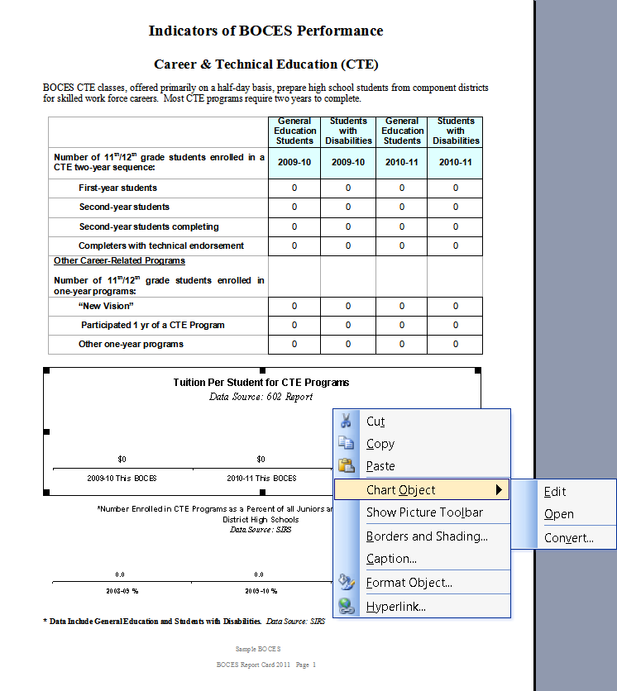

- Right click on the line of the chart.
- Highlight Chart Object
- Click on Open

Method 1:
Step 2 -Editing the data in a graph

Note: Be sure to enter data into all fields, replacing sample data. Use scroll bars to access all rows or columns in chart.

* Click on datasheet to bring to front.
* Enter information into datasheet to populate graph.

* Click top X when finished to close.
STEP 3 - Adding values to the graph ALT TXT

- Right click on the line of the chart.
- Click on Format Object
- Click the Web tab which is on the Format Object screen
- Update year information and enter the values which is entered in the datasheet

- Click OK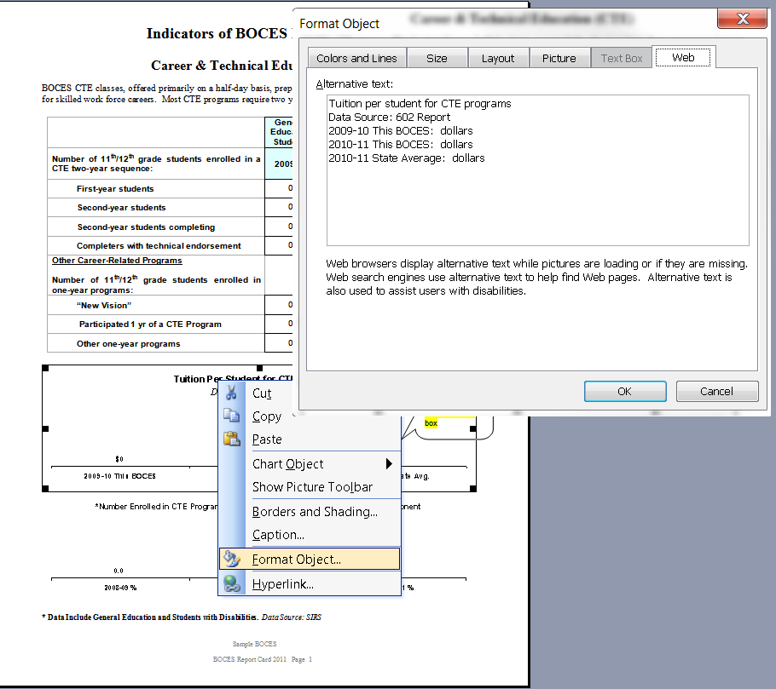
Method 2
- Step 1 - Opening a Pie Chart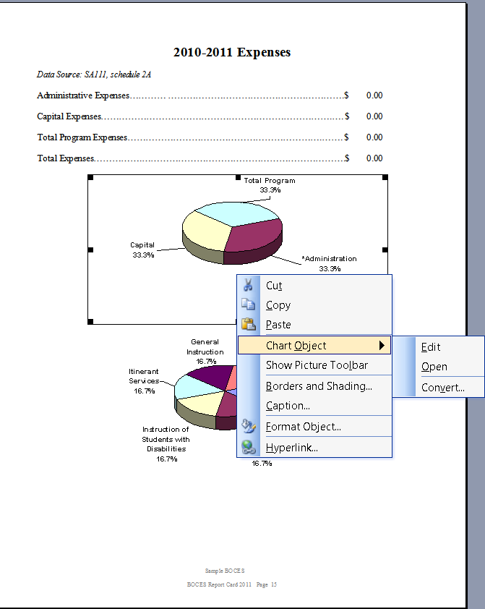

*Right click on the Pie chart.

* Highlight Chart Object

* Click on Open
- Method 2
Step 2 - Editing the data in a Pie Chart

Note: Be sure to enter data into all fields, replacing sample data. Use scroll bars to access all rows or columns in chart. Enter values into chart; the pie chart will convert data into % of whole.
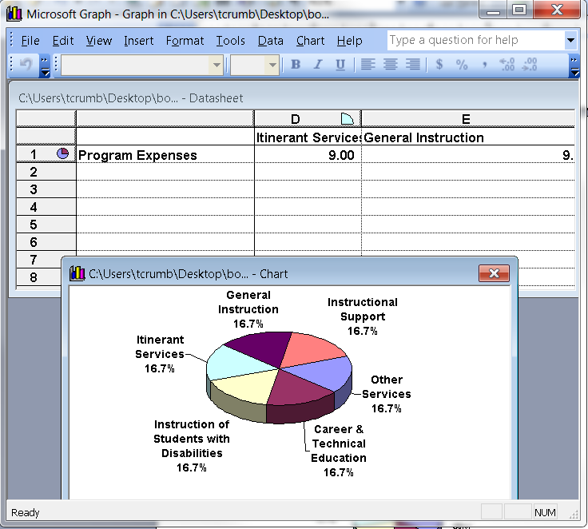
.

* Click on datasheet to bring to front.

* Enter information into datasheet to populate graph.

* Click on top X when finished to close.
STEP 3 - Adding values to the Pie Chart ALT TXT

- Right click on the line of the chart.
- Click on Format Object
- Click the Web tab which is on the Format Object screen
- Enter the values which is entered in the datasheet
- Click OK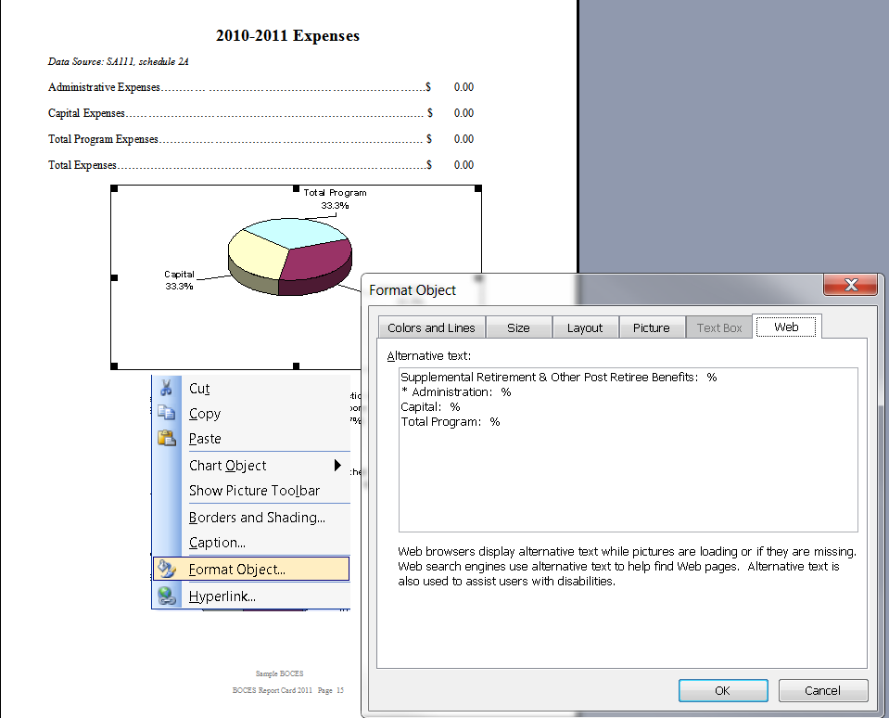

Completing

the

BOCES Report Card

This section walks you through each page of the Report Card and provides basic directions for inputting your data.
Cover Page
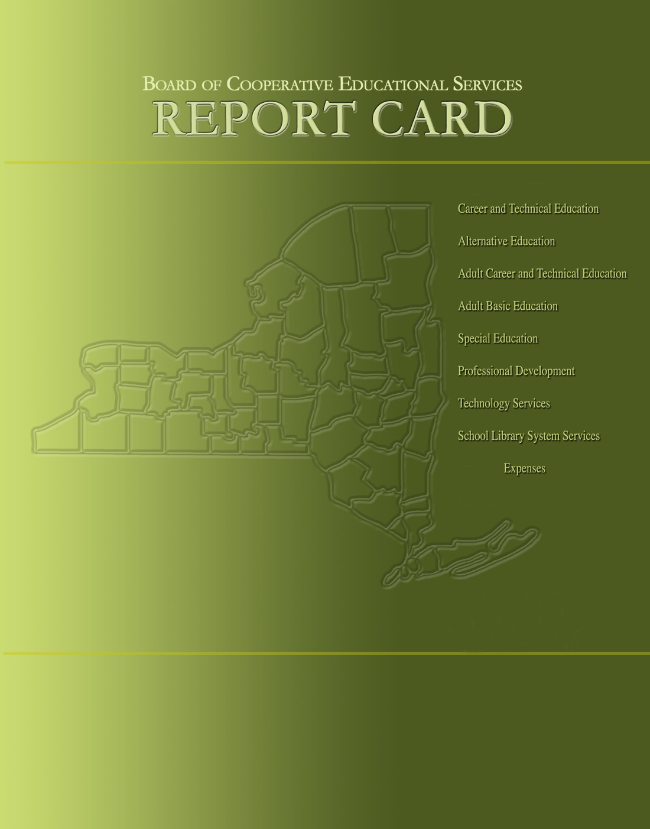
Table of Contents

- Click in year and type report card year.

- Click in text box "Click HERE and Type BOCES Name".
2011-2012
BOCES

2011-2012

BOCES
Board of Cooperative Educational Services

2011-2012 Report Card
- Click HERE and Type BOCES Name

- Click HERE and Type report card year
Table of Contents

Page

Component/Non-Component District List…………………………………… ii

Indicators of BOCES Performance
Career & Technical Education……………………………………….…..… 1-3
Alternative Education……………………………………………………..… 4-6
Adult Career & Technical Education…………………………………….... 7
Adult Basic Education……………………………………….…………….... 7
Special Education
Special Education Enrollment and Tuition in BOCES Programs……. 8
State Testing Program………………………………………………….... 9-11
Professional Development…………………………………………………… 12
Technology Services……..……….…………..……………………………… 13
School Library System Services…………………………………………..…14

2011-2012 Expenses……………………………………………………………… 15
- Click HERE and Type report card year

Prior editions of the BOCES Report Card included other data representing information on component districts.
The following data were not included in this report.
- State Testing Program for All Component Districts
- Graduation Results

BOCES Components

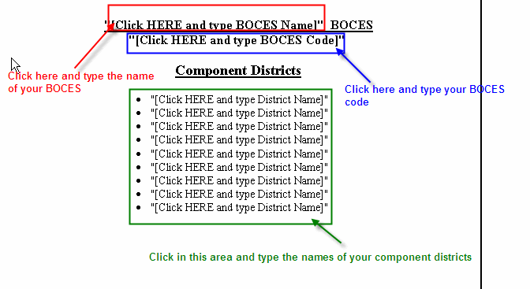

Career and Technical Education
- BOCES CTE classes
- Tuition Per Student for CTE Programs
- Number Enrolled In CTE Programs as Percent

Enter number of students on chart.

Follow Method 1 for graphs.
Enter $ amounts.

Follow Method 1 for graphs.
Enter % values.

CTE Student Performance on Perkins Indicators
- Who Left School in report card year
- Status of Career and Technical Education (CTE) Students

Follow Method 1 for graphs.
Enter % values.

Follow Method 1 for graphs.
Enter % values.

General Education Development Leading to (GED)

Enter number of students on chart.

Alternative Education
- Alternative Education Enrollment

Follow Method 1 for graphs. Enter number of students.

Follow Method 1 for graphs. Enter $ amount.

Enter number of students.

.

- Alternative Education Tuition
- Alternative Education Outcomes

Alternative Education State Testing Program Information

Enter counts or percents as needed.

.

Alternative Education Performance of Students on RCT Exams

Enter counts or percents as needed.

.

Adult Career and Technical Education (CTE)
- Adult CTE Student Counts
- Adult Basic Education
- Adult CTE Educational Gain

Enter enrollment number here

Enter either counts or percents as needed.

Enter either counts or percents as needed.

Special Education Enrollment and Tuition

Enter # of students

Follow Method 1 for graphs. Enter $ amounts.

.

- Special Education Enrollment Trends
- Special Education Tuition Rates Per Student

State Testing Program
- Performance of Students Enrolled in BOCES Programs

Enter counts or percents as needed.

Enter counts or percents as needed.

State Testing Program
- Performance of Students Enrolled in BOCES Programs on Regents Exams

State Testing Program

Enter counts or percents as needed

- Performance of Students with Severe Disabilities

Enter counts or percents as needed

Professional Development
- Workshop Participant Counts by Category

Enter counts.

.

Technology Services
- Technology Service Participants Counts by Category

Enter counts.

Place a X in the correct column to indicate RIC Service or BOCES Service

.

School Library Systems
- Number of Library Media Centers
- Consulting and Technical Assistance Services plus Reference by SLS Staff
- Number of Professional Workshops
- Number of Participants at Professional Development Workshops

Follow Method 1 for graphs. Enter counts.

.

Expenses
- Budget percentage by category
- Total Expense breakdown by category

Enter expense information on these lines.

Follow Method 2 for pie charts. Enter expense figures.

