Word to Accessible PDF (Using Word 2003 & Adobe Acrobat Professional X)

The Word File
- Before converting the Word file, to PDF, have the conversion settings (Adobe PDF, Change Conversion Settings) set as follows:

  - Under Settings, set your settings as shown.

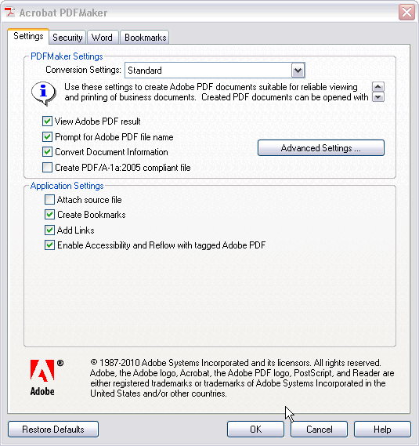

  - Click the Advanced Settings button.
    - Under General, set your settings as shown.

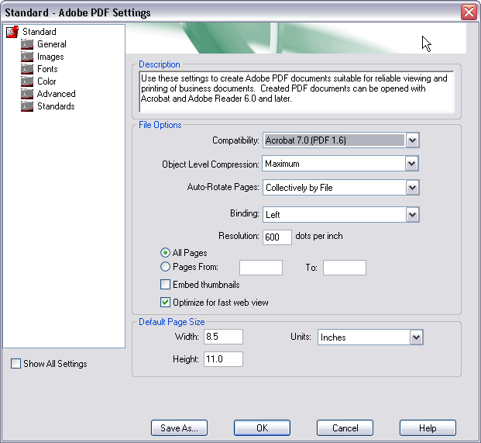

    - Click the Save As… button. Save file as ReportCard.joboptions. Click Save.

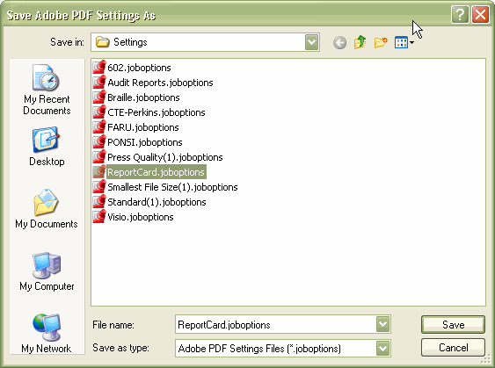

  - Under Word, set your settings as shown:

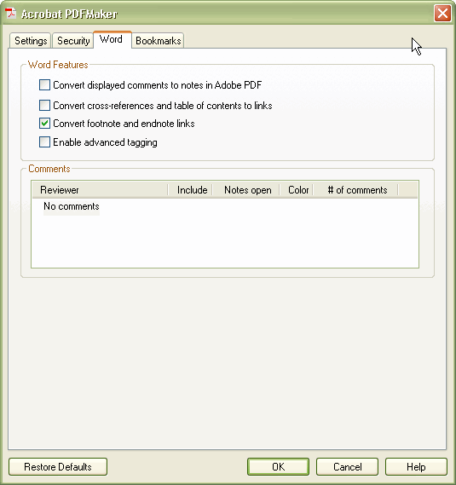

  - Under Bookmarks, set your settings as shown:

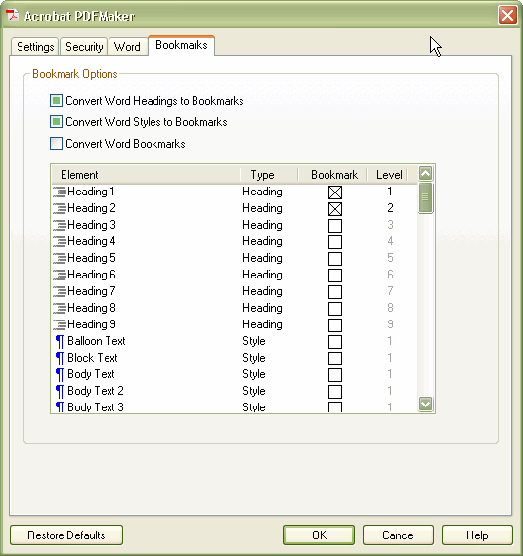

    - Click OK.
- Click Adobe PDF, Convert to Adobe PDF.

PDF File

When the document is converted, you will see something like this:

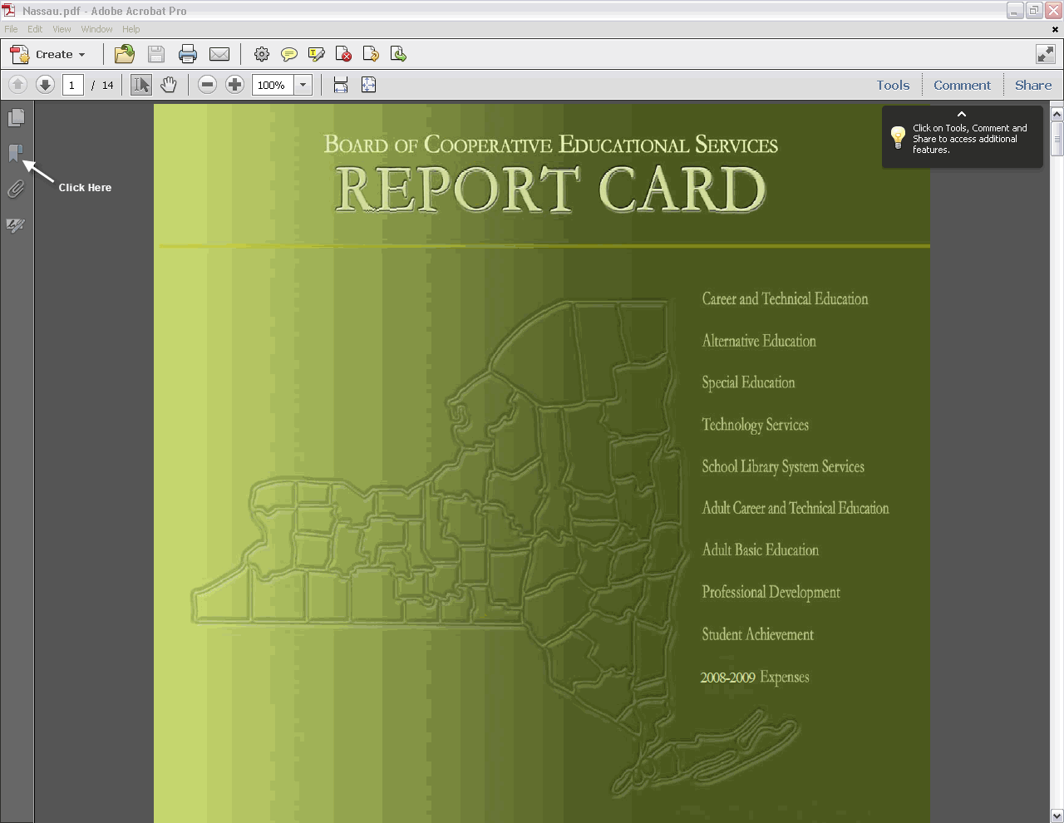

You can click on the bookmark icon, in the left-hand frame, in order to see the listing of bookmarks.

Some setting changes now have to be done to the PDF file:
- Click File, Properties, Description tab. Make sure that the correct Title info is filled in.
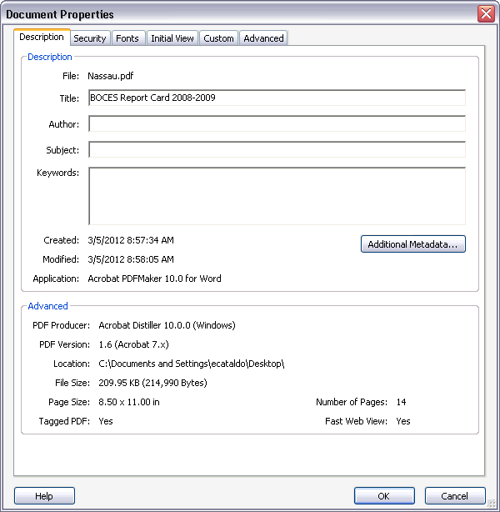
- Click Initial View tab. Under Layout and Magnification section:

  - For Navigation tab section, select Bookmarks Panel and Page.
  - For Page layout section, select Single Page Continuous
  - For Magnification section, select 100%
- Under Window Options section:
  - For Show section, select Document Title
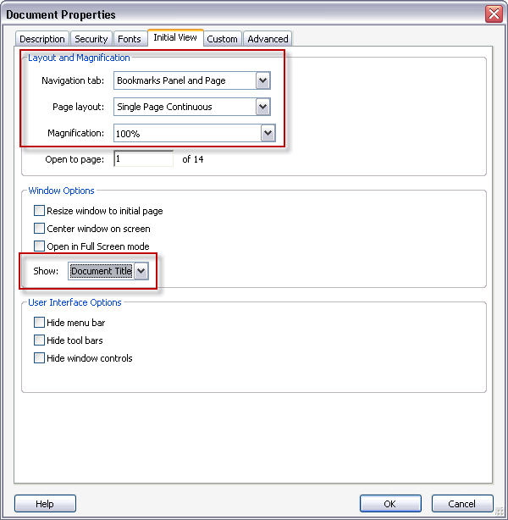
- Click the Advanced tab. Under Reading Options, Language, select English.
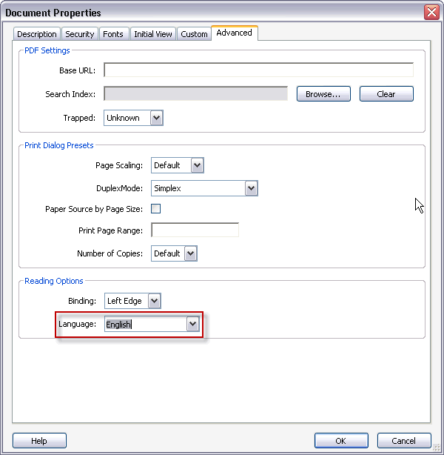
- Click OK.
- Save the file.

To perform the next steps, you will need to add Accessibility to the Tools list. To do this:
- Click Tools
- Click the Show or hide panels icon
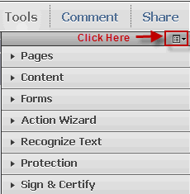
- The item now appears in the Tools menu
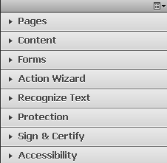

To check the PDF file, for accessibility:

- Open the file, in Adobe Acrobat. Click Tools, Accessibility. Click Full Check.
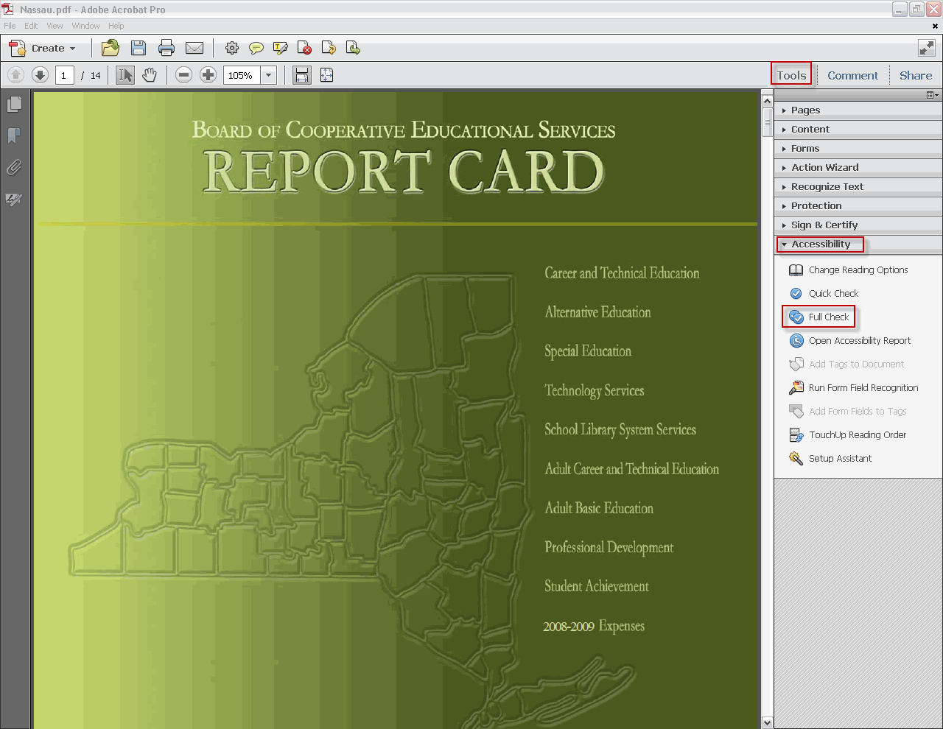
- Select these options in the Accessibility Full Check screen. Click Start Checking.
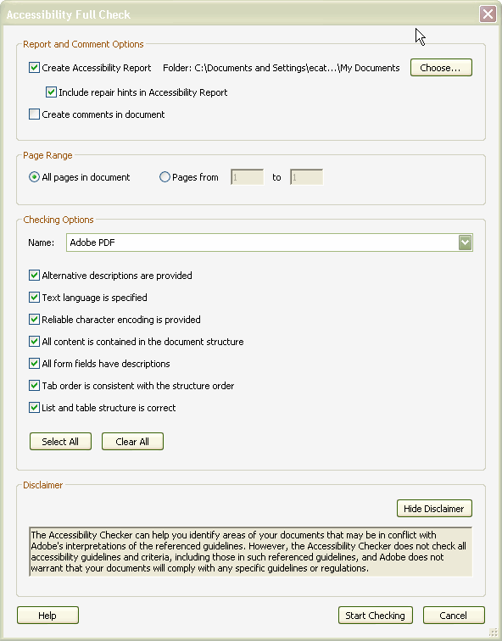
- If everything was created correctly, you should see this screen: Click OK.
- The Accessibility Report will open, in the left-hand frame.
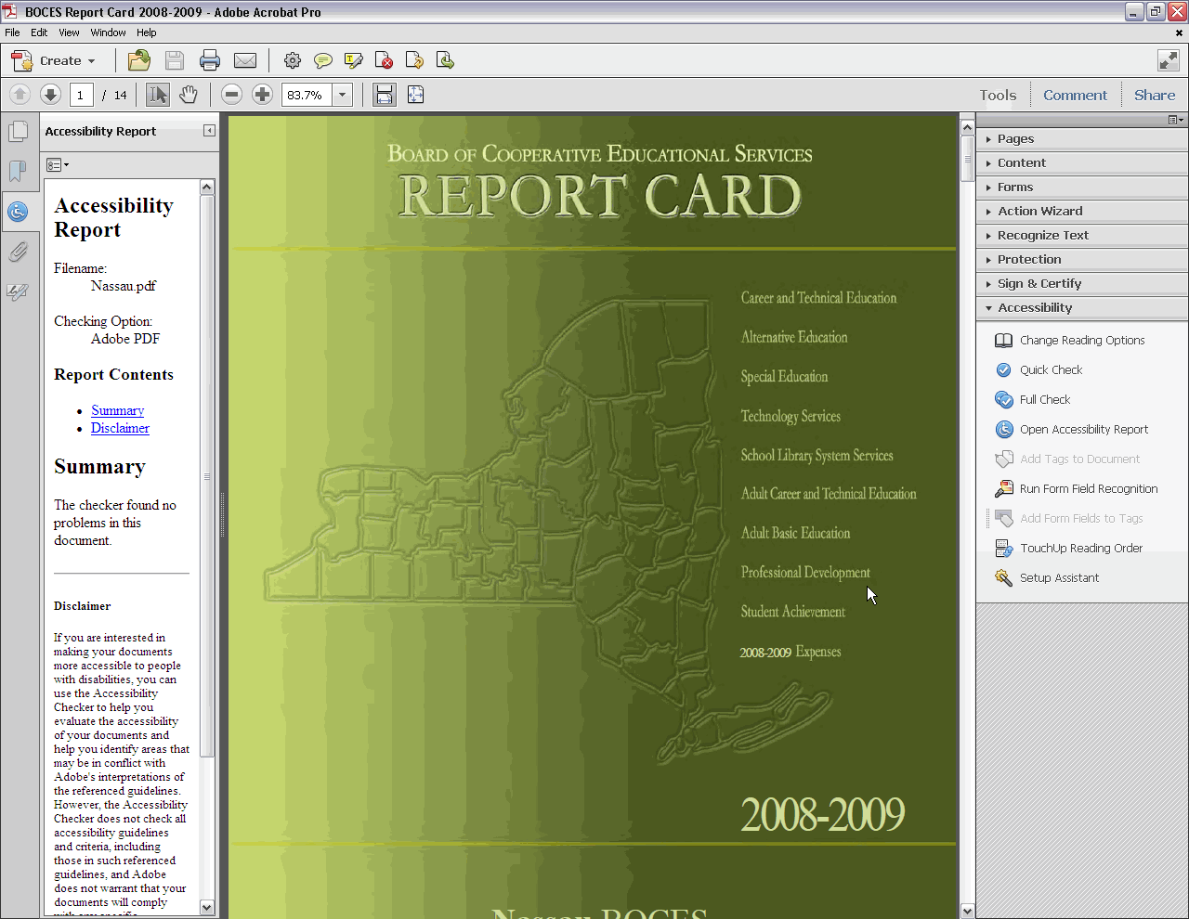
Please Note: The last thing you may want to consider doing is reducing the PDF file size:
  - Click File, Save As, Reduced Size PDF
  - In the Reduce File Size window, select Acrobat 8.0 and later for Acrobat Version Compatibility
  - Click OK
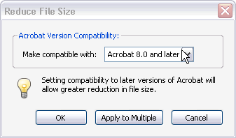
  - Click Save in the Save As window. You will be told that the file already exists. Click Yes to replace the existing file.

