REQUEST FOR PROPOSAL (RFP)
#22-005
NEW YORK STATE EDUCATION DEPARTMENT

Title: Elementary, Intermediate (Middle), and High School Level New York State
English as a Second Language Achievement Test (NYSESLAT)

The New York State Education Department (NYSED)’s Office of State Assessment (OSA) is seeking proposals from highly qualified respondents with expertise in the development and administration of statewide English language proficiency assessments to implement the New York State (NYS) English as a Second Language Achievement Test (NYSESLAT) for multiple years, as defined in this RFP. These requested services include the ongoing development and administration of tests primarily delivered by computer for grades 2-12, with the exception of the first operational test of the contract, which is to be paper-based for all grades. Kindergarten and grade 1 will remain paper-based for all operational and Stand-Alone Field Tests (SAFTs) for the duration of the contract period. The requested services also include constructing SAFT forms, conducting field testing, scoring SAFTs, constructing interim (mid-school year) assessments, constructing operational test forms, ancillary materials, and scoring materials; scoring of all student responses to questions on operational tests entered by students on computer; and performing analysis and research. Proposals must include the provision of a computer-based platform for grades 2-12 that includes systems for administration and test delivery and a scoring platform. All SAFTs will be administered to students in grades 2-12 strictly on computer, except as an accommodation for students with disabilities, for the duration of the contract. The first SAFTs to be administered by the contractor will take place late February/early March 2023.

The contractor is expected to make the new NYSESLAT interim assessments available to schools starting December 1, 2023. It will be administered in schools strictly on computer for grades 2-12, except that printed editions are to be made available to schools for administration to students with disabilities enrolled in grades 2-12 who require this accommodation. The NYSESLAT interim assessments will be paper-based for Kindergarten and grade 1. Proposals must include the printing, shipping, collection, and return of the paper-based NYSESLAT interim and operational test forms.

Additionally, proposals must include the provision of the same computer-based testing platform for the administration of the existing paper-based NYS Identification Test for English Language Learners (NYSITELL). Note that the development of the NYSITELL has been completed by the previous vendor; therefore, further development of the NYSITELL will not be part of this RFP. Use of the computer-based testing platform for grades 2-12 for the NYSITELL will begin on June 1, 2023.

The primary purpose of the NYSESLAT is to measure annual student progress in achieving English language proficiency and ascertain when students can appropriately exit English Language Learner (ELL) status. In NYS, ELLs are students who, by reason of foreign birth or ancestry, speak or understand a language other than English and speak or understand little or no English, and require support in order to become proficient in English and are identified by scoring below the commanding level on the initial identification test (NYSITELL) or on the NYSESLAT. NYS Commissioner’s Regulations (CR) Part 154-2.3 (l) stipulates that each school district with ELLs shall annually assess the English language proficiency of each such student using such assessment as prescribed by the Commissioner for this purpose. The NYSESLAT is used to assess the English language proficiency of students in kindergarten through grade 12 who are ELLs. The results of the NYSESLAT measure English language proficiency relative to the linguistic demands of ELA Standards in grade-level classrooms and prescribe the provision of ELL services as per CR-Part 154-2 for the following academic year.

According to 2018-19 school year data, of the approximately 2.6 million public school students in NYS more than 238,000 students (9.15%) are ELLs. The linguistic diversity of ELLs and their families consists of more than 200 languages. ELLs are a diverse group of students with various backgrounds, cultures, and academic experiences.

The services described in this RFP are divided into five components. Bidders must bid on all five components.

Component 1 services are for the development of NYSESLAT SAFTs and operational tests. Initial forms will be based on previously developed test items. In addition, Component 1 will also include ongoing development of an operational test item bank and construction of SAFT and operational test forms.
Component 2 services are for computer-based delivery of the NYSESLAT SAFTs and operational tests for grades 2-12.
Component 3 services are for the printing, shipping, collection, and return of printed test forms that will be administered on paper rather than computer. As part of services required by Component 3, the contractor will provide paper-based SAFT and operational test forms for grades K-1 and will also provide paper-based and accommodated versions of the NYSESLAT for those students with disabilities who require these accommodations. This component also includes the printing, shipping collection, and return of printed operational test forms for all test takers in grades K through 12 for the spring 2023 administration.
Component 4 services encompass the provision of interim assessments for students in all grade levels populated with items from previously administered NYSESLAT operational tests.
Component 5 services encompass the provision of a computer-based testing and scoring platform for grades 2-12 for NYS’s existing paper-based NYSITELL. Because the existing NYSITELL test forms will be used on an ongoing basis for the duration of the contract term, future development of new forms of this assessment is not required.

Bidders are required to submit a technical proposal that clearly delineates the bidder’s plan for providing all of the services required in the RFP.

Subcontracting will be limited to thirty percent (30%) of the total contract budget. A higher subcontracting limit will be allowed only when a bidder is proposing to subcontract for the provision of the CBT platform. In this case, the subcontracting limit will be increased to fifty percent (50%) of the total contract budget. In all other cases, the subcontracting limit will be 30%. NYSED reserves the right to approve all subcontractors. Subcontracting is defined as non-employee, direct, personal services and related incidental expenses, including travel. For purposes of the RFP, the subcontracting limit does not include expenses related to printing, shipping, or the purchase of equipment, supplies, and materials.

NYS’s Transition from Paper-based Tests (PBT) to Computer-based Tests (CBT)

One intent of this project is to shift the NYSELAT and NYSITELL administration from PBT to CBT. The contractor must provide the technical specifications for a multi-faceted electronic assessment technical solution that includes, at minimum, an online test delivery system, online test administration system, and online scoring platform. Technical specifications must include the following:

- Minimum specifications for all devices on which the test is delivered,
- Minimum specifications for any administrative computer associated with the devices on which the test is delivered (if applicable),
- Minimum specifications for the networking associated with any devices involved in the delivery of tests (if applicable),
- Minimum infrastructure specifications for Internet, printing, and any other applicable requirements involved in the delivery of the tests, and
- Minimum infrastructure specifications for a contractor-based distributed local scoring platform.

NYSESLAT — The NYSESLAT is currently offered to schools exclusively on paper for students in all grade levels. For the first year of this contract, as we shift to CBT for grades 2-12, the contractor will provide the Spring 2023 operational NYSESLAT to schools exclusively with PBT. SAFTs will be administered strictly using the contractor’s CBT delivery system. Starting with the Spring 2024 operational NYSESLAT, all testing, except as noted below, will be with CBT. The contractor must provide printed test materials for students in grades K and 1 and for students with disabilities enrolled in grades 2-12 who require PBT as a testing accommodation.

NYSESLAT Interim Assessment —The contractor must provide schools with an interim assessment to administer to students in the months of December and January of each school year, starting December 1, 2023 (Year 2 of the contract).

NYSITELL — With this contract, NYSED will initiate the transition from PBT to CBT for the NYSITELL for grades 2-12. Beginning on June 1, 2023, NYS schools will be given the option of continuing to administer the State’s existing NYSITELL forms with PBT (printed and provided by NYSED) to students at all grade levels or to administer these tests to students in grades 2-12 using the contractor’s CBT delivery system. Included in the services required for a CBT platform for the NYSITELL is the provision of a computer-delivered scoring platform that will be used by teachers at their students’ schools to score the open-ended speaking and writing items. The CBT system provided by the contractor will also score students’ responses to multiple-choice items (listening and writing) and generate reports with the students’ test results. Since districts and schools are required to administer the NYSITELL within 10 school days of a student entry to a NYS school, the CBT delivery system must be available for use by school personnel on a year-round, as-needed basis for all schools across NYS.

The contractor may choose to subcontract for the provision of a computer-based testing platform. For tests administered by computer, the contractor, and its subcontractor, if there is one, must ensure that the test administration and test delivery systems and scoring platform are compatible with the existing devices and infrastructure most often available in NYS schools. See “Minimum Technical Requirements for Computer Devices to be Used by Schools for CBT” in the RFP for details.

Bidders are required to comply with NYSED’s Minority and Women-Owned Business Enterprises (M/WBE) participation goals for this RFP through one of three methods. Compliance methods are discussed in detail in the Minority/Women-Owned Business Enterprise (M/WBE) Participation Goals section below.

NYSED will award one contract pursuant to this RFP for a term of three (3) years and three (3) months. The contract resulting from this RFP will be for a term anticipated to begin August 1, 2022 and to end October 31, 2025, with the option to extend for one additional two-year period (November 1, 2025 – October 31, 2027).

Service Area: Statewide

Components contained in RFP Proposal #22-005 are as follows:

- Description of Services to Be Performed
- Submission
- Evaluation Criteria and Method of Award
- Assurances
- Attachments
- Submission Documents (separate document)

Each bidder will be scheduled for a mandatory demonstration of the online delivery system it proposes. The demonstration will be scheduled in consultation with the bidder. It is anticipated that all demonstrations will be scheduled for 90 minutes (which includes a 30-minute question and answer period) on a date mutually agreed upon by NYSED and the bidder. Demonstrations will be conducted by webinar. This demonstration must take place between December 6, 2021 and December 10, 2021. To schedule the demonstration, bidders may contact McKenzie Johnson via email at AssessmentRFP@nysed.gov prior to the deadline for submitting proposals. Bidders who have not scheduled a demonstration time in advance will be provided a time once bids are received.

Questions regarding the request must be submitted by e-mail to AssessmentRFP@nysed.gov no later than the close of business on October 11, 2021. Questions regarding this request should be identified as Program, Fiscal or M/WBE. A Questions and Answers Summary will be posted to Competitive Procurement Contracts website no later than October 21, 2021.

The following are the designated contacts for this procurement:
Program Matters | Fiscal Matters | M/WBE Matters
McKenzie Johnson | Jessica Hartjen | Brian Hackett
Email Address:AssessmentRFP@nysed.gov

The following documents must be submitted in separately sealed envelopes, as detailed in the Submission section of the RFP, and be received by NYSED no later than November 10, 2021 by 3:00 PM:

- Submission Documents labeled Submission Documents - RFP #22-005 Do Not Open
- Technical Proposal labeled Technical Proposal - RFP #22-005 Do Not Open
- Cost Proposal labeled Cost Proposal – RFP #22-005 Do Not Open
- M/WBE Documents labeled M/WBE Documents—RFP #22-005 Do Not Open
- CD or USB containing the technical, cost, submission and M/WBE proposals submitted using Microsoft Office.

The mailing address for all the above documentation is:
NYS Education Department
Bureau of Fiscal Management
Attn: (Jessica Hartjen, RFP #22-005)
Contract Administration Unit
89 Washington Avenue, Room 501W EB
Albany, NY 12234
(Facsimile copies of the proposals are NOT acceptable)
Table of Contents

Glossary of Terms and Acronyms Used in this RFP 10
1.) Description of Services to be Performed 12
Mandatory Requirements 12
Minority and Women-Owned Business Enterprise (M/WBE) Participation Goals Pursuant to Article 15-A of the NYS Executive Law 12
Service-Disabled Veteran-Owned Business (SDVOB) Participation Goals Pursuant to Article 17-B of NYS Executive Law 14
Background 14
Organizational Structure of NY Institutions 16
CBT Preparedness in NYS Schools 17
Deliverables and/or Project Description 18
Tentative Test Administration Schedule 19
Component 1: Test Development Requirements for the NYSESLAT 20
Overview of the NYSESLAT Test Development Process 21
Breakdown of ToMs by Year: 2017, 2018, & 2019 Test Specification Alignment to ToMs 26
Technical Advisory Committee 30
Educator Committees 30
Educator Committees Chart 32
Item Development Requirements and Guidelines 33
NYSESLAT Review Checklist for Listening, Reading, and Writing 35
NYSESLAT Review Checklist for Speaking 36
Stand Alone Field Testing for NYSESLAT 37
Recommended Outline for NYSESLAT SAFT Technical Report 39
Research Guidelines for Selection of Operational Test Items 39
Operational Test Administration for the NYSESLAT 40
Operational Form Development and Linking 40
NYSED Specifications and Requirements for Transcribing the NYSESLAT into Braille 41
Specifications for Large Type 42
Scoring Protocols for Operational Tests 43
Training for Local Scoring of the Operational Tests 44
Psychometric Analysis and Score Reporting 45
Technical Manual Outline for NYSESLAT 47
Quality Control of Data Analysis 49
Technical Documentation and Support 49
NYSESLAT Standard Setting for the Separation of Grades 1 and 2 50
Component 2: Computer-Based Testing (CBT) for the NYSESLAT 51
Minimum Technical Requirements for Computer Devices to be Used by Schools for CBT 52
Hosting and Preparation of Computer-Based SAFTs and Operational Tests 53
Testing System Specifications 54
Training and Technical Support 62
Liquidated Damages Related to CBT 64
Component 3: Printing, Duplication, and Shipping of Operational Tests 65
Procedure for Schools to Order Exams from Contractor 67
Customer Service Helpline 68
Component 4: NYSESLAT Interim Assessments 68
Test Specifications: 69
Services for the NYSESLAT Interim Assessment 69
Testing System Specifications 71
Scoring 72
Online Student Testing Accommodations 72
Features of the CBT Platform for the NYSESLAT Interim Assessment 73
Training and Technical Support 73
Computer-Based Testing Hosted Solution, Minimum Technical Specifications 74
Component 5: Hosting Computer-Based Testing & Scoring for the NYSITELL in Grades 2-12 74
Test Design of the NYSITELL 75
NYSITELL Test Specifications 76
CBT Services for the NYSITELL for Grades 2-12 (Levels III-VIII) 76
Timeline for CBT Services to be Provided by the Contractor for the NYSITELL Grades 2-12 76
Testing System Specifications 78
CBT Scoring System 78
Online Student Testing Accommodations 79
Features of the CBT Platform for the NYSITELL 79
Training and Technical Support 79
Computer-Based Testing Hosted Solution, Minimum Technical Specifications 80
Requirements for All Components of this RFP 80
Program Management and Staffing Requirements 80
Program Manager Requirements 81
Program Manager Duties 81
Test Development Team 82
Item Writers 83
Changes in Key Staffing 83
NYSED Authority and Approval 83
Monitoring and Evaluation 84
Ownership Provisions 84
Cooperation with Other Contractors 85
Challenges to the NYSESLAT 85
Notification Procedures 85
Contract Completion Requirements 86
Data Security, Data Privacy, and Appropriate Use 86
Security Guidelines for the NYS Assessment Program 87
Non-Disclosure Agreement 89
Payments and Reports 91
Requirements of Education Law Section § 2-d 91
Accessibility of Web-Based Information and Applications 91
Subcontracting Limit 92
Contract Period 92
CPI Adjustment 93
Electronic Processing of Payments 93
2.) Submission 97
Technical Proposal 98
Mandatory Computer-Based Testing Demonstration 102
Cost Proposal 103
M/WBE Documents 103
3.) Evaluation Criteria and Method of Award 104
Technical Criteria 104
Financial Criteria 105
Method of Award 105
NYSED’s Reservation of Rights 106
Post Selection Procedures 106
Debriefing Procedures 106
Contract Award Protest Procedures 107
Vendor Responsibility 107
Subcontractors: 108
Procurement Lobbying Law 108
Consultant Disclosure Legislation 108
Public Officer’s Law Section 73 109
NYSED Substitute Form W-9 110
Workers’ Compensation Coverage and Debarment 110
Sales and Compensating Use Tax Certification (Tax Law, § 5-a) 112
4.) Assurances 113
State of New York Agreement 114
Appendix A 116
APPENDIX A-1 121
5.) Attachments 125
Attachment A: Passage and Item Writing Guidelines for NYSESLAT 125
Attachment B: NYSESLAT Speaking Rubric Grades Kindergarten through 12 149
Attachment C: NYSESLAT Writing Rubrics Grades Kindergarten through 12 150
Attachment D: Operational Test Materials to be Printed, Duplicated, and Shipped by the Contractor 157
Attachment E: The NYSESLAT Test Construction Specifications 164

Glossary of Terms and Acronyms Used in this RFP
Term | Description
BCCI | NYSED launched the Bilingual Common Core Initiative in Spring 2014 to develop new English as a New Language (formerly referred to as English as a Second Language) and Native Language Arts Standards aligned to the Common Core Learning Standards. As a result, NYSED has developed two sets of resources known as New Language Arts Progressions (NLAP) and Home Language Arts Progressions (HLAP) for every NYS Learning Standard in every grade. The NLAP and HLAP provide a framework for teachers to ensure that students in English as a New Language and Bilingual Education programs are meeting the Standards. The Progressions include five levels of language proficiency and demonstrate a trajectory of language learning and teaching.
BELLS | The Blueprint for English Language Learner Success is comprised of eight distinct principles each outlining priorities and expectations for how districts across NYS are to provide instruction and support for English Language Learners in public schools. The Blueprint increases responsibility, provides guidance, promotes appreciation, and raises standards for accountability while preparing ELLs for success.
BOCES | Board of Cooperative Educational Services-BOCES is a public organization that was created by the NYS Legislature in 1948 to provide shared educational programs and services to school districts.
CAU | NYSED’s Contract Administration Unit
CBT | Computer-Based Test or Computer Based Testing
Commissioner’s Regulations (CR) Part 154-2 and 154-3 | CR Part 154-2 and CR Part 154-3 establish the legal requirements for the education of English Language Learners (ELLs) in NYS. CR Part 154-2 describes the new and expanded requirements of schools and school districts that went fully in effect as of the 2015-2016 school year. CR Part 154-3 establishes ELL Identification criteria for Students with Disabilities; and the ELL Exit process and criteria for ELL Students with Disabilities.
CR | Constructed-Response Question
Data Dictionary | A set of information describing the contents, format, and structure of a database and the relationship between its elements, used to control access to and manipulation of the database.
ELA | English Language Arts
ELL | English Language Learner - students who, by reason of foreign birth or ancestry, speak or understand a language other than English and speak or understand little or no English, and require support in order to become proficient in English and are identified by scoring below the commanding level on the initial identification test (NYSITELL) or on the NYSESLAT. ELLs are not only developing English skills, but becoming bilingual or, in some cases, multilingual.
English as a New Language | Formerly known as English as a Second Language
Entry K | Kindergarten Entry
ESSA | Every Student Succeeds Act – the 2015 reauthorization of the 1965 Elementary and Secondary Education Act (ESEA), which replaced No Child Left Behind (NCLB).
ISP | Internet Service Provider
Item Sets | A set of items (multiple-choice and/or constructed response) associated with a passage.
Large Scale Assessment | The measuring of student achievement on a specified set of academic constructs at numerous schools or testing locations, such as across a large city, region, state, or nation, using test instruments administered and scored in strict accordance with test publisher-provided standardized procedures and within the same specified interval of time
Linguistic Demands | NYSESLAT measures student English language proficiency relative to the linguistic demands of the NYS ELA Standards in grade-level classrooms. The linguistic demands that are measured with the NYSESLAT reflect the language required to access grade-level content.
MC | Multiple-Choice Question
M/WBE | Minority/Women-Owned Business Enterprise
New Entrant | A student who enrolls for the first time in the NYS public school system. If these students are identified as speaking a language other than English at home, they are given the initial identification exam to determine their English language proficiency and appropriate support services. “For the purposes of ELL identification, students are considered new entrants if they have not been enrolled in a NYS public school at any time during the preceding immediate two continuously enrolled school years.”
NYSED | New York State Education Department
NYSESLAT | New York State English as a Second Language Achievement Test
NYSITELL | New York State Identification Test for English Language Learners
PBT | Paper-Based Test or Paper Based Testing
Performance Level Descriptors (PLDs) | Performance levels or performance categories refer to the various classifications that are the intent of the assessment (e.g., pass versus fail; basic, proficient, advanced). PLDs are descriptions of the knowledge, skills, abilities, and behaviors that distinguish performance between adjacent performance categories. Standard-setting methods are designed to identify which scores along the scale optimally represent the PLDs for a given assessment; these scores are often referred to as cut scores. PLDs are alternatively known in the literature as Achievement Level Descriptors.
SAFT | Stand-Alone Field Test
SEDREF | State Education Department Reference File- NYSED source system for core identifying information on institutions.
ToMs | Targets of Measurement: ToMs describe what students should be able to do at each grade-band level, linked to specific targets of measurement and their linguistic purposes.
Technical Advisory Committee (TAC) | NYSED’s Technical Advisory Committee meets twice yearly and is comprised of experts in the field of measurement who provide NYSED with technical guidance across all NYS testing programs.
UDL | Universal Design for Learning
UEB | Unified English Braille is an English language Braille code standard, developed to permit representing the wide variety of literary and technical material in use in the English-speaking world today, in uniform fashion.

1.) Description of Services to be Performed

Work Statement and Specifications

This section of the bid package details the services and products to be acquired. Please note that the contract process also includes general NYS administrative terms and conditions, as well as terms and conditions required by NYS law. These terms and conditions address issues related to both the submission of bids and any subsequent contract; they are included separately in this bid package for your information. Please review all terms and conditions.

Mandatory Requirements

The eligible bidder must agree to the Mandatory Requirements found below and must submit the Mandatory Requirements Certification Form located in 6.) Submission Documents (separate document) signed by an authorized person. If the bidder’s proposal fails to meet any of these mandatory requirements or the Mandatory Requirement Certification Form is submitted unsigned, the bidder will be disqualified.

- Bidders must be either for-profit or not-for-profit entities, including large testing companies, consultants, and/or educational organizations with a demonstrated capacity to complete all required services for large-scale English language proficiency assessments. Bidders must, at a minimum, have three years of experience in working with the development and administration of print-based and computer-based large-scale English language proficiency assessments and educational measurement, including test development, scoring, scaling and equating, data analysis, standard setting, technical reporting, and computer-based testing.

- Bidders must bid on all aspects of Components 1 through 5 as described in this RFP for all years listed.

- Bidders must provide a full staffing plan with FTEs specified for this project that, at a minimum, includes and maintains one program manager who:
a) is a full-time employee of the entity,
b) has a bachelor’s degree or above, and
c) has a minimum of three years’ experience managing large-scale assessment projects.
- Each bidder must provide NYSED with a mandatory demonstration of its computer-based testing and scoring system. All demonstrations will be scheduled for 90 minutes on a date mutually agreed upon by NYSED and the bidder. Demonstrations will be conducted by webinar. This demonstration must take place between December 6, 2021 and December 10, 2021.

Minority and Women-Owned Business Enterprise (M/WBE) Participation Goals Pursuant to Article 15-A of the NYS Executive Law

For purposes of this procurement, NYSED hereby establishes an overall goal of 30% of the total contract amount for M/WBE participation, 17% for Minority-Owned Business Enterprises (“MBE”) participation and 13% for Women-Owned Business Enterprises (“WBE”) participation, based on the current availability of qualified MBEs and WBEs. A higher subcontracting limit will be allowed only when a bidder is proposing to subcontract for the provision of the computer-based testing platform. In this case, the subcontracting limit will be increased to fifty percent (50%) of the total contract budget. In all other cases, the subcontracting limit will be 30%. All bidders must document good faith efforts to provide meaningful participation by MWBEs as subcontractors or suppliers in the performance of this Contract. Minority and Women-Owned Business Enterprise (M/WBE) participation includes any and all services, materials, or supplies purchased from NYS-certified minority- and women-owned firms. Utilization of certified Minority- and Women-Owned firms will be applied toward the goals. Bidders can achieve compliance with NYSED’s Minority and Women-Owned Business Enterprise goals as described below.

ACHIEVE FULL COMPLIANCE WITH PARTICIPATION GOALS (PREFERRED)
Bidders should submit subcontracting/supplier forms that meet or exceed NYSED’s participation goals for this procurement. All subcontracting/supplier forms must be submitted with the bid proposal. In addition, bidders must complete and submit M/WBE 100: Utilization Plan, M/WBE 102: Notice of Intent to Participate and EEO 100: Staffing Plan. Instructions and copies of these forms are located in the Submission Documents. All firms utilized must be certified with the NYS Division of Minority and Women Business Development before beginning any work on this contract. For additional information and a listing of currently certified M/WBEs, see the NYS Directory of Certified Minority- and Women-Owned Business Enterprises.

The contact person on M/WBE matters is available throughout the application and procurement process to assist bidders in meeting the M/WBE goals. NYSED reserves the right to approve the addition or deletion of subcontractors or suppliers to enable bidders to comply with the M/WBE goals, provided that such addition or deletion does not affect the technical proposal and/or increase the total cost of the bid proposal.

DOCUMENTATION OF GOOD FAITH EFFORTS
Bidders must undertake a good faith effort to solicit NYS-Certified M/WBE firms as subcontractors and/or suppliers in fulfillment of this procurement. Means of solicitation may include, but are not limited to: advertisements in minority-centered publications; solicitation of vendors found in the NYS Directory of Certified Minority and Women-Owned Business Enterprises; and the solicitation of minority- and women-oriented trade and labor organizations. Bidders will be required to certify and attest to their good faith efforts by completing NYSED’s Certification of Good Faith Efforts (Form M/WBE 105). See the M/WBE Submission Documents for detailed examples of and required forms to document good faith efforts.

NYSED reserves the right to reject any bid for failure to document “good faith efforts” to comply with the stated M/WBE goals.

In the event THAT Bidders cannot comply with NYSED-designated participation goals, said bidders must document their “good faith efforts” to comply and submit one of the following requests:

REQUEST A PARTIAL WAIVER OF PARTICIPATION GOALS
In order to request a partial waiver of the participation goals for this procurement, Bidders must provide documentation of their good faith efforts to obtain the use of certified M/WBE enterprises along with their bid proposal forms. The subcontracting forms must include the participation percentage(s) for which they seek approval. Bidders will be required to certify and attest to their good faith efforts. Bidders should submit a request for a partial waiver (Form M/WBE 101) and document their Good Faith Efforts (Form M/WBE 105) at the same time as the bid is submitted. Bidders must also complete and submit M/WBE 100: Utilization Plan, M/WBE 102: Notice of Intent to Participate and EEO 100: Staffing Plan. The M/WBE Coordinator is available throughout the procurement process to assist in all areas of M/WBE compliance.

REQUEST A COMPLETE WAIVER OF PARTICIPATION GOALS
In order to request a complete waiver of the participation goals for this procurement, Bidders must provide documentation of their Good Faith Efforts to obtain the use of certified M/WBE enterprises along with their bid proposal forms. Bidders will be required to certify and attest to their good faith efforts. Bidders should submit a request for a complete waiver on Form M/WBE 101 and document their Good Faith Efforts (Form M/WBE 105) at the same time as they submit their bid. The M/WBE Coordinator is available throughout the procurement process to assist in all areas of M/WBE compliance.

All payments to Minority- and Women-Owned Business Enterprise subcontractor(s) must be reported to NYSED M/WBE Program Unit using M/WBE 103 Quarterly M/WBE Compliance Report. This report must be submitted on a quarterly basis and can be found at NYSED’s M/WBE Forms and Compliance Forms webpage.

Service-Disabled Veteran-Owned Business (SDVOB) Participation Goals Pursuant to Article 17-B of NYS Executive Law

Article 17-B of Executive Law was enacted to ensure that certified SDVOBs are provided opportunities for meaningful participation in the performance of State contracts. To this end, NYSED strongly encourages bidders to make maximum possible use of SDVOBs as subcontractors and/or suppliers under this contract, consistent with the requirements of State Finance Law and State procurement guidelines, as well as NYSED policies and procedures. Bidders should consider fulfilling the requirements of this contract through the participation of SDVOBs at a rate of 6%. For additional information about this program, including a list of SDVOBs, please visit the Office of General Services, Division of Service-Disabled Veterans’ Business Development website.

Background

NYSESLAT

Title I of the Elementary and Secondary Education Act of 1965 (ESEA), as amended by Every Student Succeeds Act (ESSA), requires that a State ensure that each school district in the State provide for an annual assessment of English language proficiency for all English learners (ELs). Under ESEA section 1111(b)(2)(G), English language proficiency assessments must be aligned to the English language proficiency standards under section 1111(b)(1)(F) and measure ELLs’ proficiency levels annually in the four recognized domains of language: speaking, listening, reading, and writing. An English language proficiency assessment may incorporate items from each of the four domains separately (e.g., in four sub-tests) or in an integrated manner (e.g., a test with a receptive language component and a productive language component).
NYSED administers the NYSESLAT to ELL students in grades K–12, in compliance with the federal law. The NYSESLAT continues NYS’s efforts to provide ELLs with a test that is consistent with the NYS Learning Standards, the NYS Language Arts Progressions, and current advances in the field of language assessment.

The NYSESLAT is currently administered in Six Grade Bands, K, 1-2, 3-4, 5-6, 7-8, and 9-12, aligned to the linguistic demands of grade-level instruction. The NYSESLAT measures the Linguistic Demands necessary to meet the discipline-specific NYS curriculum standards for the corresponding grade band as required by the ESSA. The Linguistic Demands are derived from the NYS Language Arts Progressions of the Bilingual Common Core Initiative (BCCI). In the classroom, the Linguistic Demands identify the words, phrases, and forms of language that students need to understand and use to meet discipline-specific NYS Learning Standards in K–12 across all four modalities (Listening, Speaking, Reading, and Writing). As presented in the Progressions, the Linguistic Demands reflect the language skills required to access grade-level content, rather than the content itself.

The Linguistic Demands are articulated for the purposes of assessment development as Targets of Measurement (ToMs). ToMs describe what students should be able to do at each grade-band level, linked to specific targets of measurement and their linguistic purposes. To capture performance with the necessary level of precision, every grade-band ToM has been delineated across five
levels—Entering, Emerging, Transitioning, Expanding, and Commanding—which reflect a continuum of English language acquisition that culminates in Commanding. Together with the ToMs, these five Performance Level Descriptions (PLDs) allow a student’s English proficiency improvement to be measured annually.

To meet federal and State requirements regarding the assessment of ELL students, NYSED requested test development, research, and scoring based on the State’s Language Arts Progressions. As in past years, the NYSESLAT consists of four modalities (Speaking, Listening, Reading, and Writing). Individual test items align to specific ToMs and PLDs, and the test was developed in conformance with the Standards for Educational and Psychological Testing (AERA, APA, & NCME, 2014) and NYS testing requirements, as well as other applicable federal and State requirements.

The NYS Board of Regents approved the Blueprint for ELL Success (BELLS) and the BCCI to ensure that all ELL students attending NYS schools are college- and career-ready upon graduation. Based on ESSA mandates, and because each student’s annual progress toward proficiency must be tracked, all ELLs in Grades K–12 are assessed each year to measure academic English language proficiency in Listening, Speaking, Reading, and Writing. The NYSESLAT helps schools and teachers determine the type of English language instructional support that their ELLs need to fully acquire the language proficiency that will prepare them for success in the classroom. The purpose of the NYSESLAT is to measure English language proficiency in order for students to ultimately exit ELL status, become Former ELLs, and move into English instructional programs.

The NYSESLAT is used when making decisions regarding language instructional programs and for accountability determinations. First, the test measures the level of English language proficiency of all ELLs in Listening, Speaking, Reading, and Writing. School districts then use these data to determine the type and amount of ELL instructional services (via either English as a New Language (ENL) or Bilingual Education courses to which the students are entitled. Second, the NYSESLAT measures students’ annual progress toward learning English and attaining academic English language proficiency. It determines whether school districts and the State meet the required progress and attainment targets as defined in the NYS Title I accountability system. Third, an ELL student’s NYSESLAT score is used as the sole criterion for that student to exit from ELL status if the student scores at the:
- Commanding level, or
- Expanding level and scores a Level 3 or 4 on the Grades 3-8 ELA Test, or
- Expanding level and scores 65 or higher on the Regents Examination in ELA.

NYSESLAT results provide important English language development information to ensure that ELLs are adequately and appropriately supported in the classroom. NYSED uses NYSESLAT results to best serve current ELLs in bilingual education and ENL programs and Former ELLs receiving Former ELL services for 2 years after meeting the criteria for exiting ELL status.

NYSESLAT results provide important information about each ELL’s English proficiency level, which then drives the provision of ELL services and ENL/Bilingual Education instruction aligned to:

- Commissioner’s Regulations Subparts 154-2:
- Commissioner’s Regulations Subparts 154-3:
- Blueprint for English Language Learners Success
- NYS Learning Standards
- New Language Arts Progressions

NYSITELL

In the fall of 2014, the Board of Regents adopted amendments to Part 154 of the Regulations of the Commissioner of Education (CR Part 154), which establishes the legal requirements for the education of English Language Learners (ELLs) in NYS. CR Part 154 outlines specific procedures that must be followed to determine English language proficiency during the initial enrollment or reentry process.

The NYSITELL serves as the approved means of initially identifying ELLs in NYS. All public and charter schools must follow the steps outlined in the initial and reentry processes prescribed by CR Part 154-2.3, which includes administering the Home Language Questionnaire (HLQ) and conducting an individual interview with students who have indicated on the HLQ that a language other than English is spoken at home. If the school determines that a student may potentially be an ELL based on the information gathered from the HLQ and the Individual Interview, then the student is administered the NYSITELL. Further guidance regarding the identification of ELLs and the process can be found on the ELL Identification & Placement/Home Language Questionnaire webpage.

The NYSITELL is aligned to the NYSESLAT and includes many of the same question types as the NYSESLAT; however, it is abbreviated in length. Results of the NYSITELL are used to determine if the student needs ELL services including ENL or bilingual education instruction. Based on NYSITELL results, students are categorized into one of five levels (Entering, Emerging, Transitioning, Expanding, and Commanding), which determine the number of hours of services that each student will receive. NYSITELL results also help teachers inform instruction by determining a student’s relative strengths in each modality (Listening, Reading, Writing, and Speaking). Further guidance regarding the identification of English language learners can be found on the ELL Identification & Placement/Home Language Questionnaire webpage.

Organizational Structure of NY Institutions

Many public schools throughout NYS partner with Boards of Cooperative Educational Services (BOCES). BOCES provide educational programs and services to school districts as a way of consolidating these services to make them more cost-effective. BOCES are also important liaisons between NYSED and schools. There are 37 BOCES throughout the State that assist NYSED in the implementation of many aspects of State assessments. District Superintendents, the chief executive officers for the BOCES, are an important part of the partnership between the State and the BOCES and are central points of contact for communication. It should be noted that BOCES membership is not currently available to the “Big Five” city school districts in New York: New York City, Yonkers, Syracuse, Rochester, and Buffalo.

NYS also relies heavily on its partnership with Regional Information Centers (RICs) and large city scanning centers. RICs are located throughout the State and offer technology-related services to school districts. There are 12 RICs in the State that participate in the NYSESLAT and NYSITELL assessment process. Two of the “Big Five” city school districts, NYC and Yonkers, operate their own scanning/data processing centers that serve the same functions as the RICs for the schools in their districts. The other three large cities obtain services from one of the RICs. RICs provide scannable answer sheets and scanning services to schools for paper-based tests. For operational testing, the contractor is not responsible for the printing of scannable answer sheets or for their delivery to schools.

CBT Preparedness in NYS Schools

No single technical architecture for WAN, LAN, server hardware, or desktop hardware is in use by NYS school districts. Currently, four primary types of testing devices can be used by students in NYS schools: Windows, iPads, Chromebooks, and Macintosh. The contractor must be prepared to support testing on all four types of devices. Local school districts contract with multiple Internet Service Providers (ISPs) statewide for varying levels and types of Internet connectivity. Any proposed online test delivery solution must accommodate this variability and make use of existing technology within schools at the time of test administration. The contractor must develop a method for capturing what testing device(s) each school anticipates using, as well as a method for determining the technological preparedness of a school new to computer-based testing.

In 2014, NYS voters approved the Smart Schools Bond Act, which authorized the issuance of
$2 billion of general obligation bonds to finance improved educational technology and infrastructure to improve learning and opportunities for students throughout the state. Information and guidance can be found on NYSED’s Office of Education Management Services website. Please note that NYSED does not regulate, mandate, or make decisions on technology, device, or infrastructure purchases; all purchasing decisions are under local school district control. The section “Minimum Technical Requirements for Computer Devices to be Used by Schools for CBT” provides NYSED’s minimum device specifications for NYS schools for use with CBT at the time of the development of this RFP.

For tests administered by computer, the contractor must ensure that the test administration and test delivery systems and scoring platforms are compatible with the existing computers and infrastructure available in NYS schools.

Tentative Test Administration Schedule for the NYSESLAT and NYSITELL

Currently, the test administration schedule provides for administration of the Speaking portion of the NYSESLAT beginning in April and the Listening, Reading, and Writing portion of the NYSESLAT in May. SAFTs are administered in February/March. The NYSITELL is administered individually throughout the year to eligible students within ten school days of their initial enrollment.

Deliverables and/or Project Description

Component 1 encompasses providing the services necessary for the continued development of the NYSESLAT. The NYSESLAT is a secure test that is designed to annually assess the English language proficiency of all ELLs enrolled in Grades K–12 in NYS schools. The NYSESLAT is aligned to the Linguistic Demands of grade-level instruction delivered to ELLs based on the NYS learning standards. The NYSESLAT measures the Linguistic Demands necessary to meet the
discipline-specific standards at the corresponding grade band. The NYSESLAT will be developed by the contractor in the following grade bands: K, 1, 2, 3-4, 5-6, 7-8, 9-12.

Component 2 encompasses the provision of a CBT platform (test delivery system, administration system for the NYSESLAT. The CBT platform must include a test delivery system and administration system for SAFTs and operational tests. The contractor must be flexible and must be prepared for the tests to be administered via PBT for students in grades K and 1 and for students with disabilities enrolled in grades 2-12 who require PBT as a testing accommodation.

Component 3 encompasses providing printing, shipping, collection, return and secure destruction of the paper-based NYSESLAT to schools for the Spring 2023 Operational test. Additionally,
paper-based tests are required for grades K and 1 and as part of the provision of accommodations for certain students with disabilities enrolled in grades 2-12. This includes the provision of large-type paper-based tests and Braille for those students requiring these accommodations.

Component 4 services encompass the provision of an interim (mid school-year) assessment that will cover all four modalities (Speaking, Listening, Reading, Writing) and will be administered to students in the following grade bands: K, 1, 2, 3-4, 5-6, 7-8, and 9-12. The NYSESLAT interim assessment will be designed to be administered in two sessions, one Speaking and one Listening/Reading/Writing (LRW), populated with items from previously administered operational tests. (Please see Component 4 Test Specifications.) The interim assessments will be available to schools in the months of December and January starting December 1, 2023. The contractor will provide a paper-based interim assessment for grades K and 1 and a computer-based interim assessment for grades 2-12. The CBT platform for the interim assessments must include a test delivery system, administration system, and an online scoring platform for local school use.

Component 5 services encompass the provision of the same CBT platform for CBT administration of the State’s existing NYSITELL in grades 2-12 as the contractor is providing for the administration of NYSESLAT SAFTs, operational tests, and interim assessments. The CBT platform for the NYSITELL must include a test delivery system, administration system, and an online scoring platform for local school use. The NYSITELL is composed of eight distinct levels: I–VIII, includes many of the same question types as the NYS NYSESLAT, and covers the same four modalities of Speaking, Listening, Reading, and Writing. However, schools will only be offered the local option of administering the NYSITELL levels III-VIII (grades 2-12) with CBT.

The following table provides the tentative test administration schedule for the interim assessments, operational tests, and SAFTs for each of the three years of the contract resulting from this RFP. This table includes information on the new contractor’s responsibility with regard to construction of tests using items developed by the previous contractor, as well as inclusion of new items on the NYSESLAT developed by the new contractor as part of the services required under Component 1 and provision of a CBT platform for the administration of the NYSITELL levels III- VIII.

Tentative Test Administration Schedule

Contract Year | Month of Test Administration | Test Administered | How Developed | Contractor’s Responsibility for Test Delivery
Year 1  August 1, 2022 – July 31, 2023 | February/March 2023 | NYSESLAT SAFTs | The contractor constructs SAFTs drawing from bank of item sets developed by previous contractor. | PBT (grades K and 1)  CBT (grades 2-12)
 | April/May 2023 | NYSESLAT Operational Tests | The contractor constructs operational tests drawing from the bank of item sets developed and field tested by previous contractor. | PBT
 | Beginning July 15, 2023- Ongoing | NYSITELL  Levels III-VIII | The contractor provides a CBT platform for schools to administer on an ongoing basis the previously developed paper-based NYSITELL forms. | CBT
Year 2  August 1, 2023 - July 31, 2024 | December 2023-January 2024 | NYSESLAT Interim Assessments | The contractor constructs an interim assessment for each NYSESLAT grade band using items that previously appeared on the NYSESLAT operational tests. | PBT (grades K and 1)  CBT (grades 2-12)
 | February/March 2024 | NYSESLAT SAFTs | The contractor constructs SAFTs drawing from bank of item sets developed by previous contractor and by the current contractor. | PBT (grades K and 1)  CBT (grades 2-12)
 | April/May 2024 | NYSESLAT Operational Tests | The contractor constructs operational tests drawing from the bank of item sets developed by the previous contractor and field tested in 2023. | PBT (grades K and 1)  CBT (grades 2-12)
 | August 1, 2023-  June 30, 2024 | NYSITELL  Levels III-VIII | The contractor provides a CBT platform for schools to administer on an ongoing basis the same existing NYSITELL online test forms. | CBT
Year 3  August 1, 2024 - October 31, 2025 | December 2024 | NYSESLAT Interim Assessments | The contractor constructs a second set of interim assessment forms using items that previously appeared on the NYSESLAT. | PBT (grades K and 1)  CBT (grades 2-12)
 | February/March 2025 | NYSESLAT SAFTs | The contractor constructs SAFTs drawing from the bank of item sets developed by previous contractor and by the current contractor. | PBT (grades K and 1)  CBT (grades 2-12)
 | April/May 2025 | NYSESLAT Operational Tests | The contractor constructs operational tests drawing from the bank of item sets developed by the previous contractor and field tested in 2024. | PBT (grades K and 1)  CBT (grades 2-12)
 | August 1, 2024- October 31, 2025 | NYSITELL  Levels III-VIII | The contractor provides a CBT platform for schools to administer on an ongoing basis the same existing NYSITELL online test forms. | CBT

Component 1: Test Development Requirements for the NYSESLAT

The NYSESLAT is currently developed in six grade bands: K, 1-2, 3-4, 5-6, 7-8, 9-12. Each test assesses students’ English language proficiency in four modalities: Listening, Reading, Writing, and Speaking. For the 2023 SAFTs, the contractor will construct SAFTs drawing from a bank of passage and item sets developed by the previous contractor. In March 2023, the contractor will begin developing a new set of passages and items for use in the 2024 and 2025 SAFTs. The contractor will construct the 2024 operational tests drawing from a bank of passage and item sets developed by the previous contractor.

In April 2021, NYSED requested that the current contractor begin the development of a discrete Grade 1 operational test and a discrete Grade 2 operational test. The current contractor is analyzing the Grade 1-2 ToMs, PLDs, and rubrics to advise NYSED on the development specifications for the new discrete Grade 1 operational test. The specifications for the discrete Grade 2 operational test will retain the same test design as is used with the current Grades 1-2 operational test. The passage sets that were previously developed for use in Grades 1 and 2 will be re-reviewed with NYS educators at the 2022 Passage and Item Educator Review meeting being conducted by the current contractor.

For the 2023 SAFTs, the new contractor will be required to construct, with input from NYSED and NYS educators, discrete Grade 1 and Grade 2 SAFTs to be administered in February/March 2023. Beginning with the spring 2024 operational tests, the NYSESLAT will consist of seven grade bands: K, 1, 2, 3-4, 5-6, 7-8, and 9-12. The new contractor will conduct a standard setting exclusively for the discrete grades 1 and 2 operational tests during the early summer of 2024.

NYSED retains the right to approve final item types and test specifications. Additionally, NYSED requires that all initial and ongoing item and test specification conversations include NYSED’s Content Advisory Panels and Technical Advisory Committee (TAC), as appropriate. If necessary, contractor staff may be required to attend up to three one-day meetings in Albany or New York City to present information or receive guidance from NYSED’s advisory organizations. The test development process and related outcomes are governed by certain requirements as detailed throughout this section. The Educator Committees chart provides information regarding the involvement of NYS teachers as a central part of the test development process. NYSED requires that:

- All operational tests adhere to the design specifications (test designs, blueprints, SAFT designs, linking designs, etc.)
- All test content adheres to content specifications, including:
- Adherence to the Passage and Item Writing Guidelines for NYSESLAT (see Attachment A).
- The contractor is responsible for writing all passages and items. NYSED prefers that items be written by individuals with a minimum of a Bachelor’s degree, as well as a degree in TESOL / bilingual education; knowledge of appropriate questions for the target audience; experience in writing and editing items; experience with the assessment of English language learners, grades K-12; knowledge or experience with cultural sensitivity/cultural responsiveness; and knowledge and training in the NYS Learning Standards. Item writers who are authoring items for the Item Sets should also have applicable expertise in the content area addressed by the item set. The contractor is encouraged, but not required, to use NYS teachers to write items for the NYSESLAT.
- The NYSESLAT Test Development Process is followed or enhanced to ensure:
- Adherence to principles for UDL Guidelines
- Conformance with the Standards for Educational and Psychological Testing (American Educational Research Association, American Psychological Association, and the National Council of Educational Measurement in Education, 2014)
- As part of the test development process, the contractor will conduct cognitive labs with NYS students to provide validation of test item types developed by NYSED for each grade band of the NYSESLAT. A cognitive study will be conducted for the purpose of content validation and peer review for each of the NYSESLAT grade bands only once during the contract resulting from this RFP, at such time as specified by NYSED. Results of these cognitive labs must be documented and included in the Technical Manual to provide evidence that:
  - Test items elicit the intended response processes appropriate for each grade band level as represented in the NYS Learning Standards, Linguistic Demands, and ToMs
  - Test items require complex demonstrations or applications of knowledge and skills; and
  - Ancillary constructs needed for success on the assessments do not provide inappropriate barriers to measuring the achievement of all students.
The contractor must develop a detailed plan for conducting the cognitive labs for NYSED’s approval. The plan must include information on the selection of a sample of items from each grade band test title in all four modalities, the administration of the cognitive labs, and the analysis of student performance on the items. NYSED will provide assistance to the contractor in recruiting volunteers from schools expressing willingness to participate in this activity. The item types (i.e., multiple choice, short constructed response, and extended constructed response) selected for cognitive labs should be distributed proportionately to the operational test blueprint. The contractor will provide, for NYSED’s approval, the proposed number of items selected from each grade band test and the number of students selected to participate in labs for each item.

- All documentation stipulated by the test development process is complete and accurate.

Overview of the NYSESLAT Test Development Process

Activity | Months/Year
Contract Year 1: August 1, 2022–July 31, 2023
Contractor constructs SAFTs drawing from the bank of item sets developed by previous contractor | Aug-Sep 22
Contractor conducts forms construction meeting with NYSED staff for 2023 operational tests | Oct-Nov 22
Contractor conducts operational test forms construction meeting with NYS educators for 2023 operational tests | Oct-Nov 22
Contractor conducts final eyes review meeting with NYS educators for 2023 SAFTs | Nov-Dec 22
Contractor conducts operational test final eyes review meeting with NYS educators | Dec 22
Contractor develops 2023 operational test scoring materials for speaking and writing | Dec 22-Feb 23
Contractor prepares final copies of the 2023 PBT operational test forms | Jan-Feb 23
Contractor creates a list of future global themes for SED to review and approve | Jan-Feb 23
Contractor recruits, trains, and assigns item writers | Jan-Feb 23
Administer 2023 SAFTs | Feb-Mar 23
Contractor commissions passages and items for future SAFTs | Feb 23
Contractor reviews and approves passages and items | Feb-Apr 23
Contractor selects passages and items to send to NYSED for review | Apr 23
Contractor reviews and applies NYSED’s edits to the passages and items | May-Jun 23
Contractor conducts rangefinding with NYS educators for scoring 2023 writing SAFTs | Jul 23
Contractor conducts rangefinding with NYS educators for scoring 2023 speaking SAFTs | Jul 23
Contractor develops exemplars for scoring the 2023 SAFT open ended questions and submits them to NYSED for review and approval | Jul 23
Contractor scores 2023 NYSESLAT SAFTs (MC items) | Jul 23
Contract Year 2: August 1, 2023–July 31, 2024
Contractor scores 2023 NYSESLAT SAFTS (CR items) | Aug 23
Contractor conducts passage and item review meeting with NYS educators for future SAFTs | Aug 23
Contractor constructs SAFTs | Sept 23
Contractor conducts forms construction meeting with NYSED staff for 2024 operational tests | Oct-Nov 23
Contractor conducts operational test forms construction meeting with NYS educators for 2024 operational tests | Oct-Nov 23
Contractor conducts final eyes review meeting with NYS educators for 2024 SAFTs | Nov-Dec 23
Contractor conducts operational test final eyes review meeting with NYS educators | Dec 23
Contractor develops 2024 operational test scoring materials for speaking and writing | Dec 23-Jan 24
Contractor prepares final copies of the 2024 CBT and PBT operational test forms | Jan-Feb 24
Contractor creates a list of future global themes for SED to review and approve | Jan-Feb 24
Contractor recruits, trains, and assigns item writers | Jan-Feb 24
Administer 2024 SAFTs | Feb-Mar 24
Contractor commissions passages and items for future SAFTs | Feb 24
Contractor reviews and approves passages and items | Feb-Apr 24
Contractor selects passages and items to send to NYSED for review | Apr-Jun 24
Contractor reviews and applies NYSED’s edits to the passages and items | May-Jun 24
Contractor scores 2024 operational tests MC items | May-Jun 24
Contractor scores 2024 student responses for operational tests speaking and writing items | Jun-Jul 24
Contractor conducts rangefinding with NYS educators for scoring 2024 writing SAFTs | Jul 24
Contractor conducts rangefinding with NYS educators for scoring 2024 speaking SAFTs | Jul 24
Contractor develops exemplars for scoring the 2024 SAFT open ended questions and submits them to NYSED for review and approval | Jul 24
Contractor scores 2024 NYSESLAT SAFTS (MC items) | Jul 24
Contractor conducts standard setting for new discrete grade 1 and grade 2 2024 operational tests | Jul 24
Contract Year 3: August 1, 2024–October 31, 2025
Contractor scores 2024 NYSESLAT SAFTS (CR items) | Aug 24
Contractor conducts passage and item review meeting with NYS educators for 2025 SAFTs | Aug 24
Contractor constructs SAFTs | Aug-Sep 24
Contractor conducts forms construction meeting with NYSED staff for 2025 operational tests | Oct-Nov 24
Contractor conducts operational test forms construction meeting with NYS educators for 2025 operational tests | Oct-Nov 24
Contractor conducts final eyes review meeting with NYS educators for 2025 SAFTs | Nov-Dec 24
Contractor conducts operational final eyes review meeting with NYS Educators | Dec 24
Contractor develops 2025 operational test scoring materials for Speaking and Writing | Dec 24-Jan 25
Contractor prepares final copies of the 2025 CBT and PBT operational forms | Jan-Feb 25
Contractor creates a list of global themes for SED to review and approve | Jan-Feb 25
Contractor recruits, trains, and assigns item writers | Jan-Feb 25
Administer 2025 SAFTs | Feb-Mar 25
Contractor commissions passages and items for future SAFTs | Feb 25
Contractor reviews and approves passages and items | Feb-Apr 25
Contractor selects passages and items to send to NYSED for review | Apr-Jun 25
Contractor reviews and applies NYSED edits to the passages and items | May-Jun 25
Contractor scores 2025 operational tests MC items | May-Jun 25
Contractor scores 2025 student responses for operational tests speaking and writing items | Jun-Jul 25
Conduct rangefinding with NYS educators for scoring 2025 writing SAFTs | Jul 25
Conduct rangefinding with NYS educators for scoring 2025 speaking SAFTs | Jul 25
Contractor develops exemplars for scoring the 2025 SAFT open ended questions and submits them to NYSED for review and approval | Jul 25
Contractor scores 2025 NYSESLAT SAFTs (MC items) | Jul 25
Contractor conducts passage and Item review meeting with NYS educators for 2026 SAFTs | Aug 25
Contractor scores 2025 NYSESLAT SAFTs (CR items) | Aug 25

Key Principles for this Test

- The test is built directly on the standards/progressions identified by NYSED.
- The test must be developmentally appropriate. For example, in kindergarten, it is expected that there will be fewer items that address reading and writing standards. As students’ progress to higher grades, it is expected that students will encounter more items written to reading and writing standards as a proportion of the entire test.
- The test must take an integrated approach to assessing each of the four modalities (Reading, Writing, Listening, and Speaking) for Grades 1-12, while for Kindergarten modalities will be assessed separately.
- The test items must reflect the academic context in which students will be placed because of scores from the test. That is, all scenario-based items should be situated in academic situations that students find interesting, familiar, and challenging.
- The purpose of the tests is to measure annual student improvement in achieving English language proficiency for students to ultimately exit ELL status and move into content-area classes without additional English language development supports. Additionally, this test is used to determine where students fall along a range of proficiency levels to determine the amount of language development support needed.
- The test must assess the language of core content (ELA, science, and social studies). Contractors are expected to ensure that innovative approaches are used to assess the academic language, and not the content demands, of each of the content areas (e.g., a question that assesses the language of science should not require the student to solve a scientific problem or rely on outside knowledge of scientific concepts, but rather test the use of language within the context of science). The contractor must develop a rationale and protocol for determining the degree to which items are testing content versus language demands. This protocol should be used during item development and documentation should be provided to NYSED.
Test Overview

Speaking consists of constructed-response items individually administered to students, while Listening and Reading consist of group-administered multiple-choice items. Writing consists of short and extended constructed-response items that are group administered. Speaking constructed-response items require oral responses, and Writing constructed-response items require written responses.

The Test Overview Table that follows shows estimated testing times. The grades 1–12 test forms consist of either one modality (Speaking) or a combination of modalities (Listening, Reading, and Writing). Listening/Reading/Writing will consist of three test booklets, each containing a theme-based Listening, Reading, and Writing section. Each Listening/Reading/Writing test booklet will be administered in a separate session. The kindergarten test form consists of one modality per test booklet: either Speaking, Listening, Reading, or Writing. The testing times given are for planning purposes only. The time allotment indicated should be adequate for most students to complete testing. However, if necessary, students are allowed as much time as needed to complete the test while still working productively. If a student is no longer working productively, administration may be stopped for that modality/subsection, but the administrator should continue with administration of the next modality/test session booklet.

Test Overview Table
Session | Grade Band | Number of Questions/Tasks | Total Number of Questions/Tasks | Estimated Testing Time (Minutes)
Speaking | K–12 | 12 Constructed Response | 12 | 15
Listening | K | 19 Multiple-choice | 19 | 35–40
Reading | K | 18 Multiple-choice | 18 | 35–40
Writing | K | 8 Short Constructed Response | 18 | 35–40
Listening/Reading/Writing Session 1 | 1–12 | Listening: 8 Multiple-choice | 17 | 35–55
 |  | Reading: 8 Multiple-choice
 |  | Writing: 1 Short Constructed Response
Listening/Reading/Writing Session 2 | 1–12 | Listening: 8 Multiple-choice | 17 | 35–55
 |  | Reading: 8 Multiple-choice
 |  | Writing: 1 Short Constructed Response
Listening/Reading/Writing Session 3 | 1–12 | Listening: 8 Multiple-choice | 20 | 45–65
 |  | Reading: 11 Multiple-choice
 |  | Writing: 1 Extended Constructed Response

Test Blueprint and Specifications

The test specifications for the current NYSESLAT consist, at a minimum, of the elements articulated in this section. Further details on the current NYSESLAT may be found in the NYSESLAT technical report available at http://www.p12.nysed.gov/assessment/reports/home-tr-nyseslat.html.

The NYSESLAT uses Global Themes and associated Topics (two per Global Theme for Speaking, Listening, and Reading) as an organizing principle underlying the presentation of test material. Using Global Themes provides continuity for the students as they move from passage to passage and modality to modality during testing. The Global Themes and Topics guide the creation of passages and graphics used on the test. They are grounded in the NYS Curriculum Standards so that students interact with material with Linguistic Demands like those experienced in the grade-level classroom. The Linguistic Demands are articulated for the purposes of assessment development as ToMs. Each modality uses a specific set of ToMs, and each test item is written to a particular ToM and performance level. The breakdown of the ToMs proposed at each grade band is presented in Tables A-1 through A-6 in the Breakdown of ToMs by Year: 2017, 2018, and 2019 Test Specification Alignment to ToMs in this section of the RFP.

Breakdown of ToMs by Year: 2017, 2018, & 2019 Test Specification Alignment to ToMs

ToMs | Total 2017 |  |  | Total 2018 |  |  | Total 2019
 | N Item | N Points | % Point | N Item | N Points | % Point | N Item | N Points | % Point
1 | 15 | 19 | 26.4 | 16 | 21 | 29.2 | 17 | 24 | 33.3
2 | 15 | 25 | 34.7 | 13 | 20 | 27.8 | 8 | 12 | 16.7
3 | 13 | 14 | 19.4 | 15 | 18 | 25.0 | 15 | 19 | 26.4
4 | 14 | 14 | 19.4 | 13 | 13 | 18.1 | 17 | 17 | 23.6
5 | - | - | - | - | - | - | - | - | -
Total | 57 | 72 | 100.0 | 57 | 72 | 100.0 | 57 | 72 | 100.0
Table A-1. 2017, 2018, and 2019 Test Specification Alignment to ToMs—Grade Band K

Table A-2. 2017, 2018, and 2019 Test Specification Alignment to ToMs—Grade Band 1–2
ToMs | Total 2017 |  |  | Total 2018 |  |  | Total 2019
 | N Item | N Points | % Point | N Item | N Points | % Point | N Item | N Points | % Point
1 | 23 | 27 | 32.1 | 19 | 20 | 23.8 | 20 | 22 | 26.2
2 | 25 | 34 | 40.5 | 26 | 36 | 42.9 | 24 | 33 | 39.3
3 | 13 | 18 | 21.4 | 12 | 16 | 19.0 | 15 | 22 | 26.2
4 | 4 | 4 | 4.8 | 7 | 10 | 11.9 | 5 | 5 | 6.0
5 | 1 | 1 | 1.2 | 2 | 2 | 2.4 | 2 | 2 | 2.4
Total | 66 | 84 | 100.0 | 66 | 84 | 100.0 | 66 | 84 | 100.0

Table A-3. 2017, 2018, and 2019 Test Specification Alignment to ToMs—Grade Band 3–4
ToMs | Total 2017 |  |  | Total 2018 |  |  | Total 2019
 | N Item | N Points | % Point | N Item | N Points | % Point | N Item | N Points | % Point
1 | 19 | 19 | 22.7 | 14 | 15 | 17.9 | 15 | 16 | 19.0
2 | 27 | 39 | 46.4 | 25 | 37 | 44.0 | 22 | 32 | 38.1
3 | 14 | 17 | 20.2 | 20 | 25 | 29.8 | 19 | 26 | 31.0
4 | 5 | 8 | 9.5 | 4 | 4 | 4.8 | 7 | 7 | 8.3
5 | 1 | 1 | 1.2 | 3 | 3 | 3.6 | 3 | 3 | 3.6
Total | 66 | 84 | 100.0 | 66 | 84 | 100.0 | 66 | 84 | 100.0

Table A-4. 2017, 2018 and 2019 Test Specification Alignment to ToMs—Grade Band 5–6
ToMs | Total 2017 |  |  | Total 2018 |  |  | Total 2019
 | N Item | N Points | % Point | N Item | N Points | % Point | N Item | N Points | % Point
1 | 19 | 20 | 23.8 | 19 | 22 | 26.2 | 20 | 23 | 27.4
2 | 21 | 32 | 38.1 | 23 | 31 | 36.9 | 21 | 29 | 34.5
3 | 17 | 20 | 23.8 | 16 | 20 | 23.8 | 14 | 21 | 25.0
4 | 7 | 10 | 11.9 | 5 | 8 | 9.5 | 8 | 8 | 9.5
5 | 2 | 2 | 2.4 | 3 | 3 | 3.6 | 3 | 3 | 3.6
Total | 66 | 84 | 100.0 | 66 | 84 | 100.0 | 66 | 84 | 100.0

Table A-5. 2017, 2018 and 2019 Test Specification Alignment to ToMs —Grade Band 7–8
ToMs | Total 2017 |  |  | Total 2018 |  |  | Total 2019
 | N Item | N Points | % Point | N Item | N Points | % Point | N Item | N Points | % Point
1 | 18 | 21 | 25 | 18 | 21 | 25.0 | 17 | 19 | 22.6
2 | 22 | 31 | 36.9 | 21 | 31 | 36.9 | 23 | 34 | 40.5
3 | 14 | 17 | 20.2 | 13 | 15 | 17.9 | 15 | 20 | 23.8
4 | 8 | 11 | 13.1 | 10 | 13 | 15.5 | 8 | 8 | 9.5
5 | 4 | 4 | 4.8 | 4 | 4 | 4.8 | 3 | 3 | 3.6
Total | 66 | 84 | 100.0 | 66 | 84 | 100.0 | 66 | 84 | 100.0

Table A-6. 2017, 2018 and 2019 Test Specification Alignment to ToMs—Grade Band 9–12
ToMs | Total 2017 |  |  | Total 2018 |  |  | Total 2019
 | N Item | N Points | % Point | N Item | N Points | % Point | N Item | N Points | % Point
1 | 17 | 21 | 25 | 15 | 17 | 20.2 | 22 | 28 | 33.3
2 | 23 | 32 | 38.1 | 26 | 38 | 45.2 | 20 | 28 | 33.3
3 | 16 | 18 | 21.4 | 15 | 16 | 19.0 | 14 | 15 | 17.9
4 | 7 | 10 | 11.9 | 6 | 9 | 10.7 | 8 | 11 | 13.1
5 | 3 | 3 | 3.6 | 4 | 4 | 4.8 | 2 | 2 | 2.4
Total | 66 | 84 | 100.0 | 66 | 84 | 100.0 | 66 | 84 | 100.0

NYSESLAT Operational Test Design: Grades 1–12

At Grades 1–12, there are three sessions, known as L/R/W sessions, each of which contains a Listening, Reading, and Writing component and a single Speaking session. For these grade bands, each L/R/W session of the NYSESLAT is associated with a single Global Theme. All of stimuli and all of the listening, reading, and writing questions within each L/R/W session are associated with a single over-arching Global Theme. See Attachment A: Passage and Item Writing Guidelines for NYSESLAT and page 11 of Spring 2015 NYSESLAT: Questions and Answers for more information about Global Themes.

The Current NYSESLAT Operational Test Design: Grades 1-12 tables show the number of items and passages on the 2019 NYSESLAT for Grades 1–12, as well as the test design for Speaking.

Current Operational NYSESLAT Listening (Grades 1–12)
Session | Passage Length |  | Response Type |  |  | Number of Items by Grade Band
 |  |  |  |  |  | 1–2 | 3–4 | 5–6 | 7–8 | 9–12
1 | Short |  | MC4 |  |  | 3 | 3 | 3 | 3 | 3
 | Long |  | MC4 |  |  | 5 | 5 | 5 | 5 | 5
2 | Short |  | MC4 |  |  | 3 | 3 | 3 | 3 | 3
 | Long |  | MC4 |  |  | 5 | 5 | 5 | 5 | 5
3 | Short |  | MC4 |  |  | 3 | 3 | 3 | 3 | 3
 | Long |  | MC4 |  |  | 5 | 5 | 5 | 5 | 5
MC4 = 4-Option Multiple-Choice Items
Total Listening |  |  |  |  |  | 24 | 24 | 24 | 24 | 24
Total Listening Points |  |  |  |  |  | 24 | 24 | 24 | 24 | 24
Current Operational NYSESLAT Reading (Grades 1–12)
Session |  | Passage Length |  | Response Type | Number of Items  by Grade Band
 |  |  |  |  | 1–2 |  | 3–4 | 5–6 | 7–8 | 9–12
1 |  | Short |  | MC4 | 3 |  | 3 | 3 | 3 | 3
 |  | Medium |  | MC4 | 5 |  | 5 | 5 | 5 | 5
2 |  | Short |  | MC4 | 3 |  | 3 | 3 | 3 | 3
 |  | Medium |  | MC4 | 5 |  | 5 | 5 | 5 | 5
3 |  | Medium |  | MC4 | 5 |  | 5 | 5 | 5 | 5
 |  | Long |  | MC4 | 6 |  | 6 | 6 | 6 | 6
Total Reading |  |  |  |  | 27 |  | 27 | 27 | 27 | 27
Total Reading Points |  |  |  |  | 27 |  | 27 | 27 | 27 | 27
MC4 = 4-Option Multiple-Choice Items
Current Operational NYSESLAT Writing (Grades 1–12)
Session | Response Type | Number of Items  by Grade Band
 |  | 1–2 | 3–4 | 5–6 | 7–8 | 9–12
1 | SCR | 1 | 1 | 1 | 1 | 1
2 | SCR | 1 | 1 | 1 | 1 | 1
3 | ECR | 1 | 1 | 1 | 1 | 1
Total Writing |  | 3 | 3 | 3 | 3 | 3
Total Writing Points |  | 12 | 12 | 12 | 12 | 12
SCR = Short Constructed-Response item worth 4 points.
ECR = Extended Constructed-Response item worth 4 points.

Current Operational NYSESLAT Speaking (Grades 1–12)
Section | Item Type |  | Response Type | Number of Items
I | Respond to Graphic/Text |  | CR1 (0–1) | 1
 | Respond to Graphic/Text |  | CR2 (0–2) | 3
II | Respond to Graphic/Text |  | CR1 (0–1) | 1
 | Respond to Graphic/Text |  | CR2 (0–2) | 3
III | Respond to Graphic/Text |  | CR1 (0–1) | 1
 | Respond to Graphic/Text |  | CR2 (0–2) | 3
 |  | Total Speaking |  | 12
 |  | Total Speaking Points |  | 21

Current NYSESLAT Operational Test Design: Kindergarten

Each session of the Kindergarten test is specific to a single modality (e.g., Listening, Reading, Writing or Speaking). The Speaking session for Kindergarten is similar in design to the Grades 1–12 test.

The Current NYSESLAT Operational Test Design: Kindergarten tables provide the design for the Listening, Reading, Writing, and Speaking sessions of the Kindergarten NYSESLAT.
Current Operational NYSESLAT Kindergarten Listening Test Design
Item Type | Response Type | Number of Items
Character-Image Sorting | MC3 | 2–3
Main Topic-Image Sorting | MC3 | 2–3
Story Order | MC3 | 2–3
Descriptions | MC3 | 2–3
Word Recognition | MC3 | 2–3
Words from Context | MC3 | 2–3
Dev. of Story-Image Sorting | MC3 | 2
Dev. of Ideas-Image Sorting | MC3 | 1
 | Total Listening | 19
 | Total Listening Points | 19
MC3 = 3-Option Multiple-Choice Items
Current Operational NYSESLAT Kindergarten Reading Test Design
Item Type | Response Type | Number of Items
Letter-Sound Recognition | MC3 | 3
Sound-Letter Match | MC3 | 3
Alphabet Recognition | MC3 | 1
Word Reading 1 | MC3 | 4–5
Word Reading 2 | MC3 | 4–5
Sentence Reading | MC3 | 2
 | Total Reading | 18
 | Total Reading Points | 18
MC3 = 3-Option Multiple-Choice Items
 | Current Operational NYSESLAT Kindergarten Writing Test Design
 | Item Type |  | Response Type |  | Number of Items
 | Letter Writing |  | CR1 (0–1) |  | 4
 | Word Writing |  | CR2 (0–2) |  | 2
 | Sentence Writing |  | CR2 (0–2) |  | 1
 | Write a Story |  | CR4 (0–4) |  | 1
 |  |  |  |  | Total Writing |  | 8
 |  |  |  |  | Total Writing Points |  | 14
Current Operational NYSESLAT Speaking (Kindergarten)
Section |  | Item Type |  |  |  | Response Type |  | Number of Items
I |  | Respond to Graphic/Text |  |  |  | CR1 (0–1) |  | 1
 |  | Respond to Graphic/Text |  |  |  | CR2 (0–2) |  | 3
II |  | Respond to Graphic/Text |  |  |  | CR1 (0–1) |  | 1
 |  | Respond to Graphic/Text |  |  |  | CR2 (0–2) |  | 3
III |  | Respond to Graphic/Text |  |  |  | CR1 (0–1) |  | 1
 |  | Respond to Graphic/Text |  |  |  | CR2 (0–2) |  | 3
 |  |  |  |  |  | Total Speaking |  | 12
 |  |  |  |  |  | Total Speaking Points |  | 21

Test Development Requirements and Guidelines

This section details the test development process, including the test blueprint and specifications, a description of the item development and review process, field testing of the items, and test construction.

The contractor must annually review The NYSESLAT Test Construction Specifications (Attachment E of this RFP) for this program and propose revisions to it to NYSED if any are deemed necessary by the contractor. This document addresses all required and suggested aspects associated with test form development for this test. The document addresses both the form development process and the actual required and suggested characteristics of the test form.

Technical Advisory Committee

The contractor is required to work with NYSED’s Technical Advisory Committee (TAC) to ensure that independent guidance is given to the assessment program. This may require contractor staff to travel to TAC meetings up to three times during the term of the contract to receive guidance and/or present information as determine to be needed by NYSED. (NYSED’s assessment TAC meets twice per year in New York City.)

Educator Committees

The involvement of NYS teachers representing NYS geographically and demographically is a central part of the test development process.

All activities involving NYS teachers, except for regional training sessions, must be held within a radius of 30 miles of the NYSED building at 89 Washington Avenue in Albany, New York. The contractor is responsible for maintaining complete records of committee meetings, including attendance records, and providing these records to NYSED upon request.

The contractor is responsible for all of the arrangements and costs for teachers participating in test development activities, including meals and travel expenses. Teachers residing more than 50 miles from Albany must also be reimbursed for their lodging. Teachers from throughout NYS will be invited to participate and may travel distances as near as 3 miles or as far as 350 miles each way. For budgeting purposes, contractors should assume an average travel distance of 150 miles each way and assume that 90% of participating teachers will require lodging.

The contractor will also pay teachers honoraria of $200 a day for a 7.5-hour workday except that NYS educators will not receive these honoraria for participating in the annual NYS Educator Review of the NYSESLAT program. The honorarium will not be payable for travel days. All travel expenses for teachers are to be reimbursed by the contractor at the approved NYS rates. NYS rates are available at http://www.gsa.gov/perdiem and http://www.gsa.gov/mileage. The contractor is not responsible for providing any substitute teacher reimbursement for school districts.

The contractor will host a one-day Educator Review of the NYSESLAT meeting to be held annually during the summer months. This meeting will give stakeholders the opportunity to provide input on the future development and administration of the NYSESLAT. There will be no honoraria for this meeting; however, the contractor is responsible for all the arrangements and costs for teachers participating in test development activities, including meals and travel expenses. Educators residing more than 50 miles from Albany must also be reimbursed for their lodging.

The contractor does not pay any honoraria or provide any reimbursement for travel expenses for any NYSED employees participating in these educator committee meetings.

The Educator Committees Chart lists the teacher committees required for the NYSESLAT program and the approximate number of teachers required for each.

Educator Committees Chart
Date | Committee | # of NYS Educators | # of Days | Honoraria  Per Day | Purpose | Product
Summer  2023  2024  2025 | SAFT Passage and Item Review | 54 | 4 | $200 | Review passages and refine prospective SAFT items | SAFTs
Nov-Dec  2022  2023  2024 | SAFT Final Eyes Review | 15 | 3 | $200 | Final review of SAFTs | CBT and Print-ready Error-Free SAFTs
October-November  2022  2023  2024 | Operational Tests Forms Construction | 36 | 4-5 | $200 | Review tests forms proposed by contractor and select alternative passage/  item sets | Educator judged develop-mentally appropriate operational test forms aligned to the test blueprints
December  2022  2023  2024 | Operational Test Final Eyes Review | 15 | 2-3 | $200 | Final review of operational tests | Print-ready Operational Tests
Summer  2023  2024  2025 | Rangefinding for SAFTs (Speaking) | 56-60 | 4-5 | $200 | Choose exemplar papers | Scoring Materials
Summer  2023  2024  2025 | Rangefinding for Field  Tests (Writing) | 56-60 | 4-5 | $200 | Choose exemplar paper | Scoring Materials
Summer  2024 | Standard Setting for Operational Tests  Grades 1 and 2 | 25 | 2 | $200 | Determine cut scores | Cut Scores
Summer  2023  2024 | Annual NYS Educator Review of the NYSESLAT program | 50 | 1 | N/A | Provide input on the development and administration of the NYSESLAT | Compendium of recommendations from the participants

Item Development Requirements and Guidelines

The contractor must adhere to Attachment A: Passage and Item Writing Guidelines in developing passages and items for this testing program. This document addresses both the item-development process and the actual required and suggested characteristics of test items.

The following must be included in the contractor’s item-development process:

- The contractor must propose to NYSED a list of new Global Themes and associated Topics for which new SAFT stimuli and items will be written.
- Grade-appropriate content, graphics, style, typeface, and font size must be proposed by the contractor and approved by NYSED.
- Develop and field test items with a wide range of item difficulties, including items that cover both extremes of proficiency level – early stages of language development through proficiency.
- Write items that are clear, free from bias, and age-/grade- and proficiency-level appropriate for each test.
- Ensure that the items and item types reflect the best educational research available. Items must match the linguistic demands defined for each standard and be clear to the reader.
- Ensure that the constructed-response items clearly define the expectations of the students, such as the necessity of providing details from a passage or other stimulus as support.
- Ensure that multiple-choice questions are organized by using an A B C D pattern. The use of “none of the above” or “all of the above” may not be used. Items having negative words such as “not” should be used only when necessary. There must be only one correct answer choice for each multiple-choice question.

The contractor must implement an industry-standard item-development process that adheres to the quantities and qualities articulated in this RFP, as well as address the test specifications described in this RFP.

Contractors should assume that it will be necessary to annually develop and field test 70-90 items per grade band and that each grade band has 7-9 Item Sets (see definition of Item Sets in the “Glossary of Terms and Acronyms Used in this RFP”). NYSED anticipates that 8-10 items are developed for each set, and that these include multiple-choice items and performance tasks. Contractors should assume that each set will have a maximum of 3 performance tasks per set. The contractor should expect that at least one Item Set per form should involve each of the following three core content areas: ELA, Science, and Social Studies.

Item Sets

Items developed for the current NYSESLAT are developed as sets. Each set will have a central theme, related to a core academic content area (ELA, science, social studies), and consist of one text with embedded information presented visually (e.g., in charts, graphs, diagrams, timelines, or illustrations) or one audio component (either a pre-recorded audio of the text or the text as spoken by the proctor). Students will respond to multiple-choice questions or writing performance tasks. Speaking performance tasks, which must be individually administered, will be contained in a separate session and need not be related to the global themes or topics included in the other sessions of the tests.

Parameters for Items

In developing items for new SAFTs and ultimately for inclusion in new operational test forms, the contractor should adhere to the following requirements:

- Passages. Passages at younger grades should be approximately evenly distributed between informational texts and literature, whereas in older grades, there should be an emphasis on informational texts. All passages must be of grade-appropriate text complexity as determined by using NYSED’s text complexity protocols, found within Attachment A of this RFP.

NYSED prefers that the contractor use passages commissioned expressly for this test, but some passages or graphics may come from materials in the public domain.

- Alignment. All items must align to standards articulated in NYSED’s standards/ progressions. As such, all item development must begin with a close evaluation of how each standard can be operationalized within the constraints of this test. It is admissible and encouraged for standards to be grouped if educationally / developmentally defensible.

See Attachment A: Passage and Item Writing Guidelines for NYSESLAT, in section “5.) Attachments” of the RFP, for more information.

Item Rubrics

For the operational tests based upon the current NYS New Language Arts Progressions and Targets of Measurement the contractor will develop writing and speaking items that will be scored in accordance with the generic current scoring rubrics (see Attachment B: NYSESLAT Speaking Rubric Grades Kindergarten through 12 and Attachment C: NYSESLAT Writing Rubrics Grades Kindergarten through 12 of the RFP, for more information.)

Item Review: Content Review and Final Eyes Educator Committees
Passages and items must be reviewed by staff of OSA and the Office of Bilingual Education and World Languages (OBEWL). The staff from the above offices must be supported in their efforts by selected NYS English to Speakers of Other Languages (ESOL) and bilingual teachers who are trained to review and edit the NYSESLAT passages and items.
The Contractor will convene, maintain, and budget for the expenses for the following review committees:
- Content Review Committees (Passage and Item Review) must be convened to review test passages and items before field testing, to ensure their quality and fairness, and advise accepting, rejecting or modifying based on test design and quality content. The committee shall examine each test passage and item to ensure compliance with Standard 4.8 of the Standards for Educational and Psychological Testing (2014). The committees make recommendations on which items to include. Passage and item review should be divided into grade bands.
- Final Eyes Committees (SAFTs and Operational Tests) review the final proposed form of each SAFT and operational test. One committee should review the K, 1, 2, and 3-4 tests, a second committee should review the 5-6 and 7-8 tests, and a third committee should review the 9-12 tests. For the 2023 operational final eyes meeting, the NYSESLAT will be paper-based and grades 1 and 2 will be banded. For all subsequent years the NYSESLAT will have discrete forms for grades 1 and 2 and will be administered on computer for grades 2-12. The NYSESLAT will be paper based for all students in kindergarten and grade 1 and for those students with disabilities in grades 2-12 who require PBT as a testing accommodation.

Contractors should refer to the “Educator Committees Chart” section of this RFP for the complete list of NYS educator committee meetings that the contractor will convene as a central part of the ongoing development process for the NYSESLAT program.

For each committee, the contractor is required to develop a meeting procedures proposal to be approved by NYSED. Following the meeting, the contractor must prepare a written report of the meeting results, including the feedback of committee members, and provide the report to NYSED. See Educator Committees for additional information.

Item Review Checklists

The contractor will use the existing NYSESLAT Review Checklist for Listening, Reading, and Writing and NYSESLAT Review Checklist for Speaking (in this section of the RFP) and will propose to NYSED suggested enhancements to these documents. All changes to review checklists and other review protocol must be approved by NYSED. All Passage and Item Review Checklists should ensure the following:

- Absence of bias and sensitive topics in passages that reflect cultural responsiveness
- Factual accuracy of informational passages
- Item soundness, which can be interpreted as item validity and is based on the idea that the information derived from an item is true or valid
- Absence of bias in items that reflect cultural responsiveness
- Appropriateness of topic, vocabulary, and language structure for each grade band
- Alignment of an item to the intended ToM and PLD

NYSESLAT Review Checklist for Listening, Reading, and Writing
- Keep edits simple. If item meets all criteria in the checklist, do not make changes
- Keep in mind that any changes in text must adhere to word count rules
- If you edit the text, you need to edit the distractors and rationales affected
 |  |  | Yes
ALL | Passage, Item, or Prompt, including the graphics, is free of content that might offend or typecast a group of students (by ethnicity, gender, country of origin, race, religion, geographical location, physical ability, socio-economic level, first language, etc.)
 | Passage, Item, or Prompt, including the graphics, is free of content that might unfairly advantage or disadvantage groups of students (by ethnicity, gender, country of origin, race, religion, geographical location, physical ability, socio-economic level, first language, etc.)
 | Passage, Item, or Prompt is free from unnecessary cultural or religious references.
 | Passage, Item, or Prompt, including the graphics, does not rely on an assumed shared experience that is class oriented or native English speaking oriented
 | Passage, Item, or Prompt does not require any prior knowledge and/or experience for comprehension
LANGUAGE | Uses vocabulary that is appropriate for ELLs and the grade band (avoids unnecessary, ambiguous, multi-meaning words; unrelated (technical) or irrelevant words; irregularly spelled words)
 | Uses vocabulary that is targeted for the lower grade of the grade band; For example, Gr 9-12 readability should range from low Gr 9 to high Gr 10
 | Uses sentence complexity that is appropriate for ELLs and the grade band (no lengthy, confusing, or ambiguous sentences)
 | Topic is appropriate for ELLs
 | Possesses the necessary characteristics to assess the ToMs
 | Overall organization of the text is appropriate for ELLs
 | Figurative language (simile, metaphor), used sparingly, is appropriate for ELLs
 | Pronouns are clear and unambiguous
 | Avoids the use of proper names that may be unfamiliar or difficult for ELLs
 | Relationship structures (cause/effect, compare/contrast, problem/solution) are clear
 | Tier 2 (Gr 1-12) or Tier 3 (Gr 7-8 and 9-12 only) vocabulary is within the lower grade of the grade band
QUESTION | Is aligned to the relevant ToM and PLD
 | Has one, unambiguous correct KEY
 | Requires understanding of the language in the passage (including vocabulary items); does not test content
 | Does not use hypotheticals. For example, “Imagine you are in a spaceship…”, “What would you say if Timmy asked you…?”, “What do you think will happen next?”
WRITING PROMPT | Is written to allow for a response from ELLs at different proficiency levels
 | Is fair and focuses the response;
 | SCR | Asks students to write a clear response that reflects the expectations of ToMs 1 and 2
 |  | Poses a question that is answerable in one paragraph
 | ECR | Requires students to write a clear response that reflects the expectations of ToMs 1, 2 and 3 (Narrative) or ToMs 1, 2 and 4 (Informational)
 |  | Poses a question that is answerable in two paragraphs for Gr. 1-2 and at least two paragraphs for Gr. 3-12
GRAPHICS | Provide appropriate support for ELLs and the grade band

NYSESLAT Review Checklist for Speaking

NYSESLAT REVIEW CHECKLIST FOR SPEAKING ITEMS

- Keep edits simple. If item meets all criteria in the checklist, do not make changes.

Yes
Content, graphic, and vocabulary are appropriate for the lower end of the grade band
Rephrasing is a restatement of the prompt and appropriate for the grade band
(Rephrasing is used for the Emerging level only.)
Expected responses are appropriate for the grade band and proficiency level (PLD)
Aligned to the selected ToM

Provides all content necessary to elicit appropriate language for the PLD assigned to the item
Allows for an open-ended range of responses beyond the proficiency level

Free of bias or information that might offend or unfairly advantage a group of students based on gender, race, religion, origin, socio-economic status, etc.
Elicits more than one word as a response
Pronouns have clear referents in the item

Does not use ambiguous words, words with multiple meanings or hard to pronounce names
Provides appropriate vocabulary and context for a response
The item aligns both the text and the graphics
Does not use hypotheticals. For example, “Imagine you are in a spaceship…”, “What would you say if Timmy asked you…?”, “What do you think will happen next?”

Stand Alone Field Testing for NYSESLAT

SAFTs must be administered annually to build the item bank with which the operational tests are constructed. The contractor must administer NYSESLAT SAFTs based on the Language Arts Progressions and Targets of Measurement. SAFTs for K and 1 will be administered to students strictly on paper. For the full duration of the contract term, all SAFTs for grades 2-12 will be administered to students on computer, except for the provision of printed SAFTs as an accommodation for those students with disabilities requiring this accommodation. The first SAFTs to be administered by the contractor will take place late February/early March 2023.

Typically, the SAFTs will occur within the four- to six-week period prior to the administration of the operational tests. This RFP requires the contractor to conduct three years of field testing (2023-2025) and annually develop passages/items with which new SAFTs will be developed. SAFTs are administered in most of the public, nonpublic, and charter schools that administered the operational NYSESLAT in the prior school year. The contractor will collaborate with NYSED in developing a sampling plan for the annual field testing. Participating schools do not receive a stipend. Specific contractor responsibilities for each SAFT are as follows:

- The contractor must create a detailed plan for the development, computer delivery and printing, distribution, and administration of SAFTs, which must be provided to NYSED and approved prior to any SAFT activities occurring.
- The contractor must administer the SAFTs separately from the operational tests. The contractor must provide a CBT platform for grades 2-12 consistent with the platform that will be provided for administration of operational tests in these grades. The contractor is required to provide paper based SAFTs for grades K and 1 and for those students with disabilities in grades 2-12 who require this accommodation.
- The contractor must prepare large type (see Specifications for Large Type, in this section of the RFP) editions of SAFTs for the administration to students with disabilities requiring this accommodation.
- The contractor will select a statewide representative sample of NYS public, charter, and nonpublic schools for each grade band to participate in the SAFTs. The samples must be selected in collaboration with, and approved by, NYSED and reflect the diversity of the State’s ELL population, ethnicity, home languages, and Needs/Resource Categories (New York City, Big 4 Cities, Urban/Suburban High Need Districts, Rural High Need Districts, Average Need Districts, and Low Need Districts).
- The contractor must notify the selected schools in writing of their SAFT assignment. The solicitation by the contractor must be explicit as to the grade band for which the school is selected. All contractor correspondence to school administrators must be provided to NYSED for review and approval prior to dissemination by the contractor.
- The SAFTs must include an adequate number of ELLs to accommodate the number of SAFT forms each year. Separate SAFT samples must be selected for each grade band.
- The contractor must collect a minimum of 500 usable SAFT student responses per SAFT form. Since SAFT participation in NYS is not mandated, the contractor must over sample to achieve the minimum target of 500 answer papers written per SAFT form. The amount of over sampling should be based on the previous years’ SAFT return rates (typically around 70%).
- The contractor will use data from the prior year’s operational administration to determine the number of SAFTs required by each school in the selected sample. The contractor must provide a customer service number for schools to call if they have any questions or concerns about their SAFT assignment. All contractor correspondence related to the NYSESLAT program, including that to schools and committee members, must be provided to NYSED for review and approval.
- The contractor will be responsible for the development, and distribution to schools of SAFT required ancillary materials including printed copies of the teacher directions for administration of the computer based and paper based SAFTs.
- The contractor must provide each participating school with an easy-to-follow set of instructions that explains how to administer the SAFTs assigned to that school and how to obtain regular and large type printed editions of the SAFTs to administer to students with disabilities requiring either accommodation.
- The contractor is required to propose a detailed plan to SAFT at least 1.75 times the required number of items for each multiple-choice item type and 2.5 times the number of required items for each constructed-response item type for each operational NYSESLAT test. The contractor must ensure that there will be enough quality items available to afford the NYS educators participating in the operational test forms construction meeting with viable options for which items and item sets to include in these test forms.
- The SAFT item pool is also required to be large enough so that the operational test forms needed can be developed using “successfully” field tested items, and so those items found unusable for an immediate operational test can be revised and reworked in order to be used in future SAFT cycles, thus building an item bank for NYSED’s future use. The contractor is responsible for maintaining an item bank with equated items (both used and unused). The contractor will work with NYSED to determine an appropriate format for the item bank, to allow for NYSED’s future use of the item bank both during and following the contract period. The full item bank may be requested by NYSED at any time during the contract period and must be provided to NYSED at completion of the contract.
- SAFTs are to be abbreviated in length, as compared to the operational test sessions, such that students can generally complete the form in a 40-minute class period.

SAFT Security

The SAFT items, and test materials must remain secure. The contractor must provide notice to schools on each printed page of the SAFT forms and administration directions that photocopying materials or retaining original or images of any type of the SAFT secure contents is strictly prohibited. The notice should state: “Secure materials. All rights reserved. No part of this booklet may be reproduced and/or transmitted by any means without written permission of the NYSED. Use of these materials is expressly limited to the NYSED.”

Field Test Scoring

The contractor will score the SAFTs (multiple-choice and open-ended questions), verify the results, and provide all score results to NYSED. The results of the SAFT will also be detailed in the annual SAFT Technical Report.

Recommended Outline for NYSESLAT SAFT Technical Report

(include but not limited to the following content)

SAFT Overview
SAFT Design
SAFT Sample Design
SAFT Participation Rates
Common Items across FT Forms (if applicable)
SAFT Analysis
File merging and Data Cleaning
SAFT and Operational Data Matching
Assessment of Sample Representativeness
Classical Analysis
Item analysis for all field-tested items
Inter-Rater Reliability for CR Items
Differential Item Functioning
IRT Scaling
Item Calibration
Item Equating and Scaling
Item Fit Evaluation

Research Guidelines for Selection of Operational Test Items

Immediately after rangefinding, the contractor will develop exemplars for scoring the open-ended questions in speaking and writing and submit them to NYSED for review and approval. These exemplars should emulate stylistically as much as possible the scoring materials that have been used for local scoring of constructed response item in past years’ operational tests. NYSED does not require that the contractor use NYS teachers to score the SAFTs. However, scorers hired by the contractor must have at least a bachelor’s degree and twelve college credits in English, ESOL/TESOL, and/or education. Scorers must be trained in accordance with the scoring model proposed by the contractor and approved by NYSED. To ensure inter-rater reliability the contractor must have at least 15% of the responses scored independently by two separate raters. NYSED will work with the contractor to arrive at an agreed upon process for resolving discrepant scores.

In conducting the scoring, the vendor will ensure that the raters use the rubrics and scoring guides developed by the contractor and approved by NYSED to score the constructed-response questions. For each item, the vendor will record, in narrative, summary style, how students appear to relate to the stimulus, any problems the students appear to have in undertaking the task, items that were misunderstood, and comments on the effectiveness of the training materials.

Rangefinding for scoring speaking and writing SAFTs must be conducted in Albany annually for each year of field testing. Rangefinding meetings will be arranged collaboratively between NYSED and the contractor. All rangefinding expenses will be paid by the contractor (excluding the travel expenses of NYSED staff who attend the sessions).

Rangefinding committees will include NYS-certified ESOL, bilingual education, ELA with experience teaching ELLs in the classroom, and bilingual special education teachers. A minimum of eight to ten members must comprise each grade band committee. Members must represent different geographic and demographic populations of NYS. NYSED will provide the contractor with names and contact information for teachers to participate in rangefinding, but the contractor is responsible for making all of the contacts to determine the teacher’s availability and willingness to participate and provide teachers with confirmations and details regarding their participation.

Analysis of SAFT Data

The contractor must provide statistical analyses for each NYSESLAT SAFT administration and submit a technical report. All SAFT items must be equated to the operational scale. The analyses must include both classical item analysis and IRT statistics. Specifically, the contractor must provide:

- SAFT data analysis: file merging, data clean up, and evaluation of sample representativeness.
- Classical item analysis: n-count, item mean, item-total correlations (point-biserial), percent choosing each answer choice for multiple-choice items, percent receiving each possible score point for open-ended items, and distracter analysis.
- Reliability analysis: inter-rater reliability analysis for the constructed-response items.
- Item response theory (IRT) statistics: SAFT data must be calibrated using item response theory (IRT) model, including IRT calibrations (item difficulty, discrimination), equating and scaling, and item fit evaluation.
- Differential item functioning (DIF) analysis: The Mantel-Haenszel process for multiple-choice items, a derivative process for open-ended items, or an IRT-derived process for both item types must be used to evaluate DIF on SAFT items for population focal groups identified by NYSED. The minimum sample size for a focal group is 200.

A research file must be prepared for NYSED containing student item-level data as well as the demographic information necessary to replicate all analysis. If the contractor is using proprietary software, the contractor must provide NYSED’s research staff with access to that software at no additional charge to NYSED for the duration of the contract and three years after the end of the contract, and must provide free training in its use.

Operational Test Administration for the NYSESLAT

The May 2023 operational tests will be paper based for all grades. All subsequent operational tests will be paper based for grades K and 1. Grades 2-12 will be administered on computer, except as an accommodation for students with disabilities requiring PBT as a testing accommodation, for the remainder of the contract term.

Operational Form Development and Linking

Following the administration and scoring of SAFTs, the contractor must construct the proposed NYSESLAT operational test forms based on the SAFT results and research guidelines for item selection. The contractor must provide NYSED with the proposed operational test forms, as well as additional field-tested items for possible replacement. The proposed operational test forms will be jointly reviewed by the contractor, NYSED staff, and NYS educators, and signed off by NYSED.

Each contract year, the contractor will hold one Forms Construction meeting with NYSED’s staff in Albany and one Forms Construction Meeting with NYS educators in the Albany area. The contractor will propose tentative forms for NYSED’s pre-review. Contractor psychometric and content staff must attend both meetings in person. The contractor must provide proposed forms and all SAFT statistical data for NYSED’s and educators’ review. The contractor must provide item cards or their equivalent for all items proposed for the operational test forms, as well as possible alternative or replacement items, including classical and Item Response Theory (IRT) statistics for the items, at least two weeks before the forms construction meetings. At the time of form selection, the contractor must also provide the NYS educators and NYSED staff with a mapping of all proposed items to the test specifications, as well as the ToMs and PLDs associated with the possible replacement items.

Operational test forms should adhere to the following guidelines:
- It is anticipated that each test will consist of four sessions. One session will contain those items that must be individually administered to each student (such as speaking performance tasks) and the remaining three sessions will be designed to be administered in a group setting. Each session will likely contain multiple item sets and a mix of item types.
- For each form and modality, the raw score value representing English language proficiency at each grade level must be no greater than 90 percent of the highest raw score value attainable. Each test must be constructed so that students do not have to earn a perfect or near perfect score on any modality to demonstrate English language proficiency.
For the 2023 operational NYSESLAT, the contractor must provide separate test booklets for each of the sessions for each student. All subsequent years will be administered on computer for grades 2-12, grades K and 1 and students with disabilities in grades 2-12 who have PBT documented as an accommodation in their IEP/504 plan will be administered on paper.

- The contractor must prepare full-length braille (see NYSED Specifications and Requirements for Transcribing the NYSESLAT into Braille, in this section of the RFP) and large type (see Specifications for Large Type, in this section of the RFP) editions of all test books and develop special instructions, as necessary, for the administration of these forms. The contractor must work with NYSED to determine the most appropriate way to present test materials to students with visual impairments and make any adjustments to the test content that are necessary for appropriate assessment.

Linking

To link each successive year’s NYSESLAT with the prior year’s edition, approximately one-third of the prior year’s form should be carried over to the next edition. At Grades 1–12, one session is selected as the linking session for Listening, Reading, and Writing. Similarly, one section of the Speaking session will be used for linking. For Kindergarten, a representative selection of items in Listening, Reading, and Writing are chosen as linking items, along with one section of the Speaking session.

NYSED Specifications and Requirements for Transcribing the NYSESLAT into Braille

- The contractor/subcontractor must be certified by the National Library Service for the Blind and Physically Handicapped, Library of Congress (NLS), in literary Braille transcribing, under the rules of Unified English Braille (UEB).
- The contractor is required to provide UEB for literary Braille transcriptions and mathematic transcriptions under the rules of Nemeth Code for Mathematics and Scientific Notation, adhering to all current Braille codes, guidelines, and standards provided by the Braille Authority of North America (BANA) for all countries using English Braille.
- Original transcriptions must be checked thoroughly and proofread by a reviewer, and discrepancies resolved before submission to NYSED.
- The contractor must use a method for producing tactile graphics that is well suited for the sense of touch for students who use Braille editions.
- Tests and related materials must be transcribed into Braille text and raised-line graphics for illustrations in their entirety, including all labeled items on tactile graphics (maps, graphs, diagrams, charts, and tables).
- If the contractor is going to use interpoint (Braille on both sides of the paper), the contractor/subcontractor must use paper of enough quality that will prevent the Braille from pressing through and allow for maximum embossing quality.
- If a tactile graphic (maps, graphs, diagrams, charts, and tables) contains information that does not fit within the constraints of a standard Braille page (11 inches by 11.5 inches), then foldouts must be used to create these graphics.
- If a tactile graphic has information that cannot fit in the constraints of the BANA codes for tactile graphics due to the amount of space Braille takes up, the contractor/subcontractor must obtain NYSED’s prior approval to change, modify, or eliminate information contained in the printed copy.
- The contractor must adhere to the Security Guidelines for the NYS Assessment Program in working with its Braille subcontractor. Test materials (regular English printed copies, pdf files, initial and final braille transcriptions, and reproductions) must be shipped in NYSED-provided locked boxes via UPS Next Day Air.
- All materials will be transcribed into grade II (contracted) Braille, unless otherwise specified by NYSED.
- The contractor must complete the project using its own hardware and software.
- Since the items on the tests are often graphics-based, some adaptations and adjustments to various items may be required. Any suggestions for adapting these items to make them more accessible and able to be transcribed into Braille more efficiently should be discussed with NYSED prior to beginning transcription.
- The exclusion and/or prorating of items from the Braille edition of these tests are prohibited.
- The contractor must ensure electronic and hard copy master files of braille transcribed documents are retained for various reasons including, but not limited to, the need to produce duplicate orders or replace items. These files must be maintained for the life of the contract and the vendor must be prepared to transfer files to NYSED at the end of the contract period.
- The contractor must make all corrections to braille transcriptions after NYSED review. No additional payment will be made for pages that must be re-transcribed due to errors made by the contractor.

Specifications for Large Type

- The typeface, size and spacing should be standardized on all tests, including print contained in charts, graphs, maps, tables and other graphics and visual stimuli, using a serif-free typeface.
- Base text size will be 18 pt., with headings and subheadings that are proportionately larger.
- A sans serif font, such as Helvetica, should replace existing primary text fonts (New Century Schoolbook, New Caledonia).
- Minimal use of parentheses, italics, underlining, and boldface in text.
- Spacing between lines of print is at least 1.25 spaces.
- Paragraphs are block-style with no indentation. The left margin should be justified, and the right-hand margin should not be justified (“flush left”/” ragged right”).
- Pages should be single-column, with one-inch margins.
- Divided (hyphenated) words should not be used.
- Type should be solid black with no shades of gray printed on white, ivory, cream or yellow paper with a dull finish so as not to promote glare.
- Avoid text used over a background design or other graphical material.
- Graphics should not only be enlarged but maintain strong contrast and clarity. Graphics should be modified to eliminate or minimize gray shades and fills, increase contrast, and enlarge type.
- High-quality black line art should be used instead of grayscale or shaded drawings.
- Page layouts should keep any referenced art together on a spread with the related questions (to avoid flipping).
- Artist credits and other copyright information that typically appear right below graphics, illustrations and other visual stimuli shall be moved to a clearly delineated section at the bottom of the page or to an appendix whenever it is determined that such material is not relevant to the student’s understanding of the item itself.
- If staple binding is utilized, staples shall be placed along the spine side (instead of at the upper left corner). This will make it easier for students to manipulate the pages and to maintain continuity.

Style Guide

Upon the award of the contract, NYSED will provide to the contractor the existing NYSESLAT Style Guide. The contractor will be required to propose to NYSED suggested enhancements to this document, particularly to help guide the transition of this testing program from PBT to CBT. All changes to the Style Guide must be reviewed and approved by NYSED.

Tests and test-related materials must be completed in the style and format prescribed and approved by NYSED. NYSESLAT Resources, Materials and Sample Items with Annotations includes information regarding sample test questions for all four modalities of NYSESLAT, and scoring.

Updating the School Administrator’s Manual (Operational PBT and CBT), Operational Directions for Administration (DFA) (PBT and CBT), the Scoring Guides (Speaking and Writing) and SAFT Test Coordinator Instructions

The contractor must also annually update the School Administrator’s Manual (SAM), all Directions for Administration (DFA), both PBT and CBT, and the Scoring Guides to reflect the current year’s testing policies and procedures. Print ready copies must be produced for printing and distribution to schools as outlined in the section on Printing, Shipping, Collection, and Return of Operational Test Materials. Additionally, the contractor must prepare the SAM for posting on the NYSED website, ensuring that all documents intended to be posted on the NYSED web site meet NYSED’s Web Accessibility Guidelines as outlined in the “Accessibility of Web-Based Information and Applications” section of this RFP.

Scoring of Operational Tests

Scoring Protocols for Operational Tests

The scoring protocols for the current NYSESLAT are provided in the NYSESLAT School Administrator’s Manual. Student responses for the constructed-response questions on the 2023 operational NYSESLAT will be scored locally. Beginning with the 2024 NYSESLAT operational tests, all student responses will be scored by the contractor.

Development of Operational Tests Scoring Materials for Speaking and Writing

For all years of the contract term, the contractor will develop exemplars for scoring the open-ended questions in speaking and writing, similar to those developed in prior years, and submit them to NYSED for review and approval. The contractor will develop the Speaking Scoring guide with exemplars and the Writing Scoring guide with training sets for each grade band. (See 2019 Turnkey Training Speaking and Writing.) For the 2023 operational NYSESLAT, the contractor is required to duplicate, print, and ship scoring materials to schools for local scoring. For the 2024 and 2025 operational NYSESLAT, the contractor is required to develop scoring materials that will be used to train raters hired by the contractor.

2023 Operational NYSESLAT Local Scoring of Constructed Responses (Speaking and Writing)

For 2023, constructed-response items will be scored locally by teachers in the public schools and in participating nonpublic schools. Scores for the constructed-response items are recorded by the teacher on an answer sheet printed and provided to the school by one of the State’s scanning centers. There are approximately 15 different local or regional scanning centers responsible for providing answer sheets to NYS schools.

2023 Operational NYSESLAT Scoring of Multiple-Choice Items

Multiple-choice items are not scored locally. After the local scoring of the constructed-response speaking and writing items has been completed, answer sheets are scanned at the same scanning center that provided them to the school. The contractor must coordinate with NYSED and the scanning centers to develop a file layout for the resulting scanned records.

After scanning their answer sheets, the scanning centers send their data files to a central
repository – the State’s Student Information Repository System (SIRS) – which merges all files into one raw data file and sends this file to the contractor.

The contractor will:

- Receive the raw data file for all test takers from SIRS.
- Score each of the multiple-choice items for each student, sum the raw scores for each modality, and determine the student’s scale score for each modality, and overall performance level.
- Insert scaled scores and performance levels into the data file.
- Send the scored file back to the SIRS.

Training for Local Scoring of the Operational Tests

For the 2023 operational administrations of the NYSESLAT, the contractor must provide one in-person and one webinar type turnkey training session using released test scoring materials. Both the in-person and the webinar type training sessions should be conducted in January 2023.The webinar should be recorded for subsequent viewing online by local scoring leaders and teachers. The contractor will be responsible for developing training materials for use at the in-person and webinar type turnkey training sessions. The contractor will also be responsible for printing/reproducing training materials (one set per attendee) for distribution to up to 100 train-the-trainers attending the in-person training session.

The contractor must provide to NYSED a technical report on the training for scoring. The report must include the following:

- A summary of the training process
- List of participants, titles, school districts, and ethnicity
- Location of training
- Evaluation Form results
- Copies of all training materials

2024 and 2025 Operational NYSESLAT Contractor Scoring of Constructed-Response Items (Speaking and Writing)

For 2024 and 2025 operational testing, the contractor will score for both CBT and PBT all operational test constructed-response items (speaking and writing) for all grade levels. For students that test with paper-based or accommodated versions of the NYSESLAT, schools will have the students’ responses to speaking items recorded by the speaking recorder embedded in the contractor’s CBT platform. In addition, schools will ship these students’ written responses to the paper-based writing test items to the contractor, at the contractor’s expense, to be scored. (This applies to both all students in grades K and 1 and those students in grades 2-12 testing with paper-based or accommodated versions.)

The contractor will develop exemplars for scoring the constructed-response questions and submit them to NYSED for review and approval. These exemplars should emulate as much as possible the scoring materials that have been used for local scoring in past years. NYSED does not require that the contractor use NYS teachers to score the operational tests. However, as with the scoring of the SAFTs, scorers hired by the contractor must have at least a bachelor’s degree and twelve college credits in English and/or education. Scorers must be trained in accordance with the scoring model proposed by the contractor and approved by NYSED. To ensure inter-rater reliability the contractor must have a minimum of 15% of the responses scored independently by two raters, who will rate the same student responses independently. Please note, NYSED will work with the contractor to arrive at an agreed upon process for resolving discrepant scores.

2024 and 2025 NYSESLAT Scoring of Multiple-Choice Items

Multiple-choice responses for students in grades 2-12 testing on computer will be scored by the contractor’s CBT program. For students in Grades K and 1 and students in Grades 2-12 testing with paper-based or accommodated versions of the NYSESLAT, teachers will transcribe students’ multiple-choice responses into the CBT platform.

Psychometric Analysis and Score Reporting

The contractor must conduct item calibration, equating, and scaling; provide analysis of test and item psychometric properties; and conduct research, to support the validity of the inferences being made from test scores.

Equating

A post-equating design must be used. The contractor must use an IRT model to calibrate, equate, and scale the NYSESLAT. Bidders must propose the most appropriate IRT equating designs for both SAFT and operational test equating. Currently, the Rasch and Partial Credit Models are used for NYSESLAT; internal anchor and chain linking are used for equating.

SAFT equating: The operational test will include anchor items to allow SAFT items to be calibrated on the operational scale. The common scaling of SAFT items to the operational scale must be based on representative statewide samples.

Operational test equating: Operational data must be used for item calibrations and equating. The new operational tests will be equated by using operational item parameters to the baseline year, or to the previous year if chain linking design is used.

For quality control purposes, two simultaneous and independent equatings must be performed by the contractor and the equating results must agree.

The bidder must propose how to link the new tests with the prior year’s tests, in order to provide continuity. Currently, an IRT-internal common-item design is used for linking the NYSESLAT forms across years. Each year, approximately 25% - 33% of the test questions from the previous year’s test are included in the current year’s test. The contractor must propose to use either this or another linking method.

The alignment of test characteristic curves and standard error curves of the baseline operational tests and the new operational forms must be evaluated. The contractor is required to submit all equating files and an impact data summary to NYSED for its review and approval prior to scoring the operational tests.

Scaling

The contractor must develop a total test scale score and link each test form from year to year. To exit from ESL/Bilingual programs, a student must score at the:

- Commanding level,
- Expanding level and score a Level 3 or 4 on the Grades 3-8 ELA Test, or
- Expanding level and score 65 or higher on the Regents Examination in ELA.
All items within the four modalities will be calibrated separately to create the four modality scales and equated from year to year. The four modality scale scores are then summed to produce the overall scale score and proficiency level.

The total test scale score, performance level, State and district percentile ranks, and modality sub score information will be used for individual student reporting purposes. The contractor must be prepared to provide NYSED with calibrated and scaled sub scores for each modality. However, NYSED may choose to report only raw scores and/or some form of simplified normative data (e.g. state average modality raw score) for each modality.

The contractor must provide scale scores and proficiency levels, as well as any other technical information necessary for calculating student growth, to NYSED and any NYSED consultant or contractor working on student growth models.

For each year of operational testing, the contractor must produce State-level reports that include, at a minimum:
- The total number of identified ELL students statewide,
- The number of students assessed at each grade level by school, school district, and statewide,
- The percent of students scoring at each performance level for each assessment component and for the total assessment,
- Performance level descriptors,
- Percentage of students who responded correctly to each multiple-choice test question,
- The mean raw score for each open-ended test question, and
- The standard and performance indicator associated with each test item.

These reports must be provided by the contractor electronically via the secure FTP site to NYSED by July 20 of each year.

Re-scoring of Paper Based 2023 Operational Tests

For the 2023 paper based NYSESLAT, the contractor must select:

- A representative sample of 10% of student responses for each grade band and rescore the locally scored written performance tasks for an inter-rater reliability study.
- A representative sample of 10% of student test recordings for each grade band and rescore the locally scored speaking results for an inter-rater reliability study.

The sample for these audits must be selected in cooperation with NYSED. The rescoring of the operational examinations must be completed by the first week in September.

The contractor must provide scoring training to the scorers whom they hire for the audit rescoring, using the same scoring training materials used by schools to score the operational tests. Scorers hired by the contractor for these operational tests must have at least a bachelor’s degree and twelve college credits in English, ESOL/TESOL, and/or education.

The contractor must provide NYSED with data files that merge the original scores and re-scores and an electronic school-level report on the rescoring. The Student Information Repository System will provide electronic data files to the contractor of the local scores for open-ended questions for each school as part of the larger data set sent to the contractor. The contractor must develop a technical report of the rescoring results, which will then be included in the annual operational test technical manual. (See the Technical Manual Outline for NYSESLAT below)

Technical Manual Outline for NYSESLAT

Overview
Section I: Introduction
- Purpose of Assessment
- Test Use and Decisions Based on Assessment
- Target Population
- Test Accommodations
Section II: Test Design and Development
- Framework of Test Program
- Test Description
- Test Configurations and Format
- Test Blueprint
- Item Mapping by NYS Learning Standards and Key Ideas by Grade
- Item Development and Item Review Processes
- SAFT
- Operational Test Selection
- Description of Proficiency Levels
Section III: Test Administration and Scoring
- Test Administration
- Rangefinding
- Scoring of Operational Tests
- Scoring Audit
- Scorer Qualifications and Training
- Quality Control Process
Section IV: Operational Data Collection and Classical Analysis
- Data Collection
- Data Processing
- Classical analysis
- Item Difficulty and Response Distribution Point-Biserial Correlation Coefficients Distractor Analysis
- Reliability Coefficients
- Item Differential Functioning Analysis
Section V: IRT Calibration, Equating, and Scaling
- IRT Models and Rationale for Use
- Calibration Sample
- Calibration process
- Item Parameters
- Item Fit Statistics
- Local Dependence
- Scaling and Equating Anchor Item Security Anchor Item Evaluation
- Test Characteristics Curves
- Raw-Score to Scale Score and CSEM Conversion Tables
- IRT DIF Statistics
Section VI: Validity
- Content Validity
- Internal Structure (Construct) Validity
- External Structure
- Relationship with Grade 3-8 ELA Tests
- Relationship with Regents English Examination
- Consequential Validity
- Generalizability
Section VII: Reliability and Standard Error of Measurement
- Reliability for Total Test
- Reliability for Test components
- Estimated Conditional SEM of Scale Scores
- Accuracy of Performance Level Classification
- Consistency of Performance Level Classification
- Inter-Rater Reliability of CR items
Section VIII: Summary of Operational Test Results
- Proficiency
- Cut Score
- Tables
- Raw Score and Scale Score Distribution Summary (N, Mean, Median, Range, SD, Percentile) for Each Scale by:
- Total State (public/charter versus non-public)
- Gender (public/charter only)
- Grade Level (public/charter only) Grade Band (public/charter only) Ethnicity (public/charter only) Disability (public/charter only)
- Need/Resource Category (public/charter only)
- Major Language Background (public/charter only)
- Summary of Performance Level Distribution for the State (public/charter versus non-public) and Subgroups (public/charter only).
- Exit Rate for Total State (public/charter versus non-public) and Subgroups (public/charter only)

Quality Control of Data Analysis

All data files must be submitted to NYSED’s research staff to verify and replicate all analysis. The files must include, but not be limited to, the following:

- Clean, scored, and merged data files for each SAFT form and data layout files.
- Clean calibration data files, IRT program files, output files, equating constants, and equated item parameters for each SAFT form.
- Metadata for the calibrated item bank in a specified format including classical item statistics (e.g. p-values, point bi-serials) and IRT parameter estimates, as well as the demographic information necessary to the analysis.
- Raw score to theta to scale score tables, transformation constants, conversion charts for each operational test form.

Technical Documentation and Support

The contractor must develop technical manuals/reports for each year’s operational NYSESLAT and each year’s SAFTs, based on the outlines in this RFP: Recommended Outline for NYSESLAT SAFT Technical Report and Technical Manual Outline for NYSESLAT. Prior to submission of draft reports to NYSED, all reports must be carefully proofread and edited by the contractor. The draft technical reports must then be reviewed and approved by NYSED. The operational test technical manuals/reports must provide adequate information for Peer Review.

The contractor must provide field and operational test statistical data about each test question after each administration, so that NYSED may conduct subsequent secondary analysis at its discretion. If the contractor is using proprietary software, the contractor must provide NYSED’s research staff with access to that software, at no additional charge to NYSED, for the duration of the contract and three years after the end of the contract, and must provide free training to NYSED’s staff in its use.

The contractor must also provide any additional information necessary to substantiate the psychometric characteristics and appropriate content of all items to NYSED in the event of concern or criticism about test items. Additionally, the results of cognitive labs must be documented and included in the Technical Manual.

NYSESLAT Standard Setting for the Separation of Grades 1 and 2

Beginning with the 2024 operational tests, the NYSESLAT will consist of seven grade bands (K, 1, 2, 3-4, 5-6, 7-8, and 9-12) rather than the current six grade bands (K, 1-2, 3-4, 5-6, 7-8, 9-12). The contractor will be required to create a discrete grade 1 test form and a discrete grade 2 form based on previously developed TOMs, PLDs, and grades 1 and 2 item sets.

To obtain recommendations on performance standards, NYSED requires that a standard setting be performed using operational test data. Standard setting will occur after the first operational administration of the discrete grades 1 and 2 tests in spring 2024.

Standard Setting Meeting

The standard setting meeting will be conducted by the contractor in Albany area within two months after the 2024 NYSESLAT operational tests are administered. The contractor will be responsible for arranging and paying for conference room space within 30 miles of Albany for the standard setting meeting. In addition, the contractor must provide all meeting facilitation and training for participants, and develop and produce all materials necessary to conduct the meetings (e.g., item statistic books, handouts, PowerPoint presentations, sign in and sign out sheets, meeting agendas, Non-Disclosure Agreements). The contractor must ensure that all materials are kept secure always, including implementing the security guidelines found in Security Guidelines for the NYS Assessment Program, in this RFP.

The Educator Committee for the standard setting meetings will include 25 NYS-certified educators. This will include teachers in ENL, bilingual education, bilingual special education, and common branch and content area teachers with experience working with ELLs. Participants will be broken into two groups to work separately on the grade 1 and grade 2 tests. NYSED will provide the contractor with names and contact information of NYS educators for the contractor to contact to determine availability and willingness to participate in the standard setting. NYSED staff and members of NYSED’s Technical Advisory Committee (TAC) will also attend the meetings, primarily in an observational role.

The contractor will be responsible for arranging and paying for travel reimbursement and hotel accommodations for participants residing more than 50 miles from the standard setting location and meals for all participants. Teacher participants will also be paid honoraria of $200 per day of attendance. The contractor will not provide any payment or reimbursement to any NYSED staff or TAC members who attend this event.

A final determination of the methodology to use for the standard setting will be determined collaboratively between the contractor and NYSED, but the standard setting meeting should include the following steps:

- development of threshold PLDs
- review of items and item- and test-level statistics
- training of participants in standard setting procedures
- practice judgments with discussion
- multiple rounds of judgment with discussion
- discussion of impact data
- all appropriate procedural validity documentation (e.g., surveys of panelists)
- recording and summarizing the decisions of the committee

The charge to the standard setting panelists is to provide the NYS Commissioner of Education with their recommendations on the overall scale score cut scores defining the boundaries between the five performance levels for the grades 1 and 2 operational tests. Immediately following the completion of the standard setting meeting, the contractor will prepare and provide to NYSED a summary document showing the recommendations of the standard setting committees following each round of judgment with impact analysis.

Standard Setting Technical Report

A comprehensive technical report for the NYSESLAT grades 1 and 2 standard setting is required. The technical report should include recommendations that indicate the judgments of each expert in each phase of judgment, as appropriate to the standard setting model. In addition to the technical reports, the contractor must provide NYSED with all electronic data files within two weeks following the standard setting meeting.

A draft of the technical report should be submitted to NYSED within six weeks of the completion of the standard setting meeting. Prior to submission to NYSED, the draft report must be carefully proofread and edited. The draft technical report must then be reviewed and approved by NYSED. The final technical report should be submitted within two weeks of receiving final approval of the draft report by NYSED.

Component 2: Computer-Based Testing (CBT) for the NYSESLAT

Component 2 services require the contractor to provide a CBT testing platform that includes a test delivery system and a test administration system for the Computer-Based Testing of NYSESLAT SAFTs and operational tests. The contractor must have the staffing levels needed to maintain a high level of quality assurance and customer service throughout the duration of the contract including peak levels leading up to and during test administration windows.

The contract that results from this RFP requires the contractor to provide schools with computer-based stand-alone field testing for grades 2-12 beginning in February 2023 and
computer-based operational testing for grades 2-12 beginning in Spring 2024. It is NYSED’s expectation that all schools will be required to administer the NYSESLAT operational tests for students in grades 2-12 on computer. However, the contractor must be prepared to provide printed test booklets in unknown proportions for use by grades 2-12 students with disabilities requiring this format as a testing accommodation, as well as printed ancillary materials including Directions for Administration, listening scripts, and a school administrator’s manual.

In preparation for administering operational forms on computer, the contractor must ensure that the system will function without incident using existing computers and Infrastructure available in NYS’s schools and districts (see the “Minimum Technical Requirements for Computer Devices to be Used by Schools for CBT” section) and provide a CBT administration and delivery platform. The testing platform must have the capability to administer the speaking and listening sections of the NYSESLAT and record the student’s speaking responses.

The platform must also offer certain accommodations to students with disabilities, as outlined in the “Testing Systems Specifications” section of this RFP.

Minimum Technical Requirements for Computer Devices to be Used by Schools for CBT

At the time of the development of this RFP, the minimum device specifications for NYS schools are provided below. The contractor shall ensure the test administration and test delivery platforms are compatible with the existing computers and infrastructure likely to be available in NYS’s schools.

General System Requirements:

- System Memory/Hard Disk Space
  - Minimum 512MB Free RAM
  - Recommended 2GB Free RAM with 1GB free
  - Minimum 1GB Free Storage Space

- LAN Network
  - Recommended available LAN bandwidth at each workstation 2Mbps

- Internet Speed
  - Minimum per device: 150Kbps
  - Recommended: 300Kbps

- Connectivity
  - Wired
  - Wireless

- Input Device Requirements
  - Keyboard
  - Mouse
  - Touchpad
  - Touchscreen
  - Stylus

- Headphones/Earphones/Microphones Required

- External Keyboards
  - Due to the onscreen space occupied by a tablet’s virtual keyboard, external keyboards are required for test takers using tablets so as not to limit or obscure the view of test item content and related functionalities when text input is required.

- Thin Client Environment
  - Each computer operating in a thin client environment must meet or exceed minimum hardware specifications, as well as bandwidth and security requirements.

OS Specific System Requirements:
Operating System | OS Version | Processor | Screen Size Resolution
Windows | 10+ (Home Education Pro, Pro Education Enterprise) | Intel Core 2 Duo 1.6 GHz equivalent or higher performing CPU | Minimum 10”–11.6+ screen size  Minimum 1024–768 screen resolution  Recommended 11.6 or larger screen size
Mac | Mac OS X  10.15x  Need to be able to support mass installations | Intel Core 2 Duo 1.6 GHz equivalent or higher performing CPU | Minimum 10: screen size  Minimum 1024 X 768 screen resolution  Recommended 11.6 or larger screen size
Apple iOS  iPad 4 or newer | 14x | 1.0 GHz dual core equivalent or higher | Minimum 9.7 screen size  Minimum 1024 X 768 screen resolution
Chrome | V86 + | 1.6 GHz dual core equivalent or higher | Minimum 10” screen size  Minimum 1024 X 768 screen resolution
Windows Tablets | 10+ | 1.0 GHz dual core equivalent or higher | Minimum 9.7 screen size  Minimum 1024 X 768 screen resolution
Linux |  | Intel Core 2 Duo 1.6 GHz equivalent or higher performing CPU | Minimum 10inch--11.6+ screen size  Minimum 1024 X 768 screen resolution  Recommended 11.6 or larger screen size

Hosting and Preparation of Computer-Based SAFTs and Operational Tests

The contractor must provide a timeline to develop test forms for computer-based SAFTs starting in 2023 and computer-based operational testing starting in 2024. The design of these forms will be consistent with the prior years’ paper-based test forms. The contractor must ensure that NYSED has, at minimum, 60 days to review and quality check the operational test and field test forms in the CBT platform environment in which students will engage with these CBT forms. NYSED is amenable to conducting its review of these CBT forms on a rolling basis so long as the contractor provides 60 days for NYSED’s review of the preponderance of the CBT test forms and no less than 30 days for NYSED’s review of any remaining forms. Representatives of NYSED will review all test forms developed under the contract.

During the forms review process, the contractor will provide NYSED with the test forms and needed platforms to complete a review for the online and paper forms for accuracy and functionality. The contractor will provide a checklist for reviewers to utilize to validate each form. The checklist provided by the contractor must include all known online functionality. NYSED and the contractor will communicate all edits requested through a secure site. Additionally, NYSED will confirm that all edits requested were applied correctly and are resolved in the review process. If the edits are resolved, NYSED will give approval. If the edits are not resolved, NYSED will provide feedback to the contractor. The contractor is responsible for correcting any errors in work products arising from activities that are responsibility of the contractor at the contractor’s expense. Such corrections may involve activities that include, but are not limited to, the following:

- Analyses to identify the cause and extent of errors.
- Edit, revise, and reproduce items or materials.
The CBT operational tests and SAFT Tests forms for the NYSESLAT must be available for participating schools to securely access the encrypted test content between 7 a.m. and 6 p.m. Eastern Time each school day that the schedule allows administration for those tests.

Testing System Specifications

The contractor is responsible for providing an online test delivery platform and an administration platform that is detailed in a technical system manual and at a minimum provides:

- Test access control
NYSED requires a system that provides student authentication with the ability to maintain student and test security, including:
  - Student authentication (e.g., login ID, password) must be required to access an online test. The required authentication information for gaining access to a computer-based test should be generated only within a secure administrative system. A student test record should exist in the administrative system before the corresponding authentication information may be generated.
  - Additional means of access control are required (e.g., no concurrent logins, access controls based on time and date, randomly generated authentication information).

- Administrative access control
NYSED requires administrative authentication and access, that will enable school-based non-technical staff to manage the assessment successfully.
  - Administrative authentication (e.g., login ID, password) must be required to gain access to administer computer-based tests, view/maintain student data, and access student performance reports.
  - Administrative user accounts must be manageable to include the capability to be assigned varying levels of access and functionality and be activated or inactivated as needed. Multiple roles and responsibilities must be given administrative permissions by functionality to regional, district, and building users.

- Security of test content and student data
Test security and the security of student data is a primary concern of the NYSED. The contractor must use a specific method of encryption that is supported by research. The following are additional considerations:
  - All test content must be encrypted at the host server and remain encrypted during all network transmissions.
  - Only valid authentication information may enable test content to be decrypted to a viewable format. Decryption to memory only (versus being written to disk) is highly desirable by NYSED for protection of its test content. No decrypted or unencrypted test content should exist on equipment outside the hosting facility or NYSED’s physical location.
  - All confidential data must be stored on computer and storage facilities maintained within the United States using appropriate firewalls and security measures.
  - Test content accessed via valid authentication information must be displayed only while the student is taking the test. Upon completing the test, any residual, decrypted test content must automatically be removed from any systems outside of the host systems.
  - When caching technology is utilized, the cached content is secured, managed, and purged in accordance with the description of the caching technology provided in the technical systems manual.
  - All transmissions of student data must occur over secure network connections that utilize authentication and encryption technologies.
  - The contractor will review all system security features quarterly with NYSED and meet all student data security requirements as noted in Education Law §2d and other component rules and regulations in NYS. Additional information on the regulations can be found in the confidentiality and privacy forms posted with this RFP.
- Desktop, laptop, and tablet security during testing
  - Content must be protected through control of the desktop, laptop, and/or tablet.
  - Contractor must provide a solution by which access to other applications (including but not limited to meeting applications such as Microsoft Teams, Zoom, and Webex) or websites will be disabled while a test is being accessed. Strict controls must be maintained over operating system functionality, printing, copy and pasting, screen captures, keyboard shortcuts, right-mouse clicks or other functionality that could compromise test content.
  - Security on the desktop, laptop, and/or tablet should exist equally for all approved operating systems as specified under the hardware requirements for managed and non-managed environments.
- Wireless Networking
Some schools and districts utilize wireless networking. The proposed solution should be compatible with the current wireless networking standards (IEEE.802.11x) but should not assume that all wireless networks have been configured as secure networks. Details of the security of the online testing solution in a wireless environment must be provided in the technical systems manual.
- Network Availability
- The platform must have the ability to preserve a student’s work on the assessment if the student’s device loses its internet connection while the student is testing and have a recovery plan for the student’s work which includes communication to NYSED and the field.
- The contractor will provide a system that allows for online testing simultaneously to no less than 400,000 students in NYS with optimal page-turn, system performance and user experience during peak testing hours during the test administration windows.
- The contractor will investigate any reports of systems slow down and seek immediate solutions specified by NYSED to improve reports of poor online test performance.
- The contractor will conduct extensive load testing and provide reports to NYSED prior to the start of the NYS test administration windows.
- The contractor must maintain appropriate technical expertise and also provide third party external verification and validation of all load testing of the CBT system to include the capacity of database servers and the ability of the system to accommodate the anticipated high volume of users.
- The contractor will provide twice daily “health” reports to NYSED on the test delivery system, administrative, and once in the morning, and once in the evening. The contractor must provide immediate reports to NYSED if at any time adverse conditions occur. The contractor will provide guidance to the field as requested by NYSED.
- Data Interoperability
- The contractor will accept any data, such as student enrollment information, provided to it by NYSED in a non-proprietary interoperable format. It is the contractor’s responsibility to use the format provided by NYSED to integrate the NYSED data into the contractor’s system.
- The contractor has an established system of data transmission which will limit the number of integrations in order to extract data from multiple sources. In addition, the contractor will securely connect applications to ensure data privacy.
- The contractor has the capability to manage a migration from flat-file delivery methods to electronic data transmission, including XML and development and adoption of data standards.
- The contractor will ensure that all components function properly, and the interchange of data between all components of the assessment system and across diverse networks meets key interoperability requirements.

User Interface

This user interface that will be used by students should provide:
- standardized display of text and graphics for all students regardless of monitor type and resolution setting. (If a specific resolution setting is required, this should be indicated.)
- Ability for students to navigate throughout complete test form (forward, backward, and skipping items).
- Ability for students to mark a multiple-choice answer using an input device or touchscreen.
- Ability for students to change a multiple-choice answer using an input device or touchscreen.
- Ability for students to complete constructed-response items by typing their response and selecting basic text formatting options. Italics, underlining, undo/redo functionality are required text formatting capabilities. Additionally, the “tab” functionality must indent a paragraph within the constructed response box, rather than move the cursor/focus to the next control.
- Constructed-response boxes comparable in size to the answer space provided in the printed test booklets. Constructed response boxes must have the ability to expand to view so that the student can view his/her entire response. Text within the extended response box should automatically wrap and move dynamically if/when the box is expanded or contracted. Horizontal scrolling is not allowed.
- Ability and capacity to capture and record students’ speaking responses.
- Ability and capacity to play embedded audio files for the listening section of the NYSESLAT.
- Ability for students to pause the test, log out, and, with proper authority, be re-located to another computer to login and resume taking the test, and answers should be available to be viewed and changed by the student upon resuming the secure assessment with appropriate permission.
- Ability for students to view germane text or graphics simultaneously with the test item stem and distractors when an item or set of items is text or graphic intensive.
- Ability for students to view the text, item stimulus, question, and answers without the need for scrolling horizontally and vertically.
- Indication (on the workstation display) of the name of the student login used to access the test.
- Indication via a pop-up warning that appears on the screen to the student for confirmation to end their test. The pop-up warning screen should allow the student to return to continue taking the test and/or submit their test.

At a minimum, the contractor will provide an online testing environment that provides options to support additional test-taking strategies such as:

- Visually eliminating one or more distractors,
- Highlighting key words, text, images, and/or graphics to recall and/or emphasize text,
- Flagging items as incomplete or in need of review using a visible icon or other option prior to completing the test,
- Indicators of which items have been answered/unanswered which also allows the users to move to different sections of the assessment,
- Using an embedded Notepad application in which students are able to write and edit text,
- Blocking certain parts of the test so a student can focus on one portion at a time (line reader),
- Zoom text capabilities, ability for the student to enlarge or reduce text and graphics on the screen, up to 300% and no less than 50% (while preserving clarity, contrast, and color),
- Split screen controls,
- Ability for student to copy and paste any text within a test item into a Notepad or
constructed-response entry box for all assessments,
- Ability to use writing process tools for written responses, such as underline, bold, and italics,
- Ability to pause the test and retrieve all saved work, including but not limited to any typed text, highlighting, and eliminated distractors.

At a minimum, the contractor will provide the following online student testing accommodations in its administrative and test delivery system:

- Text to Speech—Allows all text, special characters, as well as any text embedded in graphics to be read aloud to the student, highlighting the text as it is spoken. The text, special characters, as well as any text embedded in graphics must be highlighted word by word,
- Reverse Contrast—Presents all text in white on a black background,
- Answer Masking—Hides answers that the students select, allowing the student to focus on just the answers they want,
- Background Color—Changes the color of the background and text based on the selection made,
- Initial Zoom (with responsive design)—Provides any text, graphics, and/or images on the assessment enlarged in increments up to 300% initially when the student logs into the test delivery system. As indicated by responsive design the display must dynamically adjust to each zoom setting rather than require students to scroll horizontally.

Administrative System

The administrative system used to manage the delivery of online tests must be capable of supporting the various aspects of the assessment program.

- Data Management. The administrative system must be:
  - Able to allow administrative users to view and edit student information and corresponding demographic information entered as part of the pre-id process as defined by NYSED.
  - Able to allow administrative users to upload files and manually enter new student records prior to or at the time of testing.
  - Capable of maintaining unique student test records with both optional and required data fields.
  - Capable of maintaining both student-specific data fields and test-specific data fields.
  - Capable of maintaining information on student enrollment requiring students to be tested in the grade/content area but who do not complete the associated test or whose test is invalidated (e.g., absence from all or part of the test session(s), administrative error, etc.).
  - Capable of handling multiple individual test records for a single student.
  - Capable of providing a database and user interface for managing all NYS educational organizations and users.
  - Capable of managing testing accommodations and reason not tested codes for classes and students.
  - Capable of allowing authorized users to download and to export reports by region, district, school, testing group, and student levels; These reports in the Administrative System must contain information as to the enrollment of students in computer-based testing and their status relating to the start and completion of the NYSESLAT Test sessions. The reports should include student testing accommodations such as text to speech; reason not tested codes such as medically excused or test refusal; test sessions started and submitted; and number of questions answered for test sessions in progress. These reports are not expected to include information on the student scores on the tests.
  - Capable of providing access to scored student constructed responses for school-level authorized users for no less than three months.

- Test Management. The administrative system must have:
  - Ability for administrative users with appropriate access to schedule students for online tests and generate necessary student login information prior to testing.
  - Ability to manage test assignments for individual students such that a test may not be administered to a student more than one time in a test session.
  - Ability for authorized users to view individual student test information including initial logins, subsequent logins, pausing of the test session, and submission entries.
  - Ability for authorized users to view aggregate test information by subject including number of test sessions, number of tests being administered (real-time), number of tests submitted.
  - Ability for authorized users to set Not Tested reason codes on a student and group level.
  - Ability for authorized users to set accommodations on a student and group level.
  - Ability for authorized users to print student login tickets individually, by groups of students, and by batch.
  - Ability for authorized users to organize testing groups.

- Security Management. The administrative system must have:
  - Ability to control access based on specific password-protected user accounts (e.g., school-level, district-level, state-level accounts).
  - Capable of secure transmission of all student information.
  - Availability through role-based access 24/7 and year-round to all authorized NYS educational organization entities. All scheduled and/or unscheduled system updates to the test administration system must be agreed upon by NYSED.

System Monitoring and Reporting

Various types and levels of system monitoring shall be implemented by the contractor to ensure availability of the online testing system and to provide NYSED with user statistics.

- All system monitoring shall be conducted by the contractor with results available to NYSED daily and upon request during the pre-administration, administration and scoring windows.
- The contractor’s system will provide a means for automatically monitoring system availability to authorized users. The proposed monitoring system should automatically notify the contractor on an on-going basis of system warnings and/or system failures to appropriate contractor staff for corrective action.
- The contractor’s system will provide real-time and archived users statistics to include, but not be limited to, concurrent administrative system users, administrative user activity history, including log of enrollment/demographic data uploads and manual entries, concurrent testers, number of test sessions scheduled, number of items completed by test takers, items remaining for students with test sessions in progress, and number of test sessions submitted.
- Statistics should be by test administration, test session, and school district as determined by NYSED. Authorized users should be able to filter/sort data by test session, and grade. Authorized users will be provided the capability of exporting data in a format agreed upon by NYSED. Additionally, the contractor will provide user statistics post administration for the student’s interactions with the components of the testing interface collected in the background. User statistics include, but are not limited to, start and end time on each test session, start and end time of individual questions, and usage of the available tools and features provided.
- The contractor will provide regular reports to NYSED of online system usage that include, but are not limited to, usage over time, by browser type, and operating system type.
- The contractor will conduct extensive load testing and provide reports to NYSED prior to the start of the NYS test administration window.
  - The contractor must maintain appropriate technical expertise and also provide third party external verification and validation of all load testing of the CBT system to include the capacity of database servers and the ability of the system to accommodate the anticipated high volume of users.
- The contractor shall conduct comprehensive capacity planning prior to each Testing Window to ensure that all system resources are appropriately sized and configured for the expected size and volume of that Testing Window.
- The contractor will provide a narrative that illustrates the ability of the contractor's CBT delivery system to function in low bandwidth scenarios and explains the compatibility of the contractor’s test delivery system that student responses are not lost if there is a disruption in the students’ device connection to the local or contractor’s servers.
- The online test delivery system must provide confirmation on each student testing device that the test delivery system is installed properly.
- The contractor must provide a method for reporting of transactions at school, district and state level including but not limited to: number of attempted logins, number of successful logins, length of delay from attempt to login to successful login, number of interrupted test session administrations, number of students paused transactions, and number of successfully submitted tests.

System Availability, Maintenance, and Updates

The contractor’s online test delivery system must be available to schools, with the exception of scheduled downtime as approved by NYSED, to deliver and score online tests and conduct related administrative functions for multiple test administration periods and content areas with the capacity for some of these functions to occur concurrently.
- System Availability and Maintenance:
  - The online test delivery system must be capable of delivering online tests and allowing access to conduct related administrative functions on all days during scheduled testing periods and three weeks before and after. Scheduled downtime should occur outside of the above timeframes as agreed upon by NYSED.
  - In the event that system downtime is determined necessary to resolve a critical issue within the above timeframes, NYSED must be notified and approve the downtime prior to the system becoming unavailable.
  - A communication plan must be designed to be used for planned and unplanned system outages, including communication with NYSED, districts, and schools.
  - The contractor must provide NYSED with a recovery plan for its approval.
- System Updates:
  - Throughout the life of the awarded contract, it is assumed the proposed online solution may change due to necessity and system enhancements. NYSED must be made aware of any planned changes to the online testing system that will occur no less than six (6) months prior to the deployment of any system changes.
  - The contractor conducts elicitation sessions with NYSED’s designated staff to finalize the enhancements and associated requirements into a formal document.
  - Enhancements are agreed-upon and finalized between contractor and NYSED by October 1 each year.
  - Final documentation is presented to NYSED by October 15 of each year.

  - Accurate, detailed documentation of all changes must be provided to NYSED for review at least three (3) months prior to deployment into production. The updated functionality also should be made available in a non-production test environment for 8 weeks prior to deployment for NYSED to review. Requests for exceptions to this timeline shall be presented to NYSED, in writing, for case-by-case consideration.
  - NYSED reserves the right not to have system upgrades deployed immediately prior to or during a statewide test administration period. System changes should be deployed only when approved by NYSED and with the intent to maintain or improve the level of system functionality. System updates should take place only after 4:00 pm with completion by no later than 7:00 am the next day. The contractor may perform these updates at a different time only if agreed upon with NYSED.
  - The contractor must provide NYSED with a detailed rationale and description of how system updates, system patches, and/or system enhancements are planned, managed, and fully tested prior to deployment into production.
  - If the contract provides locally installed software as part of the proposed online testing solution, NYSED must approve the updating process. NYSED strongly desires a solution that includes minimal update efforts to be put forth by school or school district personnel especially within an academic year. Ideally, any system update processes will be automated when possible to reduce the need to configure or update individual workstations within schools prior to administering tests.

Readiness Verification Process

Prior to conducting computer-based operational tests, the contractor must provide an online tool, utility, or process for schools and school districts to use to verify the capacity of their technical infrastructure for conducting computer-based tests that use the contractor’s test administration platform. Districts and schools should be able to verify that workstations meet minimum specifications, that bandwidth meets minimum requirements, and that their network can support concurrent users during normal school hours.

The verification tool must reflect the minimum connectivity and hardware needed for successful online testing using the contractor’s online delivery solution. The tool should be available for school districts to use for benchmarking throughout the academic year.

By October 1 of each school year, the contractor will begin contacting those schools identified by NYSED to have the schools verify their technology readiness. The contractor’s administration database:

- Is refreshed each year for the new school-year educational organization and user data.
- Offers an online form for school users to verify they meet NYS CBT technology readiness requirements.
- Collects student testing device information.
- Collects user contact information for operational testing communication from contractor and NYSED.
- Provides reporting capabilities.
- Provides messaging capabilities to school users about CBT Technology Readiness.
- Offers tool for schools to test bandwidth and test student testing device minimum requirements.
- Provides NYSED and schools with a quick reference guide to assist schools with important information and clarification to complete CBT Technology Readiness Checklist.

The contractor will provide access to Online Technology Readiness Checklist, including:

- Confirmation of requirements met,
- Collection and display of School Device Use,
- Collection and display of Operational Contact Information, including technical coordinators and other users who are not collected in SEDREF, and
- Ability to export data.

Online Question Sampler

The contractor will be required to provide a web-based online question sampler test for grades 2-12 that will be accessible to parents, students and educators. Except for grade 2, the contractor will use the items in the previously developed paper-based NYSESLAT sampler to populate the web-based online question sampler tests. For grade 2, the contractor will draw from items from the previously developed paper-based NYSESLAT sampler for grades 1-2 and additional items from the item bank to develop the online question sampler for grade 2. These web-based question sampler tests must be made available by December 1, 2022. This will enable all students to have the opportunity to practice with and become familiar with the online tools and navigation available before sitting for the
computer-based SAFTs.

The format of the web-based online question sampler tests will be consistent with the operational tests. The multiple-choice questions will each feature four answer choices. The four answer choices must be rendered by the contractor in such a manner that all four of the answer choices will be visible at the same time to the student on the computer screen without the student having to scroll horizontally or vertically. For some multiple-choice questions, it may be necessary for the contractor to render the four answer choices in a two by two column arrangement. Additionally, empty constructed-response boxes need to be provided by the contractor in the question sampler test environment to allow schools to familiarize students with the CBT platform in answering questions provided by the teacher.

The contractor will be required to provide the same online accommodations that are available to NYS students during operational testing in the web-based question sampler for each grade band to allow students and test administration staff to become familiar with the online testing environment.

Training and Technical Support

The contractor must provide local schools and districts with clear and complete training materials and complete technical support to enable them to successfully administer tests using the online delivery system.

The following types of system documentation shall be written, maintained, and provided to NYSED and local schools and school districts. The following represents a minimum requirement; additional documentation types and formats may be proposed.
- System User’s Guide that fully details the functionality of the online testing system for an end user in a school or district.
- System Infrastructure Guide that details the minimum and recommended technical specifications and configurations needed to successfully access the online testing system and deliver online tests.
- System Training Workbook that provides step-by-step details for how to complete the most commonly needed tasks in the online testing system.
- System Update Notifications that detail the specifics of newly deployed system changes. Such information also should be included in the previous documents; however, this documentation will summarize system changes for advanced users who would not likely reread a complete user’s guide.
- Set-up and Installation Guide that details a high-level overview, guidelines for deployment and implementation, and troubleshooting tips.
- Develop and distribute transition communication to educational organizations.

The contractor must provide written training materials for schools and districts. In addition, the contractor must annually plan and host six in-person and four virtual training sessions for teachers and administrators that train teachers in how to administer the NYSESLAT using the CBT platform. Prior to the first training session with teachers, the contractor must conduct a dry run in Albany. This dry run should be the full length of, and include all presentations planned for, the live sessions. The first turnkey training session with teacher participants should be scheduled in the Capital Region. Sites for the remaining turnkey training sessions must be geographically distributed across the State, typically in Nassau, Suffolk, Southern Westchester, Mid-Hudson, North Country, Syracuse, Rochester, and at least four in New York City. Up to 100 teachers may attend each training session.

Each training session shall accommodate both in-person and virtual (video and online) participation. The contractor will also be required to record at least one virtual training session and make an on demand asynchronous training for NYSED to make available online.

The contractor will be responsible for developing training materials, arranging for training sites, and all associated costs of training. Teachers attending the training do not receive honoraria or reimbursement for travel or lodging costs. School districts are not reimbursed for substitute teachers.

In year one, the training sessions will be held in December and January prior to the administration of the 2023 SAFTs. In subsequent years, training sessions will be held in November, prior to the start of the NYSESLAT interim assessment window. Specific dates and locations will be determined in collaboration with NYSED, the Regional Bilingual Education Resource Networks (RBERNs), local BOCES, and the Big Five city school districts, which should be contacted to coordinate the turnkey training activities and assist with planning.

These training sessions and video tutorials should incorporate the NYSITELL and NYSESLAT Interim assessments.

In addition to training materials and system documentation, the contractor must provide a telephone support helpline for schools to contact during practice testing, field testing, operational testing, and online scoring. Telephone support must be available each business day from 7 am–7 pm EST during critical periods and from 7:30 am–4:30 pm EST during the duration of the contract to answer calls related to the use of the online delivery and scoring systems with no longer than a two-minute wait time. School personnel must be able to communicate by email and fax to the contractor.

The contractor shall provide NYSED with a report showing the number of calls and emails received each day, the concerns or issues, their escalation, if necessary, their resolution, the number of remaining open tickets per time period, and the average wait time for a response, the duration of calls, and the total time from start of the call to resolution of the issue.

Informational Brochures

In addition, as the NYS transitions to CBT for the NYSESLAT and NYSITELL, the contractor must also develop an informational brochure for parents, in user-friendly language. The brochures must be made available by the contractor in English, Arabic, Bengali, Chinese (Simplified), Chinese (Traditional), French, Haitian-Creole, Korean, Russian, Spanish, Urdu, and two additional languages as specified by NYSED at the time that the brochure is being developed.

Both publications must be reviewed and approved by NYSED and be prepared in PDF and html format for web posting by NYSED.

Liquidated Damages Related to CBT

Because quantifying losses arising from the contractor’s failure to perform under the contract would be inherently difficult insofar as the contractor’s failure to deliver or perform its obligations may impact the State’s reputation, the contractor and State shall agree to certain liquidated damages provisions throughout the contract. Liquidated damages terms are non-negotiable. The contractor and the State shall agree that the agreed-upon sums are not a penalty, but rather represent reasonable measure(s) of damages, based upon the parties’ experience and given the nature of the losses that may result therefrom. The liquidated damages clauses herein are intended to cover reputational and other losses suffered by the State in the event the contractor fails to provide a deliverable or perform a duty as outlined therein.

General timelines for deliverables and services under this Contract are set forth in this RFP.

Key Deliverables: It is hereby agreed that, without limitation to other rights and remedies of the State under this contract, the State shall be entitled to liquidated damages for the contractor’s failure to deliver the CBT platform for the NYSESLAT:
- Uninterrupted access to the secure CBT platform for every school day from 7:00 a.m.–6:00 p.m. Eastern Time for the entire test administration period. CBT Platform: The term “CBT platform” means the test administration and test delivery systems by which schools administer the tests to students using computer devices. The term includes any servers on which the system operates. The term test administration period includes initial test administration dates as well as makeup dates. The State will be entitled to liquidated damages of any school day on which the CBT platform is not accessible and fully functional for schools or the State for 20 or more minutes during the test administration window. For each day during the test administration period that the CBT platform is inaccessible and not fully functional for 20 or more minutes, the State is entitled to liquidated damages in the amount of $50,000 for the first day and then $75,000 for each additional day during which the test delivery system is inaccessible and not fully functional for schools or the State for 20 or more minutes.

- Uninterrupted access to online testing accommodations for every school day from 7:00 a.m.-6:00 p.m. Eastern Time for the entire test administration period. The full selection of online testing accommodations, for Students with Disabilities and as described in the section Component 2: Computer-Based Testing must be available, without interruption and during the entire test administration period, to all NYS eligible students requiring them. The State will be entitled to liquidated damages for any school day on which the CBT system is functioning continuously but one or more of the testing accommodations in the CBT platform are inaccessible or not fully functional for schools, as follows: for each day during the test administration period, that an accommodation tool is inaccessible or not fully functional for 20 or more minutes, the State is entitled to liquidated damages in the amount of $50,000 for the first day and then $75,000 for each additional day during which an accommodation tool is inaccessible or not fully functional for schools for 20 or more minutes.

- Uninterrupted access to the test administration portion of the contractor’s CBT platform for every school day from 7:00 a.m.–6:00 p.m. Eastern Time for the six weeks prior to each test administration period. The term “test administration system” includes the portion of the CBT platform whereby schools and districts can set up the testing environment for their students and schools. For each day that the test administration portion of the CBT platform is inaccessible or not fully functional for a period of three hours or more during the six week period prior to the test administration window established by NYSED for the NYSESLAT, the State is entitled to liquidated damages in the amount of $10,000 for the first day and then $25,000 for each additional day during which the system is inaccessible or not fully functional for three hours or more.

Component 3: Printing, Duplication, and Shipping of Operational Tests

For the operational tests in Spring 2023, the contractor is required to print the school-requested quantities of the NYSESLAT and all NYSESLAT-related materials and ship all such materials to the schools requesting them. Materials to be printed and shipped include all operational test booklets, including those in braille and large type, as requested by schools; teacher directions; printed copies of dictation for listening passages; scoring guides for local scoring that must include rubrics; annotated scoring exemplars; practice sets; and any other test-related materials necessary for valid test administration. Local scoring will only be done with the 2023 operational tests. The contractor will be required to re-ship any missing or damaged materials. The contractor is also required to reproduce on CDs and ship to schools the audio files needed for the listening components of the test. Alternatively, the contractor may propose to make the audio files needed for the listening components available to schools, at no additional cost to NYSED, through another secure means such as secure online hosting.

The contractor must have defined procedures in place for order processing, test printing, distribution, and security. The contractor must ensure that it has the technical support and staffing levels necessary to provide an effective quality control program for all test materials. The contractor must provide a customer service number and email, which must be staffed from 7:30 A.M.-4:30 P.M. Eastern Standard Time each business day to handle all ordering, printing, and shipping-related questions, starting with the first day on which school administrators have received instructions from the contractor on how to submit NYSESLAT exam orders and continuing through the test administration and scoring periods until schools return test materials to the contractor in May and June. (Note: NYSED, and not the contractor, is responsible for receiving, processing, printing, and shipping all components of the operational NYSITELL.)

The contractor will be responsible for receiving and inputting supplemental requests from schools that occur after the regular ordering period. The contractor must create and print individual packing lists (manifests) for each individual school, to pick and pack test materials ordered by schools.

The grade band and “NYS English As a Second Language Achievement Test” must appear on all test materials. Printed operational test materials must be noticeably different in appearance from printed SAFT materials.

All secure test materials for operational tests must be shrink-wrapped. Packages of secure materials that could be administered on different days must be printed in separate booklets and shrink-wrapped separately. Those secure test materials the contractor produces for NYSED which must be returned to the contractor must be printed with a barcode security ID number, in both machine- and human-readable formats, that enables pinpoint tracking of materials at every stage and location. It also must allow the contractor to produce accurate reporting of unreturned materials, by school, to facilitate reconciliation and accounting.

NYSESLAT materials will be shipped to schools by the contractor in three shipments. The first shipment will include those materials needed to administer the individually administered Speaking session, including student test books, teacher directions, and scoring materials. The second shipment will include student test books and teacher directions for the three additional test sessions. The third shipment will include scoring materials for the Writing tasks of the test.

The contractor must provide written transcripts of the Listening passages for schools that request them. These scripts are provided for administration, as an accommodation as specified in the student’s IEPs, only to hearing-impaired students who are not proficient in American Sign Language, so that such students may read those passages. The contractor must also provide written instructions to schools on how they may request these scripts from the contractor.

The contractor must print and ship to the schools the quantities of braille and large-type editions of the tests that are requested by schools and NYSED. The braille editions must be accurately labeled on the front of each test with the grade band, session, and the words “Braille Edition.” The large-type edition must be designed in a manner that recognizes the page-to-page break that provides for printing in booklet format, stapled in the spine by machine. The contractor must ensure that the enlargement of graphics does not prevent students from getting the correct answer.

Attachment D: Operational Test Materials to be Printed, Duplicated, and Shipped by the Contractor, in Section 5.) Attachments of the RFP gives the quantities for the operational test materials that were printed and reproduced for operational test administration in 2021 under by the contract for the NYSESLAT. The contractor will be required to re-ship any missing or damaged materials. The contractor is responsible for printing and distributing as many materials ordered and needed for administration. These quantities may increase from the quantities printed for the 2021 administration, as the number of students statewide participating in the NYSESLAT has continued to increase almost every school year.

For the operational tests in 2024 and 2025, the contractor is only required to print and ship all NYSESLAT materials requested by schools for administration to students in grades K and 1 as well as the directions for administration for administrations for all grade levels, and all paper-based and accommodated versions of the grades 2-12 NYSESLAT for administration to students with disabilities in these grades who have documented need for such accommodation. For students that test with paper-based or accommodated versions of the NYSESLAT, schools will have the students’ responses to speaking items recorded by the speaking recorder embedded in the CBT platform. In addition, schools will ship these students’ responses to paper-based writing test items to the contractor to be scored. (This applies to both all students in K and 1 and those students in grades 2-12 testing with paper-based or accommodated versions.)

Procedure for Schools to Order Exams from Contractor

The contractor must provide either an online ordering system or send printed or scannable order forms to all schools so that schools may order exams from the contractor. This procedure must include processing operational test orders, including large-type and braille editions submitted by schools, sending written confirmation of test orders via e-mail to each school, inputting supplemental requests from schools, and developing and printing packing lists (manifests) to pick and pack test materials ordered by schools. NYSED will provide the contractor with an Excel file, annually in October, that includes school name, school address, school code, principal name, e-mail address, and the fax and phone numbers of the schools to which the contractor will send ordering instructions. The building principal will be the contractor’s primary contact.

On the order form, the contractor must provide each school with the opportunity to specify an alternate school location to which the school may prefer to have its secure examination materials shipped.

The contractor will collaborate with NYSED in developing monitoring systems to control excesses in schools’ exam requests. This may include systems that compare each school’s current school year request with their prior year usage. Such controls are likely to be especially important with respect to large type and braille editions.

The contractor shall provide NYSED with a comprehensive plan to develop operating hours and the capacity to support the demand for the program.

Collection, Return, and Secure Destruction

Secure Handling of Returned Assessment Materials

The contractor will collaborate with NYSED to develop processes and materials return kits that are both tailored to the assessment and geared toward safeguarding the secure nature of the contents being sent back to the contractor, with the goal of achieving 100-percent accounting for those secure materials required to be returned.

Highlights of this process include:

- Supply tools for school staff to pack for return/arrange pick-up. The contractor will provide the appropriate kits necessary for the collection and return of secure NYSESLAT printed and reproduced materials as outlined by NYSED, including all labels, forms, and instructions. The return kits will contain pre-paid common carrier (such as UPS) return labels for schools and bills of lading for centralized locations. The contractor may plan that the boxes that were used to deliver the materials to schools may be re-used by schools to return secure materials as required. The contractor will send out additional return kits as needed by schools. Once properly packaged and sealed, the boxes will be ready to ship. For returns, schools will contact the contractor’s preferred customer care representative at the contractor’s common carrier to schedule pick-up.
- Receive shipment and account for all returned boxes. The contractor will confirm that all the cartons that were shipped have arrived using barcodes, incoming scan data, and tracking information from the shippers to account for every piece. If there are issues, the contractor will follow up with the carrier and the school contact to initiate resolution.
- Sort received materials. Once logged into receiving, the contractor will sort the cartons based on their labels and scan again to verify they have been sorted correctly. Materials are grouped as used/unused for continued processing, through storage. All contents are examined, to ensure that no inappropriate documents were sent back.
- Verify quantities of materials. The contractor will confirm that receiving logs are correct and that all materials are in a condition suitable for storage. The contractor will apply NYSED-approved processes to mitigate incidental document damage and notify test coordinators of any unresolved issues, including missing items. At the end of this stage, materials are ready to be sent to storage, for one year. During this one-year period, the booklets containing student responses must be made readily accessible to the contractor’s staff for audit rescoring in 2023 and contractor scoring in 2024 and 2025. After the one-year period the secure materials will be disposed of by the contractor in accordance with NYSED-approved procedures.

The storage of the locally scanned answer sheets is not included in the scope of the RFP, as this will not be the contractor’s responsibility.

The contractor must contact, repeatedly if necessary, all schools that do not return the operational test materials. NYSED requires that the contractor provide a weekly report to NYSED on the status of operational test returns and make its best effort to attain a 100% return of materials.

The contractor must store all 2023 operational test student writing booklets that are returned by the schools for one year after the administration of the test. These documents must be stored in a retrievable fashion. Student responses may then be securely destroyed in a manner that protects students’ privacy.

Customer Service Helpline

The contractor must maintain a customer service helpline for schools throughout the ordering, shipping, administration, and scoring periods, beginning with the 2023 operational test administration. The contractor must provide a customer service helpline from November through April for ordering and pre-administration questions from local schools. The contractor must also provide a customer service helpline from April through June for test administration and scoring questions for the 2023 operational tests from local schools concerning the administration of the tests and the scoring of the constructed-response questions. Schools typically inquire about test scoring issues, the answers to which must be limited to scoring procedures, or about untypical responses to questions. The customer service number must be adequately staffed from 7:30 A.M.– 4:30 P.M. Eastern Standard Time each business day, beginning the first day of testing and for four weeks after the testing period, to handle all test-related questions. Wait time for the customer service helpline should not exceed three (3) minutes.

Component 4: NYSESLAT Interim Assessments

The NYSESLAT interim assessment will be available to schools in the months of December and January, starting December 1, 2023. The interim assessment will be administered via CBT for students in grades 2-12 and on paper for students in grades K and 1 as well as for grades 2-12 students with disabilities requiring testing with paper-based or accommodated versions as requested by schools.

The contractor will construct two forms for each grade band for the interim assessment populating the forms with items from previously administered NYSESLAT operational tests. The first form, Form A will be constructed during the second year of the contract and the second form, Form B, will be constructed and administered during the third year of the contract. Form A will be administered in December and January starting December 1, 2023 and Form B will be administered in December and January starting December 1, 2024. The Department anticipates that in successive school years Form A and Form B will be made available to schools for the months of December and January by the Department’s contractor on a rotating basis.

The purpose of the NYSESLAT interim assessment is to allow educators to evaluate the English language proficiency of ELLs and to predict their performance level (Entering, Emerging, Transitioning, Expanding, and Commanding) for the spring administration of the NYSESLAT. The interim assessment will be available to schools in the months of December and January starting December 1, 2023.

For grades 2-12 of the interim assessment, the contractor is required to provide the same computer-based testing platform that includes a test delivery system and test administration system, as it is providing for the NYSESLAT SAFTs and for the operational tests. As such, the CBT system must meet all requirements stated for the contractor hosting of the NYSESLAT, as described in component 2 of this RFP. In addition, for the interim assessment the contractor must provide schools with access to a CBT scoring platform to be used by for the local scoring of the constructed-response Speaking and Writing items.

The contractor must provide a paper-based interim assessment for students in grades K and 1 and for students with disabilities in grades 2-12 testing with paper-based or accommodated versions as requested by schools. The contractor is also responsible for the ordering, printing, shipping, and return of the paper-based NYSESLAT interim assessments for all students in grades K and 1 as well as for students with disabilities in grades 2-12 requiring paper-based testing as an accommodation.

The NYSESLAT interim assessment will cover all four modalities (Speaking, Listening, Reading, Writing) and will be administered to students in the following grade bands: K, 1, 2, 3-4, 5-6, 7-8, and
9-12. To keep the NYSESLAT interim assessment brief, it will be designed to be administered in two sessions, one Speaking and one L/R/W. The table below provides an overview of the test design for the new NYSESLAT interim assessments.

Test Specifications:
Subtest | Response Type* |  | Number of Questions
Grade Level |  | K |  | 1 | 2 | 3-4 | 5-6 | 7-8 | 9-12
Listening | MC | 10 |  | 11 | 11 | 11 | 11 | 11 | 11
Reading | MC | 9 |  | 14 | 14 | 14 | 14 | 14 | 14
Writing | Letter | 1 (1 pt.) |  | — | — | — | — | — | —
 | Word | 1 (2 pts) |  | — | — | — | — | — | —
 | Sentence | 1 (2 pts) |  | — | — | — | — | — | —
 | CR | 1 (4 pts) |  | 1 (4 pts) | 1 (4 pts) | 1 (4 pts) | 1 (4 pts) | 1 (4 pts) | 1 (4 pts)
Speaking | CR | 6  (11 pts) |  | 6  (11 pts) | 6  (11 pts) | 6  (11 pts) | 6  (11 pts) | 6  (11 pts) | 6  (11 pts)
Total Questions |  | 29 |  | 32 | 32 | 32 | 32 | 32 | 32
Total Points |  | 39 |  | 40 | 40 | 40 | 40 | 40 | 40

*Response Type: MC = multiple-choice question; CR = constructed-response (open-ended) question

Services for the NYSESLAT Interim Assessment

Results of the interim assessment will be reported using the same five performance levels as the NYSESLAT. This will allow educators to gauge student progress and estimate the students’ likely achievement on the NYSESLAT. In order to map scores to the performance levels, the test items on the interim assessment will use the item statistics from when they were operationally administered. This will allow for a relationship to be established between the interim assessment raw score and the performance levels on the NYSESLAT score scale (i.e., pre-equating).

The contractor must ensure that NYSED has sufficient time to review and check the quality of the interim assessment CBT and PBT forms. Computer-based test forms must meet the requirements specified in Component 2 of this RFP. The CBT NYSESLAT interim assessment must be available for participating schools to administer to students between 7 am and 6 pm Eastern Time in the months of December and January of the 2023-24 and 2024-25 school years.

For Component 4, the contractor will be interacting with and providing services to those schools that elect to administer the NYSESLAT interim assessment. NYSED does not have a means to predict the number of students or the percent of schools that will elect to administer the NYSESLAT interim assessments. For those schools that elect to administer the NYSESLAT interim assessment, the contractor will be responsible for printing and distributing to participating schools all printed materials necessary for grades K and 1 and for students with disabilities in grades 2-12 testing with paper-based or accommodated versions. In addition, for grades 2-12 the contractor is responsible for printing and distributing to participating schools any ancillary materials, such as CBT NYSESLAT interim assessment directions, and scoring materials that may be necessary to provide to schools in printed form to support the schools’ CBT administration of these tests.

Timeline for Development and CBT Services to be Provided by the Contractor for the NYSESLAT Interim Assessment

Activities | Months/Year
Year 1: August 1, 2022–July 31, 2023
Develop NYSESLAT Form A interim assessment (all grades) | May-Jun 23
Year 2: August 1, 2023–July 31, 2024
Submission of Form A interim assessment PBT (all grades) and CBT (grades 2-12) to NYSED for its review | Aug 23
Prepare a CBT Test Administration System/Platform for the interim assessment Form A (Grades 2-12) | Aug-Sep 23
Prepare the CBT Scoring System that tabulates the student’s raw scores and provides the educator with the student’s raw score for each modality and overall proficiency level and a scoring platform for use by schools in Local Scoring of the interim assessment Form A constructed responses in Speaking and Writing | Aug-Sept 23
Develop and provide to NYSED for its review scoring materials for local scoring of the interim assessment Speaking and Writing questions (all grades) | Aug-Sep 23
Provide online ordering system for schools’ NYSESLAT Form A Interim Assessment requests | Sep-Nov 23
Print and ship Grades K and 1, printed ancillary materials for all grade levels, and accommodated versions of Grades 2-12 interim assessments to schools | Oct-Nov 23
Provide a CBT test administration system and local scoring system for the interim assessment | Nov 23-Feb 24
Maintain CBT NYSELAT interim assessment Helpline | Nov 23-Feb 24
Return of shipped materials | Dec 23-Feb 24
Develop NYSESLAT Form B interim assessment (all grades) | May-Jun 24
Year 3: August 1, 2024–October 31, 2025
Submission of Form B interim assessment PBT (all grades) CBT (grades 2-12) to NYSED for its review | Aug 24
Prepare/update CBT test administration system/platform for the Interim Assessment Form B (Grades 2-12) | Aug-Sept 24
Prepare/update the CBT scoring system that tabulates the student’s raw scores and provides the educator with the student’s raw score for each modality and overall proficiency level and the scoring platform for use by schools in Local Scoring of the Form B Interim Assessment constructed responses in Speaking and Writing | Aug-Sept 24
Develop and provide to NYSED for its review scoring materials for local scoring of the interim assessment Form B Speaking and Writing questions (all grades) | Aug-Sept 24
Provide online ordering system for schools’ NYSESLAT Form B Interim Assessment requests | Sept- Nov 24
Print and ship grades K and 1, printed ancillary materials for all grade levels, and accommodated versions of Grades 2-12 interim assessments to schools | Oct-Nov 24
Provide a CBT test administration system and local scoring system for the interim assessment Form B (grades 2-12) | Nov 24-Feb 25
Maintain CBT NYSELAT interim assessment Helpline | Nov 24-Feb 25
Return of shipped materials | Dec 24-Feb 25

Testing System Specifications

The contractor is responsible for providing an online test delivery platform and an administration platform for the provision of the NYSELAT interim assessment that meets all the requirements specified in Component 2 of this RFP for CBT administration of the NYSESLAT SAFTs and operational tests. These requirements include but are not limited to test access control; administrative access control; security of test content and student data; desktop, laptop, and tablet security during testing; wireless networking; network availability; data interoperability; user interface including online student testing accommodations; data management and test management; security management; administrative system; system monitoring and reporting; system availability, maintenance, and updates; readiness verification process; computer-based testing hosted solution, minimum technical specifications; training and technical support.

Scoring

In addition to a test delivery platform and an administration platform Component 4 includes the provision of a scoring platform that enables the local scoring of the constructed response Speaking and Writing questions on the interim assessment and the computer system scoring of the multiple-choice questions in Listening and Reading. Students’ multiple-choice responses will be scored by the computer and the constructed responses for speaking and writing will be scored by a local educator. Once the constructed-response scores have been entered into the scoring platform by the educator, the contractor’s CBT system must then tabulate the student’s raw scores and provides the educator with the student’s raw score for each modality and overall proficiency level.

Scoring Platform and Data Management

The contractor must provide a scoring platform addressing the following criteria:

- Administration. The scoring platform must be:
- Synchronized with the contractor’s CBT administration and test delivery systems,
- Able to accept school and district demographic information that is captured by NYSED’s data collection systems,
- Able to display scoring data required by NYSED: At a minimum, the scoring platform must display the BEDS code associated with the school and the scorers’ names,
- Able to provide a scoring dashboard, and
- Able to allow for scoring reports by groups, items scored, scoring times, and scorers.

- Scoring. The scoring system must:
- Allow for scoring according to all NYS scoring rubrics, and
- Allow for audio playback of speaking responses for local scoring

- Data Management. The contractor must:
- Review with NYSED the Data Dictionary for student score and score data to ascertain if any changes are needed for CBT administration,
- Review with NYSED the business rules to ascertain if any changes are needed for CBT administration,
- Provide quality control mechanisms that ensure that the scores inputted by scorers and the student responses are securely stored and transferred to the contractor’s exam data management system with 100% accuracy and reliability,
- Ensure the scoring system meets all NYS Education Law privacy regulations and guidelines. Additional information on the regulations can be found in the confidentiality and privacy forms posted with this RFP, and
- Securely store and provide secure platform for schools to access student constructed responses for no less than one year from the date of release.

Online Student Testing Accommodations

The contractor is expected to provide the same online student testing accommodations for the NYSESLAT interim assessments for students in grades 2-12 as are specified in Component 2 of this RFP for the NYSESLAT SAFTs and operational tests:

- Text to Speech—Allows all text, special characters, as well as, any text embedded in graphics to be read aloud to the student which highlights the text as it is spoken. The text, mathematical symbols, special characters, as well as, any text embedded in graphics must be highlighted word by word.
- Reverse Contrast—Presents all text in white on a black background.
- Answer Masking—Hides those answers that the student selects, allowing the student to focus on just the answers they want to continue viewing.
- Background Color—Changes the color of the background and text based on the selection made.

Initial Zoom (with responsive design)—Provides any text, graphics, and/or images on the assessment enlarged in increments up to 300% initially when the student logs into the test delivery system. As indicated by responsive design the display must dynamically adjust to each zoom setting rather than require students to scroll horizontally.

Features of the CBT Platform for the NYSESLAT Interim Assessment

The CBT NYSESLAT interim assessment will include multiple-choice and constructed-response items. All multiple-choice questions will feature four answer choices. The answer choices must be rendered by the contractor in such a manner that all of the answer choices will be visible at the same time to the student on the computer screen without the student having to scroll horizontally or vertically. For some multiple-choice questions it may be necessary for the contractor to render the four answer choices in a two by two column arrangement.

Training and Technical Support

The contractor must furnish for NYSED to provide to local schools and districts clear and complete training materials and complete technical support to enable them to successfully administer the NYSELAT interim assessment using the online delivery system. The training materials developed by the contractor for this component may be the same materials as the contractor is providing for the NYSESLAT as long as these materials have been adapted to address aspects of the online delivery system that are unique to the NYSESLAT interim assessment. The contractor will be responsible for the printing and distribution to schools of any materials that NYSED deems it necessary for schools to receive in printed form.

Prior to each school year’s NYSESLAT interim assessment administration, the contractor must provide written training materials for schools and districts. The contractor must plan, and host trainings as specified in in Component 2 of this RFP. The contractor must address in the trainings the aspects that are unique to the NYSESLAT interim assessment.

In addition to training materials and system documentation, the contractor must provide a telephone support helpline for schools to contact for support with online testing and scoring. Telephone support must be available each business day from 7:30 am–4:30 pm EST for the duration of the contract to answer calls related to the use of the online delivery and scoring systems with no longer than a two-minute wait time. In addition, school personnel must be able to send in concerns by email and fax. The contractor shall provide NYSED with a report showing the number of calls associated with the CBT NYSESLAT interim assessment, the concerns or issues prompting the calls and their resolution, the average wait time for a response, the number of remaining open tickets per time period, the duration of calls, and the total time from start of the call to resolution of the issue prompting the call.

The contractor will be responsible for providing technical support for the contractor-provided computer-based scoring platform. The support provided by the contractor is limited to the use of the scoring system and should not provide any guidance to schools in the rating of responses, except for how to record the scores. The contractor shall provide NYSED with a report showing the number of calls received each day, the concerns or issues prompting the calls and their resolution, and the average wait time for a response.

Computer-Based Testing Hosted Solution, Minimum Technical Specifications

The hosted solution for CBT offered by the contractor must meet all NYS education laws and regulations. The solution’s online testing component must meet minimum specifications to perform on all student testing devices allowable for purchase by NYS schools, including iPad, Chromebooks, Windows laptops and personal computers, and Mac laptops and personal computers. The solution’s online testing component must meet minimum specifications to perform on complimentary testing device operating systems for the last three released versions or older.

Hosting a Secure Site at Which School Administrators Can Access Their School’s Student CBT-Entered Constructed Responses for the NYSESLAT Interim Assessment

As a component of either its CBT administration system or its CBT scoring platform, the contractor must securely store and provide a secure platform for school administrators and other NYSED-approved parties to access student constructed responses and the associated student scores on the interim assessments for up to three months after administration. Only the school principal and designated NYSED employees are to be allowed access to the student responses and the associated scores. NYSED may also approve access to select school district level employees such as superintendents of schools if granting such access is feasible in the contractor’s secure system. NYSED will not be approving parents or private citizens to be given this access.

Component 5: Hosting Computer-Based Testing & Scoring for the NYSITELL in Grades 2-12

Beginning July 15, 2023, for grades 2-12 (Levels III-VIII) of the NYSITELL, the contractor is required to provide the same CBT platform that includes a test delivery system and test administration system, as it is providing for the NYSESLAT SAFTs and the CBT operational tests. As such, the CBT system must meet all requirements stated for the contractor hosting of the NYSESLAT, as described in component 2. In addition, for the NYSITELL the contractor must provide schools with access to a CBT scoring platform for the local scoring of the constructed-response Speaking and Writing questions.

Background

The NYSITELL serves as the State’s formal English language proficiency assessment in the process for initially identifying English Language Learners in NYS. The NYSITELL must be administered to eligible students within ten school days of their initial enrollment. All public and charter schools must follow the steps outlined in the initial and reentry processes prescribed by Commissioner’s Regulations (CR) Part 154-2.3 (d), which includes administering the Home Language Questionnaire (HLQ) and conducting an individual interview with students who have indicated on the HLQ that a language other than English is spoken at home. Information gathered from the HLQ and the individual interview is carefully assessed to determine if a student is required to take the NYSITELL.

The NYSITELL includes many of the same question types as the NYSESLAT and will cover the same four modalities of Speaking, Listening, Reading, and Writing. The NYSITELL questions are grounded in the Linguistic Demands of grade-level instruction delivered to ELLs and are based on the NYS Learning Standards. The Linguistic Demands have been articulated for the purposes of assessment development as ToMs. Each test question measures one of the NYSESLAT ToMs for the appropriate grade band. To capture performance, the NYSITELL test level has been delineated across five levels, which are known as the Performance Level Descriptions (PLDs) for Entering, Emerging, Transitioning, Expanding, and Commanding. Each question on the NYSITELL targets a specific modality and ToM at one of the five PLDs.

The NYSITELL is composed of eight distinct levels: I–VIII and the test content is aligned with the expectations for an English Language Learner, depending on the grade and when in the school year the new student arrives. The Level I test may be administered starting June 1 only to new students who will not begin Kindergarten until September. With the exception of Level I, the NYSITELL is only administered during the month of June to students entering school for the remainder of the current school year and/or students enrolling in a summer school program. The table below shows the eight NYSITELL levels and identifies which level to administer to each new entrant, depending on the grade in which the student is enrolling and the date on which the test administration begins.

Test Administration Schedule:

Level | Grade in which  student is enrolling | Dates on which test  will be administered
I | Grade K | June 1—January 31
II | Grade K  Grade 1 | February 1—June 30  July 15—January 31
III | Grade 1  Grade 2  Grade 3 | February 1—June 30  July 15—June 30  July 15—January 31
IV | Grade 3  Grade 4 | February 1—June 30  July 15—January 31
V | Grade 4  Grade 5 | February 1—June 30  July 15—January 31
VI | Grade 5  Grade 6  Grade 7 | February 1—June 30  July 15—June 30  July 15—January 31
VII | Grade 7  Grade 8  Grade 9 | February 1—June 30  July 15—June 30  July 15—January 31
VIII | Grade 9  Grade 10—12 | February 1—June 30  July 15—June 30

Test Design of the NYSITELL

With the exception of Level I, which consists of only integrated Listening and Speaking questions in a single student test booklet, the NYSITELL assesses language proficiency in four modalities: Listening, Reading, Writing, and Speaking. The Listening, Reading, and Writing subtests are contained in one test booklet; the Speaking subtest is in a separate test booklet. Administration of all Levels II–VIII subtests, covering all four modalities, is mandatory. The CBT NYSITELL must follow the same design as the paper based NYSITELL.

The NYSITELL Test Specifications table provides an overview of the NYSITELL subtests, response types, number of questions, and total points per each NYSITELL Level.

NYSITELL Test Specifications:
Subtest | Response Type* | Number of Questions
Level |  | I | II | III | IV | V | VI | VII | VIII
Listening | MC | 16 | 10 | 11 | 11 | 11 | 11 | 11 | 11
Reading | MC | — | 9 | 14 | 14 | 14 | 14 | 14 | 14
Writing | Letter | — | 1 (1 pt) | — | — | — | — | — | —
 | Word | — | 1 (2 pts) | — | — | — | — | — | —
 | Sentence | — | 1 (2 pts) | — | — | — | — | — | —
 | CR | — | 1 (4 pts) | 1 (4 pts) | 1 (4 pts) | 1 (4 pts) | 1 (4 pts) | 1 (4 pts) | 1 (4 pts)
Speaking | CR | 9  (16 pts) | 6  (11 pts) | 6  (11 pts) | 6  (11 pts) | 6  (11 pts) | 6  (11 pts) | 6  (11 pts) | 6  (11 pts)
Total Questions |  | 25 | 29 | 32 | 32 | 32 | 32 | 32 | 32
Total Points |  | 32 | 39 | 40 | 40 | 40 | 40 | 40 | 40

*Response Type: MC = multiple-choice question; CR = constructed-response (open-ended) question

CBT Services for the NYSITELL for Grades 2-12 (Levels III-VIII)

The contractor is required to transform the previously developed paper-based NYSITELL for grades
2-12 into computer-based tests. At the start of the new contract term, NYSED will provide to the contractor the existing paper-based forms for this testing program.

Once the CBT platform is available to schools for administration of the NYSITELL in grades 2-12 (July 15, 2023) schools will have the option to administer this test to students enrolled in these grades via CBT or PBT. The contractor will be interacting with and providing services only to those schools that elect to administer the NYSITELL via CBT in grades 2-12. NYSED does not have a means to predict the number of students or the percent of schools that will elect to administer the NYSITELL via this new CBT option. However, from July 15, 2018 – June 30, 2019 approximately 33,000 students in grades 2-12 were administered the NYSITELL. Most of the NYSITELL administrations take place July through October but administrations do occur on demand throughout the year.

For those schools that elect to administer the NYSITELL via computer, NYSED (not the contractor) will be responsible for printing and distributing to participating schools any printed ancillary materials, such as CBT NYSITELL directions for administration, that may be necessary to support the schools’ CBT administration of these tests. However, the contractor will be expected to assist NYSED with developing the content of the ancillary materials. These materials will explain to school administrators how their faculty and students will use the contractor’s CBT administration and scoring systems and platform.

Timeline for CBT Services to be Provided by the Contractor for the NYSITELL Grades 2-12

Activity | Months/Year
Year 1: August 1, 2022–July 31, 2023
Prepare a CBT test administration system/platform for the NYSITELL Levels III-VIII | Mar-May 23
Prepare the CBT scoring system that tabulates the student’s raw scores and provides the educator with the student’s raw score for each modality and overall proficiency level and scoring platform for use by schools in Local Scoring of the NYSITELL Speaking and Writing questions (Levels III-VIII) | Mar-June 23
Prepare a guide for administering the NYSITELL with CBT and Directions for Administering CBT NYSITELL Speaking and Directions for Administering CBT NYSITELL L/R/W for NYSED to print and ship to schools. | Mar-June 23
Host an online On-Demand Tutorial for training teachers to administer the CBT NYSITELL levels III-VIII | Jun-July 23
Maintain CBT NYSITELL Helpline | July 23
Year 2: August 1, 2023–July 31, 2024
Host an online On-Demand Tutorial for training teachers to administer the CBT NYSITELL | Aug 23-July 24
Maintain CBT NYSITELL Helpline | Aug 23-July 24
Provide a CBT test administration and local scoring system on an ongoing basis for the NYSITELL (Level III-VIII) | Aug 23-July 24
Provide to NYSED (OSA) data records of the student responses to the MC Items and locally-determined scores for the student constructed responses for the NYSITELL on a monthly basis | Aug 23-July 24
Year 3: August 1, 2024– October 31, 2025
Host an online On-Demand Tutorial for training teachers to administer the CBT NYSITELL (Levels III-VIII) | Aug 24-Oct 25
Maintain CBT NYSITELL Helpline (Levels III-VIII) | Aug 24-Oct 25
Provide a CBT test administration and local scoring system on an ongoing basis for the NYSITELL (Level III-VIII) | Aug 24-Oct 25
Provide to NYSED (OSA) data records of the student responses to the MC items and locally-determined scores for the student constructed responses for the NYSITELL on a monthly basis. | Aug 24-Oct 25
Provide to NYSED’s State Repository data records of the student’s date of NYSITELL administration and performance level results on a quarterly basis | Aug 24-Oct 25

Computer-Based Test Forms

The contractor must ensure that NYSED has sufficient time to review and quality check the CBT forms, comparable to the requirements specified in Component 2 of this RFP. The CBT NYSITELL must be available for participating schools to securely access the encrypted test content between 7 am and 6 pm eastern time each day beginning July 15, 2023 year-round through the end of the contract period.

Testing System Specifications

The contractor is responsible for providing an online test delivery platform and an administration platform for the provision of the NYSITELL that meets all the requirements specified in Component 2 of this RFP for CBT administration of the NYSESLAT SAFTs and operational tests. These requirements include but are not limited to test access control; administrative access control; security of test content and student data; desktop, laptop, and tablet security during testing; wireless networking; network availability; data interoperability; user interface including online student testing accommodations; data management and test management; security management; administrative system; system monitoring and reporting; system availability, maintenance, and updates; readiness verification process; computer-based testing hosted solution, minimum technical specifications; training and technical support.

CBT Scoring System

In addition to a test delivery platform and an administration platform, Component 5 includes the provision of a scoring platform that supports local scoring of the constructed responses. Students’ multiple-choice responses will be scored by the computer system and the constructed responses for Speaking and Writing will be scored and input by a local educator. Once the constructed-response scores have been entered into the scoring platform by the educator, the contractor’s CBT system must then tabulate the student’s raw scores and provide the educator with the student’s raw score for each modality and overall proficiency level. The system must include a feature that enables the school’s administrator to produce a report of the results of all NYSITELL administrations that took place in that school over the past 12 months.

Scoring Platform and Data Management

The contractor must provide a scoring platform addressing the following criteria:

- Administration. The scoring platform must be:
- Synchronized with the contractor’s CBT administration and test delivery systems,
- Able to accept school and district demographic information that is captured by NYSED’s data collection systems,
- Able to display scoring data required by NYSED: At a minimum, the scoring platform must display the BEDS code associated with the school and the scorers’ names.
- Able to provide a scoring dashboard,
- Able to allow for scoring reports by groups, items scored, scoring times, and scorers.

- Scoring. The scoring system must:
- Allow for scoring according to all NYS scoring rubrics
- Allow for audio playback of speaking responses for local scoring

- Data Management. The contractor must:
- Review with NYSED the Data Dictionary for student score and score data to ascertain if any changes are needed for CBT administration,
- Review with NYSED the business rules to ascertain if any changes are needed for CBT administration.
- Provide quality control mechanisms that ensure that the scores inputted by scorers and the student responses are securely stored and transferred to the contractor’s exam data management system with 100% accuracy and reliability,
- Ensure the scoring system meets all NYS Education Law privacy regulations and guidelines. Additional information on the regulations can be found in the confidentiality and privacy forms posted with this RFP; and
- Securely store and provide secure platform for schools to access student constructed responses for no less than one year from the date of release.

Online Student Testing Accommodations

At a minimum, the contractor is expected to provide the same online student testing accommodations for the NYSITELL as is specified in Component 2 of this RFP for the NYSESLAT SAFTs and operational tests:

- Text to Speech—Allows all text, special characters, as well as any text embedded in graphics to be read aloud to the student which highlights the text as it is spoken. The text, mathematical symbols, special characters, as well as any text embedded in graphics must be highlighted word by word.
- Reverse Contrast—Presents all text in white on a black background.
- Answer Masking—Hides answers that the students select, allowing the student to focus on just the answers they want.
- Background Color—Changes the color of the background and text based on the selection made.
- Initial Zoom (with responsive design)—Provides any text, graphics, and/or images on the assessment enlarged in increments up to 300% initially when the student logs into the test delivery system. As indicated by responsive design the display must dynamically adjust to each zoom setting rather than require students to scroll horizontally.

Features of the CBT Platform for the NYSITELL

The NYSITELL will include multiple-choice and constructed-response items. All test level multiple choice questions will feature four answer choices. The answer choices must be rendered by the contractor in such a manner that all of the answer choices will be visible at the same time to the student on the computer screen without the student having to scroll horizontally or vertically.

Training and Technical Support

Beginning in June 2023, the contractor must prepare and host an online on-demand tutorial for training teachers to administer the CBT NYSITELL (Levels III-VIII). The online on-demand tutorial must be available for the duration of the contract. The contractor must furnish for NYSED to provide to local schools and districts clear and complete training materials and complete technical support to enable them to successfully administer the NYSITELL using the online delivery system. The training materials developed by the contractor for this component should be similar to the training materials that the contractor is providing for the NYSESLAT but should be adapted to address aspects of the online delivery system that are unique to the NYSITELL. NYSED will be responsible for the printing and distribution to schools of any ancillary materials that NYSED deems are necessary for schools to receive in printed form.

The contractor must prepare written training materials annually for schools and districts. The contractor must plan, and host trainings as specified in Component 2 of this RFP. The contractor must address in the trainings the aspects that are unique to the NYSITELL.

In addition to training materials and system documentation, the contractor must provide a telephone support helpline for schools to contact for support with online testing and scoring. Telephone support must be available each business day from 7:30 am–4:30 pm EST from July 1, 2023 through October 31, 2025 to answer calls related to the use of the online delivery and scoring systems with no longer than a two-minute wait time. In addition, school personnel must be able to send in concerns by email and fax. The contractor shall provide NYSED with monthly reports showing the number of calls associated with the CBT NYSITELL, the concerns or issues prompting the calls and their resolution, the average wait time for a response, the number of remaining open tickets per time period, the duration of calls, and the total time from start of the call to resolution of the issue prompting the call.

The contractor will be responsible for providing technical support for the contractor-provided computer-based CR scoring platform. The support provided by the contractor is limited to the use of the scoring system and should not provide any guidance to schools in the rating of responses, with the exception of how to record the scores. The contractor shall provide NYSED with a report showing the number of calls received each day, the concerns or issues prompting the calls and their resolution, and the average wait time for a response.

Computer-Based Testing Hosted Solution, Minimum Technical Specifications

The hosted solution for computer-based testing (CBT) offered by the contractor must meet all NYS education laws and regulations. The solution’s online testing component must meet minimum specifications to perform on all student testing devices allowable for purchase by NYS schools, including iPad, Chromebooks, Windows laptops and personal computers, and Mac laptops and personal computers. The solution’s online testing component must meet minimum specifications to perform on complimentary testing device operating systems for the last three released versions or older.

Provision to NYSED of the Raw Data Records of Students’ CBT-Entered Responses for the NYSITELL

On a monthly basis, the contractor must provide to NYSED in a secure manner the raw data records of the student responses to the MC items and the locally-determined scores for the student constructed responses for the NYSITELL.

Hosting a Secure Site at Which School Administrators Can Access Their School’s Student CBT-Entered Constructed Responses for the NYSITELL

As a component of either its CBT administration system or its CBT scoring platform for the NYSITELL, the contractor must securely store and provide a secure platform for NYSED to access for audit purposes student constructed responses and the associated student scores. Only designated NYSED employees are to be allowed access to the student responses and the associated scores for the NYSITELL.

Requirements for All Components of this RFP

Program Management and Staffing Requirements
The contractor’s organization must provide efficient and effective operations, and strong management support systems utilizing information effectively for organizational and project management purposes. The organization must retain capable staff and technical resources to provide asset, risk, and technology management that align with developing and delivering large-scale English language proficiency assessments and high quality NYSESLAT interim assessments and operational tests according to the specifications outlined in this RFP.
The contractor must demonstrate the organization’s capacity to provide expertise and resources that are congruent with the tasks and deliverables outlined in the RFP. The contractor must ensure that program delivery and staffing will be provided by quality personnel and expertise that aligns with the project’s scope of work throughout the duration of the contract.
The contractor must provide a staffing plan with FTE’s that identifies key staff who will be responsible for performing all services required by the contract. The contractor must provide staffing levels needed to maintain a high level of quality assurance and customer service throughout the duration of the contract.
NYSED prefers that key staff will not fill more than one of the positions required for the services of the RFP.
The program manager and all other key personnel of the contractor involved with this contract must be identified by name and experience in writing to NYSED and approved by NYSED.

Program Manager Requirements

The individual identified as program manager must have documented strong organizational, managerial, and communication skills, and sufficient authority across departments within the organization to ensure that the work of the contract has the necessary priority to be completed with the highest quality and on time.

The program manager or his/her designee must not have primary responsibility for any other contract with NYSED or for a large-scale testing program for another state and must be available 8 AM – 6 PM Eastern Standard Time, Monday through Friday, except state holidays, for program management purposes. The contractor must also provide a means for key staff to be reached during periods of field and operational testing.

The program manager must, at a minimum, meet the requirements above and:

- have a bachelor’s degree (a master’s degree or above, and project management certification through the Project Management Institute (PMI) as a Project Management Professional (PMP), or other recognized program management certification, is preferred.)
- be a fulltime employee of the organization,
- be the central point of contact with NYSED for the contract,
- have at least three years’ experience managing large-scale assessment projects from conception through completion,
- have experience with the assessment of English language learners, Grades K-12, and knowledge or experience with cultural sensitivity/cultural responsiveness, and
- have demonstrated knowledge of educational testing procedures.

Program Manager Duties

The program manager’s responsibilities will include, but will not be limited to:

- Developing and submitting an annual, detailed project plan and/or schedule to NYSED for review and sign-off. The purpose of the plan is to provide NYSED with an overall analysis of the methods that the contractor will utilize to perform all aspects of the contract in the required timeframe. The project plan will be developed and approved at the beginning of each year, and the contractor will not perform work on the project until NYSED has accepted the contractor’s annual project plan.

- Travelling to Albany or New York City to meet with NYSED program staff.

- Coordinating and participating in annual start-up meetings and quarterly status meetings (one full day in length). The first meeting must be held no more than one month after final approval of the contract. All quarterly status meetings must be conducted in person. These meetings can be scheduled to coincide with other activities being held in Albany.

- Providing minutes of all meetings and conference calls, to NYSED for review and approval.

- Submitting monthly status reports to NYSED that includes: a detailed list of all work and activities completed, in progress and upcoming; corresponding dates on all phases of the development and implementation and progress made in accordance with the detailed project plans and contractual requirements; a list of all information needed from NYSED to proceed with work; and external dependencies, if any, that may affect the schedule, and the variance by which it would affect the schedule.

- Coordinating and participating in conference calls biweekly to discuss the status report and any issues related thereto.

- Submitting all deliverables and other work products in the manner prescribed by NYSED according to a mutually agreed-upon timeline to allow for appropriate review and approval. All materials must be proofed for errors prior to submission to NYSED.

- Maintaining accurate, up-to-date information of the status of all contractor and subcontractor(s) work on the project and communicating such to NYSED in a timely manner.

- Notifying the NYSED Director of State Assessment, or his/her designee, via telephone and in writing, of any problem or potential problem that arises regarding the quality, timeliness, or any other issue and the contractor’s proposed solution. The issue and solution shall also be included in subsequent reports.

- Overseeing the development and implementation of changes as necessary to ensure that the projects remain within specified scope and are within time, cost, and quality objectives.

- Appropriately and effectively communicating with teachers and NYSED staff. This includes the effective and professional facilitation of trainings, technical assistance, and relationship building with all involved stakeholders.

Test Development Team

The contractor must maintain a skilled test development staff consisting at a minimum of:

- One test development supervisor for the duration of the contract, who will supervise and be responsible for all aspects of the program’s test development and will serve as a single point of contact for test development technical issues and decisions.

- Two English language development specialists. These individuals should have a minimum of a master’s degree at least 36 college credits in the content area, at least three years of experience in developing items for the appropriate grade levels, experience with the assessment of English language learners, Grades K-12, and knowledge or experience with cultural sensitivity/cultural responsiveness.

- One ELA content specialist. This individual should have a minimum of a master’s degree, at least 36 college credits in the content area, and must have at least three years of experience in developing items for the appropriate grade levels.

- Additional content specialists should be available as needed to ensure appropriate and accurate coverage of math, social studies, and science content language. These individuals should have a minimum of a master’s degree in the field, at least 36 college credits in the content area, experience in developing items for the appropriate grade levels, experience with the assessment of English language learners, grades K-12, and knowledge or experience with cultural sensitivity/cultural responsiveness. Related experience can compensate for a master’s degree. Content specialists should be familiar with the NYS Learning Standards, in order to ensure that test content is consistent with these standards and appropriate for the content area expectations in each grade.

Item Writers

The contractor is responsible for writing all items. NYSED prefers items written by individuals with a minimum of a Bachelor’s degree, as well as a degree in ESOL/bilingual education, knowledge of appropriate questions for the target audience, experience in writing and editing items, experience with the assessment of English language learners, grades K-12, and knowledge or experience with cultural sensitivity/cultural responsiveness, and knowledge and training in the NYS Learning Standards. Item writers who are authoring items for the Item Sets should also have applicable expertise in the content area addressed by the item set. The contractor is permitted, but not required, to use NYS teachers to write items for the NYSESLAT.

Changes in Key Staffing

The contractor will maintain continuity of staff throughout the course of the contract. NYSED must be immediately notified of any changes in staffing including any subcontractors. NYSED reserves the right to review and approve any proposed changes in key staffing and/or subcontractors. This provision applies to all employees of the contractor or of its subcontractors whose regular work assignments include contributing to the development and/or administration of the NYSESLAT.

NYSED Authority and Approval

NYSED shall have approval authority over all aspects of the NYSESLAT and NYSITELL tests program including, but not limited to, the following:

- All development plans and timelines for item development, field-testing items, item replenishment, scoring, and reporting.

- All development plans and drafts for NYSED-approved scannable test answer booklets.

- All schedules, including but not limited to training schedules, rollout schedules, implementation schedules, scoring/reporting schedules, and item review schedules.

- All reports, including but not limited to technical reports (ongoing and post-operational), score reports, and SAFT reports.

- All new and revised assessment items developed by the contractor to ensure alignment to current and revised content specifications.

- Any changes pertaining to the program manager or subcontractor(s), on and after award of the contract and commencement of work for the duration of the contract.

Monitoring and Evaluation

NYSED will monitor and evaluate the progress of the contractor in meeting the contractual requirements through bi-weekly conference calls, monthly status reports, and quarterly status meetings coordinated by the program manager. The evaluation will emphasize the contractor’s ability to meet timelines and supply deliverables in a timely manner. The contractor must retain and update records and accounts monthly and must be able to prepare and submit statistical, narrative, and/or financial and program reports and summaries related to this contract, as requested by NYSED.

Ownership Provisions

All SAFT- and operational examination-related materials, test items, and test data are the exclusive property of NYSED and cannot be used by the contractor or any subcontractor for any purpose other than what is defined in the contract.

NYSED is the sole owner of outputs resulting from the work proposed in the RFP, including, but not limited to, all passages and items developed, item banks, field and operational test forms, administration directions and manuals, scoring materials and rubrics, score scales, test samplers, informational materials, and technical documents and reports, generated under this contract. The contractor must be prepared to deliver all or part of these outputs to NYSED at any point during the term of the contract. All materials must be turned over to NYSED in print and electronic form, as specified by NYSED, prior to the final payment under this agreement. The State may, at its sole discretion, make public, and may publish on its website, all materials. The contractor may use such publicly disclosed materials in the same manner as any other party in accordance with the terms posted on NYSED’s website.

All materials are to be delivered, as appropriate, in copyrightable form. Where original works are included in the body of the material, an acknowledgment statement must be included, setting forth the copyright information with respect to such original works.

The contractor shall reproduce, use, display, and include copies of NYSED’s trademarks, trade name, logos, copyrights and other intellectual property (collectively, the “Marks”) on all copies of materials produced for NYSED. The contractor acknowledges that the Marks are owned solely and exclusively by NYSED, and nothing contained in the contract resulting from this RFP shall give the contractor any ownership right or interest in such Marks.

If the contractor also develops or publishes textbooks or practice tests for sale to schools and/or school districts within the State of New York, the contractor agrees that, when promoting to NYS customers such textbooks, ancillary materials, and/or practice tests, the contractor will not make any reference to the contractor having been awarded the contract or the contractor's performance of the services for NYSED contemplated by the contract. If the contractor is under ownership by another entity that develops or publishes textbooks or practice tests for sale to schools and/or school districts within the State of New York (“Related Publisher”): a) contractor reiterates the restriction against disclosure as stated above; b) the Related Publisher is restricted from providing any information to the contractor pertaining in any way to content uses, or proposed to be used, in the Related Publisher's development of textbooks or practice tests for adoption within the State of New York; and c) the Related Publisher is restricted, when promoting to NYS customers, the Related Publisher's practice tests and/or textbooks developed for sale to schools and/or school districts within the State of New York, from making any reference to the common ownership of the Related Publisher and the contractor or any reference to the contractor's performance.

Cooperation with Other Contractors

NYSED currently has, or may develop, contracts for certain test-related activities that are associated with the NYSESLAT program. In the future, these services may include, but are not limited to, the generation of student score reports and student growth calculation and reporting. In the event that any of these contracts are held or awarded to other contractors, the contractor awarded the contract tied to this RFP must cooperate fully and in a timely manner with those contractor(s) providing other services associated with these examinations.

Challenges to the NYSESLAT

The contractor agrees to cooperate with NYSED with respect to any challenge to the NYSESLAT and, if necessary, provide, at no cost to NYSED, experts, evidence, witness testimony, or other documentation necessary, within reason, to refute a challenge to the validity, reliability, cultural fairness, or any other aspect of the development of the examination with which the contractor was associated, for a minimum of five years after a particular test item, test form, or operational test is administered.

Notification Procedures

NYSED will have prior approval authority over all aspects of this project, including, but not limited to, all materials and services provided by the contractor, and all schedules of deliverables. All materials, including test materials, technical reports, and communications, must be provided error free and thoroughly proofed by the contractor editors. A minimum of ten (10) business days must be provided by the contractor to NYSED for final review of items, SAFT forms, operational test forms, answer keys, scoring materials plus related deliverables. This will allow NYSED sufficient time to provide feedback to the contractor and give final approval of the deliverables.

In the event that a problem or potential problem arises with regard to security, quality, timeliness, or any other issue with respect to deliverables and services at any time during the contract term, regardless of when the problem arises, the program manager must immediately notify the Director of State Assessment, or his/her designee, via telephone and in writing of the issue and the contractor’s proposed solution and shall also include the issue and NYSED approved solution on any subsequent report(s).

In the event that a delay in performance occurs as a result of a force majeure (events beyond the party’s reasonable control including without limitation, acts of God; acts or omissions of governmental authorities or any third party; strikes, lockouts or other industrial disturbances; acts of public enemies; wars; blockades; riots; civil disturbances; epidemics; floods; hurricanes; tornadoes; and any other similar acts, events, or omissions), the affected party will contact the other party in writing as soon as the delay is known and provide a written contingency plan. The non-affected party acknowledges that the affected party will not be held liable for failure to perform any provision of the contract if such failure is caused by a force majeure. Should such events occur, the contractor will use financially reasonable efforts to overcome the difficulties and will resume work as soon as reasonably possible. Notwithstanding the foregoing, if the force majeure continues beyond thirty (30) days, the parties shall decide on an appropriate course of action that will permit fulfillment of the parties' objectives hereunder.

Contract Completion Requirements

Upon completion or termination of the contract awarded as a result of this RFP, the contractor will use its best efforts to assist NYSED in completing an efficient transition to NYSED and/or any successive contractor. This shall include, but not be limited to, assisting NYSED in developing and implementing a feasible transition plan in advance of the anticipated expiration, cancellation, or termination of the contract.

The contractor agrees to cooperate fully with NYSED and any successive contractor and refrain from any activity that would interfere with the successful implementation of an efficient transition. The contractor shall provide (a) all items, reports, materials, data, and equipment owned by NYSED in the contractor’s possession, and (b) any information reasonably useful to and requested by NYSED in developing a request for proposal for a successive contractor, prior to the expiration, cancellation, or termination of the contract.

The contractor will work with NYSED to determine the format of providing materials, data, and information that will optimize the reuse by NYSED or any successive contractor. The contractor will also provide NYSED with a list of all computer programs and software tools necessary to allow an end user to read and export any materials and data provided by the contractor under this contract.

Data Security, Data Privacy, and Appropriate Use

The contractor must comply with all data security, data privacy and appropriate use laws, regulations, policies, and procedures required by the State of New York and NYSED, in accordance with the contract requirements of the Department. Such requirements include the “Security Guidelines for NYS Assessment Program” section of this RFP as well as the confidentiality and privacy forms posted with the RFP. These security guidelines were developed by NYSED to set forth the management of secure materials and should be reflected in the contractor’s procedures.

Security of individual student data and test items, including the thorough retrieval and accounting for all secure SAFT materials, is essential. The contractor must adhere to all of NYSED’s security protocols regarding transmission and shipping of secure materials. This includes secure shipment of all physical materials using a carrier with ground tracking capability.

The contractor must use encrypted files and design, host, and maintain a secure file transfer protocol (SFTP) site as a means of file transfer. Access to the NYS test information on this site must be limited to the contractor and NYSED, unless further sharing with other parties is authorized in writing by NYSED. Any other electronic transfer via e-mail, Internet, or facsimile (FAX) of individual student information or any secure test materials is not permitted unless authorized by NYSED to do so on a case-by-case basis. When shipping secure materials, the contractor must use a delivery service with online ground tracking capabilities. All shipments between the contractor and NYSED or the contractor’s subcontractors must be in locked boxes, which will be supplied by NYSED.

All confidential data must be stored on computer and storage facilities maintained within the United States using the strictest industry standards and state-of-the-art best practices, including appropriate firewalls and security measures.

All contractor staff and subcontractors having access to secure or confidential information, including but not limited to, test questions, scoring materials, student data and personally identifiable information, shall sign a Non-Disclosure Agreement provided by NYSED prior to receiving access to such materials. The contractor will maintain all signed agreements for the duration of the contract term and five years thereafter and will provide them to NYSED upon request.

Security Guidelines for the NYS Assessment Program

- Staff of NYSED and of contractors working with the Office of State Assessment who are responsible for transporting, receiving, or handling secure test materials or confidential data, distributing such materials to consultants, work groups, and committees, and/or coordinating and overseeing related activities with consultants must be provided appropriate guidance to convey the importance of maintaining the security of materials.

- Secure test materials and data must either be under the direct physical control of authorized NYSED personnel or their designated consultants or contractor personnel or in a secure storage area, which is inaccessible to other than authorized staff, always. Materials may never be left at a vacant desk or in an unattended hotel conference room.

- Contractors must discuss with their NYSED contact person and receive prior approval of arrangements for delivery and storage of secure materials to locations other than NYSED or the contractor’s place of business.

- Contractors must plan for the secure destruction of any secure materials used during the contract process of which they wish to dispose.

- The contractor’s security procedures will include shipment of all secure materials needed for test development activities to test development sites in NYSED’s locked boxes. The locked containers will be provided to the contractor by NYSED. When shipping of all non-secure test materials, the contractor must use a carrier with ground-tracking capability, to test centers and to NYSED, whenever shipment of printed materials is necessary. The contractor may not utilize electronic transfer to ship individual student information or any secure test materials, unless as authorized by NYSED on a case-by-case basis. Electronic transfer includes transfer via e-mail, Internet, or facsimile (FAX).

- Secure materials may never be emailed or faxed. If there appears to be a compelling reason to do so, prior approval must be obtained in writing from the NYSED Office of State Assessment.

- The contractor will host and maintain a secure file transfer protocol (SFTP) site as a means of file transfer. Access to the NYS test information on the site must be limited to the contractor and NYSED unless further sharing with other parties is authorized in writing by NYSED.

- Photocopying of secure or confidential material must be undertaken with care. Paper jams may result in paper containing secure or confidential materials being lodged in the copier and later discovered by another user. Extreme caution must be used. The contractor’s plan for photocopying must be approved by NYSED.
- The contractor will require all staff and consultants who review secure materials, including but not limited to secure test questions, scoring materials, and related materials that reference secure test questions, or confidential data, must sign a Non-Disclosure Agreement (NDA) to be provided by NYSED, which is shown below. The contractor must retain the signed forms for at least one year beyond the end date of the contract, and promptly submit the signed forms to NYSED upon request.

Non-Disclosure Agreement

NON-DISCLOSURE AGREEMENT
NYSED
Office of State Assessment
Name: ________________________________________________________________
Title: _________________________________________________________________
Organization: __________________________________________________________
Examination Title(s): _____________________________________________________
______________________________________________________________________
Type of work to be performed: _____________________________________________
______________________________________________________________________
Date(s) of work to be performed: ___________________________________________

The purpose of all NYS assessments is to provide a fair and equitable assessment system that reliably measures the State learning standards. The expert opinions of consultants, educational organizations, and test development companies are vital to guiding our continuing efforts to develop fair, valid, and reliable State assessments that measure what each student knows and can do. Because you will have access to secure and/or confidential materials as part of your participation in the test development process, you also have the responsibility to assist the Office of State Assessment (OSA) in ensuring the security and confidentiality of these materials. Therefore, by signing this agreement, you agree to abide by the following security restrictions and ownership provisions. Please retain a copy of this non-disclosure agreement for your records.

Secure and Confidential Information
I acknowledge that information provided by OSA or developed by me or my organization related to the work described above includes secure and confidential information that is the property of the NYSED (“Department”). I acknowledge that such secure and confidential information includes many items, including but not limited to the following information types:
- all oral or written information in draft or final form relating to the development, review and/or scoring of a NYS Assessment, including operational tests, SAFTs, and pretests;
- all test items or test forms, whether in draft or final form, prior to public release by the Department;
- all test data and statistical analyses, whether provided to me by OSA or developed by me or my organization, prior to public release by the Department;
- any reports, prior to public release by the Department;
- the results of any analyses or studies, whether provided to me by OSA or developed by me or my organization, prior to public release by the Department;
- any individual student data or information; and
- any other confidential information that has not been made available to the general public by the Department.
****************************************************************************************************
By signing this agreement, I agree to maintain and honor the security of test materials, test data, and confidential student information and to abide by the following security restrictions:
- I agree not to disclose any secure or confidential materials, including test questions, test data, individual student information, or technical reports, whether in draft or final form, to anyone other than OSA staff or other person(s) participating in the work described above, unless specifically authorized to do so by OSA. I also agree not to disclose such materials to any Department staff other than OSA staff without the prior permission of OSA.
- If I am responsible for supervising other staff or subcontractors, I agree to limit the access and use of secure and confidential materials to only those individuals who have a legitimate need to access such materials in order to perform the work described above.
- I agree to provide appropriate training, guidance, and oversight to any staff or subcontractors under my supervision who may work with secure or confidential materials in order to maintain the security of such materials.
- I agree to follow all guidelines and instructions provided by OSA regarding the transfer of the secure and confidential materials in my possession. Such transfer may include secure electronic transfer using encrypted files, shipment of materials using a carrier with ground tracking capabilities, and/or the use of locked boxes when shipping. At no time will I transfer or store any secure and confidential materials in a location other a secure area within my organization’s facility without the authorization of OSA.
- Upon completion of the work described above, I agree to securely store, destroy, or return all secure and confidential materials provided to or prepared by me, including all copies thereof and all notes prepared by me, in accordance with the instructions given to me by OSA.
- I understand that secure and confidential materials are not to be copied or duplicated in any way, shared with or discussed with anyone other than OSA staff or other person(s) participating in the work described above, unless specifically authorized to do so by OSA.
- I agree to immediately report to OSA if I learn of or suspect any potential misuse of secure and confidential information.

Ownership and Return of Secure Test Materials and Test Data
All secure test materials and test data are the property of the Department, including all materials prepared by me in the course of my participation in the work described above. All such materials prepared by me are being commissioned by the Department and shall be works made for hire as defined by the United States Copyright Law. In the event that such materials prepared by me are deemed not to be works made for hire, I hereby assign to the Department any and all right, title and interest I may have, including but not limited to any copyright, in the work commissioned by the Department.

I, _______________________________________, have read the non-disclosure agreement above and agree to abide by the security restrictions and ownership provisions described herein.
Signature: _____________________________________________
Please Print: Date: _________________________________________________
Name: _______________________________________________
Title: _________________________________________________
Address: _____________________________________________
City: ______________________ State: ______ Zip: ___________
Telephone: (________) ________________________________
E-mail: ____________________________________________

Payments and Reports

The contractor will be required to submit quarterly status reports and annual progress reports as outlined in the “Program Manager Duties” section of this RFP. Payment will be made to the contractor once the quarterly reports are reviewed, and the project deliverables are determined to be accurate in accordance with properly submitted invoices. All invoices submitted for payment must include dates of services and an itemized list of activities and costs consistent with the approved schedule of deliverables contained in the executed contract. Payment(s) to subcontractor(s) should be indicated on the invoice and should list the subcontractors’ names, payment amount, and nature of services provided. Invoices with incomplete information will be returned to the vendor. Invoices should reflect only the deliverables that have been completed and submitted to NYSED. Payments will be made upon 100% completion of each deliverable and approval by NYSED.

Requirements of Education Law Section § 2-d

The contractor agrees to comply with the Family Education Rights and Privacy Act (FERPA) and NYS Law § 2-d. The NYSED is required to ensure that all contracts with a third-party contractor include a Data Security and Privacy Plan, pursuant to Education Law § 2-d and Section 121.6 of the Commissioner’s Regulations. For every contract, the Contractor must complete the form or provide a plan that materially addresses its requirements, including alignment with the NIST Cybersecurity Framework.

The NIST Cybersecurity Framework Version 1.1 is the standard for data security and privacy for NYSED, and its related policies. Third party contractors that do business with NYSED must submit a plan that outlines how the contractor will align with the NIST CSF and implement all (i) state, (ii) federal, and (iii) NYSED data security and privacy contract requirements, over the life of the contract.

Pursuant to Education Law §2-d and Section 121.3 of the Commissioner’s Regulations, the NYSED is required to post information to its website about its contracts with third-party contractors that will receive Personally Identifiable Information (PII).

The Appendix R – Data Privacy Agreement components CPO1-2d, CPO1Supp-2d, and CPO2-2d are posted separately with this RFP, the terms of which are incorporated herein by reference, and which shall also be part of the Contract.

Bidders should use these templates to submit the required data security and privacy plan and return them with their proposal for review.

Accessibility of Web-Based Information and Applications

The NYSED web accessibility policy applies to all internal or external web content and functionality whether developed by, maintained by, or offered either by NYSED or through a third-party contractor or open source. This policy ensures that all people with disabilities have an equal opportunity to participate in our benefits, programs, and services through web content.

Any documents, web-based information and applications development, or programming delivered pursuant to the contract or procurement, will comply with NYSED IT Policy NYSED-WEBACC-001, Web Accessibility Policy as such policy may be amended, modified or superseded, which requires that state agency web-based information, including documents, and applications are accessible to persons with disabilities. Documents, web-based information and applications must conform to NYSED-WEBACC-001 as determined by quality assurance testing. Such quality assurance testing will be conducted by NYSED employee or contractor and the results of such testing must be satisfactory to NYSED before web-based information and applications will be considered a qualified deliverable under the contract or procurement.

Subcontracting Limit

Subcontracting will be limited to thirty percent (30%) of the total contract budget. A higher subcontracting limit will be allowed only when a bidder is proposing to subcontract for the provision of the CBT platform. In this case, the subcontracting limit will be increased to fifty percent (50%) of the total contract budget. In all other cases, the subcontracting limit will be thirty percent (30%). NYSED reserves the right to approve all subcontractors. Subcontracting is defined as non-employee, direct, personal services and related incidental expenses, including travel. For purposes of this RFP, the subcontracting limit does not include expenses related to printing, shipping, or the purchase of equipment, supplies, and materials.

For contractors using subcontractors, a Vendor Responsibility Questionnaire and a NYSED vendor responsibility review are required for a subcontractor where:
- the subcontractor is known at the time of the contract award,
- the subcontractor is not an entity that is exempt from reporting by OSC, and
- the subcontract will equal or exceed $100,000 over the life of the contract.

For additional information about Vendor Responsibility, see the “Vendor Responsibility” section of this RFP.

If the contractor proposes to change subcontractors during the contract period, NYSED must be notified prior to the change. NYSED reserves the right to reject any replacement subcontractors proposed by the contractor and reserves the right to approve all changes in subcontractors. The Subcontracting Form located in the Submission Documents must be updated annually and submitted to NYSED. Using this form, the contractor must also report to NYSED, on an annual basis, actual expenditures incurred for all subcontractors and indicate which subcontracting costs are associated with M/WBE.

Contract Period

NYSED will award one contract pursuant to this RFP for a term of three (3) years and five (5) months. The contract resulting from this RFP will be for a term anticipated to begin August 1, 2022 and to end October 31, 2025, with the option to extend for one additional two-year period (November 1, 2025- October 31, 2027).

An extension for the additional two-year period would be dependent upon:
- the successful completion of the first three years’ activities
- funds being allocated for the program in the State budget for the period
- successful negotiation of a scope of continued services (which may simply be the continuation of the same services described in the original agreement)
- the mutual agreement of both parties
- approval of a contract extension agreement by the NYS Comptroller as described in
“Appendix A: Standard Clauses for NYS Contracts” of the RFP.

CPI Adjustment

For the two-year extension period (November 1, 2025 - October 31, 2027), those deliverables that are repeating deliverables from the initial three-year contract term will remain consistent with the existing prices. The prices agreed upon for each of the deliverables during year three may be increased or decreased by the same percentage as the change in the Consumer Price Index (all items) for All Urban Consumers (CPI-U) during the previous 12 calendar months ending July 31, 2024 as reported by the U.S. Department of Labor Bureau of Labor Statistics in the CPI Detailed Report.

Electronic Processing of Payments

In accordance with a directive dated January 22, 2010 by the Director of State Operations - Office of Taxpayer Accountability, all state agency contracts, grants, and purchase orders executed after February 28, 2010 shall contain a provision requiring that contractors and grantees accept electronic payments. Additional information and authorization forms are available at the State Comptroller’s website at the State Comptroller's website.

M/WBE AND EQUAL EMPLOYMENT OPPORTUNITIES REQUIREMENTS CONTRACTOR REQUIREMENT AND OBLIGATION UNDER NYS EXECUTIVE LAW, ARTICLE 15-A (PARTICIPATION BY MINORITY GROUP MEMBERS AND WOMEN WITH RESPECT TO STATE CONTRACTS)

In an effort to eradicate barriers that have historically impeded access by minority group members and women in State contracting activities, Article 15-A, of the NYS Executive Law §310-318, (Participation By Minority Group Members and Women With Respect To State Contracts) was enacted to promote equality of economic opportunities for minority group members and women. NYSED has enacted its policies Equal Opportunity, Non-Discrimination and Affirmative Action and on Minority and Women-Owned Business Enterprise Procurements, consistent with the requirements as set forth under the provisions of Article 15-A (the “Article”) incorporated by reference, requiring Contracting Agencies to implement procedures to ensure that the “Contractor” (as defined under Article 15-A, §310.3 shall mean an individual, a business enterprise, including a sole proprietorship, a partnership, a corporation, a not-for-profit corporation, or any other party to a state contract, or a bidder in conjunction with the award of a state contract or a proposed party to a state contract, complies with requirements to ensure Equal Employment Opportunities for Minority Group Members and Women, in addition to providing Opportunities for Minority and Women-Owned Business Enterprises on all covered state contracts.

In keeping with the intent of the Law, it is the expectation of the Commissioner and the responsibility of all contractors participating in and/or selected for procurement opportunities with NYSED, to fulfill their obligations to comply with the requirements of the Article and its implementing regulations.

In accordance with these requirements, the contractor hereby agrees to make every good faith effort to promote and assist the participation of certified Minority and Women-Owned Business Enterprises (“M/WBE”) as subcontractors and suppliers on this project for the provision of services and materials in an amount at least equal to the M/WBE goal (Included in the procurement document) as a percentage of the total dollar value of this project. In addition, the contractor shall ensure the following:

1. All state contracts and all documents soliciting bids or proposals for state contracts contain or make reference to the following provisions:

a. The contractor will not discriminate against employees or applicants for employment because of race, creed, color, national origin, sex, age, disability, marital status, gender, religion, veteran status, sexual orientation, genetic disposition or carrier status and will undertake or continue existing programs of affirmative action to ensure that minority group members and women are afforded equal employment opportunities without discrimination.

For purposes of the Article, affirmative action shall mean recruitment, employment, job assignment, promotion, upgrading, demotion, transfer, layoff or termination and rate of pay or other forms of compensation.

b. The contractor shall request each employment agency, labor union, or authorized representative of workers with which it has a collective bargaining or other agreement or understanding, to furnish a written statement that such employment agency, labor union or representative will not discriminate on the basis of race, creed, color, national origin, sex, age, disability, marital status, gender, religion, veteran status, sexual orientation, genetic disposition or carrier status and that such union or representative will affirmatively cooperate in the implementation of the contractor’s obligation herein.

c. The contractor shall state in all solicitations or advertisements for employees, that, in the performance of the State contract, all qualified applicants will be afforded equal employment opportunities without discrimination because of race, creed, color, national origin, sex, age, disability, marital status, gender, religion, veteran status, sexual orientation, genetic disposition or carrier status.

2. The contractor will include the provisions of subdivision one of this section in every subcontract as defined under §310.14, except as provided under §312.6 of the Article, in such a manner that the provisions will be binding upon each subcontractor as to work in connection with the State contract.

3. Contractors or subcontractors shall comply with the requirements of any federal law concerning equal employment opportunity, which effectuates the purpose of this section.
4. Contractors and subcontractors shall undertake programs of affirmative action and equal employment opportunity as required by this section. In accordance with the provision of the Article, the bidder will submit, with their proposal, Staffing Plan (EEO 100).

5. Certified businesses (as defined under Article 15-A, §310.1 means a business verified as a minority or women-owned business enterprise pursuant to §314 of the Article) shall be given the opportunity for meaningful participation in the performance of this contract, to actively and affirmatively promote and assist their participation in the performance of this contract, so as to facilitate the award of a fair share of this contract to such businesses.

6. Contractor shall make a good faith effort to solicit active participation by enterprises identified in the Empire State Development (“ESD”) directory of certified businesses. The contractor must document its good faith efforts as set forth in 5 NYCRR 142.8. This document, Contractors Good Faith Efforts, can be found in the M/WBE Submission Documents.

7. Contractor shall agree, as a condition of entering into said contract, to be bound by the provisions of Article 15-A, §316.

8. Contractor shall include the provisions set forth in paragraphs (6) and (7) above, in every subcontract in a manner that the provisions will be binding upon each subcontractor as to work in connection with this contract.

9. Contractor shall comply with the requirements of any federal law concerning opportunities for M/WBEs which effectuates the purpose of this section.

10. Contractor shall submit all necessary M/WBE documents and/or forms as described above as part of their proposal in response to NYSED procurement.

11. The percentage goals established for this RFP are based on the overall availability of M/WBEs certified in the particular areas of expertise identified under this RFP. These goals should not be construed as rigid and inflexible quotas which must be met, but as targets reasonably attainable by means of applying every good faith effort to make all aspects of the entire Minority and Women-Owned Business Program work.

12. Contractor shall ensure that enterprises have been identified (M/WBE 102) within the Utilization Plan, and the contractor shall attempt, in good faith, to utilize such enterprise(s) at least to the extent indicated in the plan, as to what measures and procedures contractor intends to take to comply with the provisions of the Article.

13. Contractor shall upon written notification from NYSED M/WBE Program Unit as to any deficiencies and required remedies thereof, the contractor, within the period of time specified, will submit compliance reports documenting remedial actions taken and other information relating to the operation and implementation of the Utilization Plan.

14. Where it appears that a contractor cannot, after a good faith effort, comply with the M/WBE participation requirements, contractor may file a written application with NYSED M/WBE Program Unit requesting a partial or total waiver (M/WBE 101) of such requirements setting forth the reasons for such contractor’s inability to meet any or all of the participation requirements, together with an explanation of the efforts undertaken by the contractor to obtain the required M/WBE participation.

For purposes of determining a contractor’s good faith efforts to comply with the requirements of this section or be entitled to a waiver, NYSED shall consider at the least the following:

I. Whether the contractor has advertised in general circulation media, trade association publications and minority-focused and women-focused media and, in such event;
a. Whether or not the certified M/WBEs which have been solicited by the contractor exhibited interest in submitting proposals for a particular project by attending a pre-bid conference; and

b. Whether certified businesses solicited by the contractor responded in a timely fashion to the contractor’s solicitations for timely competitive bid quotations prior to the contracting agency’s deadline for submission of proposals.
II. Whether there has been written notification to appropriate certified M/WBEs that appear in the Empire State Development website.

All required Affirmative Action, EEO, and M/WBE forms to be submitted along with bids and/or proposals for NYSED procurements are attached hereto. Bidders must submit subcontracting forms which:
1) fully comply with the participation goals specified in the RFP; OR

2) partially comply with the participation goals specified in the RFP, and include a request for partial waiver, and document its good faith efforts to fully comply with the percentage goals specified in the RFP; OR

3) do not include certified M/WBE subcontractors or suppliers, and include a request for a complete waiver, and document its good faith efforts to fully comply with the participation goals specified in the RFP.

All M/WBE firms are required to be certified by Empire State Development (ESD) or must be in the process of obtaining certification from ESD. Online Certification can be found at the
NYS Contract System website.

Failure to comply with the requirements of Article 15-A as set forth under this procurement and in conjunction with the corresponding contract, will result in the withholding of associated funds and other enforcement proceedings set forth under Article 15-A.

2.) Submission

Documents to be submitted with this proposal

This section details the submission document or documents that are expected to be transmitted by the respondent to the State Education Department in response to this RFP. NYSED shall own all materials, processes, and products (documentation and other written materials and data) developed under this contract. Materials prepared under this contract shall be in a form that will be ready for copyright in the name of the NYSED. Any subcontractor is also bound by these terms. The submission will become the basis on which NYSED will judge the respondent’s ability to perform the required services as laid out in the RFP. This will be followed by various terms and conditions that reflect the specific needs of this project.

Project Submission

The proposal submitted in response to this RFP must include the following documents:

- Submission Documents—One (1) copy (bearing an original signature)
- Technical Proposal—Five (5) copies (one bearing an original signature)
- Cost Proposal—One (1) copy (bearing an original signature, be sure to include a printed copy of all 4 worksheets contained in the Cost Proposal Workbook)
- M/WBE Documents—One (1) copy (bearing an original signature)
- Microsoft Office (CD or Flash Drive format)—One (1) electronic version with the submission, technical, cost, and M/WBE proposals. Please note: the cost proposal should be submitted in Excel format, using the template provided by NYSED.

The proposal must be received by November 10, 2021 by 3:00 PM at NYSED in Albany, New York.

Bidders must submit one technical proposal to include all services required for Components 1 through 5 and a cost proposal containing a budget for Years 1-3.

Proposals should be prepared simply and economically, avoiding the use of elaborate promotional materials beyond those sufficient to provide complete presentation. If supplemental materials are a necessary part of the proposal, the bidder should reference these materials in the technical proposal, identifying the document(s) and citing the appropriate section and page(s) to be reviewed.

The proposal should communicate an understanding of the deliverables of the RFP, describe how the tasks are to be performed and identify potential problems in the conduct of the deliverables and methods to identify and solve such problems.

Bidders should specify all details and dates required to evaluate the technical proposal and should limit aspects of the project plan which are to be determined only after the award of a contract. No optional deliverables to be provided only at an additional cost should be included and will not be considered in the evaluation of the technical proposal. Bidder’s proposed alternate terms or modifications to the NYSED terms and conditions included in the RFP and contractual terms, conditions and assumptions are inappropriate for inclusion in the proposal. However, pursuant to NYSED’s Reservation of Rights, NYSED reserves the right to negotiate with the successful bidder within the scope of the RFP and in the best interests of the State.

Any proprietary material considered confidential by the bidder will specifically be so identified, and the basis for such confidentiality will be specifically set forth in the proposal by submitting the form “Request for Exemption from Disclosure Pursuant to the Freedom of Information Law,” located in 6.) Submission Documents (Separate Document).

Technical Proposal

Five copies (one bearing an original signature) of the Technical Proposal should be organized in a binder with tabs clearly labeling each section as detailed below and include the following:

- Mandatory Requirements Certification Form – SIGNATURE REQUIRED
- Work Plan: In its proposal, each bidder should include a comprehensive three-year detailed work plan. The work plan should describe how the activities required in the RFP will be conducted. A detailed timeline for each year of the contract, consistent with the Timeline for Required Services, provided in this RFP should be included in the work plan.
- Bidders should complete the Appendix R – Data Privacy Agreement components CPO1-2d, CPO1Supp-2d, and CPO2-2d (posted separately with this RFP).
- Project Description as outlined below:

Technical Proposal | Total (70 Points)

1. Test Development Requirements for the NYSESLAT | (Total 25 Points)

1.a Conduct NYS Educator Committee Meetings | (5 Points)

Please refer to the RFP section “Component 1 - Test Development Requirements for the NYSESLAT” for a description of the NYS educator committee meetings which must be conducted by the contractor.

At a minimum, the Technical Proposal should provide a plan to incorporate the involvement of NYS teachers as a central part of the test development process. The plan should include how the bidder will conduct each of the NYS Educator engagements as described in this RFP, and as listed in the Educator Committees Chart.

1.b Item Development Requirements and Guidelines | (5 Points)

Please refer to the RFP section “Item Development Requirements and Guidelines.”

The Technical Proposal should provide a plan to implement an industry-standard item-development process. The process should adhere to the quantities and qualities (articulated in this RFP) as well as to Attachment A: Passage and Item Writing Guidelines for the NYSESLAT in developing passages and items for this testing program. The plan should describe in detail both the item development process and the actual required and suggested characteristics of test items.

1.c SAFT Development, Administration, and Scoring | (5 Points)

Please refer to the RFP section “Component 1: Test Development Requirements for the NYSESLAT” for a description of the requirements for SAFT development, administration and scoring that will be included in the contract resulting from this RFP.

1.d Interim Assessment and Operational Test Form Development and Linking | (5 Points)

Please refer to the RFP sections “Operational Form Development and Linking” and “Component 4 - Interim Assessment Forms Development.”

At a minimum, the Technical Proposal should describe in detail how the bidder will construct the proposed NYSESLAT operational test forms based on the SAFT results and research guidelines for item selection and according to the test design and other specifications of the RFP. The plan should include how the bidder will link each successive year’s NYSESLAT operational tests with the prior year’s edition and the interim assessments with the operational tests.

A plan to provide all ancillary materials and separate test booklets (including braille and large-type editions) for each of the sessions for each student for the 2023 operational NYSESLAT, should also be included.

1.e Psychometric Analysis and Score Reporting | (5 Points)

Please refer to the RFP section “Psychometric Analysis and Score Reporting” for a description of the requirements for psychometric analysis and score reporting.

At a minimum, the Technical Proposal should provide a plan to provide for: item calibration, equating, scaling, analysis of test and item psychometric properties, and research to support the validity of the inferences being made from test scores.

The proposal should include a plan to conduct cognitive labs (with NYS students to provide validation of test item types developed by NYSED for each grade band of the NYSESLAT) and a plan to provide a Technical Manual with documented results to provide evidence.

2. Computer-Based Testing for the NYSESLAT, Interim Assessments, and NYSITELL | (Total 15 Points)

2.a: Preparation and Hosting of Computer-Based Operational Tests and SAFTs | (5 Points)

Please refer to the RFP sections “Component 2: Computer-Based Testing for the NYSESLAT” and “Computer-Based Testing Demonstration.”

The Technical Proposal should include a detailed plan for providing a computer-based testing platform that includes a test delivery system and test administration system for the NYSESLAT SAFTs and operational tests.

At a minimum, the proposal should describe:
- the capability of the administrative system to manage the delivery of online tests, testing system specifications for the test administration and test delivery platforms, user interface for both the test administration and test delivery platforms,
- quality control procedures used to verify that student responses are accurately saved and associated with the correct student demographic information,
- system capacities to support local administrative functions and student testing.

The bidder’s plan to prepare for administering operational forms on computer, should:
- ensure that the system will function without incident using existing computers within the State’s schools,
- provide a computer-based testing administration and delivery platform, and
- work with NYSED to ensure the testing platforms are compatible with the existing computers and infrastructure available in New York State’s schools and districts.

2.b: Preparation and Hosting of Computer-Based Interim Assessments and NYSITELL | (5 Points)

Please refer to the RFP sections “Component 4: NYSESLAT Interim Assessment” and “Component 5: Hosting Computer-Based Testing and Scoring for the NYSITELL” for a complete description of what will be required in the contract resulting from this RFP.

The Technical Proposal should provide a plan for providing a CBT administration system for the Interim Assessments and NYSITELL ensuring that the staffing levels will be maintained at a high level of quality assurance and customer service throughout the duration of the contract including peak levels leading up to and during test administration dates.

The Technical Proposal should also provide a plan for providing a computer-based scoring platform for the local scoring of the speaking and writing items in the Interim Assessments and NYSITELL.

2.c: Training and Technical Support for all CBT Administrations | (5 Points)
Please refer to the RFP Training and Technical Support sections “Training and Technical Support” (Component 2: Computer-Based Testing for the NYSESLAT), “Training and Technical Support” (Component 4: NYSESLAT Interim Assessment), and “Training and Technical Support” (Component 5: Hosting Computer-Based Testing and Scoring for the NYSITELL in Grades 2-12) for a complete description of what will be required in the contract resulting from this RFP.

The Technical Proposal should provide a detailed plan for providing the training and technical support delineated in the above sections of the RFP.

3. Printing, Duplication, and Shipping of Test Materials | (Total 10 Points)

3.a. Process for Schools to Order Exams and Provision of Customer Service | (5 Points)

Please refer to the RFP subsections “Procedure for Schools to Order Exams from Contractor” and “Customer Service Helpline” found within RFP section “Component 3: Printing, Duplication, and Shipping of Operational Tests” for a description of what will be required in the contract resulting from this RFP. The technical proposal should detail the contractor’s plan for providing an exam ordering system and for providing customer service that meet the requirements in this section of the RFP.

3.b. Processes/Capacity for Printing and Distribution of Test Materials | (5 Points)

Please refer to the RFP section “Component 3: Printing, Duplication, and Shipping of Operational Tests” for a complete description of what will be required in the contract resulting from this RFP.

The Technical Proposal should include a plan to provide services for the printing, shipping, collection, and return of printed test forms that will be administered on paper rather than computer. The plan should provide enough details to ensure that technical support and staffing levels are adequate to provide an effective quality control program for all test materials.

The plan should include how the bidder will print the school-requested quantities of the NYSESLAT and all NYSESLAT-related materials, duplicate any CDs, and ship all such materials to the schools requesting them, including braille and large-type editions.

4. Program Management and Staffing Requirements | (10 Points Total)

4.a: Program Management | (5 Points)

Please refer to subsection “Program Manager Requirements” (pages 81-82) of the RFP section “Program Management and Staffing Requirements” for a complete description of what will be required in the contract resulting from this RFP.

The Technical Proposal should include the bidder’s plan to provide and maintain one program manager who meets the minimum requirements specified in the “Program Manager Requirements” section of this RFP.
The individual identified as program manager must have documented strong organizational, managerial, and communication skills, and sufficient authority across departments within the organization to ensure that the work of the contract has the necessary priority to be completed with the highest quality and on time.
The program manager or his/her designee must not have primary responsibility for any other contract with NYSED or for a large-scale testing program for another state and must be available 8 AM – 6 PM Eastern Standard Time, Monday through Friday, except state holidays, for program management purposes. The contractor must also provide a means for key staff to be reached during periods of field and operational testing.
The program manager must, at a minimum, meet the requirements above and:
1. have a bachelor’s degree (a master’s degree or above, and project management certification through the Project Management Institute (PMI) as a Project Management Professional (PMP), or other recognized program management certification, is preferred.
2. be a fulltime employee of the organization,
3. be the central point of contact with NYSED for the contract,
4. have at least three years’ experience managing large-scale assessment projects from conception through completion,
5. have experience with the assessment of English language learners, Grades K-12, and knowledge or experience with cultural sensitivity/cultural responsiveness, and
6. have demonstrated knowledge of educational testing procedures.
4.b: Staffing Requirements | (5 Points)

Please refer to the RFP section “Program Management and Staffing Requirements” (pages 80-84) for a description of staffing requirements.
The organization must retain capable staff and technical resources to provide asset, risk, and technology management that align with developing and delivering large-scale English language proficiency assessments and high quality NYSESLAT interim assessments and operational tests according to the specifications outlined in this RFP.
The contractor must demonstrate the organization’s capacity to provide personnel with experience and expertise and resources that are congruent with staff assignments for all aspects of the tasks and deliverables outlined in the RFP. The contractor must ensure that program delivery and staffing will be provided by quality personnel and expertise that aligns with the project’s scope of work throughout the duration of the contract.
The contractor must provide a staffing plan with FTE’s that identifies key staff who will be responsible for performing all services required by the contract. The contractor must provide staffing levels needed to maintain a high level of quality assurance and customer service throughout the duration of the contract.
NYSED prefers that key staff will not fill more than one of the positions required for the services of the RFP.
The full staffing plan included should detail how the bidder’s staff align with the project’s scope of work and how the bidder will maintain quality staffing throughout the duration of the contract.
The Technical Proposal should include the bidder’s plan to provide and maintain the following staff:
- One test development supervisor for the duration of the contract, who will supervise and be responsible for all aspects of the program’s test development and will serve as a single point of contact for test development technical issues and decisions.
- Two English language development specialists who have a minimum of a master’s degree at least 36 college credits in the content area, at least three years of experience in developing items for the appropriate grade levels, experience with the assessment of English language learners, Grades K-12, and knowledge or experience with cultural sensitivity/cultural responsiveness.
- One ELA content specialist who has a minimum of a master’s degree, at least 36 college credits in the content area, and must have at least three years of experience in developing items for the appropriate grade levels.
- Additional content specialists should be available as needed to ensure appropriate and accurate coverage of math, social studies, and science content language. These individuals should have a minimum of a master’s degree in the field, at least 36 college credits in the content area, experience in developing items for the appropriate grade levels, experience with the assessment of English language learners, grades K-12, and knowledge or experience with cultural sensitivity/cultural responsiveness. Related experience can compensate for a master’s degree. Content specialists should be familiar with the NYS Learning Standards, in order to ensure that test content is consistent with these standards and appropriate for the content area expectations in each grade.
- Item writers preferably with a minimum of a Bachelor’s degree, as well as a degree in ESOL/bilingual education, knowledge of appropriate questions for the target audience, experience in writing and editing items, experience with the assessment of English language learners, grades K-12, and knowledge or experience with cultural sensitivity/cultural responsiveness, and knowledge and training in the NYS Learning Standards. Item writers who are authoring items for the Item Sets should also have applicable expertise in the content area addressed by the item set. The contractor is permitted, but not required, to use NYS teachers to write items for the NYSESLAT.

5. Data Security, Data Privacy, and Appropriate Use | (Total 10 Points)

5.a Data Security and Appropriate Use | (5 Points)

Please refer to the RFP section “Data Security, Data Privacy and Appropriate Use.”

The Technical Proposal should provide a security plan in accordance with the protocols set forth in this RFP and the Security Guidelines for the NYS Assessment Program. The data security plan should specifically address where the activities described in this RFP will occur and how test materials will remain secure always, including during secure shipment of printed materials and encryption and secure transmission of all digital test materials.

5.b Data Privacy | (5 Points)

Please refer to the RFP section “Data Security, Data Privacy and Appropriate Use” and “Requirements of Education Law § 2-d” for a description of what will be required for ensuring data privacy.

The proposal should describe in detail how the bidder will safeguard all individual student data and personally identifiable information and comply with all pertinent requirements of the RFP, including Appendix R – Data Privacy Agreement components CPO1-2d, CPO1Supp-2d, and CPO2-2d (posted separately with this RFP).

Mandatory Computer-Based Testing Demonstration

Each bidder submitting a proposal will be scheduled for a mandatory demonstration of its online delivery system to NYSED’s RFP proposal reviewers. It is anticipated that all demonstrations will be scheduled for 90 minutes on a date mutually agreed upon by NYSED and the bidder. Demonstrations will be conducted by webinar. This demonstration must take place between December 6, 2021 and December 10, 2021. To schedule the demonstration, bidders may contact McKenzie Johnson via email at AssessmentRFP@nysed.gov prior to the deadline for submitting proposals. Bidders who have not scheduled a demonstration time in advance of submitting their proposals will be provided with a time for the mandatory demonstration once bids are received.

Such bidder demonstration shall help NYSED’s reviewers understand what systems are being offered and any additional features that the bidder plans to develop to support CBT for the NYSESLAT and NYSITELL. The bidder should demonstrate its CBT testing platform, including the online test delivery, administration, and scoring systems (for local use with the Interim Assessments and NYSITELL). The demonstration should include, but not be limited to, demonstration of how students will respond to constructed-response questions in both speaking and writing and online testing tools. Additionally, the bidder should include a demonstration of a sample listening audio passage to be presented to students.

NYSED’s proposal reviewers’ scores for the Technical Proposal for 2. Computer-Based Testing for the NYSESLAT, Interim Assessments, and NYSITELL are subject to change following the mandatory demonstration of the computer-based testing and scoring system. The NYSED reviewers will be using these demonstrations to validate/adjust the initial scores they have assigned to the Technical Proposal for these evaluation criteria.

Cost Proposal

Cost Proposal | (30 Points)

One (1) copy of the completed Cost Proposal must be sealed in a separate envelope labeled RFP #22-005-Cost Proposal-Do Not Open and must include the following:

- Bid Form Cost Proposal—Schedule of Deliverables: Years 1–3
- Three-Year Budget Summary, Signature Required,
- Subcontracting Form,
- M/WBE Purchases Form.

On the Bid Form Cost Proposal—Schedule of Deliverables: Years 1–3 bidders are to provide a price for each deliverable.

The cost for each activity should be submitted using whole dollar figures.

The Financial Criteria portion of the RFP will be scored based upon the three-year grand total. See “Method of Award” in Section 3) of this RFP for further details.

M/WBE Documents

One (1) copy of the completed M/WBE Documents must be sealed in a separate envelope labeled RFP #22-005-M/WBE Documents-Do Not Open. Please return the documents listed for the compliance method bidder has achieved:
Full Participation-No Request for Waiver
1. M/WBE Cover Letter, Signatures Required
2. M/WBE 100 Utilization Plan
3. M/WBE 102 Notice of Intent to Participate
4. EEO 100 Staffing Plan
Partial Participation-Partial Request for Waiver
1. M/WBE Cover Letter, Signatures Required
2. M/WBE 100 Utilization Plan
3. M/WBE 102 Notice of Intent to Participate
4. EEO 100 Staffing Plan
5. M/WBE 101 Request for Waiver
6. M/WBE 105 Contractor’s Good Faith Efforts
No Participation-Request for Complete Waiver
1. M/WBE Cover Letter, Signatures Required
2. M/WBE 101 Request for Waiver
3. M/WBE 105 Contractor’s Good Faith Efforts
4. EEO 100 Staffing Plan

3.) Evaluation Criteria and Method of Award

This section begins with the criteria the agency will use to evaluate bids and closes with the “method of award” or how the contractor will be selected. This will be followed by various terms and conditions that reflect the specific needs of this project as well as NYS contract guidelines and requirements.

Criteria for Evaluating Bids

All eligible proposals received by the deadline will be reviewed using the following criteria and ratings. Applicants must ensure that all components of this application request have been addressed, the required number of copies has been provided, all forms and assurances have been completed, and the original signatures in blue are included as required.

An evaluation committee will complete a review of all proposals submitted. The committee will review each proposal based upon the submitted proposal and the requirements of the RFP only. Bidders should not assume that committee review members will be familiar with the current program or have any previous experience with the bidder. Appropriate descriptions should be included to inform review committee members about the bidder’s qualifications and capacity to perform all required deliverables.

The committee will review each proposal to determine compliance with the requirements described in the RFP. The committee retains the right to determine whether any deviation from the requirements of this RFP is substantial in nature and may reject in whole or in part any and all proposals, waive minor irregularities and conduct discussions with all responsible bidders.

Technical Criteria (70 Points)

Technical Criteria
Technical Criteria for All Components | (70% of total score)
70 Total Points

Each proposal received by the deadline will be reviewed and rated on the quality and extent to which the bidder meets the following criteria:

 | Technical Score Evaluation | Points
 | Test Development Requirements for the NYSESLAT | (25 Points)
1.a | Conduct NYS Educator Committee Meetings | 5
1.b | Item Development Requirements and Guidelines | 5
1.c | SAFT Development, Administration, and Scoring | 5
1.d | Interim Assessment and Operational Test Form Development and Linking | 5
1.e | Psychometric Analysis and Score Reporting | 5
 | Computer-Based Testing for the NYSESLAT, Interim Assessments, and NYSITELL | (15 Points)
2.a | Preparation and Hosting of Computer-Based Operational Tests and SAFTs | 5
2.b | Preparation and Hosting of Computer-Based Interim Assessments and NYSITELL | 5
2.c | Training and Technical Support for all CBT Administrations | 5
3. | Printing, Duplication, and Shipping of Test Materials | (10 Points)
3.a | Process for Schools to Order Exams and Provision of Customer Service | 5
3.b | Processes/Capacity for Printing and Distribution of Test Materials | 5
4. | Program Management and Staffing Requirements | (10 Points)
4.a | Program Management | 5
4.b | Staffing Requirements | 5
5. | Data Security, Data Privacy, and Appropriate Use | (10 Points)
5.a | Data Security and Appropriate Use | 5
5.b | Data Privacy | 5
 |  | 70 Points Total

Financial Criteria
Financial Criteria (30% of total score) | 30 Points

The Financial Criteria portion of the RFP will be scored based upon the three-year grand total for all requirements in the RFP. The cost proposal will be awarded points pursuant to a formula, which awards the highest score of thirty (30) points to the proposal with the lowest three-year total cost. The remaining cost proposals will be awarded points based on the relative difference of each proposal against the lowest budget submitted. The resulting percentage is then applied to the maximum point value of thirty points. This calculation will be computed by the Contract Administration Unit upon completion of the technical scoring by the technical review panel.

NYSED reserves the right to request best and final offers. In the event NYSED exercises this right, all responsive bidders will be asked to provide a best and final offer. The Contract Administration Unit will recalculate the financial score based on best and final offers received.

Method of Award

All technical proposals which are received by the bid due date and meet the mandatory requirements of the RFP will be reviewed by the technical evaluation panel as described in the RFP section “Criteria for Evaluating Bids.” Then, after the scoring of the technical proposals has been completed, the Contract Administration Unit will calculate the cost score for each bidder and combine the bidder’s cost score with its technical score to determine the aggregate score.

The contract issued pursuant to this proposal will be awarded to the bidder whose aggregate technical and cost score is the highest among all the proposals rated. If NYSED exercises the right to request best and final offers, the contract must be issued to the vendor with the highest aggregate technical and financial score that results from the best and final offer.

In the event that more than one proposal obtains the highest aggregate score, the contract will be awarded to the contractor in that group of highest aggregate scores whose budget component reflects the lowest overall cost.

NYSED’s Reservation of Rights

NYSED reserves the right to: (1) reject any or all proposals received in response to the RFP; (2) withdraw the RFP at any time, at the agency’s sole discretion; (3) make an award under the RFP in whole or in part; (4) disqualify any bidder whose conduct and/or proposal fails to conform to the requirements of the RFP; (5) seek clarifications of proposals; (6) use proposal information obtained through site visits, management interviews and the state’s investigation of a bidder’s qualifications, experience, ability or financial standing, and any material or information submitted by the bidder in response to the agency’s request for clarifying information in the course of evaluation and/or selection under the RFP; (7) prior to the bid opening, amend the RFP specifications to correct errors or oversights, or to supply additional information, as it becomes available; (8) prior to the bid opening, direct bidders to submit proposal modifications addressing subsequent RFP amendments; (9) change any of the scheduled dates; (10) waive any requirements that are not material; (11) negotiate with the successful bidder within the scope of the RFP in the best interests of the state; (12) conduct contract negotiations with the next responsible bidder, should the agency be unsuccessful in negotiating with the selected bidder; (13) utilize any and all ideas submitted in the proposals received; (14) unless otherwise specified in the solicitation, every offer is firm and not revocable for a period of 90 days from the bid opening; (15) require clarification at any time during the procurement process and/or require correction of arithmetic or other apparent errors for the purpose of assuring a full and complete understanding of an offerer’s proposal and/or to determine an offerer’s compliance with the requirements of the solicitation; (16) request best and final offers.

Post Selection Procedures

Upon selection, the successful bidder will receive a proposed contract from NYSED. The selected bidder may be given an opportunity to reduce its cost proposal in accordance with the agency's right to negotiate a final best price. The contents of this RFP, any subsequent correspondence during the proposal evaluation period, and such other stipulations as agreed upon may be made a part of the final contract prepared by NYSED. Successful bidders may be subject to audit and should ensure that adequate controls are in place to document the allowable activities and expenditure of State funds.

Debriefing Procedures

In accordance with section 163 of the NY State Finance Law, NYSED, upon request, must provide a debriefing to any unsuccessful bidder regarding the reasons their proposal was not selected for an award.

- All unsuccessful bidders may request a debriefing within fifteen (15) calendar days of receiving notice from NYSED of non-award. Bidders may request a debriefing by submitting a written request to the Fiscal Contact person at AssessmentRFP@nysed.gov.

- Upon receipt of a timely written request from the unsuccessful bidder, NYSED will schedule the debriefing to occur within a reasonable time following receipt of the request. Debriefings will be conducted in person, unless NYSED and the bidder mutually agree to utilize other means, including but not limited to telephone, video-conferencing or other types of electronic communication.
- The debriefing will include: a) the reasons that the proposal submitted by the unsuccessful bidder was not selected for an award; b) the qualitative and quantitative analysis employed by NYSED in assessing the relative merits of the proposals; c) the application of the selection criteria to the unsuccessful bidder’s proposal; and d) when the debriefing is held after the final award, the reasons for the selection of the winning proposal. The debriefing will also provide, to the greatest extent practicable, general advice and guidance to the unsuccessful bidder concerning potential ways that their future proposals could be more responsive.

Contract Award Protest Procedures

Bidders who receive a notice of non-award or disqualification may protest the NYSED award decision subject to the following:

- The protest must be in writing and must contain specific factual and/or legal allegations setting forth the basis on which the protesting party challenges the contract award by NYSED.

- The protest must be filed within ten (10) business days of receipt of a debriefing or disqualification letter. The protest letter must be filed with the Contract Administration Unit by emailing AssessmentRFP@nysed.gov.

- The NYSED Contract Administration Unit (CAU) will convene a review team that will include at least one staff member from each of NYSED’s Office of Counsel, CAU, and the Program Office. The review team will review and consider the merits of the protest and will decide whether the protest is approved or denied. Counsel’s Office will provide the bidder with written notification of the review team’s decision within seven (7) business days of the receipt of the protest. The original protest and decision will be filed with OSC when the contract procurement record is submitted for approval and CAU will advise OSC that a protest was filed.

- The NYSED Contract Administration Unit (CAU) may summarily deny a protest that fails to contain specific factual or legal allegations, or where the protest only raises issues of law that have already been decided by the courts.

Vendor Responsibility

State law requires that the award of state contracts be made to responsible vendors. Before an award is made to a not-for-profit entity, a for-profit entity, a private college or university or a public entity not exempted by the Office of the State Comptroller, NYSED must make an affirmative responsibility determination. The factors to be considered include legal authority to do business in NYS; integrity; capacity- both organizational and financial; and previous performance. Before an award of $100,000 or greater can be made to a covered entity, the entity will be required to complete and submit a Vendor Responsibility Questionnaire. School districts, Charter Schools, BOCES, public colleges and universities, public libraries, and the Research Foundation for SUNY and CUNY are some of the exempt entities. A complete list of exempt entities can be viewed at the Office of the State Comptroller’s website.

NYSED recommends that vendors file the required Vendor Responsibility Questionnaire online via the NYS VendRep System. To enroll in and use the NYS VendRep System, see the VendRep System Instructions.

Vendors must provide their NYS Vendor Identification Number when enrolling. To request assignment of a Vendor ID or for VendRep System assistance, contact the Office of the State Comptroller’s Help Desk at 866-370-4672 or 518-408-4672 or by email at itservicedesk@osc.ny.gov.

Vendors opting to complete and submit a paper questionnaire can obtain the appropriate questionnaire from the Vendor Responsibility website or may contact NYSED or the Office of the State Comptroller’s Help Desk for a copy of the paper form.

Subcontractors:

For vendors using subcontractors, a Vendor Responsibility Questionnaire and a NYSED vendor responsibility review are required for a subcontractor where:

- the subcontractor is known at the time of the contract award;
- the subcontractor is not an entity that is exempt from reporting by OSC; and
- the subcontract will equal or exceed $100,000 over the life of the contract.

Note: Bidders must acknowledge their method of filing their questionnaire by checking the appropriate box on the Response Sheet for Bids (5. Submission Documents).

Procurement Lobbying Law

Pursuant to State Finance Law §§139-j and 139-k, this solicitation includes and imposes certain restrictions on communications between NYSED and an Offerer/bidder during the procurement process. An Offerer/bidder is restricted from making contacts from the earliest notice of the solicitation through final award and approval of the Procurement Contract by NYSED and, if applicable, Office of the State Comptroller (“restricted period”) to other than designated staff unless it is a contact that is included among certain statutory exceptions set forth in State Finance Law §139-j(3)(a). Designated staff, as of the date hereof, is identified below. NYSED employees are also required to obtain certain information when contacted during the restricted period and make a determination of the responsibility of the Offerer/bidder pursuant to these two statutes. Certain findings of non-responsibility can result in rejection for contract award and in the event of two findings within a four-year period, the Offerer/bidder is debarred from obtaining governmental Procurement Contracts. Further information about these requirements can be found at NYSED's Procurement Lobbying Law Policy Guidelines webpage.

Designated Contacts for NYSED
Program Office – McKenzie Johnson
Contract Administration Unit – Jessica Hartjen
M/WBE – Brian Hackett

Consultant Disclosure Legislation

Effective June 19, 2006, new reporting requirements became effective for State contractors, as the result of an amendment to State Finance Law §§ 8 and 163. As a result of these changes in law, State contractors will be required to disclose, by employment category, the number of persons employed to provide services under a contract for consulting services, the number of hours worked and the amount paid to the contractor by the State as compensation for work performed by these employees. This will include information on any persons working under any subcontracts with the State contractor.
Chapter 10 of the Laws of 2006 expands the definition of contracts for consulting services to include any contract entered into by a State agency for analysis, evaluation, research, training, data processing, computer programming, engineering, environmental, health, and mental health services, accounting, auditing, paralegal, legal, or similar services.

To enable compliance with the law, State agencies must include in the Procurement Record submitted to OSC for new consultant contracts, the State Consultant Services Contractor’s Planned Employment From Contract Start Date Through the End of the Contract Term (Form A - see link below). The completed form must include information for all employees providing service under the contract whether employed by the contractor or a subcontractor. Please note that the form captures the necessary planned employment information prospectively from the start date of the contract through the end of the contract term.

Form A is available on OSC’s website.

Please note that although this form is not required as part of the bid submissions, NYSED encourages bidders to include them in their bid submission to expedite contract execution if the bidder is awarded the contract. Note also that only the form listed above is acceptable.
Chapter 10 of the Laws of 2006 mandates that State agencies must now require State contractors to report annually on the employment information described above, including work performed by subcontractors. The legislation mandates that the annual employment reports are to be submitted by the contractor to the contracting agency, to OSC and to the Department of Civil Service. State Consultant Services Contractor’s Annual Employment Report (Form B - see link below) is to be used to report the information for all procurement contracts above $15,000. Please note that, in contrast to the information to be included on Form A, which is a one-time report of planned employment data for the entire term of a consulting contract on a projected basis, Form B will be submitted each year the contract is in effect and will capture historical information, detailing actual employment data for the most recently concluded State fiscal year (April 1 – March 31).

Form B is available on OSC’s website.

For more information, please visit OSC Guide to Financial Operations.

Public Officer’s Law Section 73

All bidders must comply with Public Officer’s Law Section 73 (4)(a), as follows:
4. (a) No statewide elected official, state officer or employee, member of the legislature, legislative employee or political party chairman or firm or association of which such person is a member, or corporation, ten per centum or more of the stock of which is owned or controlled directly or indirectly by such person, shall (i) sell any goods or services having a value in excess of twenty-five dollars to any state agency, or (ii) contract for or provide such goods or services with or to any private entity where the power to contract, appoint or retain on behalf of such private entity is exercised, directly or indirectly, by a state agency or officer thereof, unless such goods or services are provided pursuant to an award or contract let after public notice and competitive bidding. This paragraph shall not apply to the publication of resolutions, advertisements or other legal propositions or notices in newspapers designated pursuant to law for such purpose and for which the rates are fixed pursuant to law.

(i) The term "state officer or employee" shall mean:
(i) heads of state departments and their deputies and assistants other than members of the board of regents of the university of the state of New York who receive no compensation or are compensated on a per diem basis;
(ii) officers and employees of statewide elected officials;
(iii) officers and employees of state departments, boards, bureaus, divisions, commissions, councils or other state agencies other than officers of such boards, commissions or councils who receive no compensation or are compensated on a per diem basis; and
(iv) members or directors of public authorities, other than multistate authorities, public benefit corporations and commissions at least one of whose members is appointed by the governor, who receive compensation other than on a per diem basis, and employees of such authorities, corporations and commissions.

Review Public Officer’s Law Section 73.

NYSED Substitute Form W-9

Any payee/vendor/organization receiving Federal and/or State payments from NYSED must complete the NYSED Substitute Form W-9 if they are not yet registered in the Statewide Financial System centralized vendor file.

The NYS Education Department (NYSED) is using the NYSED Substitute Form W-9 to obtain certification of a vendor’s Tax Identification Number in order to facilitate a vendor’s registration with the SFS centralized vendor file and to ensure accuracy of information contained therein. We ask for the information on the NYSED Substitute Form W-9 to carry out the Internal Revenue laws of the United States.

Workers’ Compensation Coverage and Debarment

NYS Workers’ Compensation Law (WCL) has specific coverage requirements for businesses contracting with NYS and additional requirements which provide for the debarment of vendors that violate certain sections of WCL. The WCL requires and has required since introduction of the law in 1922, the heads of all municipal and State entities to ensure that businesses have appropriate workers’ compensation and disability benefits insurance coverage prior to issuing any permits or licenses, or prior to entering into contracts.

Workers’ compensation requirements are covered by WCL Section 57, while disability benefits are covered by WCL Section 220(8). The Workers’ Compensation Benefits clause in Appendix A – STANDARD CLAUSES FOR NYS CONTRACTS states that in accordance with Section 142 of the State Finance Law, a contract shall be void and of no force and effect unless the contractor provides and maintains coverage during the life of the contract for the benefit of such employees as are required to be covered by the provisions of the WCL.

Under provisions of the 2007 Workers’ Compensation Reform Legislation (WCL Section 141-b), any person, or entity substantially owned by that person: subject to a final assessment of civil fines or penalties, subject to a stop-work order, or convicted of a misdemeanor for violation of Workers’ Compensation laws Section 52 or 131, is barred from bidding on, or being awarded, any public work contract or subcontract with the State, any municipal corporation or public body for one year for each violation. The ban is five years for each felony conviction.
PROOF OF COVERAGE REQUIREMENTS
The Workers’ Compensation Board has developed several forms to assist State contracting entities in ensuring that businesses have the appropriate workers’ compensation and disability insurance coverage as required by Sections 57 and 220(8) of the WCL.

Please note – an ACORD form is not acceptable proof of NYS workers’ compensation or disability benefits insurance coverage.

Proof of Workers’ Compensation Coverage

To comply with coverage provisions of the WCL, the Workers’ Compensation Board requires that a business seeking to enter into a State contract submit appropriate proof of coverage to the State contracting entity issuing the contract. For each new contract or contract renewal, the contracting entity must obtain ONE of the following forms from the contractor and submit to OSC to prove the contractor has appropriate workers’ compensation insurance coverage:
- Form C-105.2 – Certificate of Workers’ Compensation Insurance issued by private insurance carriers, or Form U-26.3 issued by the State Insurance Fund; or
- Form SI-12– Certificate of Workers’ Compensation Self-Insurance; or Form GSI-105.2 Certificate of Participation in Workers’ Compensation Group Self-Insurance; or
- CE-200– Certificate of Attestation of Exemption from NYS Workers’ Compensation and/or Disability Benefits Coverage.
Proof of Disability Benefits Coverage

To comply with coverage provisions of the WCL regarding disability benefits, the Workers’ Compensation Board requires that a business seeking to enter into a State contract must submit appropriate proof of coverage to the State contracting entity issuing the contract. For each new contract or contract renewal, the contracting entity must obtain ONE of the following forms from the contractor and submit to OSC to prove the contractor has appropriate disability benefits insurance coverage:
- Form DB-120.1 - Certificate of Disability Benefits Insurance; or
- Form DB-155- Certificate of Disability Benefits Self-Insurance; or
- CE-200– Certificate of Attestation of Exemption from NYS Workers’ Compensation and/or Disability Benefits Coverage.
For additional information regarding workers’ compensation and disability benefits requirements, please refer to the NYS Workers’ Compensation Board website. Alternatively, questions relating to either workers’ compensation or disability benefits coverage should be directed to the NYS Workers’ Compensation Board, Bureau of Compliance at (518) 486-6307.

Please note that although these forms are not required as part of the bid submissions, NYSED encourages bidders to include them in their bid submission to expedite contract execution if the bidder is awarded the contract. Note also that only the forms listed above are acceptable.

Sales and Compensating Use Tax Certification (Tax Law, § 5-a)

Tax Law § 5-a requires contractors awarded State contracts for commodities or services valued at more than $100,000 over the full term of the contract to certify to the NYS Department of Taxation and Finance (“DTF”) that they are registered to collect NYS and local sales and compensating use taxes, if they made sales delivered by any means to locations within NYS of tangible personal property or taxable services having a cumulative value in excess of $300,000, measured over a specific period of time. The registration requirement applies if the contractor made a cumulative total of more than $300,000 in sales during the four completed sales tax quarters which immediately precede the sales tax quarter in with the certification is made. Sales tax quarters are June – August, September – November, December – February, and March – May. In addition, contractors must certify to DTF that each affiliate and subcontractor of such contractor exceeding such sales threshold during a specified period is registered to collect NYS and local sales and compensating use taxes. Contractors must also certify to the procuring State entity that they filed the certification with the DTF and that it is correct and complete.

The selected bidder must file a properly completed Form ST-220-CA (with NYSED as the Contracting Agency) and Form ST-220-TD (with the DTF). These requirements must be met before a contract may take effect. Further information can be found at the NYS Department of Taxation and Finance’s website. Forms are available through these links:

• ST-220 CA

• ST-220 TD

Please note that although these forms are not required as part of the bid submissions, NYSED encourages bidders to include them with their bid submissions to expedite contract execution if the bidder is awarded the contract.

4.) Assurances

The following will be included in the contract that results from this RFP:

- The State of New York Agreement
- Appendix A – Standard Clause for all NYS Contracts
- Appendix A-1– Agency-Specific Clauses
- Appendix R – Data Privacy Appendix

Contractors who are unable to complete or abide by these assurances should not respond to this request.

The documents listed below are included in 6.) Submission Documents, which must be signed by the Chief Administrative Officer. Please review the terms and conditions. Certain documents will become part of the resulting contract that will be executed between the successful bidder and the NYS Education Department.

- Non-Collusion Certification
- MacBride Certification
- Certification-Omnibus Procurement Act of 1992
- Certification Regarding Lobbying; Debarment and Suspension; and Drug-Free Workplace Requirements
- Offerer Disclosure of Prior Non-Responsibility Determinations
- NYSED Substitute Form W-9 (If bidder is not yet registered in the SFS centralized vendor file.)
- Iran Divestment Act Certification
- Sexual Harassment Policy Certification

M/WBE Documents— (the forms below are included in 6.) Submission Documents) Please return the documents listed for the compliance method bidder has achieved:

Full Participation-No Request for Waiver Signatures Required
1. M/WBE Cover Letter
2. M/WBE 100 Utilization Plan
3. M/WBE 102 Notice of Intent to Participate
4. EEO 100 Staffing Plan

Partial Participation-Partial Request for Waiver Signature Required
1. M/WBE Cover Letter
2. M/WBE 100 Utilization Plan
3. M/WBE 102 Notice of Intent to Participate
4. EEO 100 Staffing Plan
5. M/WBE 101 Request for Waiver
6. M/WBE 105 Contractor’s Good Faith Efforts

No Participation-Request for Complete Waiver Signature Required
1. M/WBE Cover Letter
2. M/WBE 101 Request for Waiver
3. M/WBE 105 Contractor’s Good Faith Efforts
4. EEO 100 Staffing Plan

State of New York Agreement

This AGREEMENT is hereby made by and between the People of the State of New York, acting through Betty A. Rosa, Commissioner of Education of the State of New York, party of the first part, hereinafter referred to as the (STATE) and the public or private agency (CONTRACTOR) identified on the face page hereof.

WITNESSETH:
WHEREAS, the STATE has the authority to regulate and provide funding for the establishment and operation of program services and desires to contract with skilled parties possessing the necessary resources to provide such services; and

WHEREAS, the CONTRACTOR is ready, willing and able to provide such program services and possesses or can make available all necessary qualified personnel, licenses, facilities and expertise to perform or have performed the services required pursuant to the terms of this AGREEMENT;

NOW THEREFORE, in consideration of the promises, responsibilities and covenants herein, the STATE and the CONTRACTOR agree as follows:

I. Conditions of Agreement

A. This AGREEMENT may consist of successive periods (PERIOD), as specified within the AGREEMENT or within a subsequent Modification Agreement(s) (Appendix X). Each additional or superseding PERIOD shall be on the forms specified by the particular State agency and shall be incorporated into this AGREEMENT.

B. Funding for the first PERIOD shall not exceed the funding amount specified on the face page hereof. Funding for each subsequent PERIOD, if any, shall not exceed the amount specified in the appropriate appendix for that PERIOD.

C. This AGREEMENT incorporates the face pages attached and all of the marked appendices identified on the face page hereof.

D. For each succeeding PERIOD of this AGREEMENT, the parties shall prepare new appendices, to the extent that any require modification, and a Modification Agreement (The attached Appendix X is the blank form to be used). Any terms of this AGREEMENT not modified shall remain in effect for each PERIOD of the AGREEMENT.

To modify the AGREEMENT within an existing PERIOD, the parties shall revise or complete the appropriate appendix form(s). Any change in the amount of consideration to be paid, or change in the term, is subject to the approval of the Office of the State Comptroller. Any other modifications shall be processed in accordance with agency guidelines as stated in Appendix A1.

E. The CONTRACTOR shall perform all services to the satisfaction of the STATE. The CONTRACTOR shall provide services and meet the program objectives summarized in the Program Workplan (Appendix D) in accordance with: provisions of the AGREEMENT; relevant laws, rules and regulations, administrative and fiscal guidelines; and where applicable, operating certificates for facilities or licenses for an activity or program.

F. If the CONTRACTOR enters into subcontracts for the performance of work pursuant to this AGREEMENT, the CONTRACTOR shall take full responsibility for the acts and omissions of its subcontractors. Nothing in the subcontract shall impair the rights of the STATE under this AGREEMENT. No contractual relationship shall be deemed to exist between the subcontractor and the STATE.

G. Appendix A (Standard Clauses as required by the Attorney General for all State contracts) takes precedence over all other parts of the AGREEMENT.

II. Payment and Reporting

A. The CONTRACTOR, to be eligible for payment, shall submit to the STATE's designated payment office (identified in Appendix C) any appropriate documentation as required by the Payment and Reporting Schedule (Appendix C) and by agency fiscal guidelines, in a manner acceptable to the STATE.

B. The STATE shall make payments and any reconciliations in accordance with the Payment and Reporting Schedule (Appendix C). The STATE shall pay the CONTRACTOR, in consideration of contract services for a given PERIOD, a sum not to exceed the amount noted on the face page hereof or in the respective Appendix designating the payment amount for that given PERIOD. This sum shall not duplicate reimbursement from other sources for CONTRACTOR costs and services provided pursuant to this AGREEMENT.
C. The CONTRACTOR shall meet the audit requirements specified by the STATE.

III. Terminations

A. This AGREEMENT may be terminated at any time upon mutual written consent of the STATE and the CONTRACTOR.

B. The STATE may terminate the AGREEMENT immediately, upon written notice of termination to the CONTRACTOR, if the CONTRACTOR fails to comply with the terms and conditions of this AGREEMENT and/or with any laws, rules, regulations, policies or procedures affecting this AGREEMENT.

C. The STATE may also terminate this AGREEMENT for any reason in accordance with provisions set forth in Appendix A1.

D. Written notice of termination, where required, shall be sent by personal messenger service or by certified mail, return receipt requested. The termination shall be effective in accordance with the terms of the notice.

E. Upon receipt of notice of termination, the CONTRACTOR agrees to cancel, prior to the effective date of any prospective termination, as many outstanding obligations as possible, and agrees not to incur any new obligations after receipt of the notice without approval by the STATE.

F. The STATE shall be responsible for payment on claims pursuant to services provided and costs incurred pursuant to terms of the AGREEMENT. In no event shall the STATE be liable for expenses and obligations arising from the program(s) in this AGREEMENT after the termination date.

IV. Indemnification

A. The CONTRACTOR shall be solely responsible and answerable in damages for any and all accidents and/or injuries to persons (including death) or property arising out of or related to the services to be rendered by the CONTRACTOR or its subcontractors pursuant to this AGREEMENT. The CONTRACTOR shall indemnify and hold harmless the STATE and its officers and employees from claims, suits, actions, damages and costs of every nature arising out of the provision of services pursuant to this AGREEMENT.

B. The CONTRACTOR is an independent contractor and may neither hold itself out nor claim to be an officer, employee or subdivision of the STATE nor make any claim, demand or application to or for any right based upon any different status.

V. Property

Any equipment, furniture, supplies or other property purchased pursuant to this AGREEMENT is deemed to be the property of the STATE except as may otherwise be governed by Federal or State laws, rules or regulations, or as stated in Appendix Al.

VI. Safeguards for Services and Confidentiality

A. Services performed pursuant to this AGREEMENT are secular in nature and shall be performed in a manner that does not discriminate on the basis of religious belief or promote or discourage adherence to religion in general or particular religious beliefs.

B. Funds provided pursuant to this AGREEMENT shall not be used for any partisan political activity, or for activities that may influence legislation or the election or defeat of any candidate for public office.

C. Information relating to individuals who may receive services pursuant to this AGREEMENT shall be maintained and used only for the purposes intended under the contract and in conformity with applicable provisions of laws and regulations or specified in Appendix A1.

Appendix A
STANDARD CLAUSES FOR NYS CONTRACTS
The parties to the attached contract, license, lease, amendment or other agreement of any kind (hereinafter, "the contract" or "this contract") agree to be bound by the following clauses which are hereby made a part of the contract (the word "Contractor" herein refers to any party other than the State, whether a contractor, licenser, licensee, lessor, lessee or any other party):

1. EXECUTORY CLAUSE. In accordance with Section 41 of the State Finance Law, the State shall have no liability under this contract to the Contractor or to anyone else beyond funds appropriated and available for this contract.

2. NON-ASSIGNMENT CLAUSE. In accordance with Section 138 of the State Finance Law, this contract may not be assigned by the Contractor or its right, title or interest therein assigned, transferred, conveyed, sublet or otherwise disposed of without the State’s previous written consent, and attempts to do so are null and void. Notwithstanding the foregoing, such prior written consent of an assignment of a contract let pursuant to Article XI of the State Finance Law may be waived at the discretion of the contracting agency and with the concurrence of the State Comptroller where the original contract was subject to the State Comptroller’s approval, where the assignment is due to a reorganization, merger or consolidation of the Contractor’s business entity or enterprise. The State retains its right to approve an assignment and to require that any Contractor demonstrate its responsibility to do business with the State. The Contractor may, however, assign its right to receive payments without the State’s prior written consent unless this contract concerns Certificates of Participation pursuant to Article 5-A of the State Finance Law.

3. COMPTROLLER'S APPROVAL. In accordance with Section 112 of the State Finance Law (or, if this contract is with the State University or City University of New York, Section 355 or Section 6218 of the Education Law), if this contract exceeds $50,000 (or the minimum thresholds agreed to by the Office of the State Comptroller for certain S.U.N.Y. and C.U.N.Y. contracts), or if this is an amendment for any amount to a contract which, as so amended, exceeds said statutory amount, or if, by this contract, the State agrees to give something other than money when the value or reasonably estimated value of such consideration exceeds $25,000, it shall not be valid, effective or binding upon the State until it has been approved by the State Comptroller and filed in his office. Comptroller's approval of contracts let by the Office of General Services is required when such contracts exceed $85,000 (State Finance Law § 163.6-a). However, such pre-approval shall not be required for any contract established as a centralized contract through the Office of General Services or for a purchase order or other transaction issued under such centralized contract.

4. WORKERS' COMPENSATION BENEFITS. In accordance with Section 142 of the State Finance Law, this contract shall be void and of no force and effect unless the Contractor shall provide and maintain coverage during the life of this contract for the benefit of such employees as are required to be covered by the provisions of the Workers' Compensation Law.

5. NON-DISCRIMINATION REQUIREMENTS. To the extent required by Article 15 of the Executive Law (also known as the Human Rights Law) and all other State and Federal statutory and constitutional non-discrimination provisions, the Contractor will not discriminate against any employee or applicant for employment, nor subject any individual to harassment, because of age, race, creed, color, national origin, sexual orientation, gender identity or expression, military status, sex, disability, predisposing genetic characteristics, familial status, marital status, or domestic violence victim status or because the individual has opposed any practices forbidden under the Human Rights Law or has filed a complaint, testified, or assisted in any proceeding under the Human Rights Law. Furthermore, in accordance with Section 220-e of the Labor Law, if this is a contract for the construction, alteration or repair of any public building or public work or for the manufacture, sale or distribution of materials, equipment or supplies, and to the extent that this contract shall be performed within the State of New York, Contractor agrees that neither it nor its subcontractors shall, by reason of race, creed, color, disability, sex, or national origin: (a) discriminate in hiring against any New York State citizen who is qualified and available to perform the work; or (b) discriminate against or intimidate any employee hired for the performance of work under this contract. If this is a building service contract as defined in Section 230 of the Labor Law, then, in accordance with Section 239 thereof, Contractor agrees that neither it nor its subcontractors shall by reason of race, creed, color, national origin, age, sex or disability: (a) discriminate in hiring against any New York State citizen who is qualified and available to perform the work; or (b) discriminate against or intimidate any employee hired for the performance of work under this contract. Contractor is subject to fines of $50.00 per person per day for any violation of Section 220-e or Section 239 as well as possible termination of this contract and forfeiture of all moneys due hereunder for a second or subsequent violation.

6. WAGE AND HOURS PROVISIONS. If this is a public work contract covered by Article 8 of the Labor Law or a building service contract covered by Article 9 thereof, neither Contractor's employees nor the employees of its subcontractors may be required or permitted to work more than the number of hours or days stated in said statutes, except as otherwise provided in the Labor Law and as set forth in prevailing wage and supplement schedules issued by the State Labor Department. Furthermore, Contractor and its subcontractors must pay at least the prevailing wage rate and pay or provide the prevailing supplements, including the premium rates for overtime pay, as determined by the State Labor Department in accordance with the Labor Law. Additionally, effective April 28, 2008, if this is a public work contract covered by Article 8 of the Labor Law, the Contractor understands and agrees that the filing of payrolls in a manner consistent with Subdivision 3-a of Section 220 of the Labor Law shall be a condition precedent to payment by the State of any State approved sums due and owing for work done upon the project.

7. NON-COLLUSIVE BIDDING CERTIFICATION. In accordance with Section 139-d of the State Finance Law, if this contract was awarded based upon the submission of bids, Contractor affirms, under penalty of perjury, that its bid was arrived at independently and without collusion aimed at restricting competition. Contractor further affirms that, at the time Contractor submitted its bid, an authorized and responsible person executed and delivered to the State a non-collusive bidding certification on Contractor's behalf.

8. INTERNATIONAL BOYCOTT PROHIBITION. In accordance with Section 220-f of the Labor Law and Section 139-h of the State Finance Law, if this contract exceeds $5,000, the Contractor agrees, as a material condition of the contract, that neither the Contractor nor any substantially owned or affiliated person, firm, partnership or corporation has participated, is participating, or shall participate in an international boycott in violation of the federal Export Administration Act of 1979 (50 USC App. Sections 2401 et seq.) or regulations thereunder. If such Contractor, or any of the aforesaid affiliates of Contractor, is convicted or is otherwise found to have violated said laws or regulations upon the final determination of the United States Commerce Department or any other appropriate agency of the United States subsequent to the contract's execution, such contract, amendment or modification thereto shall be rendered forfeit and void. The Contractor shall so notify the State Comptroller within five (5) business days of such conviction, determination or disposition of appeal (2 NYCRR § 105.4).

9. SET-OFF RIGHTS. The State shall have all of its common law, equitable and statutory rights of set-off. These rights shall include, but not be limited to, the State's option to withhold for the purposes of set-off any moneys due to the Contractor under this contract up to any amounts due and owing to the State with regard to this contract, any other contract with any State department or agency, including any contract for a term commencing prior to the term of this contract, plus any amounts due and owing to the State for any other reason including, without limitation, tax delinquencies, fee delinquencies or monetary penalties relative thereto. The State shall exercise its set-off rights in accordance with normal State practices including, in cases of set-off pursuant to an audit, the finalization of such audit by the State agency, its representatives, or the State Comptroller.

10. RECORDS. The Contractor shall establish and maintain complete and accurate books, records, documents, accounts and other evidence directly pertinent to performance under this contract (hereinafter, collectively, the "Records"). The Records must be kept for the balance of the calendar year in which they were made and for six (6) additional years thereafter. The State Comptroller, the Attorney General and any other person or entity authorized to conduct an examination, as well as the agency or agencies involved in this contract, shall have access to the Records during normal business hours at an office of the Contractor within the State of New York or, if no such office is available, at a mutually agreeable and reasonable venue within the State, for the term specified above for the purposes of inspection, auditing and copying. The State shall take reasonable steps to protect from public disclosure any of the Records which are exempt from disclosure under Section 87 of the Public Officers Law (the "Statute") provided that: (i) the Contractor shall timely inform an appropriate State official, in writing, that said records should not be disclosed; and (ii) said records shall be sufficiently identified; and (iii) designation of said records as exempt under the Statute is reasonable. Nothing contained herein shall diminish, or in any way adversely affect, the State's right to discovery in any pending or future litigation.

11. IDENTIFYING INFORMATION AND PRIVACY NOTIFICATION. (a) Identification Number(s). Every invoice or New York State Claim for Payment submitted to a New York State agency by a payee, for payment for the sale of goods or services or for transactions (e.g., leases, easements, licenses, etc.) related to real or personal property must include the payee's identification number. The number is any or all of the following: (i) the payee’s Federal employer identification number, (ii) the payee’s Federal social security number, and/or (iii) the payee’s Vendor Identification Number assigned by the Statewide Financial System. Failure to include such number or numbers may delay payment. Where the payee does not have such number or numbers, the payee, on its invoice or Claim for Payment, must give the reason or reasons why the payee does not have such number or numbers.
(b) Privacy Notification. (1) The authority to request the above personal information from a seller of goods or services or a lessor of real or personal property, and the authority to maintain such information, is found in Section 5 of the State Tax Law. Disclosure of this information by the seller or lessor to the State is mandatory. The principal purpose for which the information is collected is to enable the State to identify individuals, businesses and others who have been delinquent in filing tax returns or may have understated their tax liabilities and to generally identify persons affected by the taxes administered by the Commissioner of Taxation and Finance. The information will be used for tax administration purposes and for any other purpose authorized by law. (2) The personal information is requested by the purchasing unit of the agency contracting to purchase the goods or services or lease the real or personal property covered by this contract or lease. The information is maintained in the Statewide Financial System by the Vendor Management Unit within the Bureau of State Expenditures, Office of the State Comptroller, 110 State Street, Albany, New York 12236.

12. EQUAL EMPLOYMENT OPPORTUNITIES FOR MINORITIES AND WOMEN. In accordance with Section 312 of the Executive Law and 5 NYCRR Part 143, if this contract is: (i) a written agreement or purchase order instrument, providing for a total expenditure in excess of $25,000.00, whereby a contracting agency is committed to expend or does expend funds in return for labor, services, supplies, equipment, materials or any combination of the foregoing, to be performed for, or rendered or furnished to the contracting agency; or (ii) a written agreement in excess of $100,000.00 whereby a contracting agency is committed to expend or does expend funds for the acquisition, construction, demolition, replacement, major repair or renovation of real property and improvements thereon; or (iii) a written agreement in excess of $100,000.00 whereby the owner of a State assisted housing project is committed to expend or does expend funds for the acquisition, construction, demolition, replacement, major repair or renovation of real property and improvements thereon for such project, then the following shall apply and by signing this agreement the Contractor certifies and affirms that it is Contractor’s equal employment opportunity policy that:
(a) The Contractor will not discriminate against employees or applicants for employment because of race, creed, color, national origin, sex, age, disability or marital status, shall make and document its conscientious and active efforts to employ and utilize minority group members and women in its work force on State contracts and will undertake or continue existing programs of affirmative action to ensure that minority group members and women are afforded equal employment opportunities without discrimination. Affirmative action shall mean recruitment, employment, job assignment, promotion, upgradings, demotion, transfer, layoff, or termination and rates of pay or other forms of compensation;
(b) at the request of the contracting agency, the Contractor shall request each employment agency, labor union, or authorized representative of workers with which it has a collective bargaining or other agreement or understanding, to furnish a written statement that such employment agency, labor union or representative will not discriminate on the basis of race, creed, color, national origin, sex, age, disability or marital status and that such union or representative will affirmatively cooperate in the implementation of the Contractor's obligations herein; and
(c) the Contractor shall state, in all solicitations or advertisements for employees, that, in the performance of the State contract, all qualified applicants will be afforded equal employment opportunities without discrimination because of race, creed, color, national origin, sex, age, disability or marital status.

Contractor will include the provisions of "a," "b," and "c" above, in every subcontract over $25,000.00 for the construction, demolition, replacement, major repair, renovation, planning or design of real property and improvements thereon (the "Work") except where the Work is for the beneficial use of the Contractor. Section 312 does not apply to: (i) work, goods or services unrelated to this contract; or (ii) employment outside New York State. The State shall consider compliance by a contractor or subcontractor with the requirements of any federal law concerning equal employment opportunity which effectuates the purpose of this clause. The contracting agency shall determine whether the imposition of the requirements of the provisions hereof duplicate or conflict with any such federal law and if such duplication or conflict exists, the contracting agency shall waive the applicability of Section 312 to the extent of such duplication or conflict. Contractor will comply with all duly promulgated and lawful rules and regulations of the Department of Economic Development’s Division of Minority and Women's Business Development pertaining hereto.

13. CONFLICTING TERMS. In the event of a conflict between the terms of the contract (including any and all attachments thereto and amendments thereof) and the terms of this Appendix A, the terms of this Appendix A shall control.

14. GOVERNING LAW. This contract shall be governed by the laws of the State of New York except where the Federal supremacy clause requires otherwise.

15. LATE PAYMENT. Timeliness of payment and any interest to be paid to Contractor for late payment shall be governed by Article 11-A of the State Finance Law to the extent required by law.

16. NO ARBITRATION. Disputes involving this contract, including the breach or alleged breach thereof, may not be submitted to binding arbitration (except where statutorily authorized), but must, instead, be heard in a court of competent jurisdiction of the State of New York.

17. SERVICE OF PROCESS. In addition to the methods of service allowed by the State Civil Practice Law & Rules ("CPLR"), Contractor hereby consents to service of process upon it by registered or certified mail, return receipt requested. Service hereunder shall be complete upon Contractor's actual receipt of process or upon the State's receipt of the return thereof by the United States Postal Service as refused or undeliverable. Contractor must promptly notify the State, in writing, of each and every change of address to which service of process can be made. Service by the State to the last known address shall be sufficient. Contractor will have thirty (30) calendar days after service hereunder is complete in which to respond.

18. PROHIBITION ON PURCHASE OF TROPICAL HARDWOODS. The Contractor certifies and warrants that all wood products to be used under this contract award will be in accordance with, but not limited to, the specifications and provisions of Section 165 of the State Finance Law, (Use of Tropical Hardwoods) which prohibits purchase and use of tropical hardwoods, unless specifically exempted, by the State or any governmental agency or political subdivision or public benefit corporation. Qualification for an exemption under this law will be the responsibility of the contractor to establish to meet with the approval of the State.

In addition, when any portion of this contract involving the use of woods, whether supply or installation, is to be performed by any subcontractor, the prime Contractor will indicate and certify in the submitted bid proposal that the subcontractor has been informed and is in compliance with specifications and provisions regarding use of tropical hardwoods as detailed in § 165 State Finance Law. Any such use must meet with the approval of the State; otherwise, the bid may not be considered responsive. Under bidder certifications, proof of qualification for exemption will be the responsibility of the Contractor to meet with the approval of the State.

19. MACBRIDE FAIR EMPLOYMENT PRINCIPLES. In accordance with the MacBride Fair Employment Principles (Chapter 807 of the Laws of 1992), the Contractor hereby stipulates that the Contractor either (a) has no business operations in Northern Ireland, or (b) shall take lawful steps in good faith to conduct any business operations in Northern Ireland in accordance with the MacBride Fair Employment Principles (as described in Section 165 of the New York State Finance Law), and shall permit independent monitoring of compliance with such principles.

20. OMNIBUS PROCUREMENT ACT OF 1992. It is the policy of New York State to maximize opportunities for the participation of New York State business enterprises, including minority- and women-owned business enterprises as bidders, subcontractors and suppliers on its procurement contracts.

Information on the availability of New York State subcontractors and suppliers is available from:

NYS Department of Economic Development
Division for Small Business
Albany, New York 12245
Telephone: 518-292-5100
Fax: 518-292-5884
email: opa@esd.ny.gov

A directory of certified minority- and women-owned business enterprises is available from:

NYS Department of Economic Development
Division of Minority and Women's Business Development
633 Third Avenue
New York, NY 10017
212-803-2414
email: mwbecertification@esd.ny.gov
NYS M/WBE Directory

The Omnibus Procurement Act of 1992 (Chapter 844 of the Laws of 1992, codified in State Finance Law § 139-i and Public Authorities Law § 2879(3)(n)–(p)) requires that by signing this bid proposal or contract, as applicable, Contractors certify that whenever the total bid amount is greater than $1 million:
(a) The Contractor has made reasonable efforts to encourage the participation of New York State Business Enterprises as suppliers and subcontractors, including certified minority- and women-owned business enterprises, on this project, and has retained the documentation of these efforts to be provided upon request to the State;
(b) The Contractor has complied with the Federal Equal Opportunity Act of 1972 (P.L. 92-261), as amended;
(c) The Contractor agrees to make reasonable efforts to provide notification to New York State residents of employment opportunities on this project through listing any such positions with the Job Service Division of the New York State Department of Labor, or providing such notification in such manner as is consistent with existing collective bargaining contracts or agreements. The Contractor agrees to document these efforts and to provide said documentation to the State upon request; and
(d) The Contractor acknowledges notice that the State may seek to obtain offset credits from foreign countries as a result of this contract and agrees to cooperate with the State in these efforts.

21. RECIPROCITY AND SANCTIONS PROVISIONS. Bidders are hereby notified that if their principal place of business is located in a country, nation, province, state or political subdivision that penalizes New York State vendors, and if the goods or services they offer will be substantially produced or performed outside New York State, the Omnibus Procurement Act 1994 and 2000 amendments (Chapter 684 and Chapter 383, respectively, codified in State Finance Law § 165(6) and Public Authorities Law § 2879(5)) ) require that they be denied contracts which they would otherwise obtain. NOTE: As of October 2019, the list of discriminatory jurisdictions subject to this provision includes the states of South Carolina, Alaska, West Virginia, Wyoming, Louisiana and Hawaii.

22. COMPLIANCE WITH BREACH NOTIFICATION AND DATA SECURITY LAWS. Contractor shall comply with the provisions of the New York State Information Security Breach and Notification Act (General Business Law § 899-aa and State Technology Law § 208) and commencing March 21, 2020 shall also comply with General Business Law § 899-bb.

23. COMPLIANCE WITH CONSULTANT DISCLOSURE LAW. If this is a contract for consulting services, defined for purposes of this requirement to include analysis, evaluation, research, training, data processing, computer programming, engineering, environmental, health, and mental health services, accounting, auditing, paralegal, legal or similar services, then, in accordance with Section 163 (4)(g) of the State Finance Law (as amended by Chapter 10 of the Laws of 2006), the Contractor shall timely, accurately and properly comply with the requirement to submit an annual employment report for the contract to the agency that awarded the contract, the Department of Civil Service and the State Comptroller.

24. PROCUREMENT LOBBYING. To the extent this agreement is a "procurement contract" as defined by State Finance Law §§ 139-j and 139-k, by signing this agreement the contractor certifies and affirms that all disclosures made in accordance with State Finance Law §§ 139-j and 139-k are complete, true and accurate. In the event such certification is found to be intentionally false or intentionally incomplete, the State may terminate the agreement by providing written notification to the Contractor in accordance with the terms of the agreement.

25. CERTIFICATION OF REGISTRATION TO COLLECT SALES AND COMPENSATING USE TAX BY CERTAIN STATE CONTRACTORS, AFFILIATES AND SUBCONTRACTORS. To the extent this agreement is a contract as defined by Tax Law § 5-a, if the contractor fails to make the certification required by Tax Law § 5-a or if during the term of the contract, the Department of Taxation and Finance or the covered agency, as defined by Tax Law § 5-a, discovers that the certification, made under penalty of perjury, is false, then such failure to file or false certification shall be a material breach of this contract and this contract may be terminated, by providing written notification to the Contractor in accordance with the terms of the agreement, if the covered agency determines that such action is in the best interest of the State.

26. IRAN DIVESTMENT ACT. By entering into this Agreement, Contractor certifies in accordance with State Finance Law § 165-a that it is not on the “Entities Determined to be Non-Responsive Bidders/Offerers pursuant to the New York State Iran Divestment Act of 2012” (“Prohibited Entities List”).

Contractor further certifies that it will not utilize on this Contract any subcontractor that is identified on the Prohibited Entities List. Contractor agrees that should it seek to renew or extend this Contract, it must provide the same certification at the time the Contract is renewed or extended. Contractor also agrees that any proposed Assignee of this Contract will be required to certify that it is not on the Prohibited Entities List before the contract assignment will be approved by the State.

During the term of the Contract, should the state agency receive information that a person (as defined in State Finance Law § 165-a) is in violation of the above-referenced certifications, the state agency will review such information and offer the person an opportunity to respond. If the person fails to demonstrate that it has ceased its engagement in the investment activity which is in violation of the Act within 90 days after the determination of such violation, then the state agency shall take such action as may be appropriate and provided for by law, rule, or contract, including, but not limited to, imposing sanctions, seeking compliance, recovering damages, or declaring the Contractor in default.

The state agency reserves the right to reject any bid, request for assignment, renewal or extension for an entity that appears on the Prohibited Entities List prior to the award, assignment, renewal or extension of a contract, and to pursue a responsibility review with respect to any entity that is awarded a contract and appears on the Prohibited Entities list after contract award.

27. ADMISSIBILITY OF REPRODUCTION OF CONTRACT. Notwithstanding the best evidence rule or any other legal principle or rule of evidence to the contrary, the Contractor acknowledges and agrees that it waives any and all objections to the admissibility into evidence at any court proceeding or to the use at any examination before trial of an electronic reproduction of this contract, in the form approved by the State Comptroller, if such approval was required, regardless of whether the original of said contract is in existence.

(October 2019)

APPENDIX A-1
AGENCY-SPECIFIC CLAUSES
Payment and Reporting

- In the event that Contractor shall receive, from any source whatsoever, sums the payment of which is in consideration for the same costs and services provided to the State, the monetary obligation of the State hereunder shall be reduced by an equivalent amount provided, however, that nothing contained herein shall require such reimbursement where additional similar services are provided and no duplicative payments are received.

- For each individual for whom costs are claimed under this agreement, the contractor warrants that the individual has been classified as an employee or as an independent contractor in accordance with 2 NYCRR 315 and all applicable laws including, but not limited to, the Internal Revenue Code, the New York Retirement and Social Security Law, the New York Education Law, the New York Labor Law, and the New York Tax Law. Furthermore, the contractor warrants that all project funds allocated to the proposed budget for Employee Benefits, represent costs for employees of the contractor only and that such funds will not be expended on any individual classified as an independent contractor.

Terminations

- The State may terminate this Agreement without cause by thirty (30) days prior written notice. In the event of such termination, the parties will adjust the accounts due and the Contractor will undertake no additional expenditures not already required. Upon any such termination, the parties shall endeavor in an orderly manner to wind down activities hereunder.

B. SED reserves the right to terminate this Agreement in the event it is found that the certification by the Contractor in accordance with New York State Finance Law §139-k was intentionally false or intentionally incomplete. Upon such finding, SED may exercise its termination right by providing written notification to the Contractor in accordance with the written notification terms of this Agreement.

Responsibility Provisions

A. General Responsibility Language
The Contractor shall at all times during the Contract term remain responsible. The Contractor agrees, if requested by the Commissioner of Education or his or her designee, to present evidence of its continuing legal authority to do business in New York State, integrity, experience, ability, prior performance, and organizational and financial capacity.

B. Suspension of Work (for Non-Responsibility)
The Commissioner of Education or his or her designee, in his or her sole discretion, reserves the right to suspend any or all activities under this Contract, at any time, when he or she discovers information that calls into question the responsibility of the Contractor. In the event of such suspension, the Contractor will be given written notice outlining the particulars of such suspension. Upon issuance of such notice, the Contractor must comply with the terms of the suspension order. Contract activity may resume at such time as the Commissioner of Education or his or her designee issues a written notice authorizing a resumption of performance under the Contract.

C. Termination (for Non-Responsibility)
Upon written notice to the Contractor, and a reasonable opportunity to be heard with appropriate SED officials or staff, the Contract may be terminated by the Commissioner of Education or his or her designee at the Contractor’s expense where the Contractor is determined by the Commissioner of Education or his or her designee to be non-responsible. In such event, the Commissioner or his or her designee may complete the contractual requirements in any manner he or she may deem advisable and pursue available legal or equitable remedies for breach.

Property

A. The Contractor shall maintain a complete inventory of all realty, equipment and other non-expendable assets including, but not limited to, books, paintings, artifacts, rare coins, antiques and other collectible items purchased, improved or developed under this agreement. The Contractor shall submit a copy of the inventory in a form identical to or essentially similar to, Exhibit A annexed hereto. The term "non-expendable assets" shall mean for the purposes of this agreement any and all assets which are not consumed during the term of this agreement and which have a cost of One Thousand Dollars ($1,000) or more.

Inventories for non-expendable assets must be submitted with the final expenditure report. In addition to or as part of whatever rights the State may have with respect to the inspection of the Contractor, the State shall have the right to inspect the inventory without notice to the Contractor.

The Contractor shall not at any time sell, trade, convey or otherwise dispose of any non-expendable assets having a market value in excess of Two Thousand Dollars ($2,000) at the time of the desired disposition without the express permission of the State. The Contractor may seek permission in writing by certified mail to the State.

The Contractor shall not at any time use or allow to be used any non-expendable assets in a manner inconsistent with the purposes of this agreement.

B. If the Contractor wishes to continue to use any of the non-expendable assets purchased with the funds available under this agreement upon the termination of this agreement, it shall request permission from the State in writing for such continued use within twenty-five (25) days of the termination of this agreement. The Contractor's request shall itemize the non-expendable assets for which continued use is sought. The State may accept, reject or accept in part such request. If the request for continued use is allowed to any degree, it shall be conditioned upon the fact that said equipment shall continue to be used in accordance with the purposes of this agreement.

If after the State grants permission to the Contractor for "continued use" as set forth above the non-expendable assets are not used in accordance with the purposes of this agreement, the State in its discretion may elect to take title to such assets and may assert its right to possession upon thirty (30) days prior written notice by certified mail to the Contractor. The State upon obtaining such non-expendable assets may arrange for their further use in the public interest as it in its discretion may decide.

C. Upon termination of this agreement, the State in its discretion may elect to take title and may assert its right to possession of any non-expendable assets upon thirty (30) days prior written notice by certified mail to the Contractor. The State's option to elect to take title shall be triggered by the termination of this agreement or by the State's rejection of continued use of non-expendable assets by the Contractor as set forth herein. The State upon obtaining such non-expendable assets may arrange for their further use in the public interest as it in its discretion may decide.

D. The terms and conditions set forth herein regarding non-expendable assets shall survive the expiration or termination, for whatever reason, of this agreement.

Safeguards for Services and Confidentiality

- Any copyrightable work produced pursuant to said agreement shall be the sole and exclusive property of the New York State Education Department. The material prepared under the terms of this agreement by the Contractor shall be prepared by the Contractor in a form so that it will be ready for copyright in the name of the New York State Education Department. Should the Contractor use the services of consultants or other organizations or individuals who are not regular employees of the Contractor, the Contractor and such organization or individual shall, prior to the performance of any work pursuant to this agreement, enter into a written agreement, duly executed, which shall set forth the services to be provided by such organization or individual and the consideration therefor. Such agreement shall provide that any copyrightable work produced pursuant to said agreement shall be the sole and exclusive property of the New York State Education Department and that such work shall be prepared in a form ready for copyright by the New York State Education Department. A copy of such agreement shall be provided to the State.

- Required Web Accessibility of Delivered Documents and Applications. If applicable, all documentation, applications development, or programming delivered pursuant to the contract or procurement, will comply with New York State Education Department IT Policy NYSED-WEBACC-001, Web Accessibility Policy, which requires that documents, web-based information and applications are accessible to persons with disabilities. All delivered documentation and applications must conform to NYSED-WEBACC-001 as determined by quality assurance testing. Such quality assurance testing will be conducted by NYSED employee or contractor and the results of such testing must be satisfactory to NYSED before documents and applications will be considered a qualified deliverable under the contract or procurement.

- All reports of research, studies, publications, workshops, announcements, and other activities funded as a result of this proposal will acknowledge the support provided by the State of New York.

- This agreement cannot be modified, amended, or otherwise changed except by a writing signed by all parties to this contract.

- No failure to assert any rights or remedies available to the State under this agreement shall be considered a waiver of such right or remedy or any other right or remedy unless such waiver is contained in a writing signed by the party alleged to have waived its right or remedy.

- Expenses for travel, lodging, and subsistence shall be reimbursed at the per diem rate in effect at the time for New York State Management/Confidential employees.

- No fees shall be charged by the Contractor for training provided under this agreement.

- Partisan Political Activity and Lobbying. Funds provided pursuant to this Agreement shall not be used for any partisan political activity or for activities that may influence legislation or the election or defeat of any candidate for public office.

- Nothing herein shall require the State to adopt the curriculum developed pursuant to this agreement.

- This agreement, including all appendices, is, upon signature of the parties and the approval of the Attorney General and the State Comptroller, a legally enforceable contract. Therefore, a signature on behalf of the Contractor will bind the Contractor to all the terms and conditions stated therein.
The parties to this agreement intend the foregoing writing to be the final, complete, and exclusive expression of all the terms of their agreement.
Certifications

- Contractor certifies that it has met the disclosure requirements of State Finance Law §139-k and that all information provided to the State Education Department with respect to State Finance Law §139-k is complete, true and accurate.

- Contractor certifies that it has not knowingly and willfully violated the prohibitions against impermissible contacts found in State Finance Law §139-j.

- Contractor certifies that no governmental entity has made a finding of non-responsibility regarding the Contractor in the previous four years.

- Contractor certifies that no governmental entity or other governmental agency has terminated or withheld a procurement contract with the Contractor due to the intentional provision of false or incomplete information.

- Contractor affirms that it understands and agrees to comply with the procedures of the STATE relative to permissible contacts as required by State Finance Law §139-j (3) and §139-j (6)(b).

- Contractor certifies that it is in compliance with NYS Public Officers Law, including but not limited to, §73(4)(a).

Notices

Any written notice or delivery under any provision of this AGREEMENT shall be deemed to have been properly made if sent by certified mail, return receipt requested to the address(es) set forth in this Agreement, except as such address(es) may be changed by notice in writing. Notice shall be considered to have been provided as of the date of receipt of the notice by the receiving party.

Miscellaneous

- Contractor shall comply with the provisions of the New York State Information Security Breach and Notification Act (General Business Law Section 899-aa; State Technology Law Section 208). Contractor shall be liable for the costs associated with such breach if caused by Contractor’s negligent or willful acts or omissions, or the negligent or willful acts or omissions of Contractor’s agents, officers, employees or subcontractors.

- If required by the Office of State Comptroller (“OSC”) Bulletin G-226 and State Finance Law §§ 8 and 163, Contractor agrees to submit an initial planned employment data report on Form A and an annual employment report on Form B. State will furnish Form A and Form B to Contractor if required.

The initial planned employment report must be submitted at the time of approval of this Agreement. The annual employment report on Form B is due by May 15th of each year and covers actual employment data performed during the prior period of April 1st to March 31st. Copies of the report will be submitted to the NYS Education Department, OSC and the NYS Department of Civil Service at the addresses below.

By mail: NYS Office of the State Comptroller
Bureau of Contracts
110 State Street, 11th Floor
Albany, NY 12236
Attn: Consultant Reporting
By fax: (518) 474-8030 or (518) 473-8808

Reports to DCS are to be transmitted as follows:

By mail: NYS Department of Civil Service
Office of Counsel
Alfred E. Smith Office Building
Albany, NY 12239

Reports to NYSED are to be transmitted as follows:

By mail: NYS Education Department
Contract Administration Unit
Room 505 W EB
Albany, NY 12234
By fax: (518) 408-1716

C. Consultant Staff Changes. If this is a contract for consulting services, Contractor will maintain continuity of the consultant team staff throughout the course of the contract. All changes in staff will be subject to STATE approval. The replacement consultant(s) with comparable skills will be provided at the same or lower hourly rate.

D. Order of Precedence. In the event of any discrepancy, disagreement, conflict or ambiguity between the various documents, attachments and appendices comprising this contract, they shall be given preference in the following order to resolve any such discrepancy, disagreement, conflict or ambiguity:

1. Appendix A – Standard Clauses for all State Contracts
2. State of New York Agreement
3. Appendix A-1 – Agency Specific Clauses
4. Appendix X – Sample Modification Agreement Form (where applicable)
5. Appendix A-3 – Minority/Women-owned Business Enterprise Requirements (where applicable)
6. Appendix B – Budget
7. Appendix C – Payment and Reporting Schedule
8. Appendix R – Security and Privacy Mandates (where applicable)
9. Appendix D – Program Work Plan
Revised 10/13/20

5.) Attachments

Attachment A: Passage and Item Writing Guidelines for NYSESLAT

New York State Department of Education
Introduction to NYSESLAT Passage and Item Writing

Introduction to NYSESLAT Passage and Item Writing
The NYS English as a Second Language Achievement Test (NYSESLAT) is designed to annually assess the English proficiency of all English Language Learners/Multilingual Learners (ELLs/MLLs) who are enrolled in Grades K–12 in New York State (NYS) schools. The assessment gives the State—and local educators—important information about the English language development status and progress of ELLs/MLLs and is part of the State’s compliance with federal laws that mandate the annual assessment of ELLs/MLLs.
The NYSESLAT is currently developed in six grade bands: K, 1-2, 3-4, 5-6, 7-8, 9-12. Each test assesses students’ English language proficiency in four modalities: Reading, Writing, Listening, and Speaking. NYSED requested that the current contractor begin to develop an independent Grade 1 test and an independent Grade 2 test. The current contractor is analyzing the grade 1-2 ToMs, PLDs, and rubrics to advise NYSED on the development specifications for grade 1. The specifications for the discrete grade 2 test will remain the same. For the 2023 SAFTs, the contractor will be required to construct, with input from NYSED and NYS educators, develop discrete grade 1 and grade 2 SAFTs to be administered in February/March 2023. Beginning with the spring 2024 operational tests, the NYSESLAT will consist of seven grade bands: K, 1, 2, 3-4, 5-6, 7-8, and 9-12. Please note that the Passage and Item Writing Guidelines will be updated to account for the development specifications for grade 1.
The Listening, Reading, and Writing modalities use grade-level literary and informational commissioned passages. The passages represent a mix of the content areas of science, social studies, and English language arts. These passages are created by the writers as opposed to “authentic” passages that have been written and published by authors for purposes other than assessment.
Passages are written to global themes and topics derived from the NYSED (NYSED) curriculum and learning standards. Global themes and topics are a means for organizing passages within the test booklet and are not given to NYS educators or to the students. Global themes and topics are provided to each writer as part of their development assignment. Table 1 exemplifies how passage ideas can be derived from global themes and topics.
Example of Global Theme and Topics, and Passages Developed
Grade Band | Global Theme | Topics | Passage Title
7–8 | Environmental Issues | 1. Energy use | 1. Going Green to Save the Planet
 |  |  | 2. Energy Use Viewed from Space
 |  | 2. Short story or poem about the environment | 1. Bald and Beautiful Eagles in New York
 |  |  | 2. Who Put the Acid in Acid Rain?

The NYSESLAT measures students’ English language proficiency and their language skills required to access grade-level content, not their knowledge of the content. Multiple-choice Reading and Listening items and Writing prompts are based on Targets of Measurement (ToMs) and Performance Level Descriptions (PLDs). Each Target of Measurement corresponds to a general claim stating a linguistic capability that successful ELL/MLL students should have in order to access instruction within the grade-level academic classroom. Each general claim has an anchor statement that provides more information about the linguistic abilities. The Language Purposes/Functions/Characteristics associated with each ToM provide information about the ways in which the linguistic demands may be exhibited in a grade-level text, grade-level spoken discourse, or student writing.
The PLDs reflect language from the ToMs, showing the range of expected linguistic abilities for students at five performance levels (Entering, Emerging, Transitioning, Expanding, and Commanding).
Passage Writing

Overarching Characteristics for Passages
The underlying premise central to the NYSESLAT is “A student’s performance on a grade-level NYSESLAT indicates his or her level of English proficiency relative to the linguistic demands of the grade-level classroom.” For this reason, all of the passages must be appropriate for the grade level. Likewise, the wording of items should be grade-appropriate. Where two grades compose the grade band (i.e., Grade 1–2, Grade 3–4, etc.), the lower grade is targeted because students at the lower of the two grades can’t be expected to be proficient relative to the language demands of the next higher grade level.
All passages created for the NYSESLAT must be of grade-appropriate text complexity using NYSED’s text complexity protocols. The foundation for preparing all students for the linguistic rigors of college and the workplace is in the nature of the texts with which students interact. Upon graduation, all students should be prepared to successfully read and analyze the types of complex texts they will encounter after high school. Creating passages of appropriate type and complexity for use in assessment of language proficiency is integral to this preparation.
In addition to the global theme and topic, writer assignments will specify whether the writer should develop informational or literary passages. The contractor will specify the text type (literary or informational) in order to maintain as even a distribution as possible between informational texts and literary texts in Grades K–4, and an emphasis on informational texts in the higher grades. The array of passages created for assessment for K–12 should support the range of informational and literary texts found in the general education classroom.
When creating passages for the assessment of language proficiency, the following should be considered:
Passage complexity
Issues of bias and sensitivity
Passage type
Passage suitability for specific Targets of Measurement (ToMs)

Passage Complexity
Creating passages of appropriate complexity is essential for assessing the language skills of ELLs/MLLS at each proficiency level. Passages too basic for a given level will not possess the necessary vocabulary, syntax, structure, and content development needed to assess grade-level language skills. Passages too complex for a given level will contain characteristics that interfere with students’ ability to access the passage and with the valid assessment of grade-level language skills. Text complexity is generally determined using quantitative and qualitative measures, and ultimately, the expert professional judgment of educators, including those from NYS, with classroom experience and knowledge of ELLs/MLLs.
Quantitative Measures of Text Complexity
Quantitative measures rely predominantly on word frequency ratings and sentence length, with some scales incorporating additional characteristics like punctuation, word meaning and syntactical features, and sentence and paragraph cohesion.
There are a variety of quantitative tools for measuring text complexity. For NYSESLAT, NYSED specified the following text complexity formulas as acceptable: the ATOS Analyzer and the Lexile Analyzer. Table 2 shows the acceptable ATOS and Lexile score ranges for each grade band of the NYSESLAT.
2021 Text Complexity Grade Bands and Associated Ranges
NYSESLAT  Grade Band | ATOS | The Lexile Framework®
K | 1.00–3.00 | N/A
1–2 | 1.57–4.21 | 190–650
3–4 | 3.89–6.08 | 520–940
5–6 | 6.01–8.00 | 830–1070
7–8 | 7.93–9.98 | 970–1185
9–12 | 9.67–14.10 | 1050–1385

For Listening passages, writers will provide the ATOS score and the Lexile score, with the emphasis on the ATOS score. Our extensive experience with Listening passages and cognitive load has resulted in a recommendation to target the lower end of the ranges to support auditory linguistic processing by ELLs/MLLs. At times, the ATOS score and the Lexile scores may not align well. Use your professional judgment to decide if the ATOS is appropriate. If not, adjust the passage until the ATOS score either aligns with the Lexile or falls at the appropriate level for the modality and grade band.
For Reading passages, writers will provide the ATOS score and the Lexile score. If the scores differ, adjust the passage until the scores align to the appropriate grade band.
Ideally, a NYSESLAT Listening or Reading passage should return ATOS and Lexile readability scores near the low end of a score range for the lower grade of a grade band. This is to help ensure that the passage will be accessible to students who have varying degrees of English language proficiency.
- Grades 1–8 readability: An overlap exists within the ranges for the grade band; passages should be written toward the low end of the range for the grade band, but no lower than the lowest grade.
- Grades 9–12 readability: Scores should fall near the low end of the Grade 9–12 range, but no higher than the middle of the ATOS or Lexile range.
Final passage complexity is ultimately determined by the expert qualitative judgment of passage writers and reviewers; in other words, quantitative measures should not supersede professional judgment of professional educators.
It should be noted that for Grades 1–2, it is sometimes challenging to get quantitative results for very short passages. It has been our experience that you can usually get a Flesch-Kincaid score for these types of passages. In instances where quantitative scores are not provided, qualitative judgments must be used.
Qualitative Measures of Passage Complexity
In addition to the use of quantitative scores when judging the suitability of a passage, qualitative judgment is also used. The qualitative measure of a passage is based on the expert judgment of experienced English as a New/Second Language (ENL/ESL) and/or English language arts professionals.
Passage writers should be conversant with the level and complexity of texts used in instruction at the grade level for which they are writing. The characteristics of these texts as found in the grade-level classroom should provide the criteria by which potential passages can be analyzed to determine if they are of suitable complexity for assessing the specific grade band, modality, and ToMs. Appendix A of the Common Core State Standards for English Language Arts and Literacy in History/Social Studies, Science, and Technical Subjects highlights important textual characteristics that are also relevant for judging qualitative text complexity when assessing the English language proficiency of English Language/Multilingual Learners (ELLs/MLLs):
Purpose (informational texts) or meaning (literary texts)
Structure (informational or literary texts)
Language conventionality and clarity
Knowledge demands
Attending to these four textual aspects when planning and writing a passage will assist with the determination of the passage’s complexity as well as its suitability for assessing specific ToMs for a specific grade level.
Passage writers should consider the questions and statements posed in the following sections before starting to write a passage. These statements are intended to guide writers as they plan the type, structure, complexity, and suitability of the passage.

Purpose (Informational Passages)
What will the main purpose of the passage be? Each passage should have a single (main) purpose. For example, informational passages may inform, describe, or entertain.
Is there information or language that must be included in order for ELLs/MLLs to determine and understand the passage’s purpose? (Please refer to the section on Knowledge Demands on page 7.)
Passages with multiple and implied purposes tend to be of higher complexity and are not as appropriate for ELLs/MLLs. At Grades 1–4, a basic clear singular purpose is appropriate and desirable. At Grades 7–12, passages written as speeches or op-ed pieces can have a richer layering of purpose. However, multiple and implied purposes are not appropriate for NYSESLAT. Passages written for ELLs/MLLs, in general, should have a single primary purpose in order to support a logical flow and easier accessibility for these students.

Meaning (Literary Passages)
What will the main theme (or themes) of the passage be?
What are the language demands required for ELLs/MLLs to determine and understand the passage’s meaning(s)? (Refer to the section on Knowledge Demands on page 7.)
Passages with too many multiple levels of meaning tend to be more complex and are not as appropriate for ELLs/MLLs. Complexity increases as meaning relies more on figurative language and is purposely ambiguous. Therefore, in an effort to have passages that are at least partially accessible to students at all proficiency levels, it is important to vary the complexity and avoid ambiguity within a passage.

Structure (Informational Passages)
What will the organizational structure of the informational passage be? For ELLs/MLLs, maintain syntax that is at the lowest grade of the grade band and avoid confusing or ambiguous sentences.
Will the structure conform to the common structures of the genre (description; sequence and order; compare and contrast; cause and effect; problem and solution)?
Will the structure be clearly marked with text features if appropriate (e.g., headings)?
To what extent will the ideas/argumentation be developed?
What graphic(s) will accompany the passage to provide context for the passage? All passage submissions require a description of, or a suggestion for, a graphic that provides a visual representation of information contained in the passage. For example, a diagram that illustrates information in a passage to aid in understanding for ELLs/MLLs would support student understanding of the passage.
Before writing, the organizational structure of a potential passage should be carefully considered to determine that the complexity of its ideas and argumentation is appropriate for the ELL/MLL population.

Structure (Literary Passages)
What will the organizational structure of the literary passage text be? In narratives, chronological structure is easier for ELLs/MLLs to understand than flashbacks or sequences that move back and forth in time. For ELLs/MLLs, maintain syntax that is within the target grade level, and use sentences and paragraphs that are logically connected to each other.
Does the structure conform to the common structures of the genre (characters; setting; problem or conflict; plot; solution or resolution; point of view; theme)?
How will events develop and move from one event to the next?
Will the structure include marked passage text features, such as a subtitle or headings as appropriate?
Before writing, the narrative structure of a potential passage should be outlined to determine its sequencing and point of view. Texts generally increase in complexity as their structures deviate from basic chronological narration. Multiple points of view and subtle transitions built primarily on dialogue can make texts more complex as well. These structures should be used sparingly when writing for ELLs/MLLs. Therefore, in an effort to have passages that are at least partially accessible to students at all proficiency levels, it is important to vary the complexity within a passage, such as using less complex text and ideas at the beginning and increasing complexity toward the end of the passage.
Language Conventionality and Clarity
Language that is unrelated, unnecessary, superfluous, or irrelevant to the main purpose of the passage can cause ELLs/MLLs difficulty in understanding the passage and, therefore, interfere with their ability to respond successfully to the test questions.
Examples of language that ELLs/MLLs may find difficult—and therefore should not be used—include:
figurative language (i.e., metaphor, simile, hyperbole);
idiomatic expressions (e.g., No pain, no gain);
cultural references (e.g., Her Yeezy Boost 350s got dirty in the mud.)
ambiguous or multi-meaning words (e.g., Each of us saw her duck.);
archaic words (e.g., We will see you in a fortnight.); or
esoteric language (e.g., “pizzicato” in music).
For the NYSESLAT, the lower of the two grade levels in a grade band is considered the “target grade level” for passage and item development. Content-related vocabulary (academic or technical vocabulary) from within the target grade level may be used as long as it is explained within the passage. However, the use of low-frequency, difficult words related to the content should be kept to a minimum—or preferably, avoided if possible.
In order to reduce syntactic overload, passages are best written in a straightforward manner, with comprehensible sentence structures. It is possible to reduce linguistic complexity and still deliver academic content.

Knowledge Demands
Passages suitable for assessing language proficiency must be self-contained in their knowledge demands. Passages that rely on the life experience and prior knowledge of a specific discipline are absolutely not suitable for the NYSESLAT. Any background knowledge needed for the student to understand the information presented in a passage must be provided as part of the passage. Such information may be reinforced through the use of a graphic (e.g., a passage about wolves that assumes that students have pre-knowledge and familiarity about these animals, their behaviors, their appearance, and their pack mentality would not be acceptable). The same principle applies to item development. Each item must be grounded in the content, substance, and language demands of the passage it references. It must not require life experience or prior content knowledge to be answered correctly.
The NYSESLAT is developed for students within grade bands (K, 1–2, 3–4, 5–6, 7–8, and 9–12). Content expectations should be targeted to the lower grade in the band and no lower than the grade immediately below (i.e., for the 5–6 grade band, it is appropriate to use Grade 5 content and, on occasion, Grade 4 content).
Issues of Bias and Sensitivity
Passages on the NYSESLAT must avoid topics that might upset or distract students and interfere with their performance. In particular, continue to pay attention to the political climate and issues that have received—or are currently receiving—media attention in ways that might offend or cause student’s anxiety if a related idea is used for a passage. It is better to be a little hyper-sensitive to topics in order to avoid those that could be problematic. With this in mind, all passages should:
respect the diversity of the assessment population;
avoid content that might unfairly advantage, disadvantage, or typecast any student subgroup (groups can be based on gender, race, ethnicity, cultural background, religion, mental condition, or socio-economic background);
be free of language, symbols, words, phrases, or examples that are biased or potentially offensive, inappropriate, or negative toward any group;
contain concise and readable text: commonly used words, vocabulary appropriate for grade level, minimum use of unnecessary words, avoid idioms, avoid technical terms and abbreviations, sentence complexity appropriate for grade level;
be free of emotionally charged item content or graphics;
avoid topics listed in Appendix A of the NYSESLAT Style Guide (Topics to Avoid).

Passage Types

Acceptable Informational Passage Types
There are a variety of types of informational texts. Each of these types has unique characteristics, but they can be grouped by general similarities in structure and purpose. The following table lists common types of informational texts according to their typical structure. All passages must be original work.
There are, of course, similarities of purpose, structure, and content across these groups, and some types generally combine purposes. Nonetheless, it’s important to have some sense of the differences for both providing a range of passages on a NYSESLAT test form and for ensuring the proper assessment of ToMs.

Table 3 shows some examples of informational passage types that may be acceptable for use on the NYSESLAT.
Informational Passage Types
Expository | Argumentative | Instructional | Narrative
Textbooks (Science)  Textbooks (Humanities)  Reports or Essays  Tourism Guides  Product/Service Descriptions  Magazine/News Articles  Company Profiles  Agendas  Correspondence  Interviews | Essays  Speeches  Advertisements  Reviews  Memoirs  Tourism Guides  Correspondence  Journal Articles  Opinion/Editorial Pieces | Training Manuals  Contracts  User Guides/Manuals  Recipes  Product/Service Descriptions | (Auto) Biographies  Histories  Correspondence  Agendas  News Articles  Essays  Interviews  Memoirs

Acceptable Literary Passage Types
There are also a variety of types and genres of literary texts, each with its own unique purposes and structures. Each of these types has unique characteristics, but they can be grouped by general similarities in structure and purpose. The following table lists common literary texts according to their typical structure. All passages must be original work.
Table 4 shows some examples of literary passage types that may be acceptable for use on the NYSESLAT.
Literary Passage Types
Stories | Drama | Poetry
Children’s Adventure  Folktales  Legends  Realistic Fiction | Plays  Scripts  Dialogues | Nursery Rhymes  Narrative Poems  Free Verse

Again, there are similarities of purpose, structure, and content across these types as well. However, some genres have a distinctive purpose and structure which should be maintained in the passage. A range of literary passage types will need to be included within a NYSESLAT test form to ensure the proper assessment of ToMs.
Passage Suitability for NYSESLAT Targets of Measurement
Before writing a passage, identify the potential purposes, meanings, structure, and text characteristics to be used in the passage to determine its suitability for assessing specific Targets of Measurement (ToMs). ToMs articulate specific skills associated with identified language purposes, functions, and characteristics. To ensure accuracy and efficacy of assessment, passages should be crafted that allow for the development of test items that assess specific language purposes, functions, characteristics, or linguistic demands. The language purposes, functions, and characteristics associated with each ToM provide information about the ways in which the linguistic demands may be exhibited in a grade-level text, grade-level spoken discourse, or student writing. Table 5 is a portion of the Grades 3–4 Reading ToMs document, which illustrates the language purposes, functions, and characteristics relative to Reading ToMs 1, 2, and 3.
Purposes, Functions, and Characteristics of Grades 3 - 4 Reading ToMs 1, 2, and 3
Target of Measurement | Language Purpose/Function/Characteristics
TOM.R.3–4.1  Students can identify words, phrases, or sentences that signal important individuals, ideas or concepts, events, point of view, and/or the main idea in a grade-level text. | identify or refer to:  a character, an individual, or a subject  the setting or a place  the point of view  an event or an action  a step in a process  a feeling  an idea, a concept, or a topic  a main idea or a message
TOM.R.3–4.2  Students can identify words, phrases, or sentences that signal or describe key details, sequence, connections, and/or relationships in a grade-level text. | signal or describe:  a key detail  the motivation of a character or an individual  a sequence of events or a chronology of ideas  a connection between characters or ideas  a cause and effect relationship  a comparison or contrast of information  a problem and solution relationship
TOM.R.3–4.3  Students can determine the literal or figurative meaning of Tier 1 and some Tier 2 vocabulary in a grade-level text. | provide:  a context clue to determine meaning  textual information to determine meaning

Passage writers should have the ToMs clearly in mind when creating or editing their passages because the content of the passage is used to develop items distributed across the ToMs. Preliminary planning and analysis will enable a writer to identify the specific ToMs the passage will support for item writing. Passage writers should have a strong understanding of the passage characteristics and linguistic demands necessary for assessing each ToM. This will lead to an understanding of how a comprehensive set of items can be crafted for particular passage types in preparation for writing items.
Passage Length
Tables 6 and 7 provide word count ranges for NYSESLAT passages. These word counts are the same as were provided in 2019 and 2020. As you can see from the tables, acceptable word counts vary by grade band and modality. In general, passages should be written to the lower end of the word count range, especially for Listening. For example, a Grades 3–4 Short Listening passage should target a length of 50 words. Passage length requirements will be included in the individual writing assignments.
Passage Word Counts for Listening, February 2021
Grade Band | Short Listening Passage | Medium Listening Passage | Long Listening Passage
K | 5–20 | 25–45 | 50–80
1–2 | 10–50 |  | 55–100
3–4 | 50–100 |  | 105–150
5–6 | 75–125 |  | 130–175
7–8 | 75–125 |  | 130–175
9–12 | 75–125 |  | 130–175
Passage Word Counts for Reading, February 2021
Grade Band | Short Reading Passage | Medium Reading Passage | Long Reading Passage
1–2 | 10–30 | 35–80 | 120–160
3–4 | 100–150 | 155–225 | 230–300
5–6 | 150–225 | 230–300 | 305–375
7–8 | 175–250 | 255–325 | 330–450
9–12 | 175–250 | 255–325 | 330–450

Passage Graphics
All Listening and Reading passages will include an accompanying graphic. The graphic may be a picture, table, chart, map, etc. that supports the information in the passage.
A passage graphic should relate to the passage and present, in a visual mode, information found in the passage without introducing additional information not in the passage. Some graphics may require labels. For example, if the graphic is a map of the United States, several states may be labeled if relevant to the passage content. This allows the passage to reference places that might be unfamiliar to ELLs/MLLs and provide a visual representation with a label to provide all students with the same geographical content. Graphics must not introduce additional information not presented in the passage.
Writers will submit ideas for graphics with each passage. In addition to including a text description of the graphics you want used, you may scan in or attach your own sketch or other type of image. If you provide an image from a textbook or other copyrighted material, please include a complete credit line for that source. Although the development team will recreate the image, the team needs to know the source of the image. NYSED prefers the use of photos for graphics as much as possible, especially above Grades 1-2.
Keep graphic suggestions straightforward and no more complex than necessary because graphics have to be described or rendered either as picture descriptions or tactile graphics in the Braille test booklets. It’s important to be sensitive to experiences that would not be common to blind students, like seeing color or shadows.
Writer Assignments
Passage and item assignments are sent to writers by email. An assignment includes grade band, global theme, topics, additional passage ideas, number of passages and their lengths, and the number of items required per passage.
Before beginning passage writing, writers must submit a synopsis for each of their passage ideas via the secure web site to ensure that passages relate to the assigned global theme and topics, will not be written about sensitive subjects, and are not duplicates of other passages. The NYSESLAT Passage and Item Submission Guide found on the writer web site provides step-by-step instructions for submitting a synopsis, as well as submitting passages and items.
Passage-writing assignments will be made by modality (Listening or Reading). A Listening assignment for a writer will typically consist of three passages (two short and one long passage); a Reading assignment for a writer will typically consist of either two short passages and a medium passage or a medium and a long passage.
An item set will be written for each of the assigned passages. The number of items to be written, and the ToMs/PLDs to be addressed, are based on the length of the passage. Refer to Table 8 for the number of items that will need to be written for the particular passage modality and length you are assigned.
In addition, the Reading assignment will include developing three Writing prompts. Writers who have been assigned to write a Reading passage and item set should also refer to Table 9, as they will also have to develop Writing prompts to accompany those passages.
Number of Multiple-Choice Items Needed by Modality and Passage Length
Modality | Passage Length | Number of Items Needed | ToMs to be Addressed | Corresponding Item Distribution Table
Listening | Short | 6**/psg | 1, 2, 3 | 10
 | Long | 10 | 1, 2, 3, 4 | 11
Reading | Short | 6**/psg | 1, 2, 3 | 12
 | Medium | 10 | 1, 2, 3 (4, 5)*** | 13
 | Long | 12 | 1, 2, 3, 4, 5 | 14
** Grades 1–2, 3–4, 5–6: a short passage may only support 5 unique items rather than the 6 assigned.
***Medium Reading passage—write items to ToMs 4 and 5 only if the language in your passage supports them.

The number and type of Writing prompts—Short Constructed Response (SCR) or Extended Constructed Response (ECR)—are based only on the Reading passages. A prompt designed to elicit an SCR can be written to either the short or medium passage. A prompt designed to elicit an ECR can be written to either the medium or long passage.

Number of Writing Prompts Needed by Passage Length and Prompt Type
Reading Passage Assignment | Short  Constructed Response  (ToMs 1, 2) | Extended  Constructed Response  (Literary—ToMs 1, 2, 3  Informational—ToMs 1, 2, 4)
Two Short and one Medium | 3 | -
One Medium and one Long | - | 3

Example Item Distribution Tables
It is important that each item set developed assesses a variety of ToMs and PLDs. Tables 10–14 illustrate how items could be distributed across ToMs and PLDs. Writers should focus primarily on the table that relates to their modality and the number/length of passages they have been assigned to write.
The item distribution tables below are for illustrative purposes only. The distribution of the multiple-choice items must comply with the guidelines in the far right cell, but the actual distribution may vary from what is shown in each example. Blank item distribution tables for an individual writer’s use are available in Appendix B .

Example Item Distribution: Short Listening
Short  6 items |  | PLDs |  |  |  |  | • Write to all 3 ToMs  • Write to all 5 PLDs  • No more than 2 items per ToM  • No more than 2 items per PLD
 |  | 1 | 2 | 3 | 4 | 5
ToMs | 1 | X | O | O | X
 | 2 |  | X | O | O | X
 | 3 | O | X | X |  | O
X = item created for Passage 1
O = item created for Passage 2

Example Item Distribution: Long Listening
Long  10 items |  | PLDs |  |  |  |  | • Write to all 4 ToMs  • Write to all 5 PLDs  • No more than 3 items per ToM (except for ToM 3–no more  than 2)  • No more than 3 items per PLD
 |  | 1 | 2 | 3 | 4 | 5
ToMs | 1 | X |  | X | X
 | 2 |  | X |  |  | X
 | 3  (2 max) | X |  | X
 | 4 | NA | 7–12 only | X | X | X

Example Item Distribution: Short Reading
Short  6 items |  | PLDs |  |  |  |  | • Write to all 3 ToMs  • Write to all 5 PLDs  • No more than 2 items per ToM  • No more than 2 items per PLD
 |  | 1 | 2 | 3 | 4 | 5
ToMs | 1 | X | O |  | O | X
 | 2 | O |  | X | X | O
 | 3 | O | X | O |  | X
X = item created for Passage 1
O = item created for Passage 2
Example Item Distribution: Medium Reading
Medium  10 items |  | PLDs |  |  |  |  | • Write to all 5 ToMs  • Write to all 5 PLDs  • No more than 3 items per ToM  (except for ToM 3–no more  than 2)  • No more than 3 items per PLD  Write to ToMs 4 and 5 only if the passage supports these item types
 |  | 1 | 2 | 3 | 4 | 5
ToMs | 1 | X | X |  |  | X
 | 2 |  | X |  | X
 | 3  (2 max) | X |  | X
 | 4 | NA | 5–12 only | X |  | X
 | 5 |  | 5–12 only |  | X

Example Item Distribution: Long Reading
Long  12 items |  | PLDs |  |  |  |  | • Write to all 5 ToMs  • Write to all 5 PLDs  • No more than 3 items per ToM  (except for ToM 3–no more  than 2)  • No more than 3 items per PLD
 |  | 1 | 2 | 3 | 4 | 5
ToMs | 1 | X |  | X | X
 | 2 | X | X |  |  | X
 | 3  (2 max) | X |  |  | X
 | 4 | NA | 5–12 only | X | X
 | 5 |  | 5–12 only | X |  | X

Item Writing
Developing Reading and Listening Multiple-Choice Items
All NYSESLAT Listening and Reading items appear in multiple-choice format. In general, when developing multiple-choice items for NYSESLAT, use the following guidelines:
Avoid abbreviations, acronyms, and errors in grammar, punctuation, and spelling.
Do not use trick questions or humor.
Do not use contractions. (If a contraction appears in the passage and the text is excerpted, then the contraction will appear in the item.)
Do not create items that require students to make inferences.
Do not use “you” in the item stem (e.g., “Which word helps you understand . . . ?”); instead, use “Which word from the passage helps tell . . . ?”
Use present tense if possible. Do not use multiple tenses in a passage or an item if possible.
Be concise. Make all words count.

General Item Content
Focus on measuring a single ToM and PLD per item.
Though it is acceptable for the language complexity to vary a bit within the passage, try to keep the item stem vocabulary fairly consistent for the grade level (i.e., lower grade in the grade band) of the students being tested.
Use the language that comes directly from the passage for item stems and answer choices for ToMs 1–3; when creating items for ToMs 4 and 5, information from the passage text can be rephrased in the stem of items for ToM 4 and in the answer choices for ToM 5.
Avoid cueing/clueing one item with another. (Clueing is present when the information in an item stem—aside from an excerpt from the passage—provides the information needed to answer another question correctly. Information found in item distractors can’t clue another item because the student doesn’t have an answer key and doesn’t know for sure which is the correct answer.) As mentioned, because text from a passage is often excerpted and included in the item stem to support the correct answer, this information isn’t considered a “clue” for another item in the set because the entire passage text is available to the student in support of all items.
For further information regarding the content and structure of items, please refer to Appendix B of the NYSESLAT Style Guide and the appropriate Item Criteria document.
Item Stem Construction
For your convenience, we have developed item stem construction charts to help you create items in keeping with the conventions of NYSESLAT. To access these charts, please refer to the NYSESLAT Style Guide, Appendix B.
Other general guidelines that should be kept in mind when creating Listening and Reading item stems are as follows:
Text in the item stems needs to be clear so students know exactly what is being asked.
All item stems must be closed—in other words, the stem should be a complete sentence.
Keep the wording simple and clear; avoid excess verbiage.
Write the stems positively; avoid using any negative phrasing such as “not” or “except.”
Nothing in item stems should be underlined EXCEPT pronoun referents (ToM 1) or vocabulary words (ToM 3). Vocabulary words should also be underlined in Reading passages. Copy and paste the excerpted text from the passage with each respective Reading item, and underline the pronoun referent or vocabulary word in this text. (Underlining isn’t used in Listening passages or item excerpts because the student doesn’t see a text excerpt.)
For ToM 1 items, the term “main idea” is used at all grades. Do not use “central idea,” “primary idea,” or “central theme/topic.” Occasionally, when a main idea sentence is difficult to extract for a question, but a phrase that describes the main topic can be readily used as an answer choice, main idea questions may be worded like this: “Which words/phrase tell what the passage is mostly about?”
ToM 3, all performance levels: For Reading passages, underline the target word in the passage itself, in the passage excerpt, and in the item stem (target words are not underlined in Listening passages). See the NYSESLAT Style Guide for more details.
ToM 4: The stem may or may not include text from the passage that provides the context for the question.
ToM 5, Reading: The stem must include the phrases/sentences from the passage as the context for the item.

When including a passage excerpt as part of the item stem, the following guidelines will help determine what amount of text is appropriate for the various proficiency levels.
- Performance Level 1 (Entering), all grades: 1–3 fairly short, basic sentences; excerpt includes all of the language used for the answer choices
- Performance Level 2 (Emerging), all grades: on average, 2–4 sentences; excerpt includes all of the language used for the answer choices
- Performance Level 3 (Transitioning), all grades: 3–5 sentences; especially if the language comes from two paragraphs; occasionally, in Reading, the student can be directed to the paragraphs within the text itself (“Read paragraphs 2 and 3 of the passage again.”)
- Performance Levels 4 (Expanding) and 5 (Commanding): At Grades 5–12, using a passage excerpt is acceptable. However, in Reading, the student can be directed to particular paragraph(s) in the text (“Read paragraphs 2 and 3 of the passage again.”).
Answer Choice Development
Developing good answer choices is as critical as constructing good item stems. As you write your items, notice that a particular selection of answer choices can impact the difficulty of an item. We encourage you to keep this in mind as you develop items for particular PLDs. In addition, the rules that govern answer choice and distractor development are very specific and standardized as much as possible.
Provide four answer choices for each multiple-choice item in Grades 1–12. Provide three answer choices for each item for Kindergarten.
Make sure each item has one and only one correct answer.
As best you can, create answer choices that are parallel in construction (all the same tense, all plural or all singular, all nouns, etc.) so that one answer choice doesn’t stand out because of non-parallel construction to the other three. (This applies either to all four answer choices or each pair of two answer choices.) Note: It may not always be possible for answer choices to be parallel in construction because the answer choices are verbatim from the passage. In those instances, some or all of these conventions may be violated when adhering to the requirement that answer choices be direct quotes from the passage for ToMs 1–4.
Do not have obvious outliers in answer choices (examples of outliers: one answer choice is significantly more complex or technical than the other choices; one answer choice is significantly longer or shorter than the others; one answer choice includes a proper noun, but the others do not).
Do not use “all of the above” or “none of the above.” Also avoid using the word “other” alone as an answer choice, even if that word is verbatim from the text. There has been concern that students might mistake that word as an indicator that the correct answer does not appear in any of the answer choices listed.
Whenever possible, avoid creating answer choices that are mutually exclusive opposites.
Avoid writing items where the words/phrases in the stem are repeated in the answer choices; if necessary, key words from the stem can appear in all answer choices (or two of the four answer choices).
Avoid grammatical clues to the correct response (e.g., one answer choice has an apostrophe or a capital letter, but the other choices do not).
When possible, order the answer choices as they appear in the text repeated from the passage. You may find that doing so causes a disproportionate number of your items to all have the same letter as the KEY. If that happens, the test development team will make a determination about whether to reorder distractors to provide KEY variety in the item set. As a writer, you needn’t worry about varying the KEYs within a set.
More detailed information about the use of punctuation marks, quotation marks, and ellipses can be found in the NYSESLAT Style Guide, but here are a few common rules:

  - Pairs of single words used as answer choices are separated by commas, with the first word capitalized.
Example:
A Thousands, soldiers
B Flowers, florist
C Assisted, aid
D Warily, carefully

  - Paired phrases used as answer choices for Listening should be stacked one over the other. Capitalize the first letter of each phrase in the stack.
Example:
A Finds a new place
Leaves the nest

  - Paired phrases used as answer choices for Reading are stacked in much the same way, with the addition of quotation marks and ellipses for longer phrases where needed. If the phrases are short (five words or fewer), these punctuation marks are not needed.
Example:
A “. . . finds a new place to call home.”
“. . . leaves the nest to look for food . . . .”

Distractor (Incorrect Answer Choice) Development and Rationales
Include a rationale for each distractor describing what makes it incorrect. A simple statement of “It is wrong” is not acceptable. A rationale needs to provide information that allows a reviewer to confirm that the distractor could not be defended as the KEY. For example, if the stem asks, “Which phrase expresses the main idea of the passage,” one of the four answer choices is a phrase capturing the main idea and is identified as the KEY. The other three answer choices, the distractors, are merely details from the passage. Acceptable rationales for each of these would be, “This is a detail from the passage, not the main idea.”
Another example would be, if the stem asks, “Which words tell when the Washington Monument was built,” one of the answer choices is a phrase that tells when the monument was built and is identified as the KEY. The other three answer choices, the distractors, answer different questions, such as who built it, where it is located, and what it is made from. Acceptable rationales for each of those would be, “This phrase tells who built the monument/where the monument is located/what the monument is made of, not when it was built.”
We ask writers to develop rationales for distractors because NYSESLAT test questions are required to have only one clearly supportable correct answer. You may find that the distractors for a majority of the items you write are clearly incorrect for obvious reasons. It should be easy to write rationales for these items. But occasionally, in having to think through and explain why an answer is incorrect, you may discover that a case could be made for that answer to be correct. When this happens, you need to carefully consider both the answer choice itself and the stem, making whatever revisions are necessary to produce an item with only one correct answer.
When developing distractors, remember:
- Make sure distractors are incorrect.
- To the extent possible, create distractors that reflect common misunderstandings made by students (e.g., For a ToM 3 item, a student might pick an answer because of the phrase’s proximity to the target word, but the phrase would not help to provide context for the target word; for a ToM 2 item, a student might assume any answer choice that contained a temporal phrase would correctly answer a question about time, but only one of the choices was the correct answer).
- Distractor text should be verbatim from the passage for ToMs 1–4; no rephrasing except for ToM 5.

KEY (Correct Answer Choice) Development
Each multiple-choice item should have only one correct answer, also known as the KEY.
KEY text should come directly from the passage for ToMs 1–4; no rephrasing except for ToM 5.
The correct answer choice should also reflect the degree to which the item tests language demands and not content knowledge.
Again, KEYs should be clearly correct. In the rationale box, writers need only to note the correct answer by writing “KEY” in all caps. On the following page, you can see an example of what a KEY rationale should look like.

Example of Rationales for a Multiple-Choice Question
Grades 5–6, Reading, Target of Measurement 2: Students can identify words, phrases, or sentences that signal or describe key details, sequence, connections, relationships, and/or conclusions in a grade-level text.
Which phrase tells when the Washington Monument was built?
A On the National Mall Rationale: This tells where the monument is located.
B Designed by Robert Mills Rationale: This tells who designed the monument.
C Marble and granite Rationale: This tells what the monument is made of.
D Between 1848 and 1884 Rationale: KEY

Item Graphics
Images
At all grades, particularly Kindergarten and Grades 1–2 and 3–4, pictures can be used as answer choices and it may be desirable to use them.
Example 1: At Grades 1–2, an item may ask students to identify the correct order of events in a passage. Captioned images of each event in a different sequence would be presented as answer choices. This allows students at lower proficiency levels to demonstrate their ability to identify the correct order of events in a passage. No more than three pictures should be used in each answer choice.
Example 2: In the lower grade bands (e.g., Grades 1–2, Entering or Emerging Proficiency Levels), a Reading item may provide only images as answer choices to allow students to select the correct answer based on an image rather than written words, if it is not developmentally or linguistically appropriate for them to read words or sentences. There are some instances where it is appropriate for the image to also have a caption (e.g., an image of a cat would have the word “Cat” underneath the image).
Graphic Organizers
A graphic that organizes information from a passage or stimulus can be used as part of the question stem.
Example: An item may ask students to compare and contrast information from a passage. A partially completed T-chart is provided in the stem. The item asks students to complete the T-chart from the answer choices. This allows students at lower proficiency levels to demonstrate their ability to compare and contrast with some support.
Other examples of graphic organizers might include: Venn diagrams, a character map, cause-effect graphic organizer, word web, main idea–key details, etc.
Listening Modality
The following sections are provided for item writers who have not had the opportunity to be involved in the administration of an ELL/MLL Listening test. Listening passages and parts of passages (passage excerpts) are read to the students by the examiner (Grades K and 1–2) or a Listening CD (Grades 3–12) and do not appear in the student test booklet. The passage graphic and the multiple-choice items grounded in the Listening passages appear in the student test booklet. Please be sure to review the example Listening items referenced as part of the item writing materials. These are good examples of how the questions and answer choices relate to a passage that is read to the students and how the items are presented to the students.
Administration of the Listening Test
Each Listening passage will be read only once to the students by the examiner (Grades 1–2) or presented via audio CD (Grades 3–12). Listening passages do not appear in the student test booklet. The graphic that was created during passage writing will appear in the test booklet. Students can focus on it as they listen to the passage. However, although the graphic will be a visual representation of information from the passage, it should not enable a student who cannot understand the language being read out loud from the passage to correctly answer the test questions.
Making Listening Passages Comprehensible
In general, Listening passages should be straightforward and easy to listen to. They should not be written as duplicates of a Reading passage. Listening passages can include academic content but will not mimic an academic Reading passage. Several factors have been identified that improve listening comprehension:
a limited number of ideas in the passage (less density) and some redundancy of important information
coherence within the passage; how ideas are carried through
the use of words and phrases that signal relationships between ideas and within the overall passage structure
the placement of important ideas, either near the beginning or at the end of a passage
the use of the active voice rather than the passive voice

Listening Items
Listening items are presented to students in several ways. The underlying approach is based on the requirement that students answer an item correctly because they understand what they have heard, not because they are able to read or remember something—in other words, Listening items should not test memory.
Preview of the Listening Question—Verbatim Repetition
At Grades 1–12, the test question and the answer choices appear in the test booklet. In the Listening modality only, the test question will be previewed for the students as part of the item stem when an excerpt from the Listening passage is included to help reduce cognitive load. The question is presented before the text excerpt is read to the student and then repeated afterwards, verbatim. This is followed by the test administrator reading an excerpt from the passage. The test question will then be repeated verbatim as stated initially, followed by the answer choices. The answer choices will be words, phrases, or sentences from the passage reflecting the ToM and PLD being measured. Both the test question and the answer choices are read to the students by the administrator or presented on the CD.

Example of a Listening Item with a Preview of the Question
Listen to these sentences from the passage again. Then I will ask you, “Which phrase shows where the wolf went?”
“The wolf looked around, hoping to find some shelter in the cold expanse of the forest. In the distance, he spotted a cave. To get to the cave’s opening, he would have to cross the stream at the bottom of the ravine, so down the hill he went.”
Which phrase shows where the wolf went?
A Looked around
B Find some shelter
C Have to cross
D Down the hill

Refer to the Listening sample questions and the NYSESLAT Style Guide, Appendix B, for more examples and information about Listening question previews.

Writing Modality
Writing will include prompts intended to elicit either a Short-Constructed Response (SCR) or an Extended Constructed Response (ECR). Both types of prompts are grounded in one of the Reading passages presented initially in the Reading section of the test booklet and repeated in the Writing Section. SCR prompts should be written to elicit 1 paragraph of writing by the student. Due to the limited nature of the response, these prompts should be aligned to only ToMs 1 and 2. ECR prompts should be written to elicit at least two paragraphs. Because these prompts will require more development of responses by the students, they should be aligned to either ToMs 1, 2, and 3 (Narrative) or ToMs 1, 2, and 4 (Expository). Both SCRs and ECRs will be scored using a 0–4 point rubric. It is important to look at the Writing Rubrics (Appendix G) before developing a Writing prompt, in order to create a prompt that will generate written responses at the 4-point level.
Steps for Item Writers
Before beginning to write items, an item writer should follow these steps to prepare for the task.
Review the ToMs document and the Item Criteria document for the assigned grade band and modality. Spend some time becoming familiar with the language purpose/function/characteristics associated with each anchor and ToM, respectively.
Review the Proficiency Level Descriptions (PLDs) to gain an understanding of how the proficiency levels are described in association with each ToM and the linguistic capability expected of a student at a given level. Note also how the linguistic expectations increase as a student progresses from Entering and Emerging to Expanding and Commanding across the performance levels. Refer to the glossary (Appendix A) for a better understanding of the PLDs.
Spend some time reviewing the sample items. These items are concrete examples of the structure and focus desired for NYSESLAT items. The samples illustrate items for the various grade bands, ToMs, and PLDs. If the target PLD is not represented, it can also be helpful to review items from either the grade band below or the grade band above, or from a proficiency level below or above.
Think about English Language Learners/Multilingual Learners and ask yourself questions such as:
  - What important language structures would ELLs/MLLs need to know to understand the passage?
  - What critical vocabulary would ELLs/MLLs need to know to understand the passage?
  - How could the language structure/vocabulary be presented to ELLs/MLLs in an item targeted to a specific proficiency level?
  - How can an item best assess an ELL’s/MLL’s linguistic proficiency for the given grade band and modality without assessing content or comprehension? This is not an ELA test but rather focuses on linguistic ability, not ELA competencies.
Review the structure of the language in the finished passage and note the types of language used that provide a basis for items.
If writing for the Listening modality, read the description of how the Listening stimuli and items are presented to students during testing. Note in particular that the students do not see the Listening passages, only the passage title, the graphic, and the test questions. The writer must read the Listening passage out loud to get a sense of its oral complexity before writing the item set. This is required to avoid confusing phrasing, sentence structure that is difficult to read aloud, etc., which can be noted and revised before the items are written.
Note: When recording the Listening CDs, our development team noticed that some language in Listening passages, when read out loud, seemed almost like tongue twisters. Eliminating these problems before passages are submitted would be extremely helpful. It is imperative that Listening passages be read aloud by the writer before submission, to catch any language that is difficult to read aloud or seems confusing when heard and not read.
Here are a couple of examples of some issues found in previous Listening passages or items. It was awkward for the reader when a sentence in a passage had several words beginning with the same letter, such as “. . . several shoes were scuffed and scarred.” In an item, it was a problem when Answer Choice C was the word “See” or a phrase that started with “See. . .” or Answer Choice B used a phrase that started with “Be. . .”.
Creating Writing Prompts
Short Constructed-Response (SCR) prompts will be written to ToM 1 and ToM 2. Because we can designate only one ToM, you will choose the Writing modality, ToM 2, and PLD 5 (e.g., PLD.5.W.GR.2) for your grade band when writing an SCR prompt on the online writing system.
Extended Constructed-Response (ECR) prompts will be written to either ToMs 1, 2, and 3 (Narrative) or ToMs 1, 2, and 4 (Expository). Because we can designate only one ToM, you will choose the Writing modality, ToM 3, and PLD 5 (e.g., PLD.5.W.GR.3) for your grade band when writing a narrative ECR prompt on the online writing system. You will choose the Writing modality, ToM 4, and PLD 5 (e.g., PLD.5.W.GR.4) for your grade band when writing an informational ECR.
Appendix A: Glossary

Support (applies to L/R PLDs and Speaking only) | Definition
Substantial | Frequent direct support that includes, but is not limited to: objects, pictures, diagrams, charts, graphic organizers, time lines, repetition, rephrasing, pointing, verbal guidance, cues, sentence starters, modeling, etc.
Moderate | Occasional direct support that includes, but is not limited to: objects, pictures, diagrams, charts, graphic organizers, time lines, repetition, rephrasing, pointing, verbal guidance, cues, sentence starters, modeling, etc.
Limited | Occasional support that includes: diagrams, charts, graphic organizers, verbal guidance, sentence starters, etc.
Complexity | Definition
Predictable sentence | A sentence that is easily learned or memorized; student generally is unable to expand beyond the memorized statement (e.g., I don’t like. I’m fine. My name is . . .)
Phrase | A group of words that does not include a subject and a verb, but may express a complete feeling, detail, idea, or thought
Simple sentence | Contains one subject and one verb; expresses a complete thought; may contain other elements such as a personal pronoun or a helping verb
Expanded sentence | Contains a subject and a verb; further developed through the use of a variety of grammatical structures (e.g., prepositional phrase, compound subject or predicate, adjective or adverb phrase, participial or infinitive phrase)
Compound sentence | Contains two independent clauses (each with a subject and a verb) joined by a coordinating conjunction (e.g., and, but, or, so, yet)
Complex sentence | Contains an independent clause and one or more dependent clauses joined by a subordinating conjunction (e.g., because, since, after, although, when) or a relative pronoun (e.g., that, who, or which)
Quality | Definition
Tier 1 words | The most basic words; rarely require direct instruction; words of everyday speech; often sight words/high frequency words (e.g., book, run, numbers, colors)  Additional Tier 1 examples: big, cat, chair, child, clock, family, happy, house, pizza, sad, school, walk; fire: fire, flame
Tier 2 words | Words that frequently occur across a variety of domains; used within mature language situations such as adult conversations and literature; may have multiple meanings and/or have multiple synonyms; used across a variety of subjects or environments (e.g., experiment, difference, exaggerate, masterpiece)  Additional Tier 2 examples: complex, contrast, element, establish, evidence, formulate, negative, measure, relative, segment, shift, structure, vary; fire: blaze, fiery
Tier 3 words | Used in specific content areas or domains; words that are central to building knowledge and conceptual understanding within the various academic domains and should be integral to instruction of content—examples include terms within the areas of science, mathematics, and literature (e.g., circulatory system, hypotenuse, protagonist)  Additional Tier 3 examples: lava, isotope, peninsula, legislature, circumference, mitosis, protagonist, circulatory system; fire: combustion, inferno
Coherence | Definition/Approximate number of occurrences
Basic  (applies to Writing PLDs only) | Occurring in a way as to indicate a fundamental understanding of organizational components in writing (such as the use of an introduction; the development of a topic; the use of transitions; making a conclusion), but an inability to incorporate more than one of these
Limited | Occurring in a way as to indicate a fundamental understanding of organizational components in writing (such as the use of an introduction; the development of a topic; the use of transitions; making a conclusion) and an ability to incorporate some of these
Partial | Occurring in a way as to indicate a complete understanding of organizational components in writing (such as the use of an introduction; the development of a topic; the use of transitions; making a conclusion) and an ability to incorporate most of these
Sufficient | Occurring in a way as to indicate a complete understanding of organizational components in writing (such as the use of an introduction; the development of a topic; the use of transitions; making a conclusion) and an ability to incorporate nearly all of these
Degree | Definition/Approximate number of occurrences
Few/A few | 1–2 in a student response
Some | Evidence and/or details are occasionally present in the response OR the response has support throughout but is brief
Many | Evidence and/or details are present in the majority of the response (with occasional lapses in detail) OR evidence and/or details are found throughout the response, but they lack variety and precision
Varied | Evidence and/or details are consistently present throughout the response in precise and diverse ways
Mechanics | Definition/ Approximate number of occurrences
Totally obscures meaning | Frequency of errors renders the response virtually incomprehensible; only one or two words may be recognizable
Often obscures, but meaning is evident | Frequency of errors interferes with comprehension of the response, but minimal control is evident (e.g., a subject and a verb; an adjective and a noun)
Occasionally obscures meaning | Errors are evident throughout the response, but the general meaning of the response is clear
Rarely obscures meaning | Few errors are evident throughout the response, and those errors do not interfere with the meaning of the response
Minimal or no errors that obscure meaning | An occasional error that does not interfere with the meaning of the response; includes errors that are also made by native speakers

Appendix B: Blank Item Distribution Tables
Listening
Short  6 items |  | PLDs |  |  |  |  | • Write to all 3 ToMs  • Write to all 5 PLDs  • No more than 2 items per ToM  • No more than 2 items per PLD
 |  | 1 | 2 | 3 | 4 | 5
ToMs | 1
 | 2
 | 3

Long  10 items |  | PLDs |  |  |  |  | • Write to all 4 ToMs  • Write to all 5 PLDs  • No more than 3 items per ToM  (except for ToM 3)  • No more than 3 items per PLD
 |  | 1 | 2 | 3 | 4 | 5
ToMs | 1
 | 2
3
(2 max)
 | 4 | NA | 7–12 only

Reading
Short  6 items |  | PLDs |  |  |  |  | • Write to all 3 ToMs  • Write to all 5 PLDs  • No more than 2 items per ToM  • No more than 2 items per PLD
 |  | 1 | 2 | 3 | 4 | 5
ToMs | 1
 | 2
 | 3

Medium  10 items |  | PLDs |  |  |  |  | • Write to all 5 ToMs  • Write to all 5 PLDs  • No more than 3 items per ToM  (except for ToM 3)  • No more than 3 items per PLD  Write to ToMs 4 and 5 only if the passage supports these item types
 |  | 1 | 2 | 3 | 4 | 5
ToMs | 1
 | 2
3
(2 max)
 | 4 | NA | 5–12 only
 | 5 |  | 5–12 only
Long  12 items |  | PLDs |  |  |  |  | • Write to all 5 ToMs  • Write to all 5 PLDs  • No more than 3 items per ToM  (except for ToM 3)  • No more than 3 items per PLD
 |  | 1 | 2 | 3 | 4 | 5
ToMs | 1
 | 2
3
(2 max)
 | 4 | NA | 5–12 only
 | 5 |  | 5–12 only

Attachment B: NYSESLAT Speaking Rubric Grades Kindergarten through 12

Item Level | Score 0  Does Not Meet Expectations | Score 1  Meets Expectations
Emerging | - No response  - Responds with “yes,” “no,” or “I don’t know”  - Responds completely in a language other than English  - Uses one word to respond  - Does not express a complete thought or idea  - Unintelligible | - Uses multiple words, short phrases, or sentences to respond  - Partially expresses thoughts and ideas  - Frequent errors may obscure meaning | N/A

Item Level | Score 0  Does Not Meet Expectations | Score 1  Approaches Expectations | Score 2  Meets Expectations
Transitioning | - No response  - Responds with “yes,” “no,” or “I don’t know”  - Responds completely in a language other than English  - Uses one word to respond  - Does not express a complete thought or idea  - Unintelligible  - Errors may totally obscure meaning | - Uses multiple words to respond  - Partially expresses thoughts and ideas  - Frequent errors may obscure meaning | - Uses connected phrases or a simple sentence to respond  - May use multiple sentences  - Expresses complete thoughts and ideas relevant to the topic  - Occasional errors in words and structures may obscure some meaning
Expanding | - Responds with “yes,” “no,” or “I don’t know”  - Uses at most multiple words to respond  - Does not express complete thoughts and ideas  - Frequent errors may obscure meaning | - Uses connected phrases or a simple sentence to respond  - Expresses complete thoughts and ideas relevant to the topic  - Occasional errors in words and structures may obscure some meaning | - Uses connected simple sentences to respond  - May use limited expanded sentences  - Expresses connected and complete thoughts and ideas relevant to the topic  - Infrequent errors in words and structure may obscure some meaning
Commanding | - Responds with “yes,” “no,” or “I don’t know”  - Uses at most connected phrases or a simple sentence to respond  - May express complete thoughts and ideas  - Occasional or frequent errors in words and structures may obscure meaning | - Uses connected simple sentences to respond  - Expresses connected and complete thoughts and ideas relevant to the topic  - Infrequent errors in words and structure may obscure some meaning | - Uses connected expanded sentences  - Generates a fluid response using linking words and phrases to sequence complete thoughts and ideas relevant to the topic  - No errors or infrequent errors that do not obscure meaning

Attachment C: NYSESLAT Writing Rubrics Grades Kindergarten through 12

NYSESLAT Writing Rubrics—Kindergarten
Letter Writing
Dimension | Score 0 – Entering  A response at this level: | Score 1 – Emerging–Transitioning  A response at this level:
- Letter Forming  - Legibility | - Is blank  - Is not a recognizable letter  - Is an incorrect letter  - Is upside down  - Is illegible or unintelligible | - Is recognizable as the correct letter Is acceptable if it:  - Is “sloppy”  - Is upper- or lowercase  - Is cursive  - Is backward (if the reversal does not change it into a different letter)  - Includes other letters before and/or after the correct letter

Word Writing
Dimension | Score 0 – Entering–Emerging  A response at this level: | Score 1 – Transitioning–Expanding  A response at this level: | Score 2 – Commanding  A response at this level:
- Letter Forming  - Accuracy | - Does not sequence letters needed to produce the recognizable correct word  - Is blank  - Is in a language other than English  - Is illegible or unintelligible  - Is spelled incorrectly (without phonemic awareness)  - Includes upside-down letter(s) | - Sequences most of the letters needed to produce the recognizable correct word  - Demonstrates phonemic awareness by using grade-appropriate spelling (phonetic or inventive spelling)  Is acceptable if it:  - Includes legible letters  - Includes letters that may be uppercase, lowercase, or both  - Is cursive  - Includes backward letters | - Sequences all letters needed to produce the correct word  Is acceptable if it:  - Includes legible letters  - Has no spelling errors  - Includes letters that may be uppercase, lowercase, or both  - Is cursive  - Includes backward letters (so long as the reversal does not change them into different letters)

Sentence Writing
Dimension | Score 0 – Entering–Emerging  A response at this level: | Score 1 – Transitioning–Expanding  A response at this level: | Score 2 – Commanding  A response at this level:
- Letter Forming  - Words  - Accuracy | - Does not differentiate letters and words  - Includes few or no words  - Is blank  - Is completely in a language other than English  - Is completely illegible or unintelligible  - Is irrelevant  - Is a single word | - Includes most of the words in the correct order Is acceptable if it:  - Does not have an initial capital letter  - Includes erratic word spacing  - Includes some incorrect spelling that is NOT phonetic or inventive  - Includes several backward letters (if the reversal does not change it into a different letter)  - Does not include appropriate end punctuation | - Includes all words in the correct order Is acceptable if it:  - Does not have an initial capital letter  - Maintains appropriate spacing  - Includes grade-appropriate spelling (phonetic or inventive spelling)  - Includes a few backward letters (if the reversal does not change it into a different letter)  - Does not include appropriate end punctuation

NYSESLAT Writing Rubrics—Kindergarten
Write a Story
Dimension | Score 0 – Entering  A response at this level: | Score 1 – Emerging  A response at this level: | Score 2 – Transitioning  A response at this level: | Score 3 – Expanding  A response at this level: | Score 4 – Commanding  A response at this level:
Complexity/ Quality of Language | - Contains zero words or short phrases  - Is blank  - Is completely in a language other than English  - Is illegible or unintelligible  - Is completely copied text from the test booklet | - Contains words, short phrases, and/ or predictable sentences | - Contains phrases and simple sentences | - Contains simple and/or expanded sentences | - Contains simple and/or expanded sentences, and one or more compound or complex sentence
Coherence of Response | - Includes zero words or a few words in a language other than English OR no  drawing(s) to write a story or write about a topic | - Includes only drawing(s), OR word(s) and phrases and drawing(s), OR  only words and phrases to minimally provide descriptions and events to write a story or write about a topic | - Includes only very detailed drawing(s), OR phrases and sentences and drawings, OR only phrases and sentences to somewhat provide descriptions and events to write a story or write about a topic | - Includes drawing(s) and a string of phrases and sentences, OR only a string of phrases and sentences to partially provide descriptions and events to write a story or write about a topic | - Includes drawing(s) and a string of phrases and  sentences, OR only a string of phrases and sentences to provide descriptions and events to write a story or write about a topic
Mechanics | - Contains numerous errors that totally obscure meaning  - Contains words that are unclear | - Contains many errors that often obscure meaning  - Contains words that may be unclear, but meaning is evident  - May include inventive spelling | - Contains some errors that occasionally obscure meaning  - Is mostly clear  - May include inventive spelling | - Contains few errors that rarely obscure meaning  - Is clear  - May include inventive spelling | - Contains minimal or no errors that obscure meaning  - Is clear  - May include inventive spelling

Note: Responses that are completely irrelevant to the prompt can be scored no higher than a 1
NYSESLAT Writing Rubric—Grades 1–2
Dimension |  | Score 0 – Entering  A response at this level: | Score 1 – Emerging  A response at this level: | Score 2 – Transitioning  A response at this level: | Score 3 – Expanding  A response at this level: | Score 4 – Commanding  A response at this level:
Complexity of Language |  | - Contains zero or few words or short phrases  - Is blank  - Is completely in a language other than English  - Is illegible or unintelligible  - Is completely copied text  - Is isolated words or a list of words or short phrases | - Contains some words, short phrases, and occasionally simple sentences  - Includes at least one sentence  - May include adapted text in a well-constructed sentence | - Contains mostly simple sentences  - Includes at least one expanded or compound sentence | - Contains simple, expanded,  and compound sentences | - Contains a variety of simple, expanded, and compound (or complex) sentences
Quality of Language |  | - Contains at most frequently used words | - Contains common words and short phrases | - Contains a few grade-level words and phrases | - Contains some grade-level words and phrases | - Contains many grade-level words and phrases
Coherence of Response |  | - Lacks a clear introduction or completion of a thought or an idea due to brevity | - Includes at least one sentence in an attempt to introduce or complete a thought or an idea | - Includes introductory and/ or concluding words and  sentences that provide limited organization of thoughts, ideas, or both | - Includes introductory and concluding words and sentences that provide partial organization of thoughts, ideas, or both | - Includes words and sentences that sufficiently introduce and complete thoughts, ideas, or both
Degree of Response | SCR | - Lacks descriptions of thoughts, feelings, or ideas | - Includes at least one description of a thought or an idea | - Includes some minimally detailed descriptions of thoughts, ideas, or both | - Includes many detailed descriptions of thoughts, ideas, or both | - Includes many sufficiently detailed descriptions of thoughts, ideas, or both
 | ECR  Narrative | - Lacks development of descriptions or events in sequence | - Includes at least one description or two events in sequence | - Includes some descriptions with minimal details and/ or two or more events in sequence | - Includes descriptions with many details and two or more events in sequence | - Includes descriptions with many and varied details and two or more events in sequence
 | ECR  Informational | - Lacks development of an opinion or additional information | - Includes at least one opinion and/or additional information | - Includes an opinion with some reasons and/or additional information | - Includes an opinion with many reasons and additional information | - Includes an opinion with many and varied reasons and additional information
Mechanics |  | - Contains numerous errors that totally obscure meaning  - Contains words that are unclear | - Contains many errors that often obscure meaning  - Contains words that may be unclear, but meaning is evident  - May include inventive spelling | - Contains some errors that occasionally obscure meaning  - Is mostly clear  - May include inventive spelling | - Contains few errors that rarely obscure meaning  - Is clear  - May include inventive spelling | - Contains minimal or no errors that obscure meaning  - Is clear  - May include inventive spelling

Note: Responses that are completely irrelevant to the prompt can be scored no higher than a 1.

NYSESLAT Writing Rubric—Grades 3–4
Dimension |  | Score 0 – Entering  A response at this level: | Score 1 – Emerging  A response at this level: | Score 2 – Transitioning  A response at this level: | Score 3 – Expanding  A response at this level: | Score 4 – Commanding  A response at this level:
Complexity of Language |  | - Contains zero or few words or short phrases  - Is blank  - Is completely in a language other than English  - Is illegible or unintelligible  - Is completely copied text  - Is isolated words or a list of words or short phrases | - Contains some words, short phrases, and occasionally simple sentences  - Includes at least one sentence  - May include adapted text in a well-constructed sentence | - Contains mostly simple sentences  - Includes at least one expanded or complex sentence | - Contains simple, expanded, and complex sentences | - Contains a variety of simple, expanded, and complex sentences
Quality of Language |  | - Contains at most frequently used Tier 1 words or predictable phrases | - Contains Tier 1 and common grade-level Tier 2 words and short phrases | - Contains Tier 1 and a few grade-level Tier 2 words and phrases | - Contains Tier 1 and some grade-level Tier 2 words and phrases | - Contains Tier 1 and many grade-level Tier 2 words and phrases
Coherence of Response |  | - Lacks a clear introduction, or development of a thought or an idea, or completion due to brevity | - Includes at least one sentence to introduce, develop, or complete thoughts or ideas | - Includes words and sentences that provide a limited introduction, development, and/or completion of linked thoughts, ideas, or both | - Includes words and sentences that provide an introduction, development, and completion of linked thoughts, ideas, or both to provide partial organization | - Includes words and sentences that provide an introduction, development, and completion of linked thoughts, ideas, or both to provide clear and sufficient organization
Degree of Response | SCR | - Lacks descriptions of ideas or facts | - Includes at least one description of an idea or a fact | - Includes some minimally detailed descriptions of ideas, facts, or both | - Includes many detailed descriptions of ideas, facts, or both | - Includes many sufficiently detailed descriptions of ideas, facts, or both
 | ECR  Narrative | - Lacks development of descriptions or events | - Includes at least one description or event | - Includes some detailed descriptions and/or two or more events in sequence | - Includes many detailed descriptions and events in sequence | - Includes many and varied detailed descriptions and events in sequence
 | ECR  Informational | - Lacks development of connected ideas | - Includes at least one original idea or two ideas that are connected | - Includes some supported and/ or connected ideas | - Includes many supported and connected ideas | - Includes many and varied supported and connected ideas
Mechanics |  | - Contains numerous errors that totally obscure meaning  - Contains words that are unclear | - Contains many errors that often obscure meaning  - Contains words that may be unclear, but meaning is evident  - May include inventive spelling | - Contains some errors that occasionally obscure meaning  - Is mostly clear  - May include inventive spelling | - Contains few errors that rarely obscure meaning  - Is clear  - May include inventive spelling | - Contains minimal or no errors that obscure meaning  - Is clear  - May include inventive spelling

Note: Responses that are completely irrelevant to the prompt can be scored no higher than a 1.

NYSESLAT Writing Rubric—Grades 5–6
Dimension |  | Score 0 – Entering  A response at this level: | Score 1 – Emerging  A response at this level: | Score 2 – Transitioning  A response at this level: | Score 3 – Expanding  A response at this level: | Score 4 – Commanding  A response at this level:
Complexity of Language |  | - Contains zero or few words or short phrases  - Is blank  - Is completely in a language other than English  - Is illegible or unintelligible  - Is completely copied text  - Is isolated words or a list of words or short phrases | - Contains some words, short phrases, and occasionally simple sentences  - Includes at least one sentence  - May include adapted text in a well-constructed sentence | - Contains mostly simple sentences  - Includes at least one expanded or complex sentence | - Contains simple, expanded, and complex sentences | - Contains a variety of simple, expanded, and complex sentences
Quality of Language |  | - Contains at most frequently used Tier 1 words or predictable phrases | - Contains Tier 1 and common grade-level Tier 2 words and short phrases | - Contains Tier 1 and a few grade-level Tier 2 words and phrases | - Contains Tier 1 and some grade-level Tier 2 words and phrases | - Contains Tier 1 and many grade-level Tier 2 words and phrases
Coherence of Response |  | - Lacks a clear orientation, or development of an idea, or closure due to brevity | - Includes words and at least one sentence to introduce, develop,  transition, or conclude ideas | - Includes words and sentences that provide limited orientation, development  of ideas, transitions, and/or closure | - Includes words and sentences that provide partial orientation, logical development of ideas, transitions, and closure | - Includes sufficient orientation, logical development of ideas, and closure to provide clear organization
Degree of Response | SCR | - Lacks descriptions of ideas or facts | - Includes at least one description of an idea or a fact | - Includes some minimally detailed descriptions of ideas, facts, or both | - Includes many detailed descriptions of ideas, facts, or both | - Includes many sufficiently and precisely detailed descriptions of ideas, facts, or both
 | ECR  Narrative | - Lacks development of characters, details, or events | - Includes at least two references to characters, details, events, or closure | - Includes some references to characters, and limited development of details, sequenced events, and/or closure | - Includes many references to characters, and partial development of details, sequenced events, and closure | - Includes many and varied references to characters, and sufficiently precise details, sequenced events, and closure
 | ECR  Informational | - Lacks development of ideas or support | - Includes at least one idea with support, or closure | - Includes some linked ideas, a variety of support, and/or closure | - Includes many stated and linked ideas, a variety of support, and closure | - Includes many and varied precisely stated and linked ideas, a variety of support, and closure
Mechanics |  | - Contains numerous errors that totally obscure meaning  - Contains words that are unclear | - Contains many errors that often obscure meaning  - Contains words that may be unclear, but meaning is evident  - May include inventive spelling | - Contains some errors that occasionally obscure meaning  - Is mostly clear  - May include inventive spelling | - Contains few errors that rarely obscure meaning  - Is clear  - May include inventive spelling | - Contains minimal or no errors that obscure meaning  - Is clear  - May include inventive spelling

Note: Responses that are completely irrelevant to the prompt can be scored no higher than a 1.

NYSESLAT Writing Rubric—Grades 7–8
Dimension |  | Score 0 – Entering  A response at this level: | Score 1 – Emerging  A response at this level: | Score 2 – Transitioning  A response at this level: | Score 3 – Expanding  A response at this level: | Score 4 – Commanding  A response at this level:
Complexity of Language |  | - Contains zero or few words or short phrases  - Is blank  - Is completely in a language other than English  - Is illegible or unintelligible  - Is completely copied text  - Is isolated words or a list of words or short phrases | - Contains some words, short phrases, and occasionally simple sentences  - Includes at least one sentence  - May include adapted text in a well-constructed sentence | - Contains mostly simple sentences  - Includes at least one expanded or complex sentence | - Contains simple, expanded, and complex sentences | - Contains a variety of simple, expanded, and complex sentences
Quality of Language |  | - Contains at most commonly used Tier 1 words or short phrases | - Contains Tier 1 and common grade-level Tier 2 words and short phrases | - Contains Tier 1 and a few grade-level Tier 2 and/or Tier 3 words and phrases | - Contains Tier 1 and some grade-level  Tier 2 and/or Tier 3 words and phrases  used appropriately | - Contains Tier 1 and many grade-level Tier 2 and/or Tier 3 words and/or phrases used appropriately
Coherence of Response |  | - Lacks a clear orientation, or organized or connected ideas, or closure due to brevity | - Includes at least one sentence that  provides an orientation, organized or connected ideas, transitions, or closure | - Includes words and sentences that provide limited orientation, organized or connected ideas, transitions, and/or closure | - Includes words and sentences that provide partial orientation, logically organized and/or connected ideas, transitions, and closure | - Includes sufficient orientation, logically organized and connected ideas, and closure to provide clear organization
Degree of Response | SCR | - Lacks descriptions of ideas or facts | - Includes at least one description of an idea or a fact | - Includes some minimally detailed descriptions of ideas, facts, or both | - Includes many detailed descriptions of ideas, facts, or both | - Includes many sufficiently and precisely detailed descriptions of ideas, facts, or both
 | ECR  Narrative | - Lacks development of characters, details, or events | - Includes at least two references to characters, details, events, or closure | - Includes some references to characters, and limited development of details, sequenced events, and/or closure | - Includes many references to characters, and partial development of details, sequenced events, and closure | - Includes many and varied references to characters, and sufficiently precise details, sequenced events, and closure
 | ECR  Informational | - Lacks development of claims and evidence or support | - Includes at least one claim with evidence, support, or closure | - Includes some linked claims and evidence, a variety of support, and/or closure | - Includes many stated and linked claims and evidence, a variety  of support, and closure | - Includes many and varied precisely stated and linked claims and evidence, support, and closure
Mechanics |  | - Contains numerous errors that totally obscure meaning  - Contains words that are unclear | - Contains many errors that often obscure meaning  - Contains words that may be unclear, but meaning is evident  - May include inventive spelling | - Contains some errors that occasionally obscure meaning  - Is mostly clear  - May include inventive spelling | - Contains few errors that rarely obscure meaning  - Is clear  - May include inventive spelling | - Contains minimal or no errors that obscure meaning  - Is clear  - May include inventive spelling

Note: Responses that are completely irrelevant to the prompt can be scored no higher than a 1.

NYSESLAT Writing Rubric—Grades 9–12
Dimension |  | Score 0 – Entering  A response at this level: | Score 1 – Emerging  A response at this level: | Score 2 – Transitioning  A response at this level: | Score 3 – Expanding  A response at this level: | Score 4 – Commanding  A response at this level:
Complexity of Language |  | - Contains zero or few words or short phrases  - Is blank  - Is completely in a language other than English  - Is illegible or unintelligible  - Is completely copied text  - Is isolated words or a list of words or short phrases | - Contains some words, short phrases, and occasionally simple sentences  - Includes at least one sentence  - May include adapted text in a well-constructed sentence | - Contains mostly simple sentences  - Includes at least one expanded or complex sentence | - Contains simple, expanded, and complex sentences | - Contains a variety of simple, expanded, and complex sentences
Quality of Language |  | - Contains at most commonly used Tier 1 words or short phrases | - Contains Tier 1 and common grade-level Tier 2 words and short phrases | - Contains Tier 1 and a few grade-level Tier 2 and/or Tier 3 words and phrases | - Contains Tier 1 and some grade-level Tier 2 and/or Tier 3 words and phrases used appropriately | - Contains Tier 1 and many grade-level Tier 2 and/or Tier 3 words and phrases used appropriately
Coherence of Response |  | - Lacks a clear orientation, or organized or connected ideas, or closure due to brevity | - Includes at least one sentence that provides an orientation, organized or connected ideas, transitions, or closure | - Includes words and sentences that provide limited orientation, organized or connected ideas, transitions, and/or closure | - Includes words and sentences that provide partial orientation, logically organized and/ or connected ideas, transitions, and closure | - Includes sufficient orientation, logically organized and connected ideas, and closure to provide clear organization
Degree of Response | SCR | - Lacks descriptions of ideas or facts | - Includes at least one description of an idea or a fact | - Includes some minimally detailed descriptions of ideas, facts, or both | - Includes many detailed descriptions of ideas, facts, or both | - Includes many sufficiently and precisely detailed descriptions of ideas, facts, or both
 | ECR  Narrative | - Lacks development of characters, details, or events | - Includes at least two references to characters, details, events, or closure | - Includes some references to characters, and limited development of details, sequenced events, and/or closure | - Includes many references to characters, and partial development of details, sequenced events, and closure | - Includes many and varied references to characters, and sufficiently precise details, sequenced events, and closure
 | ECR  Informational | - Lacks development of claims and evidence or support | - Includes at least one claim with evidence, support, or closure | - Includes some cohesive claims and evidence, a variety of support, and/or closure | - Includes many well- chosen cohesive claims and evidence, a variety of support, and closure | - Includes many and varied precise, well-chosen, cohesive claims and evidence, a variety of support, and closure
Mechanics |  | - Contains numerous errors that totally obscure meaning  - Contains words that are unclear | - Contains many errors that often obscure meaning  - Contains words that may be unclear, but meaning is evident  - May include inventive spelling | - Contains some errors that occasionally obscure meaning  - Is mostly clear  - May include inventive spelling | - Contains few errors that rarely obscure meaning  - Is clear  - May include inventive spelling | - Contains minimal or no errors that obscure meaning  - Is clear  - May include inventive spelling

Note: Responses that are completely irrelevant to the prompt can be scored no higher than a 1.

Attachment D: Operational Test Materials to be Printed, Duplicated, and Shipped by the Contractor
2020-21 Publication Title | Qty |  |  | Shrink Wrap Packaging |  | In 5's |  | In 10's | In 2's |  | In 4's |  | Serial Barcode
K Speaking Test Booklet | 5,712 |  |  | Packages of 2's & 4's |  |  |  |  | 4,024 |  | 1,688 |  | Yes
1-2 Speaking Test Booklet | 8,196 |  |  | Packages of 2's & 4's |  |  |  |  | 4,024 |  | 4,172 |  | Yes
3-4 Speaking Test Booklet | 7,780 |  |  | Packages of 2's & 4's |  |  |  |  | 4,080 |  | 3,700 |  | Yes
5-6 Speaking Test Booklet | 7,992 |  |  | Packages of 2's & 4's |  |  |  |  | 4,904 |  | 3,088 |  | Yes
7-8 Speaking Test Booklet | 5,148 |  |  | Packages of 2's & 4's |  |  |  |  | 2,552 |  | 2,596 |  | Yes
9-12 Speaking Test Booklet | 7,290 |  |  | Packages of 2's & 4's |  |  |  |  | 2,226 |  | 5,064 |  | Yes
K Speaking DFA | 5,880 |  |  | Packages of 2's & 4's |  |  |  |  | 4,120 |  | 1,760 |  | Yes
1-2 Speaking DFA | 8,442 |  |  | Packages of 2's & 4's |  |  |  |  | 4,174 |  | 4,268 |  | Yes
3-4 Speaking DFA | 8,014 |  |  | Packages of 2's & 4's |  |  |  |  | 4,210 |  | 3,804 |  | Yes
5-6 Speaking DFA | 8,228 |  |  | Packages of 2's & 4's |  |  |  |  | 5,040 |  | 3,188 |  | Yes
7-8 Speaking DFA | 5,320 |  |  | Packages of 2's & 4's |  |  |  |  | 2,640 |  | 2,680 |  | Yes
9-12 Speaking DFA | 7,520 |  |  | Packages of 2's & 4's |  |  |  |  | 2,356 |  | 5,164 |  | Yes
K-12 Speaking Scoring Guide | 31,702 |  |  | Packages of 2's & 4's |  |  |  |  | 6,810 |  | 24,892 |  | Yes
2021 Speaking: Totals | 117,224 |  |  |  |  | 0 |  | 0 | 51,160 |  | 66,064
K Reading Test | 46,125 |  |  | Packages of 5's & 10's |  | 6,885 |  | 39,240 |  |  |  |  | Yes
K Writing Test | 46,125 |  |  | Packages of 5's & 10's |  | 6,885 |  | 39,240 |  |  |  |  | Yes
K Listening Test | 46,125 |  |  | Packages of 5's & 10's |  | 6,885 |  | 39,240 |  |  |  |  | Yes
K Reading DFA | 5,600 |  |  | Packages of 2's & 4's |  |  |  |  | 3,944 |  | 1,656 |  | Yes
K Writing DFA | 5,600 |  |  | Packages of 2's & 4's |  |  |  |  | 3,944 |  | 1,656 |  | Yes
K Listening DFA | 5,600 |  |  | Packages of 2's & 4's |  |  |  |  | 3,944 |  | 1,656 |  | Yes
1-2 LRW Test Booklet Session 1 | 82,580 |  |  | Packages of 5's & 10's |  | 8,390 |  | 74,190 |  |  |  |  | Yes
1-2 LRW Test Booklet Session 2 | 82,580 |  |  | Packages of 5's & 10's |  | 8,390 |  | 74,190 |  |  |  |  | Yes
1-2 LRW Test Booklet Session 3 | 82,580 |  |  | Packages of 5's & 10's |  | 8,390 |  | 74,190 |  |  |  |  | Yes
1-2 LRW DFA Session 1 | 8,040 |  |  | Packages of 2's & 4's |  |  |  |  | 3,920 |  | 4,120 |  | Yes
1-2 LRW DFA Session 2 | 8,040 |  |  | Packages of 2's & 4's |  |  |  |  | 3,920 |  | 4,120 |  | Yes
1-2 LRW DFA Session 3 | 8,040 |  |  | Packages of 2's & 4's |  |  |  |  | 3,920 |  | 4,120 |  | Yes
3-4 LRW Test Booklet Session 1 | 75,920 |  |  | Packages of 5's & 10's |  | 8,180 |  | 67,740
3-4 LRW Test Booklet Session 2 | 75,920 |  |  | Packages of 5's & 10's |  | 8,180 |  | 67,740
3-4 LRW Test Booklet Session 3 | 75,920 |  |  | Packages of 5's & 10's |  | 8,180 |  | 67,740
3-4 LRW DFA Session 1 | 7,636 |  |  | Packages of 2's & 4's |  |  |  |  | 3,972 |  | 3,664 |  | Yes
3-4 LRW DFA Session 2 | 7,636 |  |  | Packages of 2's & 4's |  |  |  |  | 3,972 |  | 3,664 |  | Yes
3-4 LRW DFA Session 3 | 7,636 |  |  | Packages of 2's & 4's |  |  |  |  | 3,972 |  | 3,664 |  | Yes
5-6 LRW Test Booklet Session 1 | 69,450 |  |  | Packages of 5's & 10's |  | 9,430 |  | 60,020 |  |  |  |  | Yes
5-6 LRW Test Booklet Session 2 | 69,450 |  |  | Packages of 5's & 10's |  | 9,430 |  | 60,020 |  |  |  |  | Yes
5-6 LRW Test Booklet Session 3 | 69,450 |  |  | Packages of 5's & 10's |  | 9,430 |  | 60,020 |  |  |  |  | Yes
5-6 LRW DFA Session 1 | 7,836 |  |  | Packages of 2's & 4's |  |  |  |  | 4,796 |  | 3,040 |  | Yes
5-6 LRW DFA Session 2 | 7,836 |  |  | Packages of 2's & 4's |  |  |  |  | 4,796 |  | 3,040 |  | Yes
5-6 LRW DFA Session 3 | 7,836 |  |  | Packages of 2's & 4's |  |  |  |  | 4,796 |  | 3,040 |  | Yes
7-8 LRW Test Booklet Session 1 | 52,125 |  |  | Packages of 5's & 10's |  | 5,165 |  | 46,960 |  |  |  |  | Yes
7-8 LRW Test Booklet Session 2 | 52,125 |  |  | Packages of 5's & 10's |  | 5,165 |  | 46,960 |  |  |  |  | Yes
7-8 LRW Test Booklet Session 3 | 52,125 |  |  | Packages of 5's & 10's |  | 5,165 |  | 46,960 |  |  |  |  | Yes
7-8 LRW DFA Session 1 | 5,062 |  |  | Packages of 2's & 4's |  |  |  |  | 2,478 |  | 2,584 |  | Yes
7-8 LRW DFA Session 2 | 5,062 |  |  | Packages of 2's & 4's |  |  |  |  | 2,478 |  | 2,584 |  | Yes
7-8 LRW DFA Session 3 | 5,062 |  |  | Packages of 2's & 4's |  |  |  |  | 2,478 |  | 2,584 |  | Yes
9-12 LRW Test Booklet Session 1 | 86,290 |  |  | Packages of 5's & 10's |  | 5,860 |  | 80,430 |  |  |  |  | Yes
9-12 LRW Test Booklet Session 2 | 86,290 |  |  | Packages of 5's & 10's |  | 5,860 |  | 80,430 |  |  |  |  | Yes
9-12 LRW Test Booklet Session 3 | 86,290 |  |  | Packages of 5's & 10's |  | 5,860 |  | 80,430 |  |  |  |  | Yes
9-12 LRW DFA Session 1 | 7,156 |  |  | Packages of 2's & 4's |  |  |  |  | 2,128 |  | 5,028 |  | Yes
9-12 LRW DFA Session 2 | 7,156 |  |  | Packages of 2's & 4's |  |  |  |  | 2,128 |  | 5,028 |  | Yes
9-12 LRW DFA Session 3 | 7,156 |  |  | Packages of 2's & 4's |  |  |  |  | 2,128 |  | 5,028 |  | Yes
2021 Listening/Reading/Writing: Totals | 1,361,460 |  |  |  |  | 131,730 |  | 1,105,740 | 63,714 |  | 60,276
K-12 Writing Scoring Guide | 25,764 |  |  | Packages of 2's & 4's |  |  |  |  | 6,508 |  | 19,256 |  | Yes
K Writing Training Set | 5,138 |  |  | Packages of 2's & 4's |  |  |  |  | 3,934 |  | 1,204 |  | Yes
1-2 Writing Training Set | 6,968 |  |  | Packages of 2's & 4's |  |  |  |  | 3,920 |  | 3,048 |  | Yes
3-4 Writing Training Set | 6,632 |  |  | Packages of 2's & 4's |  |  |  |  | 3,960 |  | 2,672 |  | Yes
5-6 Writing Training Set | 6,860 |  |  | Packages of 2's & 4's |  |  |  |  | 4,764 |  | 2,096 |  | Yes
7-8 Writing Training Set | 4,292 |  |  | Packages of 2's & 4's |  |  |  |  | 2,468 |  | 1,824 |  | Yes
9-12 Writing Training Set | 6,166 |  |  | Packages of 2's & 4's |  |  |  |  | 2,070 |  | 4,096 |  | Yes
2021 Writing Scorer Training: Totals | 61,820 |  |  |  |  | 0 |  | 0 | 27,624 |  | 34,196
3-4 Listening CD | 7,636 |  |  | Packages of 2's & 4's |  |  |  |  | 3,972 |  | 3,664 |  | Yes
5-6 Listening CD | 7,836 |  |  | Packages of 2's & 4's |  |  |  |  | 4,796 |  | 3,040 |  | Yes
7-8 Listening CD | 5,062 |  |  | Packages of 2's & 4's |  |  |  |  | 2,478 |  | 2,584 |  | Yes
9-12 Listening CD | 7,156 |  |  | Packages of 2's & 4's |  |  |  |  | 2,128 |  | 5,028 |  | Yes
K-12 Speaking CD | 31,702 |  |  | Packages of 2's & 4's |  |  |  |  | 6,810 |  | 24,892 |  | Yes
2021 CDs: Totals | 59,392 |  |  |  |  |  |  |  | 20,184 |  | 39,208
K & 1-2 Braille Check List Directions | 1 |  |  | Individual - NO SHRINK |  |  |  |  |  |  |  |  | No
K & 1-2 Braille Check List Score Sheet | 1 |  |  | Individual - NO SHRINK |  |  |  |  |  |  |  |  | No
K Braille Check List | 0 |  |  | Individual - NO SHRINK |  |  |  |  |  |  |  |  | No
1-2 Braille Check List | 1 |  |  | Individual - NO SHRINK |  |  |  |  |  |  |  |  | No
3-4 Braille Test Booklet Session 1 | 4 |  |  | Individual Books |  |  |  |  |  |  |  |  | Yes
3-4 Braille Test Booklet Session 2 | 4 |  |  | Individual Books |  |  |  |  |  |  |  |  | Yes
3-4 Braille Test Booklet Session 3 | 4 |  |  | Individual Books |  |  |  |  |  |  |  |  | Yes
3-4 Braille DFA Session 1 | 4 |  |  | Individual Books |  |  |  |  |  |  |  |  | Yes
3-4 Braille DFA Session 2 | 4 |  |  | Individual Books |  |  |  |  |  |  |  |  | Yes
3-4 Braille DFA Session 3 | 4 |  |  | Individual Books |  |  |  |  |  |  |  |  | Yes
5-6 Braille Test Booklet Session 1 | 2 |  |  | Individual Books |  |  |  |  |  |  |  |  | Yes
5-6 Braille Test Booklet Session 2 | 2 |  |  | Individual Books |  |  |  |  |  |  |  |  | Yes
5-6 Braille Test Booklet Session 3 | 2 |  |  | Individual Books |  |  |  |  |  |  |  |  | Yes
5-6 Braille DFA Session 1 | 2 |  |  | Individual Books |  |  |  |  |  |  |  |  | Yes
5-6 Braille DFA Session 2 | 2 |  |  | Individual Books |  |  |  |  |  |  |  |  | Yes
5-6 Braille DFA Session 3 | 2 |  |  | Individual Books |  |  |  |  |  |  |  |  | Yes
7-8 Braille Test Booklet Session 1 | 6 |  |  | Individual Books |  |  |  |  |  |  |  |  | Yes
7-8 Braille Test Booklet Session 2 | 6 |  |  | Individual Books |  |  |  |  |  |  |  |  | Yes
7-8 Braille Test Booklet Session 3 | 6 |  |  | Individual Books |  |  |  |  |  |  |  |  | Yes
7-8 Braille DFA Session 1 | 6 |  |  | Individual Books |  |  |  |  |  |  |  |  | Yes
7-8 Braille DFA Session 2 | 6 |  |  | Individual Books |  |  |  |  |  |  |  |  | Yes
7-8 Braille DFA Session 3 | 6 |  |  | Individual Books |  |  |  |  |  |  |  |  | Yes
9-12 Braille Test Booklet Session 1 | 7 |  |  | Individual Books |  |  |  |  |  |  |  |  | Yes
9-12 Braille Test Booklet Session 2 | 7 |  |  | Individual Books |  |  |  |  |  |  |  |  | Yes
9-12 Braille Test Booklet Session 3 | 7 |  |  | Individual Books |  |  |  |  |  |  |  |  | Yes
9-12 Braille DFA Session 1 | 7 |  |  | Individual Books |  |  |  |  |  |  |  |  | Yes
9-12 Braille DFA Session 2 | 7 |  |  | Individual Books |  |  |  |  |  |  |  |  | Yes
9-12 Braille DFA Session 3 | 7 |  |  | Individual Books |  |  |  |  |  |  |  |  | Yes
2021 Braille: Totals | 117
K Listening Test Booklet- LP | 125 |  |  | Individual Books |  |  |  |  |  |  |  |  | Yes
K Reading Test booked - LP | 125 |  |  | Individual Books |  |  |  |  |  |  |  |  | Yes
K Writing Test Booklet - LP | 125 |  |  | Individual Books |  |  |  |  |  |  |  |  | Yes
K Speaking Test Booklet - LP | 125 |  |  | Individual Books |  |  |  |  |  |  |  |  | Yes
1-2 LRW Test Booklet Session 1 - LP | 150 |  |  | Individual Books |  |  |  |  |  |  |  |  | Yes
1-2 LRW Test Booklet Session 2 - LP | 150 |  |  | Individual Books |  |  |  |  |  |  |  |  | Yes
1-2 LRW Test Booklet Session 3 - LP | 150 |  |  | Individual Books |  |  |  |  |  |  |  |  | Yes
1-2 Speaking Test Booklet - LP | 150 |  |  | Individual Books |  |  |  |  |  |  |  |  | Yes
3-4 LRW Test Booklet Session 1 - LP | 175 |  |  | Individual Books |  |  |  |  |  |  |  |  | NA
3-4 LRW Test Booklet Session 2 - LP | 175 |  |  | Individual Books |  |  |  |  |  |  |  |  | NA
3-4 LRW Test Booklet Session 3 - LP | 175 |  |  | Individual Books |  |  |  |  |  |  |  |  | NA
3-4 Speaking Test Booklet - LP | 175 |  |  | Individual Books |  |  |  |  |  |  |  |  | Yes
5-6 LRW Test Booklet Session 1 - LP | 210 |  |  | Individual Books |  |  |  |  |  |  |  |  | Yes
5-6 LRW Test Booklet Session 2 - LP | 210 |  |  | Individual Books |  |  |  |  |  |  |  |  | Yes
5-6 LRW Test Booklet Session 3 - LP | 210 |  |  | Individual Books |  |  |  |  |  |  |  |  | Yes
5-6 Speaking Test Booklet - LP | 210 |  |  | Individual Books |  |  |  |  |  |  |  |  | Yes
7-8 LRW Test Booklet Session 1 - LP | 170 |  |  | Individual Books |  |  |  |  |  |  |  |  | Yes
7-8 LRW Test Booklet Session 2 - LP | 170 |  |  | Individual Books |  |  |  |  |  |  |  |  | Yes
7-8 LRW Test Booklet Session 3 - LP | 170 |  |  | Individual Books |  |  |  |  |  |  |  |  | Yes
7-8 Speaking Test Booklet - LP | 170 |  |  | Individual Books |  |  |  |  |  |  |  |  | Yes
9-12 LRW Test Booklet Session 1 - LP | 230 |  |  | Individual Books |  |  |  |  |  |  |  |  | Yes
9-12 LRW Test Booklet Session 2 - LP | 230 |  |  | Individual Books |  |  |  |  |  |  |  |  | Yes
9-12 LRW Test Booklet Session 3 - LP | 230 |  |  | Individual Books |  |  |  |  |  |  |  |  | Yes
9-12 Speaking Test Booklet - LP | 230 |  |  | Individual Books |  |  |  |  |  |  |  |  | Yes
2021 Large Print: Totals | 4,240
3-4 Listening Script Test Session 1 | 325 |  |  | Individual Books |  |  |  |  |  |  |  |  | Yes
3-4 Listening Script Test Session 2 | 325 |  |  | Individual Books |  |  |  |  |  |  |  |  | Yes
3-4 Listening Script Test Session 3 | 325 |  |  | Individual Books |  |  |  |  |  |  |  |  | Yes
5-6 Listening Script Test Session 1 | 390 |  |  | Individual Books |  |  |  |  |  |  |  |  | Yes
5-6 Listening Script Test Session 2 | 390 |  |  | Individual Books |  |  |  |  |  |  |  |  | Yes
5-6 Listening Script Test Session 3 | 390 |  |  | Individual Books |  |  |  |  |  |  |  |  | Yes
7-8 Listening Script Test Session 1 | 260 |  |  | Individual Books |  |  |  |  |  |  |  |  | Yes
7-8 Listening Script Test Session 2 | 260 |  |  | Individual Books |  |  |  |  |  |  |  |  | Yes
7-8 Listening Script Test Session 3 | 260 |  |  | Individual Books |  |  |  |  |  |  |  |  | Yes
9-12 Listening Script Test Session 1 | 280 |  |  | Individual Books |  |  |  |  |  |  |  |  | Yes
9-12 Listening Script Test Session 2 | 280 |  |  | Individual Books |  |  |  |  |  |  |  |  | Yes
9-12 Listening Script Test Session 3 | 280 |  |  | Individual Books |  |  |  |  |  |  |  |  | Yes
2021 Listening Scripts: Totals | 3,765

Attachment E: The NYSESLAT Test Construction Specifications

Contents
Overview
Roles and Responsibilities
Test Design
Grades 1–12
Test Construction
Linking Session
New Item Selection
Item Sequencing
Target Criteria
Reference
Appendix A: Proposed Breakdown of ToMs by Year
Appendix B: Test Characteristic Curves

List of Tables

Table 1. Timeline for 2019 Operational Forms Construction

Table 2. 2019 NYSESLAT Operational Test Design

Table 3. 2019 Linking Sessions and Sections

Table 4. 2019 Target P-Value, Item-Total Correlation, and Rasch Item Difficulty
by Grade Band

Overview

The New York State Education Department (NYSED) administers the NYSESLAT to English Language Learner (ELL) students in grades K–12, in compliance with the federal No Child Left Behind Act of 2001 (NCLB).
The NYSESLAT measures the Linguistic Demands necessary to meet the discipline-specific New York curriculum standards at the corresponding grade band as required by NCLB. The Linguistic Demands are derived from the New Language Arts Progressions of the Bilingual Common Core Initiative (BCCI)¹. In the classroom, the Linguistic Demands identify the words, phrases, and forms of language that students need to understand and use in order to meet discipline-specific standards in K–12 across all four modalities (Listening, Speaking, Reading, and Writing).
The Linguistic Demands are articulated for the purposes of assessment development as Targets of Measurement (ToMs)². ToMs are what New York State designates as the standards measured by the NYSESLAT. In order to capture performance with the necessary level of precision, every grade-band ToM has been delineated across five levels—Entering, Emerging, Transitioning, Expanding, and Commanding—which reflect a continuum of English language acquisition that culminates in Commanding. Together with the ToMs, these five Performance Level Descriptions (PLDs) ³ allow a student’s English proficiency improvement to be measured annually.
As in past years, the NYSESLAT consists of four modalities (Speaking, Listening, Reading, and Writing) in each of six grade bands: K, 1–2, 3–4, 5–6, 7–8, and 9–12. Individual test items align to specific ToMs and PLDs, and the test was developed in accordance with the Standards for Educational and Psychological Testing (American Educational Research Association, 2014) and New York State testing requirements, as well as other applicable federal and state requirements.

1For more information about the Bilingual Common Core Initiative, see https://www.engageny.org/resource/new-york-state-bilingual-common-core-initiative
2 For more information about Targets of Measurement, see https://www.engageny.org/resource/new-york-state- english-a-second-language-achievement-test-nyseslat-targets-measurement
3 For more information about Performance Level Descriptions, see https://www.engageny.org/resource/new-york-state-english-a-second-language-achievement-test-nyseslat-performance-level

Roles and Responsibilities

The timeline for constructing operational forms in Table 1 details the necessary tasks, the parties responsible for each task, and an approximate timeline for completing these tasks.
Table 1. Timeline for 2019 Operational Forms Construction

Activity | Responsible Party | Timeline
Final Test Specifications to  SED | MT | February 7, 2019
Construct and Review Test Construction Files and Test  Materials | MT | August–September 2018
Prepare and Ship Test  Materials | MT | October 5–11, 2018
Test Construction Meeting in  Albany, NY | NYSED and MT | October 29–31, 2018

Test Design

Grades 1–12

For grades 1–12, the NYSESLAT used Global Themes and associated Topics (two per Global Theme for Speaking, Listening, and Reading) as an organizing principle underlying the presentation of test material. Using Global Themes provides continuity for the students as they move from passage to passage and modality to modality during testing. The Global Themes and Topics guided the creation of passages and graphics used on the test. They are grounded in the New York State Curriculum Standards so that students interact with material featuring Linguistic Demands similar to those experienced in the grade-level classroom. The Linguistic Demands are articulated for the purposes of assessment development as Targets of Measurement (ToMs).
Each modality uses a specific set of ToMs, and each test item was written to a particular ToM and performance level. The breakdown of the ToMs at each grade band is presented in Appendix A.
At grades 1–12, there are three sessions of Listening, Reading, and Writing (LRW). One session of the NYSESLAT is defined as one Global Theme. At Kindergarten, Listening Reading, and Writing are each tested in a separate session, and include different item types. The test blueprint is determined by the distribution of ToMs and PLDs by grade band and modality. The ToMs and PLDs by grade band and modality can be found here:
https://www.engageny.org/resource/new-york-state-english-a-second-language-achievement- test-nyseslat-performance-level
The Speaking test consists of three sections, each containing one Emerging, one Transitioning, one Expanding, and one Commanding level item. Each section is defined as one Global Theme (generally the same Global Themes used in the LRW session).
Table 2 presents the operational test blueprint for the 2019 administration of the NYSESLAT.
Table 2. 2019 NYSESLAT Operational Test Design

2019 NYSESLAT Listening, Reading, and Writing (Grades 1–12)
Listening
Session | Passage Length | Response Type | Number of Items by Grade Band
 |  |  | 1–2 | 3–4 | 5–6 | 7–8 | 9–12
I | Short | MC4 | 3 | 3 | 3 | 3 | 3
 | Long | MC4 | 5 | 5 | 5 | 5 | 5
II | Short | MC4 | 3 | 3 | 3 | 3 | 3
 | Long | MC4 | 5 | 5 | 5 | 5 | 5
III | Short | MC4 | 3 | 3 | 3 | 3 | 3
 | Long | MC4 | 5 | 5 | 5 | 5 | 5
Total Listening |  |  | 24 | 24 | 24 | 24 | 24
Total Listening Points |  |  | 24 | 24 | 24 | 24 | 24
Reading
Session | Passage Length | Response Type | Number of Items by Grade Band
 |  |  | 1–2 | 3–4 | 5–6 | 7–8 | 9–12
I | Short | MC4 | 3 | 3 | 3 | 3 | 3
 | Medium | MC4 | 5 | 5 | 5 | 5 | 5
II | Short | MC4 | 3 | 3 | 3 | 3 | 3
 | Medium | MC4 | 5 | 5 | 5 | 5 | 5
III | Medium | MC4 | 5 | 5 | 5 | 5 | 5
 | Long | MC4 | 6 | 6 | 6 | 6 | 6
Total Reading |  |  | 27 | 27 | 27 | 27 | 27
Total Reading Points |  |  | 27 | 27 | 27 | 27 | 27
Writing
Session | Passage Length | Response Type | Number of Items by Grade Band
 |  |  | 1–2 | 3–4 | 5–6 | 7–8 | 9–12
I | Short/Medium | SCR | 1 | 1 | 1 | 1 | 1
II | Short/Medium | SCR | 1 | 1 | 1 | 1 | 1
III | Medium/Long | ECR | 1 | 1 | 1 | 1 | 1
Total Writing |  |  | 3 | 3 | 3 | 3 | 3
Total Writing Points |  |  | 12 | 12 | 12 | 12 | 12
MC4 = Multiple-Choice item with 4 response options
SCR = 4-Point Short Constructed-Response Item
ECR = 4-Point Extended Constructed-Response Item

2019 Operational NYSESLAT Listening, Reading and Writing (Kindergarten)
Listening
Passage Length | Item Type |  | Response  Type | Number of Items
Medium | Story Order |  | MC3 | 1
 | Dev. of Story-Image Sorting |  | MC3 | 1
Medium | Character-Image sorting |  | MC3 | 1
 | Descriptions |  | MC3 | 1
Medium | Story Order |  | MC3 | 1
 | Dev. of Story-Image Sorting |  | MC3 | 1
Medium | Dev. Of Ideas-Image Sorting |  | MC3 | 1
 | Main Topic-Image Sorting |  | MC3 | 1
Long | Main Topic-Image Sorting |  | MC3 | 1
 | Descriptions |  | MC3 | 1
 | Character-Image Sorting |  | MC3 | 1
 | Story Order |  | MC3 | 1
 | Dev. Of Ideas-Image Sorting |  | MC3 | 1
Stand-Alone Items | Word Recognition |  | MC3 | 3
 | Words from Context |  | MC3 | 2
 | Dev. Of Story-Image Sorting |  | MC3 | 1
Total Listening |  |  |  | 19
Total Listening Points |  |  |  | 19
Reading
Passage Length | Item Type | Response Type |  | Number of Items
Stand-Alone Items | Letter-Sound Recognition | MC3 |  | 2
 | Sound-Letter Match | MC3 |  | 2
 | Alphabet Recognition | MC3 |  | 1
 | Word Reading 1 | MC3 |  | 3
 | Word Reading 2 | MC3 |  | 4
 | Sentence Reading 1 | MC3 |  | 3
 | Sentence Reading 2 | MC3 |  | 3
Total Reading |  |  |  | 18
Total Reading Points |  |  |  | 18
Writing
 | Item Type | Response Type |  | Number of Items
Stand-Alone Items | Letter Writing | CR1 (0–1) |  | 4
 | Word Writing | CR2 (0–2) |  | 2
 | Sentence Writing | CR2 (0–2) |  | 1
Medium/Long | Write a Story | CR4 (0–4) |  | 1
Total Writing |  |  |  | 14
Total Writing Points |  |  |  | 14
Table 2. 2019 NYSESLAT Operational Test Design Continued

MC3 = 3-Option Multiple-Choice Item
CR1 = 1-Point Constructed-Response Item
CR2 = 2-Point Constructed-Response Item
CR4 = 4-Point Constructed-Response Item

Table 2. 2019 NYSESLAT Operational Test Design Continued
2019 Operational NYSESLAT Speaking (Kindergarten–12)
Section | Item Type | Response Type | Number of Items
I | Respond to Graphic/Text | CR1 (0–1) | 1
 | Respond to Graphic/Text | CR2 (0–2) | 3
II | Respond to Graphic/Text | CR1 (0–1) | 1
 | Respond to Graphic/Text | CR2 (0–2) | 3
III | Respond to Graphic/Text | CR1 (0–1) | 1
 | Respond to Graphic/Text | CR2 (0–2) | 3
 |  | Total Speaking | 12
 |  | Total Speaking Points | 21
CR1 = 1-Point Constructed-Response Items
CR2 = 2-Point Constructed-Response Items

Test Construction

Linking Session

In order to link the 2019 NYSESLAT to the 2018 edition, approximately one-third of the items from 2018 were selected to carry over to the 2019 edition. At grades 1–12, one session was selected as the linking session for Listening, Reading, and Writing. Similarly, one section of the Speaking session is used for linking. For Kindergarten, a representative selection of items in Listening, Reading, and Writing were chosen as linking items, along with one section of the Speaking session.

Table 3 provides the linking LRW session and Speaking section for each grade band.
Table 3. 2019 Linking Sessions and Sections
Grade Band | 2019 LRW Session | 2019 Speaking Section
Kindergarten | Not Applicable | I
1–2 | 2 | I
3–4 | 1 | II
5–6 | 2 | I
7–8 | 2 | I
9–12 | 2 | II

New Item Selection

Items selected for the 2019 NYSESLAT Operational Test represent a complete range of difficulty at all grade levels from K–12.
The selection criteria to build the operational forms includes the following:
    - item content
    - Target of Measurement
    - item difficulty

MetriTech’s psychometrician provides target criteria for content specialists to assist in item selection and new forms construction (see Section 5 for more detail). The target mean and standard deviations of p-values and total-item correlation is used as targeted difficulties. Content specialists made the initial selection of items for the operational assessment. The primary goal of this stage of forms construction is to select items which will meet both the psychometric and content requirements of the tests. The following guidelines serve to ensure the quality of the assessment. Content specialists

    - use the test blueprint to select the operational items; and
    - evaluate target criteria for all modalities following item selection, as detailed:

      - use items with no “C” DIF flags;
      - use items with acceptable point biserial (.30 or greater) and acceptable p-values range (between .30 and .95);
      - avoid items with higher than acceptable omission rates (5%);
      - avoid items with infit or outfit <0.7 or >1.3;
      - assess the accuracy of content classifications of items and their associated answer keys;
      - avoid clueing; and
      - attempt to have an even distribution of answer keys.

Item Sequencing

Content specialists recommend the initial item positioning based on their expertise. Some principles considered in this effort were:

    - Item keys should not be repeated more than twice in a row.
    - General sequencing of difficulty, when possible, should begin with the easiest items in each passage, progressing to medium and difficult.
Item sequencing is reviewed by the psychometrician during the iterative process before the on-site form’s construction meeting.

Target Criteria

This year, the available field-tested items for the 2019 NYSESLAT have been placed on the common scale; the target criteria for the 2019 NYSESLAT is based on p-value, item-total correlation, and Rasch item difficulty for each grade band and modality from the Spring 2018 operational administration, as well as matching the Test Characteristic Curves from the Spring 2018 NYSESLAT. The Spring 2019 NYSESLAT target p-value, item-total correlations, and Rasch item difficulty are presented in Table 4. The proposed Test Characteristic Curves can be found in Appendix B.
Table 4. 2019 Target P-Value, Item-Total Correlation, and Rasch Item Difficulty by Grade Band (based on Spring 2018 operational NYSESLAT administration)
Grade Band | Modality | P-Value |  | Item-Total Correlation |  | Item Difficulty
 |  | Mean | SD | Mean | SD | Mean | SD
K | Listening | 0.75 | 0.11 | 0.50 | 0.06 | -1.09 | 0.53
 | Reading | 0.82 | 0.08 | 0.59 | 0.05 | -1.39 | 0.47
 | Speaking | 0.64 | 0.18 | 0.76 | 0.06 | -0.35 | 0.66
 | Writing | 0.68 | 0.18 | 0.73 | 0.10 | -0.64 | 0.66
1–2 | Listening | 0.641 | 0.098 | 0.484 | 0.062 | -0.58 | 0.47
 | Reading | 0.564 | 0.084 | 0.561 | 0.071 | -0.15 | 0.44
 | Speaking | 0.72 | 0.13 | 0.79 | 0.07 | -0.53 | 0.63
 | Writing | 0.47 | 0.01 | 0.93 | 0 | 0.29 | 0.02
3–4 | Listening | 0.60 | 0.11 | 0.46 | 0.09 | -0.34 | 0.54
 | Reading | 0.61 | 0.11 | 0.52 | 0.09 | -0.25 | 0.51
 | Speaking | 0.78 | 0.09 | 0.81 | 0.07 | -0.77 | 0.49
 | Writing | 0.51 | 0.02 | 0.92 | 0.01 | 0.16 | 0.08
5–6 | Listening | 0.60 | 0.13 | 0.46 | 0.08 | -0.38 | 0.66
 | Reading | 0.53 | 0.11 | 0.45 | 0.09 | -0.07 | 0.42
 | Speaking | 0.76 | 0.10 | 0.81 | 0.06 | -0.65 | 0.51
 | Writing | 0.52 | 0.03 | 0.91 | 0.01 | 0.05 | 0.12
7–8 | Listening | 0.62 | 0.10 | 0.48 | 0.06 | -0.44 | 0.51
 | Reading | 0.58 | 0.09 | 0.49 | 0.07 | -0.17 | 0.39
 | Speaking | 0.75 | 0.10 | 0.81 | 0.09 | -0.66 | 0.56
 | Writing | 0.49 | 0.03 | 0.91 | 0.01 | 0.21 | 0.09
9–12 | Listening | 0.67 | 0.13 | 0.50 | 0.07 | -0.31 | 0.54
 | Reading | 0.53 | 0.11 | 0.54 | 0.09 | -0.17 | 0.45
 | Speaking | 0.72 | 0.11 | 0.81 | 0.09 | -0.54 | 0.51
 | Writing | 0.51 | 0.01 | 0.91 | 0.01 | 0.06 | 0.03

Reference

No Child Left Behind (NCLB) Act of 2001, Pub. L. No. 107-110, § 115, Stat. 1425 (2002).

Attachment E Continued-Appendix A: Proposed Breakdown of ToMs by Year

Table A-1. 2016, 2017, 2018, and Proposed 2019 Test Specification Alignment to ToMs—Grade Band K
ToMs | Total 2016 |  |  | Total 2017 |  |  | Total 2018 |  |  | Total 2019
 | N Item | N  Points | %  Point | N Item | N  Points | %  Point | N Item | N  Points | %  Point | N Item | N  Points | %  Point
1 | 15 | 19 | 26.4 | 14 | 18 | 25.0 | 16 | 21 | 29.2 | 17 | 24 | 33.3
2 | 15 | 25 | 34.7 | 14 | 22 | 30.6 | 13 | 20 | 27.8 | 8 | 12 | 16.7
3 | 13 | 14 | 19.4 | 14 | 15 | 20.8 | 15 | 18 | 25.0 | 15 | 19 | 26.4
4 | 14 | 14 | 19.4 | 15 | 17 | 23.6 | 13 | 13 | 18.1 | 17 | 17 | 23.6
5 | - | - | - | - | - | - | - | - | - | - | - | -
Total | 57 | 72 | 100.0 | 57 | 72 | 100.0 | 57 | 72 | 100.0 | 57 | 72 | 100.0

Table A-2. 2016, 2017, 2018, and Proposed 2019 Test Specification Alignment to ToMs—Grade Band 1–2
ToMs | Total 2016 |  |  | Total 2017 |  |  | Total 2018 |  |  | Total 2019
 | N Item | N  Points | %  Point | N Item | N  Points | %  Point | N Item | N  Points | % Point | N Item | N  Points | %  Point
1 | 18 | 20 | 23.8 | 23 | 27 | 32.1 | 19 | 20 | 23.8 | 20 | 22 | 26.2
2 | 29 | 39 | 46.4 | 25 | 34 | 40.5 | 26 | 36 | 42.9 | 24 | 33 | 39.3
3 | 13 | 14 | 16.7 | 13 | 18 | 21.4 | 12 | 16 | 19.0 | 15 | 22 | 26.2
4 | 5 | 10 | 11.9 | 4 | 4 | 4.8 | 7 | 10 | 11.9 | 5 | 5 | 6.0
5 | 1 | 1 | 1.2 | 1 | 1 | 1.2 | 2 | 2 | 2.4 | 2 | 2 | 2.4
Total | 66 | 84 | 100.0 | 66 | 84 | 100.0 | 66 | 84 | 100.0 | 66 | 84 | 100.0

Table A-3. 2016, 2017, 2018, and Proposed 2019 Test Specification Alignment to ToMs—Grade Band 3–4
ToMs | Total 2016 |  |  | Total 2017 |  |  | Total 2018 |  |  | Total 2019
 | N Item | N  Points | % Point | N Item | N  Points | %  Point | N Item | N  Points | %  Point | N Item | N  Points | % Point
1 | 19 | 20 | 23.8 | 19 | 19 | 22.7 | 14 | 15 | 17.9 | 15 | 16 | 19.0
2 | 23 | 32 | 38.1 | 27 | 39 | 46.4 | 25 | 37 | 44.0 | 22 | 32 | 38.1
3 | 12 | 14 | 16.7 | 14 | 17 | 20.2 | 20 | 25 | 29.8 | 19 | 26 | 31.0
4 | 10 | 16 | 19.0 | 5 | 8 | 9.5 | 4 | 4 | 4.8 | 7 | 7 | 8.3
5 | 2 | 2 | 2.4 | 1 | 1 | 1.2 | 3 | 3 | 3.6 | 3 | 3 | 3.6
Total | 66 | 84 | 100.0 | 66 | 84 | 100.0 | 66 | 84 | 100.0 | 66 | 84 | 100.0

Table A-4. 2016, 2017, 2018 and Proposed 2019 Test Specification Alignment to ToMs—Grade Band 5–6
ToMs | Total 2016 |  |  | Total 2017 |  |  | Total 2018 |  |  | Total 2019
 | N Item | N  Points | % Point | N Item | N  Points | %  Point | N Item | N  Points | %  Point | N Item | N  Points | %  Point
1 | 21 | 23 | 27.3 | 19 | 20 | 23.8 | 19 | 22 | 26.2 | 20 | 23 | 27.4
2 | 19 | 29 | 34.5 | 21 | 32 | 38.1 | 23 | 31 | 36.9 | 21 | 29 | 34.5
3 | 13 | 14 | 16.7 | 17 | 20 | 23.8 | 16 | 20 | 23.8 | 14 | 21 | 25.0
4 | 9 | 14 | 16.7 | 7 | 10 | 11.9 | 5 | 8 | 9.5 | 8 | 8 | 9.5
5 | 4 | 4 | 4.7 | 2 | 2 | 2.4 | 3 | 3 | 3.6 | 3 | 3 | 3.6
Total | 66 | 84 | 100.0 | 66 | 84 | 100.0 | 66 | 84 | 100.0% | 66 | 84 | 100.0

Table A-5. 2016, 2017, 2018 and Proposed 2019 Test Specification Alignment to ToMs —Grade Band 7–8
ToMs | Total 2015 |  |  | Total 2016 |  |  | Total 2018 |  |  | Total 2019
 | N Item | N  Points | % Point | N Item | N  Points | %  Point | N Item | N  Points | %  Point | N Item | N  Points | %  Point
1 | 16 | 18 | 21.4 | 18 | 21 | 25 | 18 | 21 | 25.0 | 17 | 19 | 22.6
2 | 22 | 31 | 36.9 | 22 | 31 | 36.9 | 21 | 31 | 36.9 | 23 | 34 | 40.5
3 | 19 | 22 | 26.2 | 14 | 17 | 20.2 | 13 | 15 | 17.9 | 15 | 20 | 23.8
4 | 6 | 10 | 11.9 | 8 | 11 | 13.1 | 10 | 13 | 15.5 | 8 | 8 | 9.5
5 | 3 | 3 | 3.5 | 4 | 4 | 4.8 | 4 | 4 | 4.8 | 3 | 3 | 3.6
Total | 66 | 84 | 100.0 | 66 | 84 | 100.0 | 66 | 84 | 100.0 | 66 | 84 | 100.0

Table A-6. 2016, 2017, 2018 and Proposed 2019 Test Specification Alignment to ToMs—Grade Band 9–12
ToMs | Total 2015 |  |  | Total 2016 |  |  | Total 2018 |  |  | Total 2019
 | N Item | N  Points | % Point | N Item | N  Points | %  Point | N Item | N  Points | %  Point | N Item | N  Points | %  Point
1 | 16 | 18 | 21.4 | 17 | 21 | 25 | 15 | 17 | 20.2 | 22 | 28 | 33.3
2 | 20 | 29 | 34.5 | 23 | 32 | 38.1 | 26 | 38 | 45.2 | 20 | 28 | 33.3
3 | 14 | 15 | 17.9 | 16 | 18 | 21.4 | 15 | 16 | 19.0 | 14 | 15 | 17.9
4 | 13 | 19 | 22.6 | 7 | 10 | 11.9 | 6 | 9 | 10.7 | 8 | 11 | 13.1
5 | 3 | 3 | 3.6 | 3 | 3 | 3.6 | 4 | 4 | 4.8 | 2 | 2 | 2.4
Total | 66 | 84 | 100.0 | 66 | 84 | 100.0 | 66 | 84 | 100.0 | 66 | 84 | 100.0

Attachment E-Appendix B: Test Characteristic Curves

Kindergarten:
NYSESLAT Test Construction Specifications
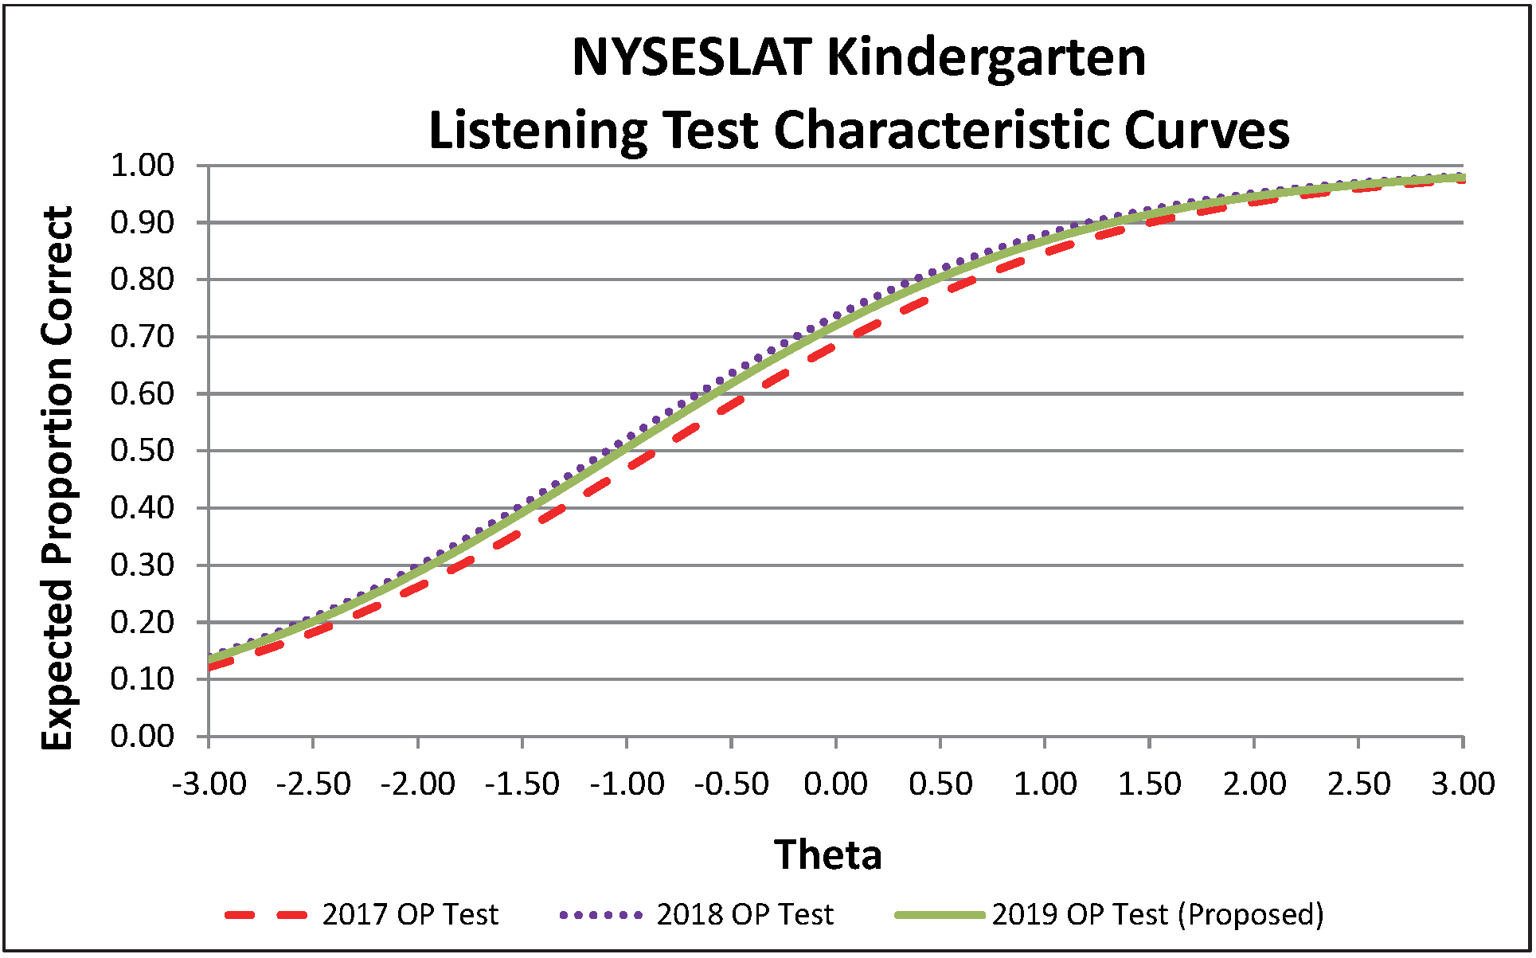

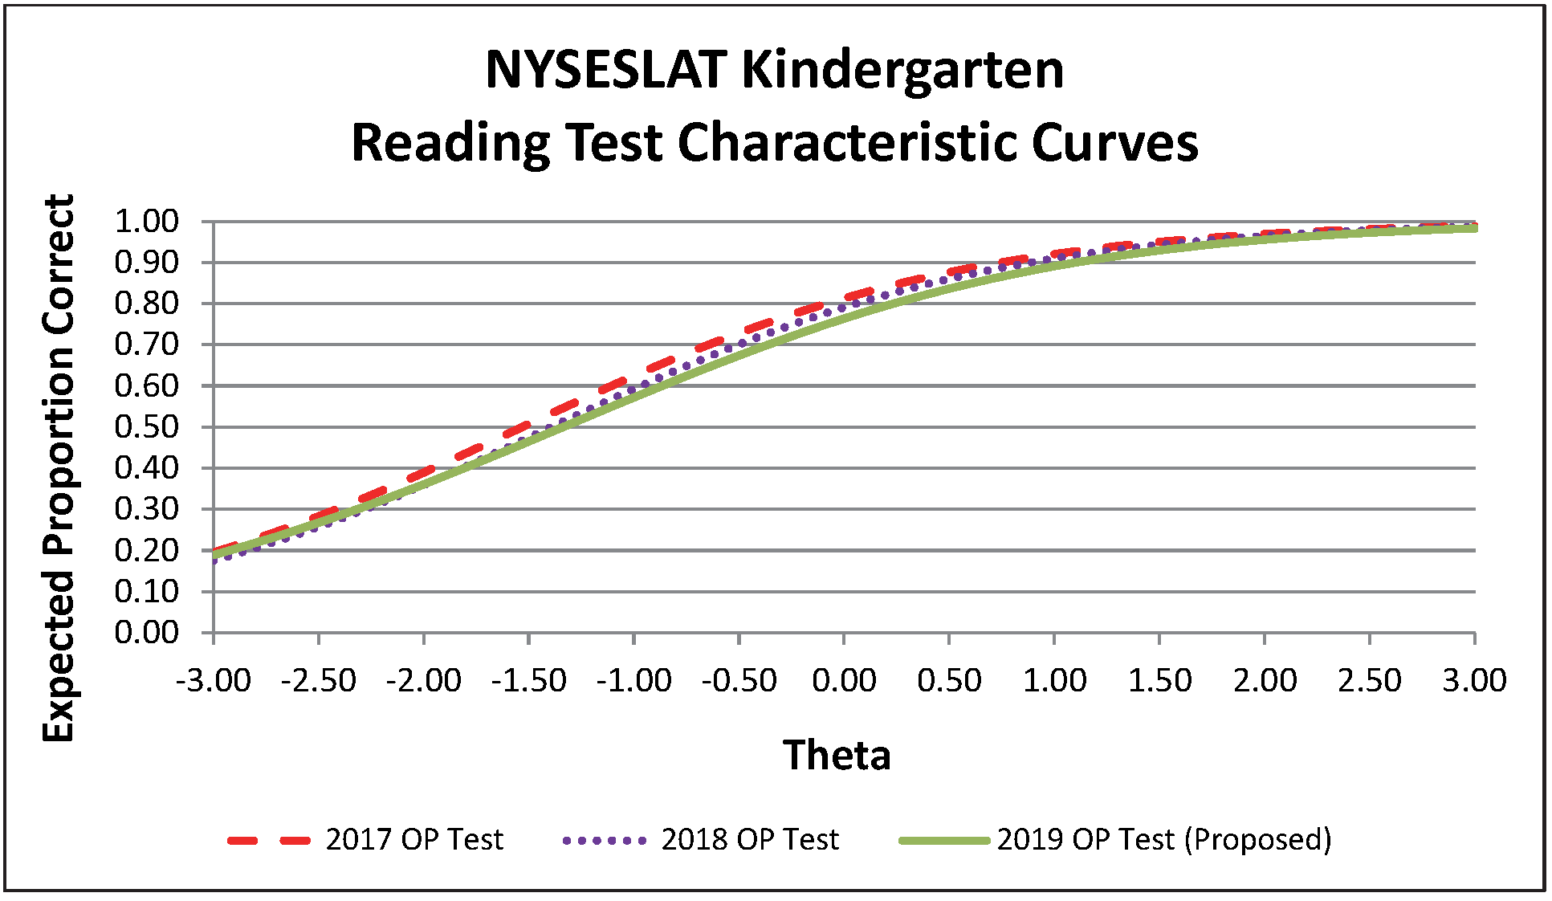
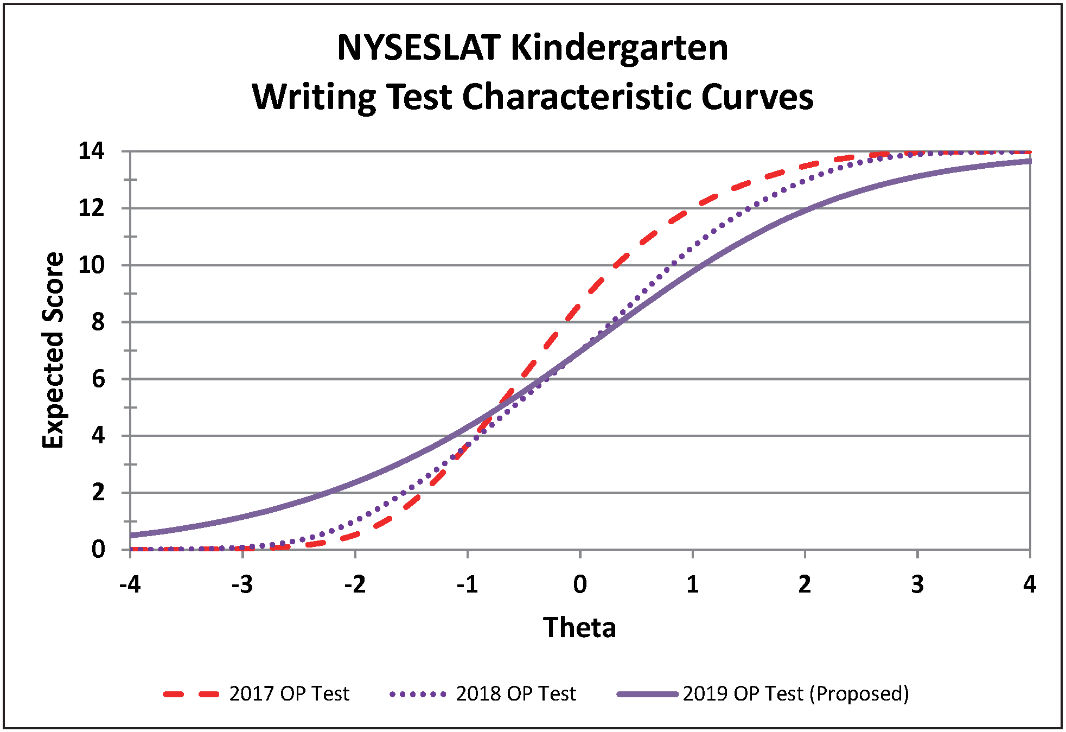
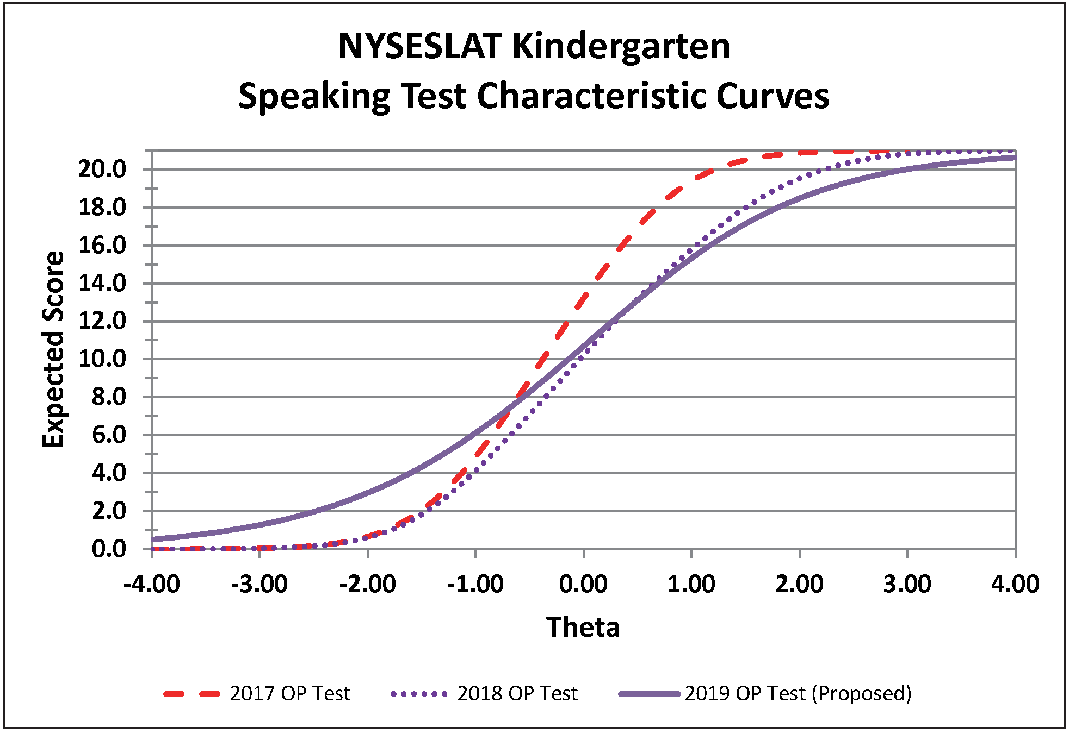
Grades 1-2:
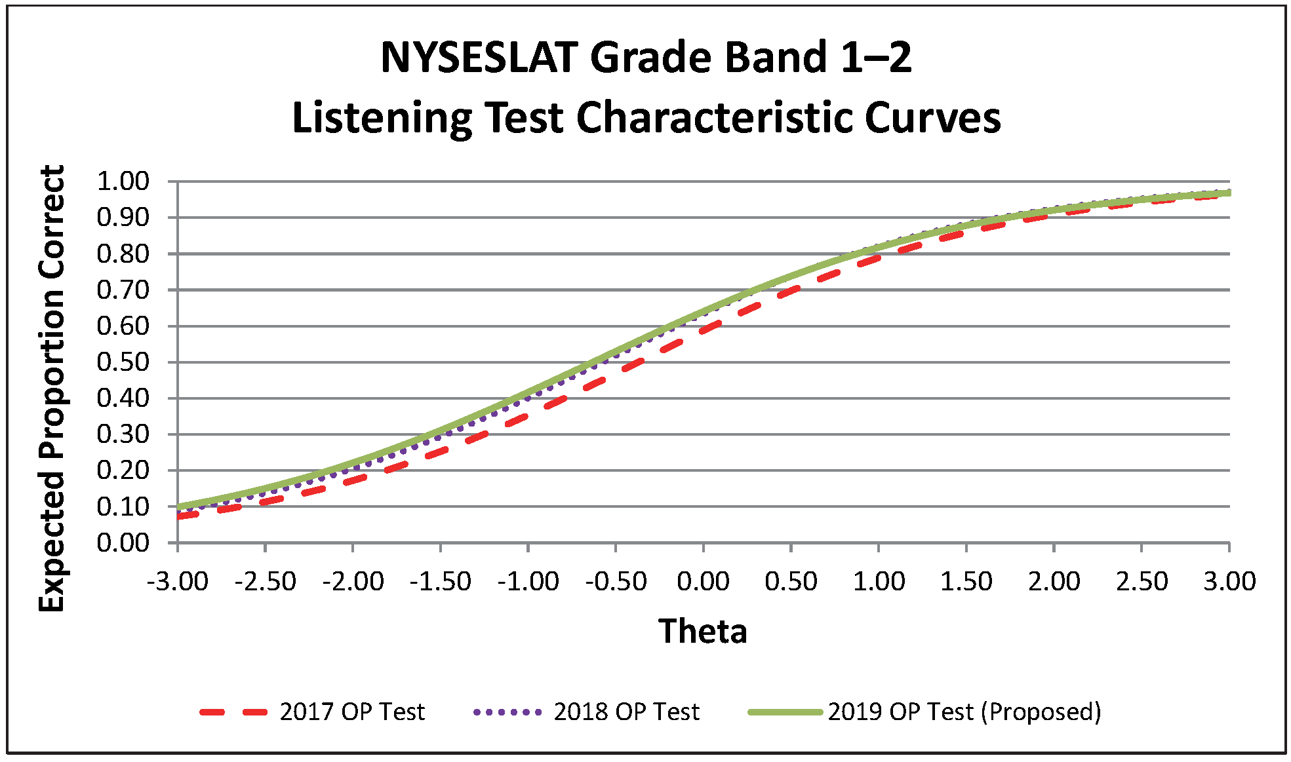
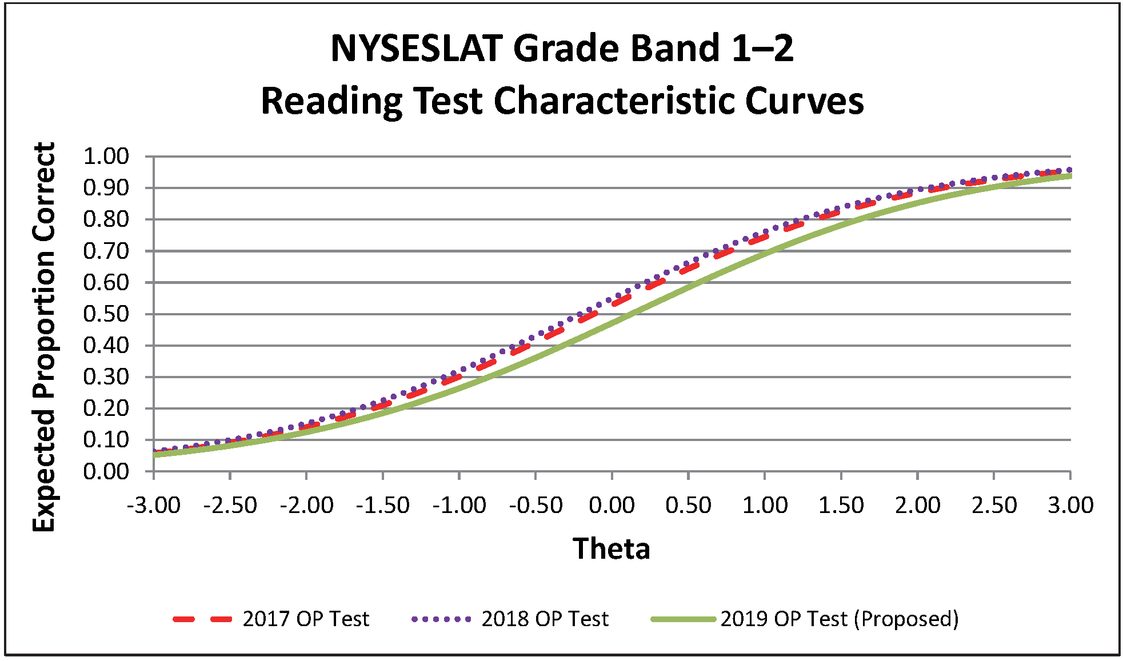
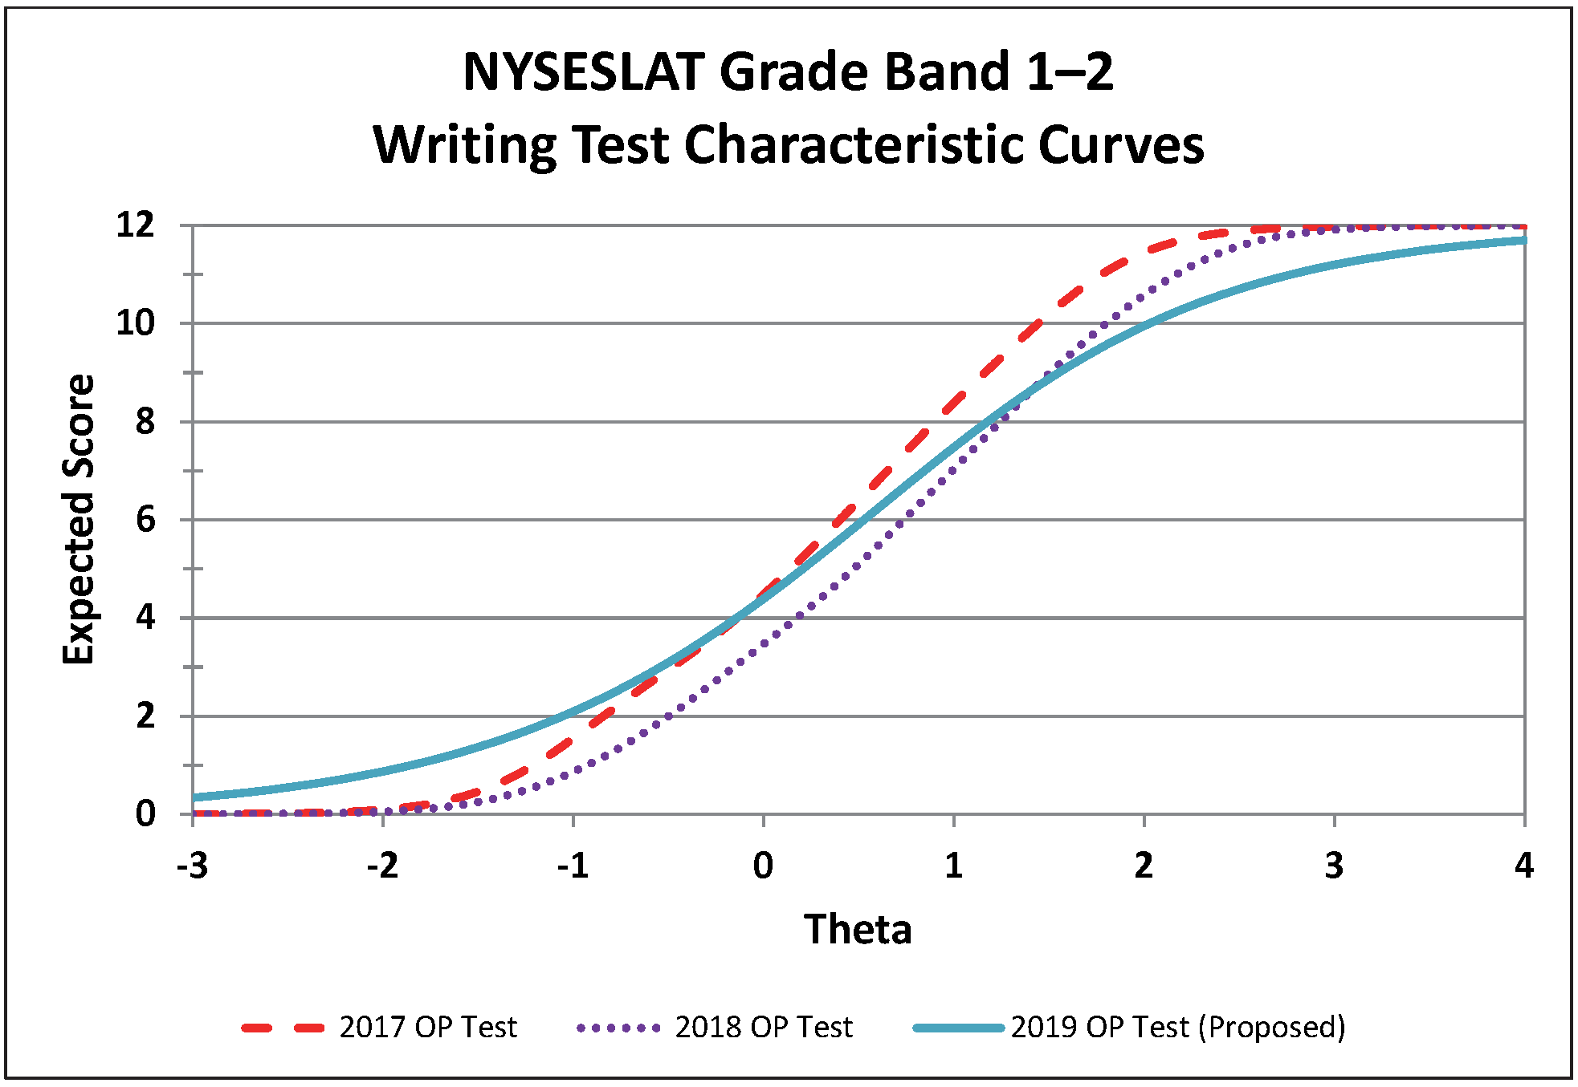
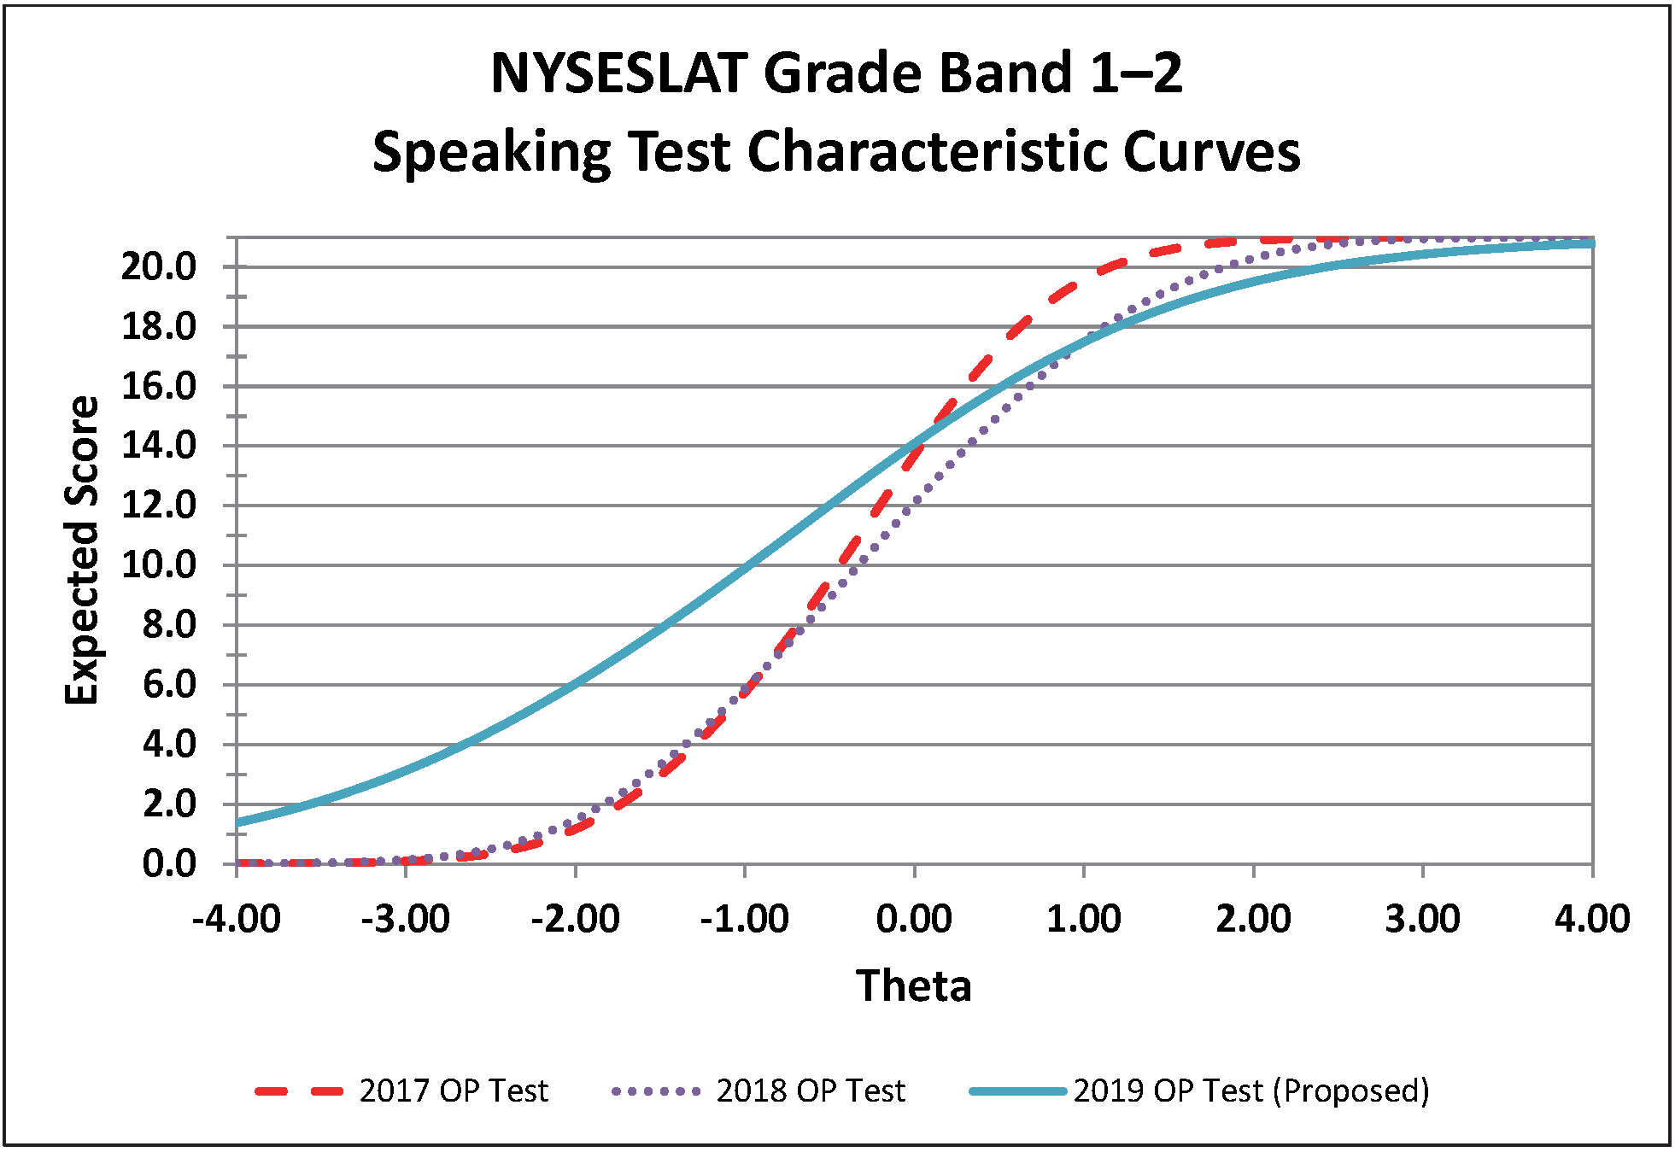
Grades 3-4:
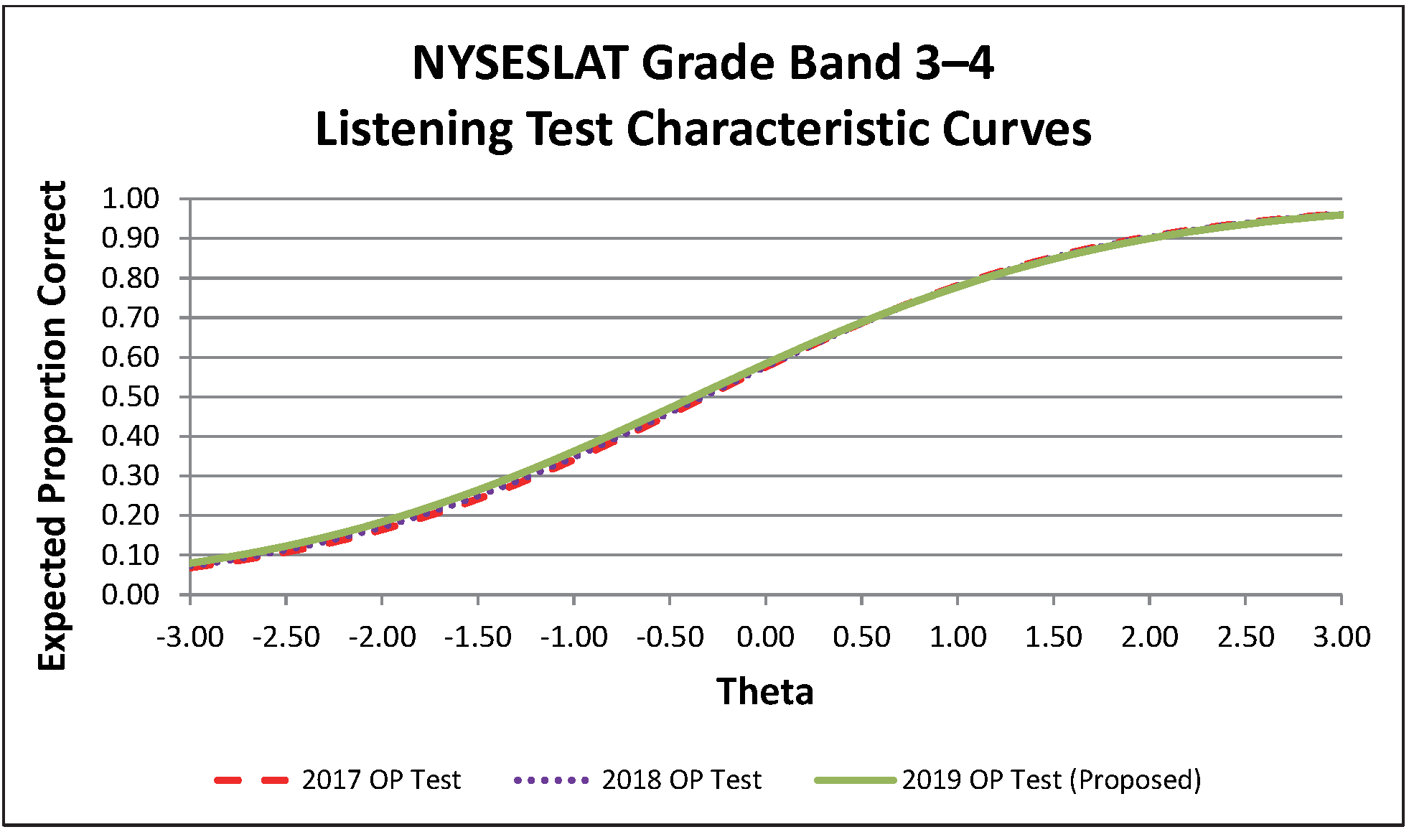
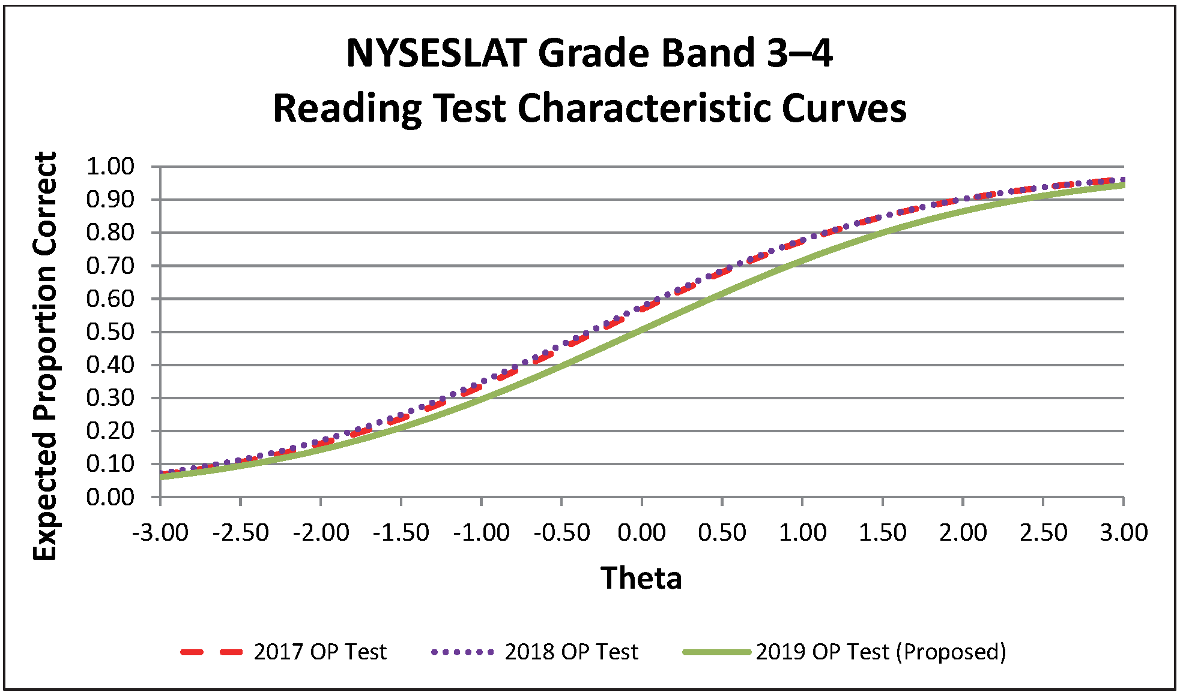
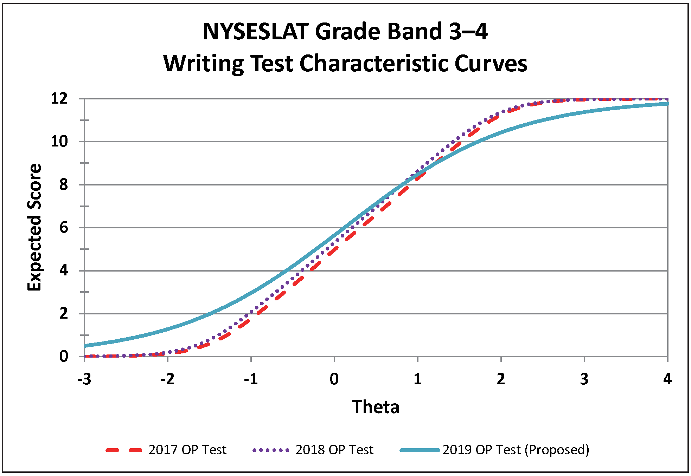
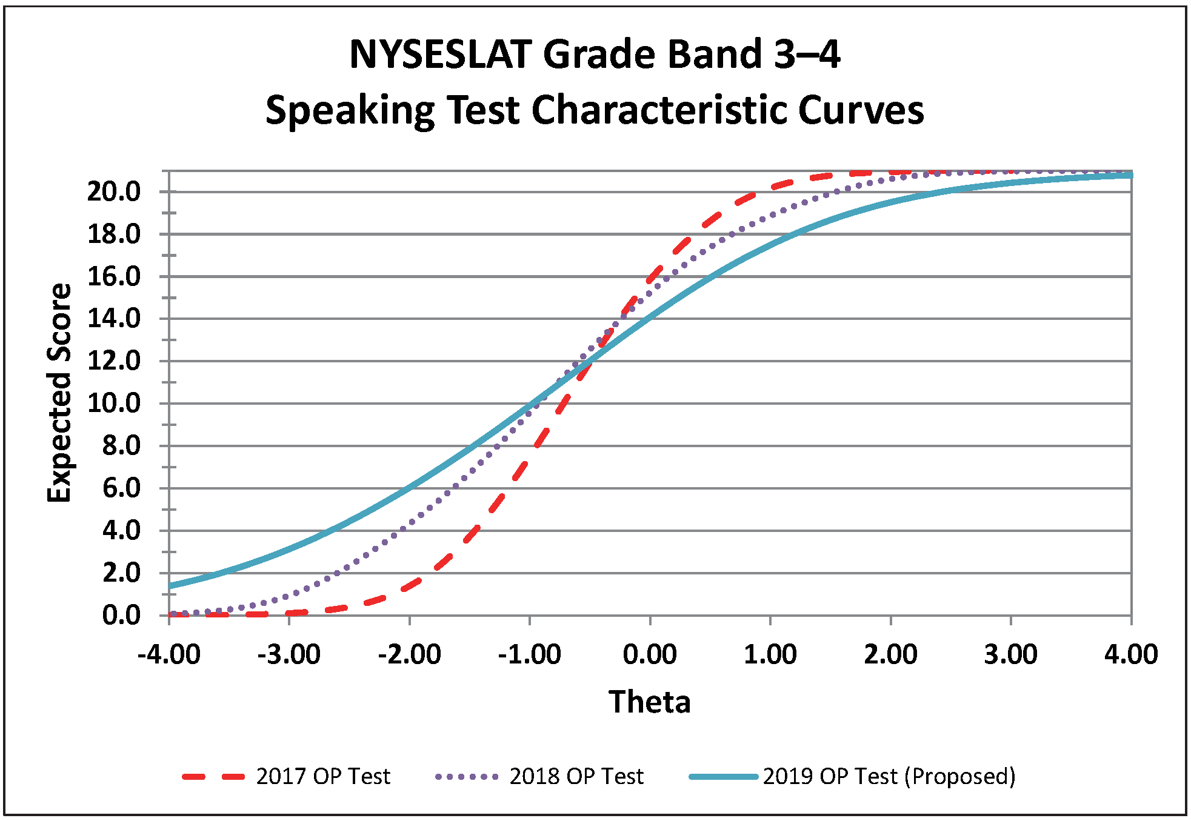
Grades 5-6:
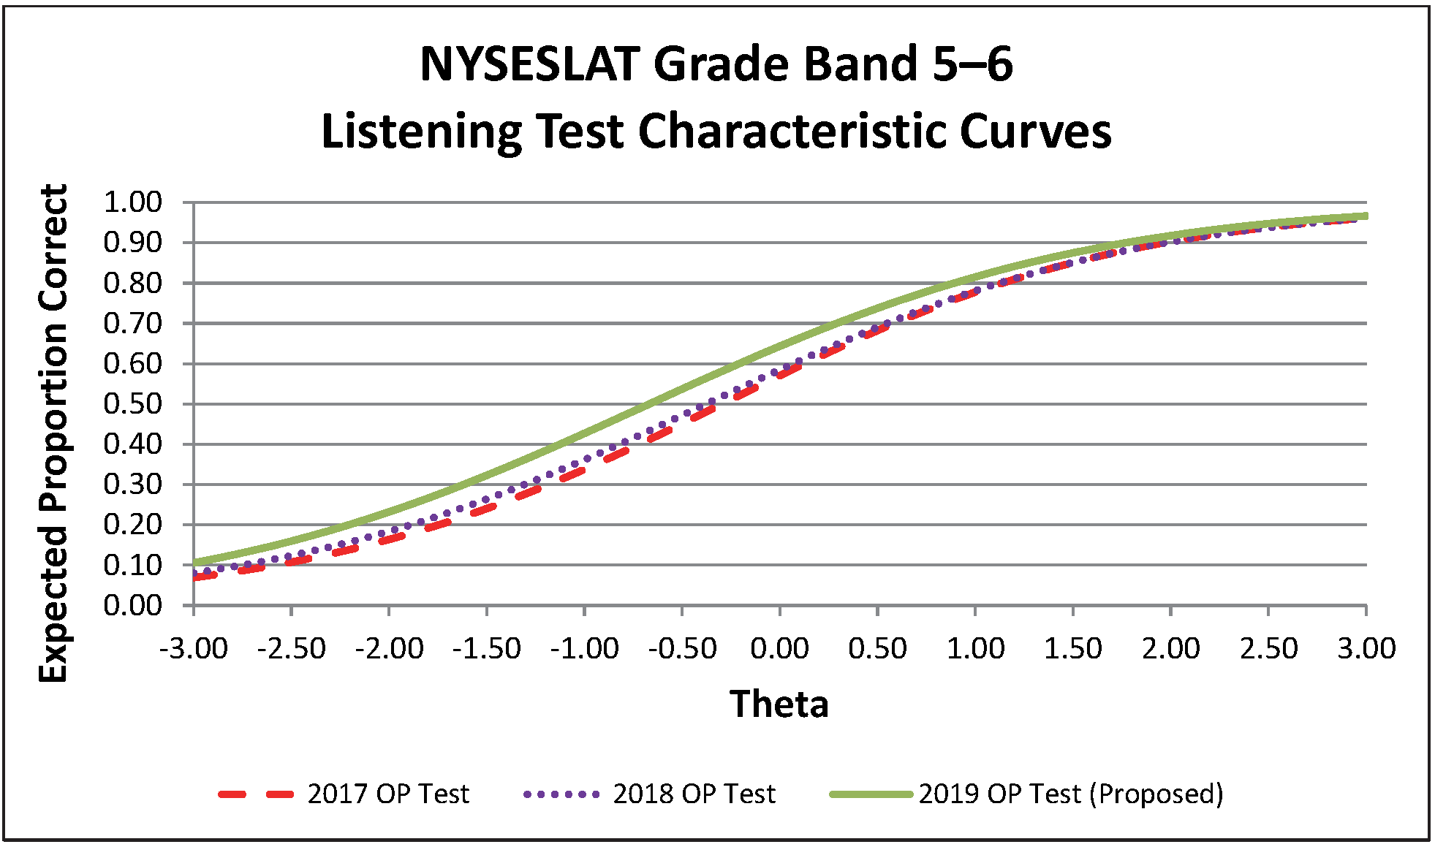
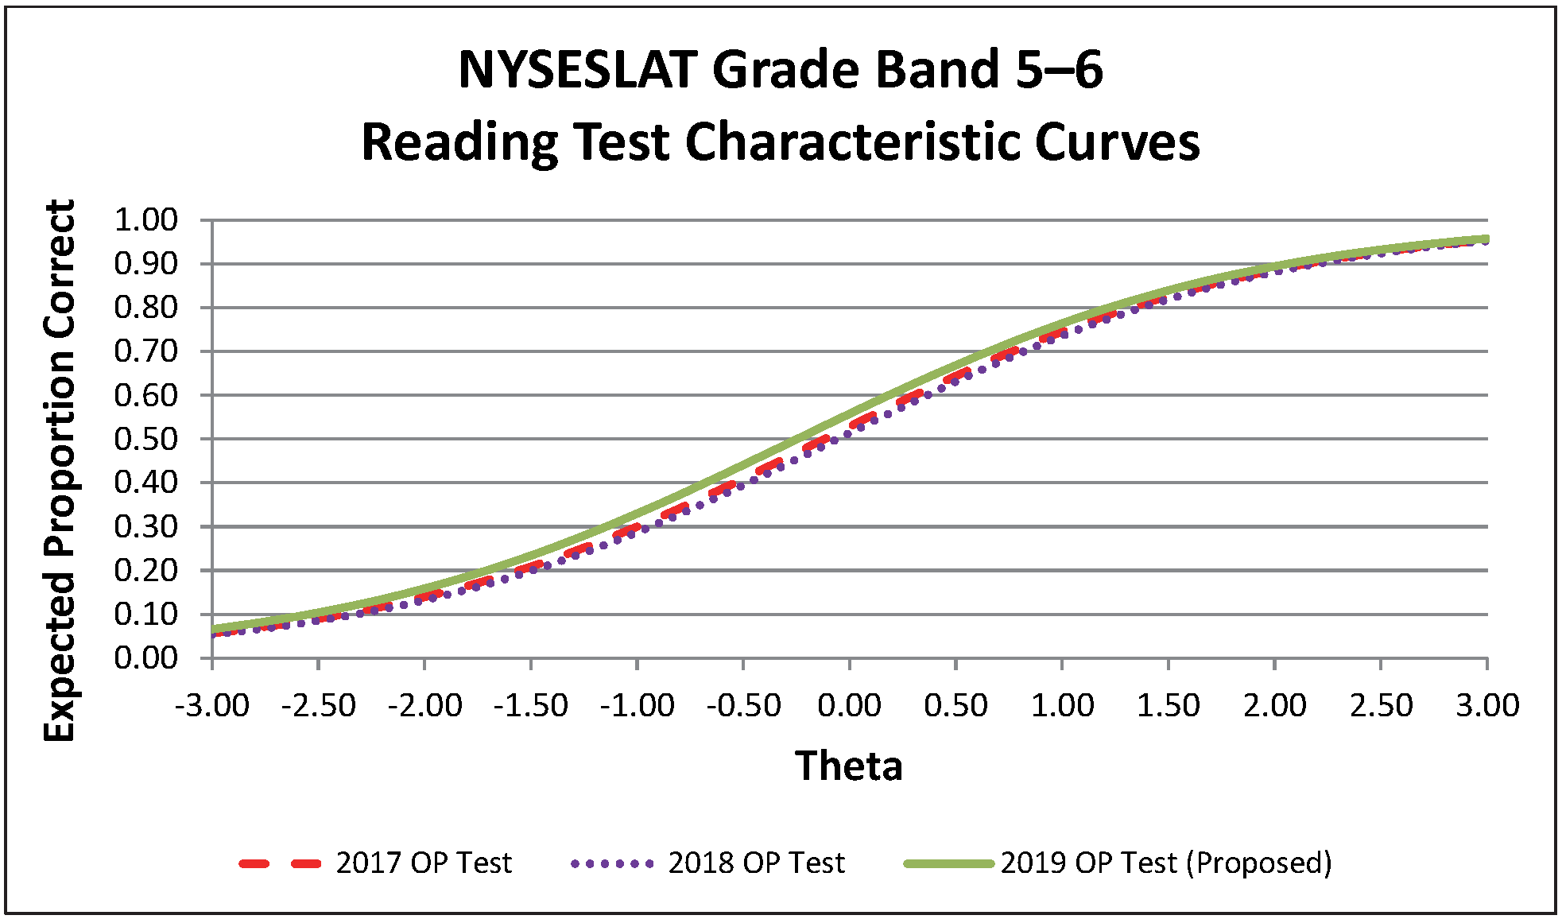
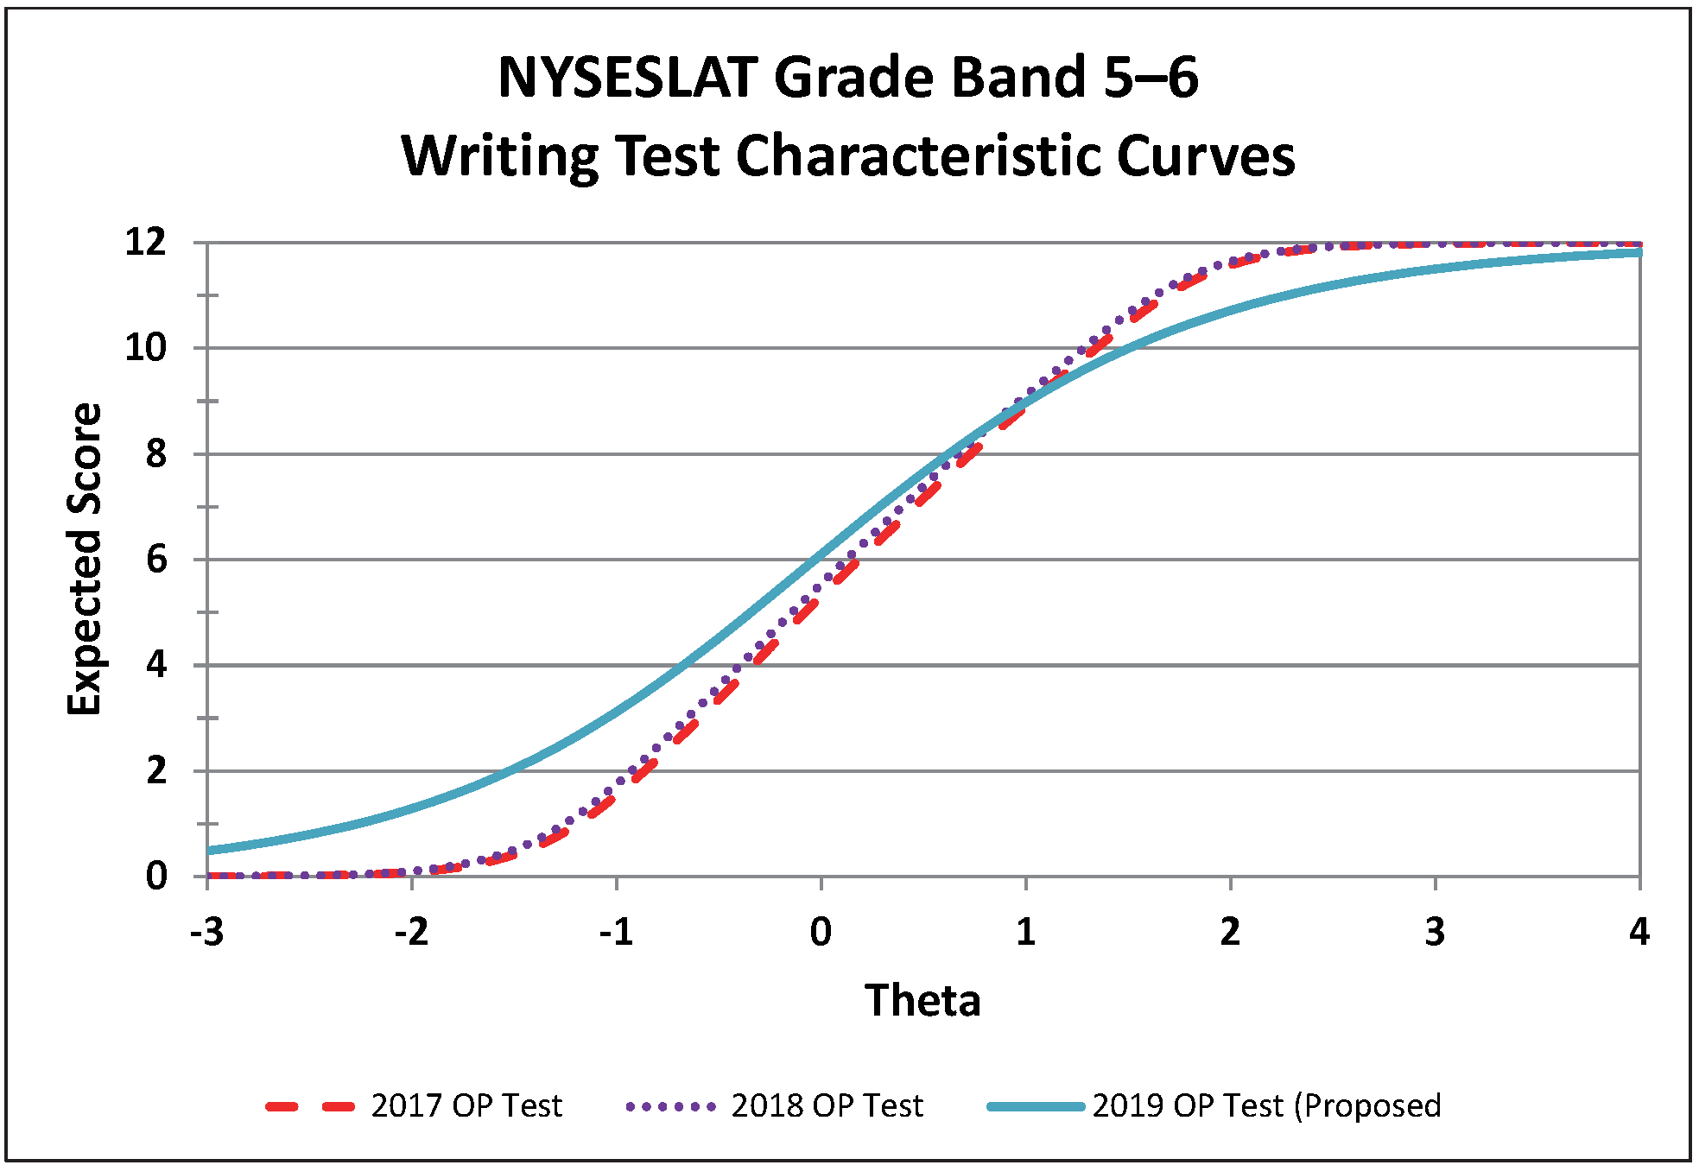
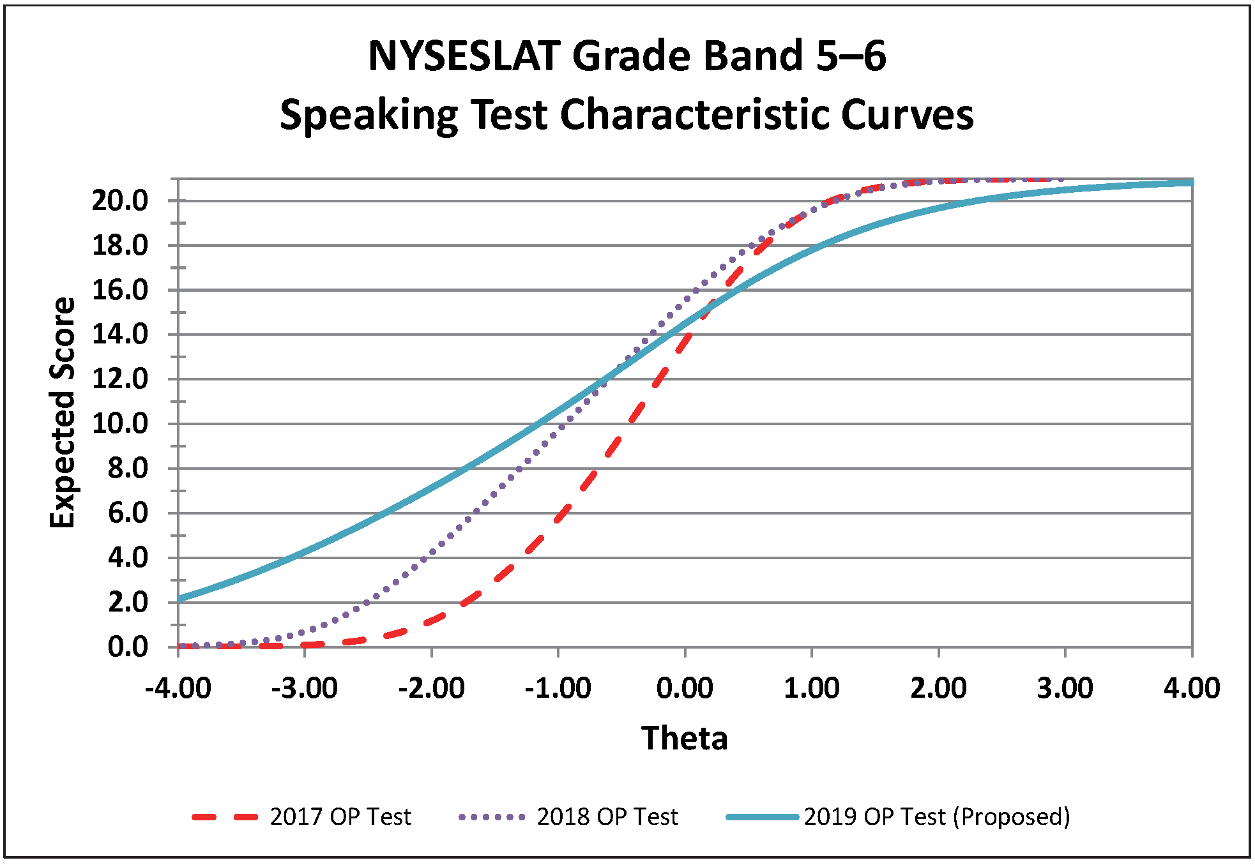
Grades 7-8:
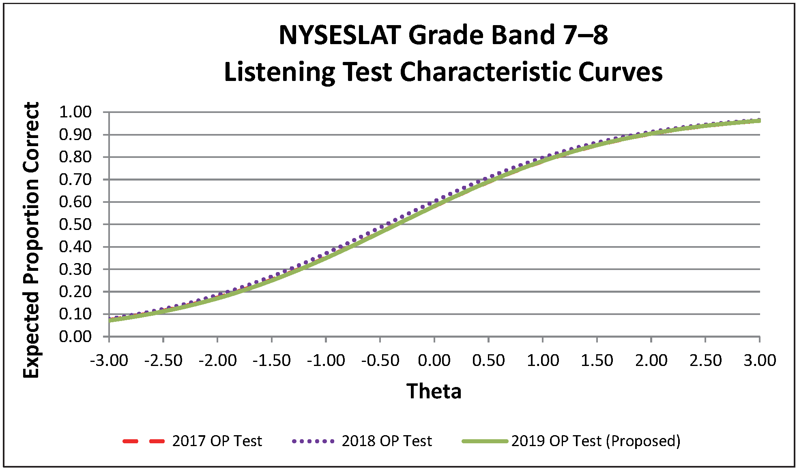
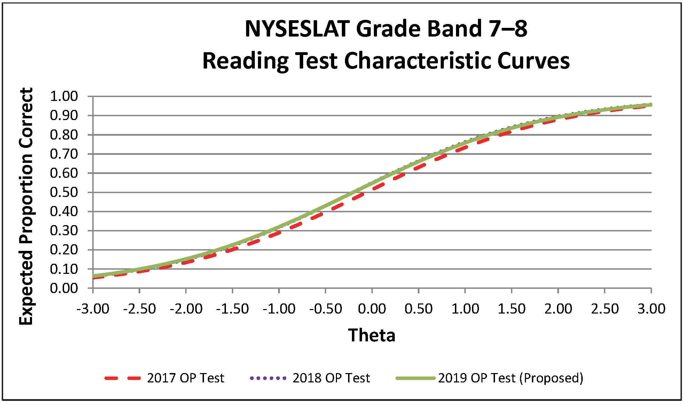
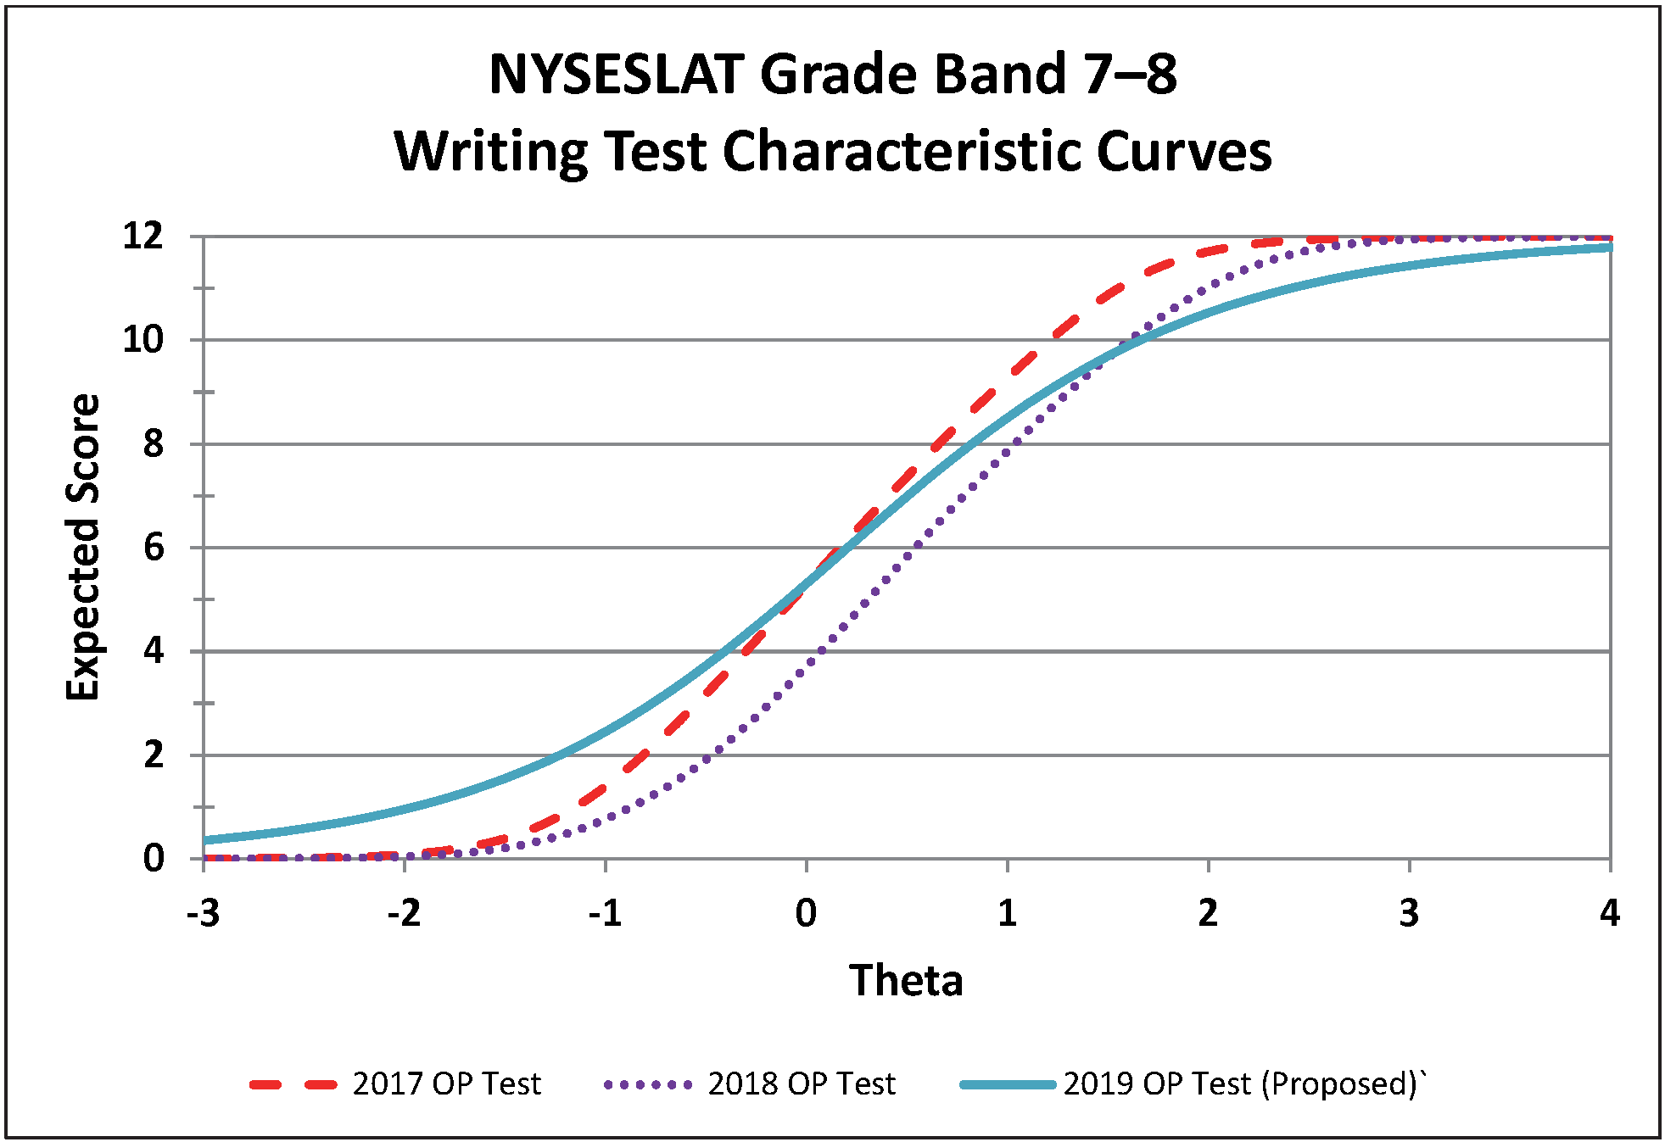
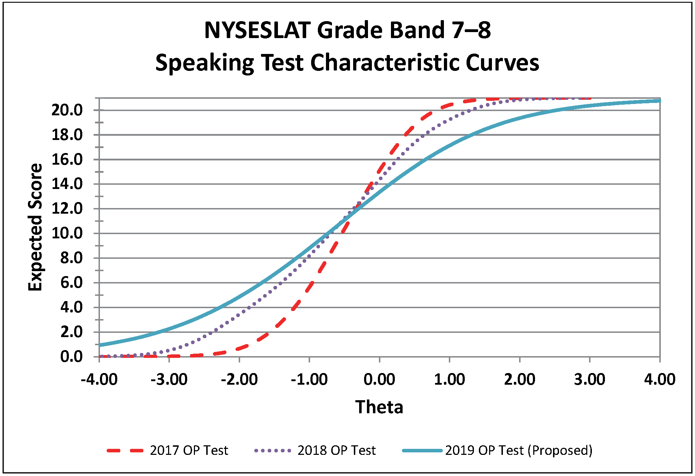

Grades 9-12:
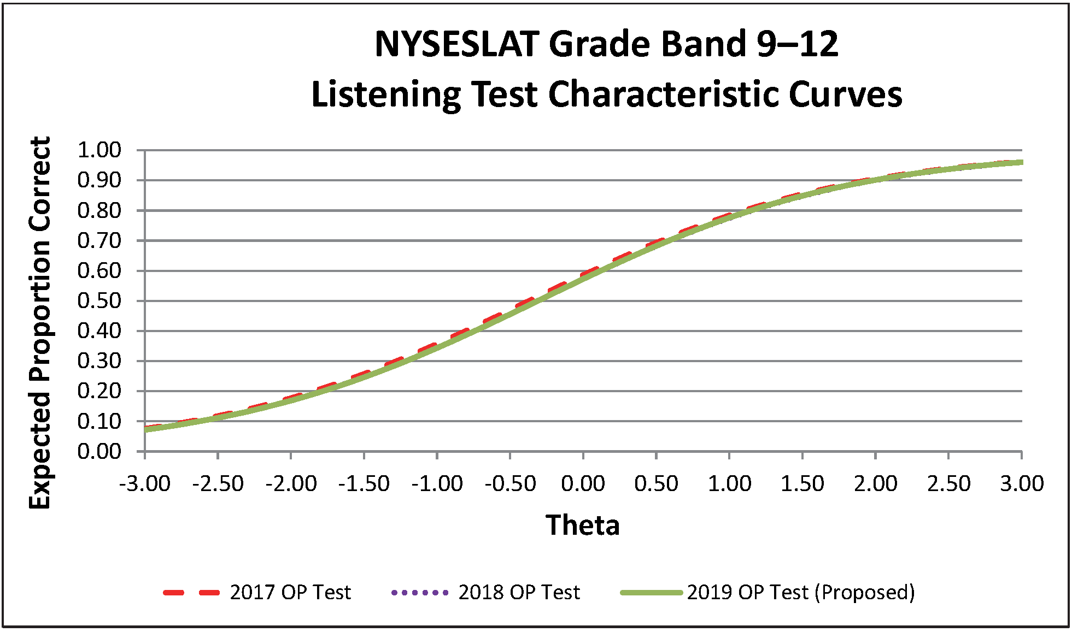
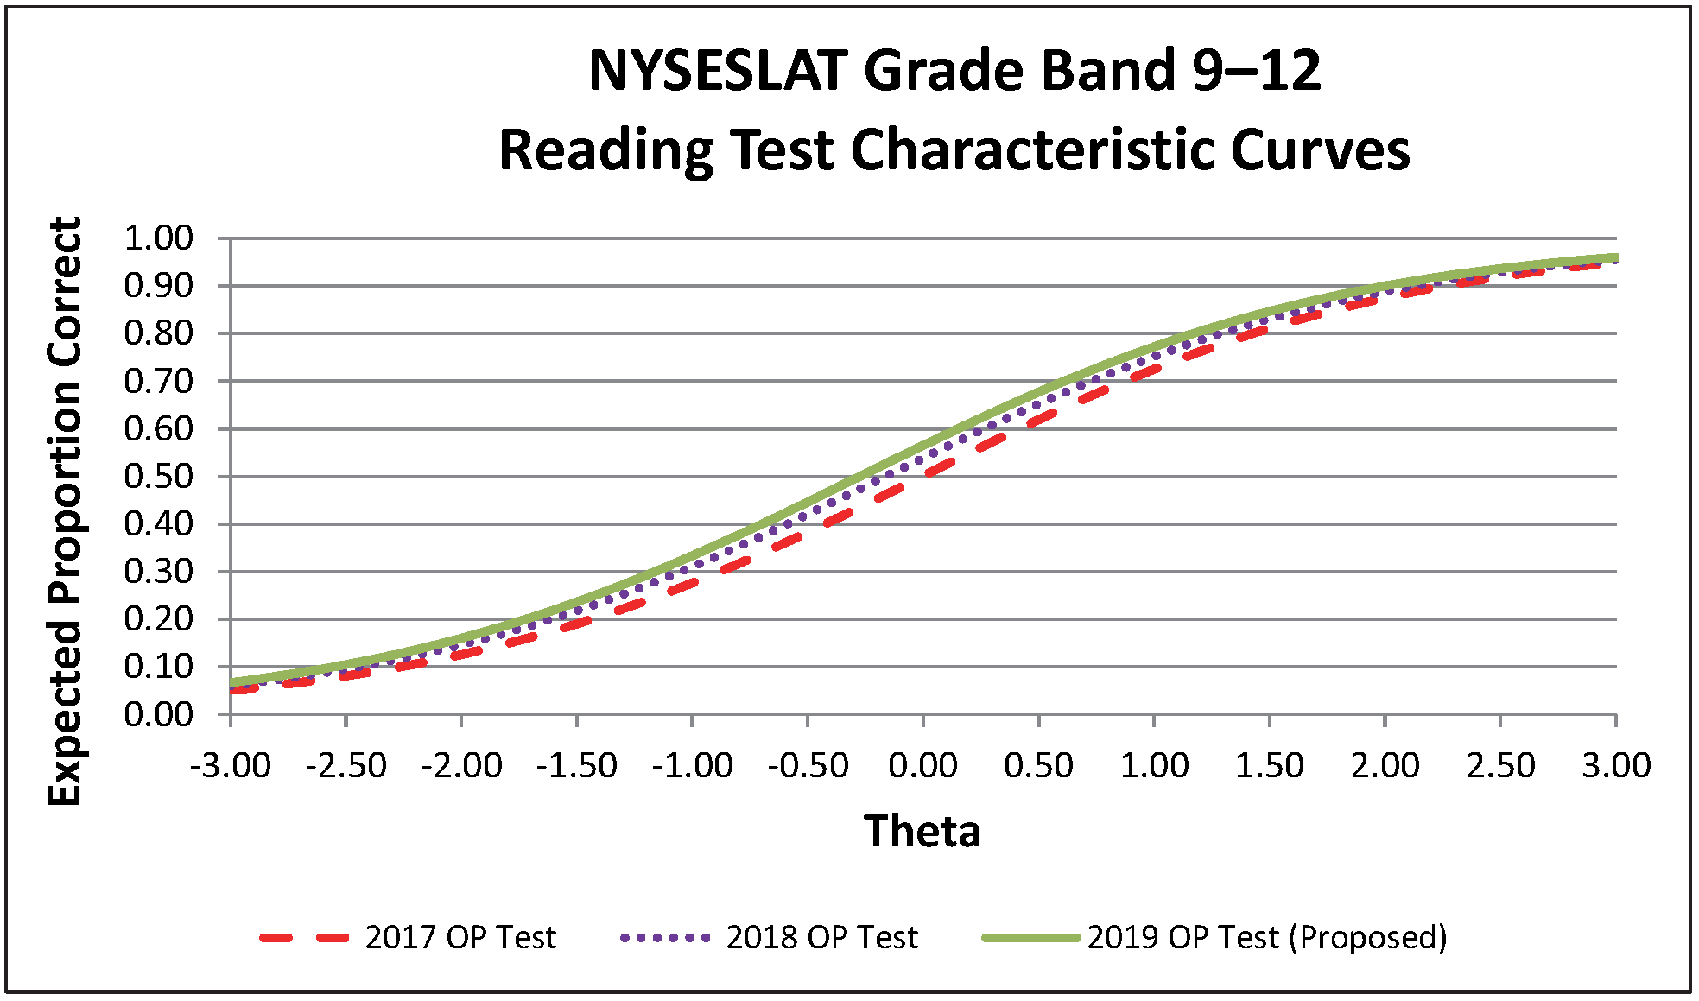
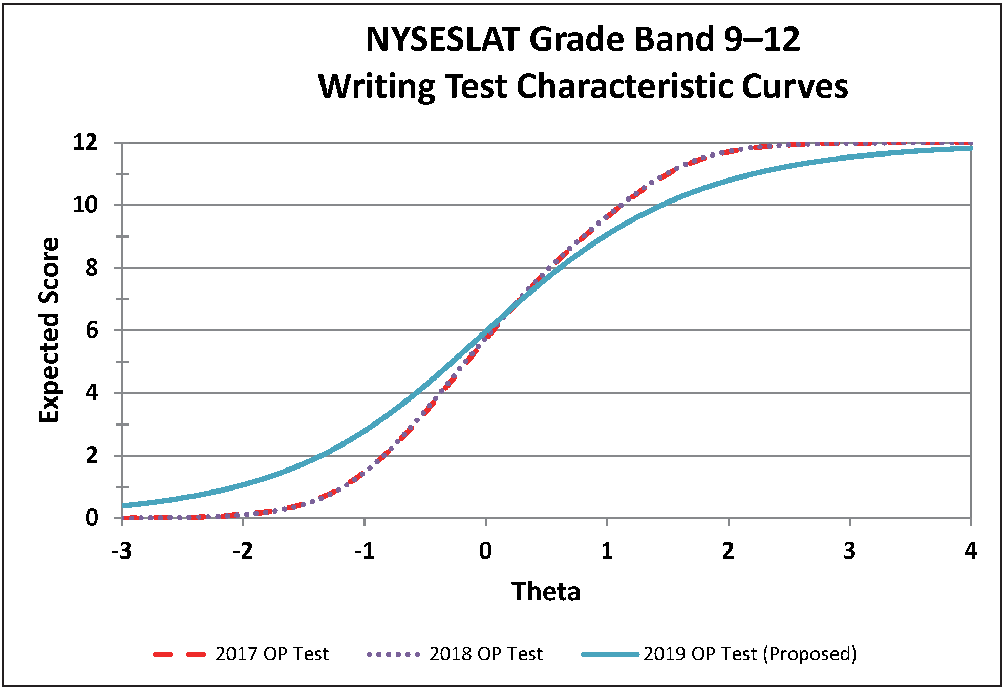
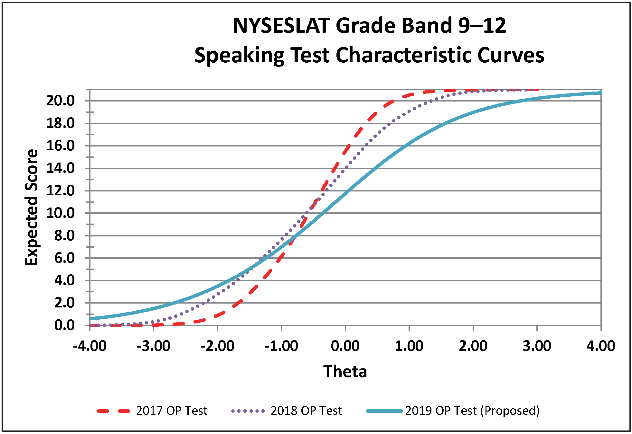

Notice – Contractors are provided with notice herein, NYSED may require a contractor to submit proof of an equal opportunity program after the proposal opening and prior to the award of any contract. In accordance with regulations set forth under Article 15-A §312.5, contractors and/or subcontractors will be required to submit compliance reports relating to the contractor’s and/or subcontractor’s program in effect as of the date the contract is executed.
Common Core State Standards for English Language Arts and Literacy in History/Social Studies, Science, and Technical Subjects; Appendix A: Research Supporting Key Elements of the Standards and Glossary of Terms.

