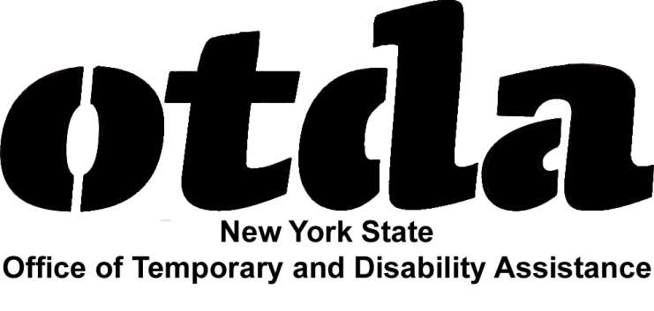

OTDA Resources for Community Schools

The New York State Office of Temporary and Disability Assistance (OTDA) is the State agency responsible for enhancing the economic security of low-income New Yorkers. OTDA fulfills this mission by providing assistance and support to eligible low-income families and individuals, mainly through local departments of social services. These benefits and services, which can help struggling families make ends meet, include:

- Supplemental Nutrition Assistance Program (SNAP) benefits (formerly, “food stamps”) – assistance in affording nutritious food.
- Home Energy Assistance Program (HEAP) benefits – assistance in paying utility bills.
- Temporary Assistance benefits – assistance in meeting basic needs, such as housing.
- Child support services – assistance in establishing paternity and court-ordered child support/health care coverage, and help in enforcing and modifying child support/health care coverage orders.
- Employment services – assistance in finding and retaining a job.
- Services for refugees/other eligible immigrants – assistance in adjusting to American society and schools, and in becoming economically self-sufficient.
- Services for victims of human trafficking – assistance in escaping and recovering from the effects of human trafficking (i.e., forced labor and/or sex).

Through OTDA’s web portal, www.myBenefits.ny.gov, families statewide can check their potential eligibility for many of these benefits and services, as well as others (e.g., free and reduced-price school meals, public health insurance, and tax credits). By answering a quick set of confidential questions on income and household composition, families can learn what kinds of help they may be able to get and how to get it. In addition, families can use the myBenefits website to apply online for SNAP and HEAP benefits in all counties outside of New York City. Families can learn more about OTDA’s child support services at https://www.childsupport.ny.gov and find additional resources for working families at http://otda.ny.gov/workingfamilies/.

Community schools can order informational materials on OTDA programs, free of charge, from www.otda.ny.gov/programs/publications.

Supplemental Nutrition Assistance Program Nutrition Education Funding Opportunity
Community schools may be interested in applying for SNAP Nutrition Education funding. This funding, made available by the United States Department of Agriculture through OTDA, supports nutrition education and obesity prevention efforts for families receiving SNAP benefits and for families eligible for SNAP benefits. Interested community schools must apply no later than 3:00 p.m. on June 20, 2014, and may do so by visiting http://otda.ny.gov/contracts/procurement-bid.asp. (All applicants must be “prequalified” through the NYS Grants Gateway at http://www.grantsreform.ny.gov/.)

